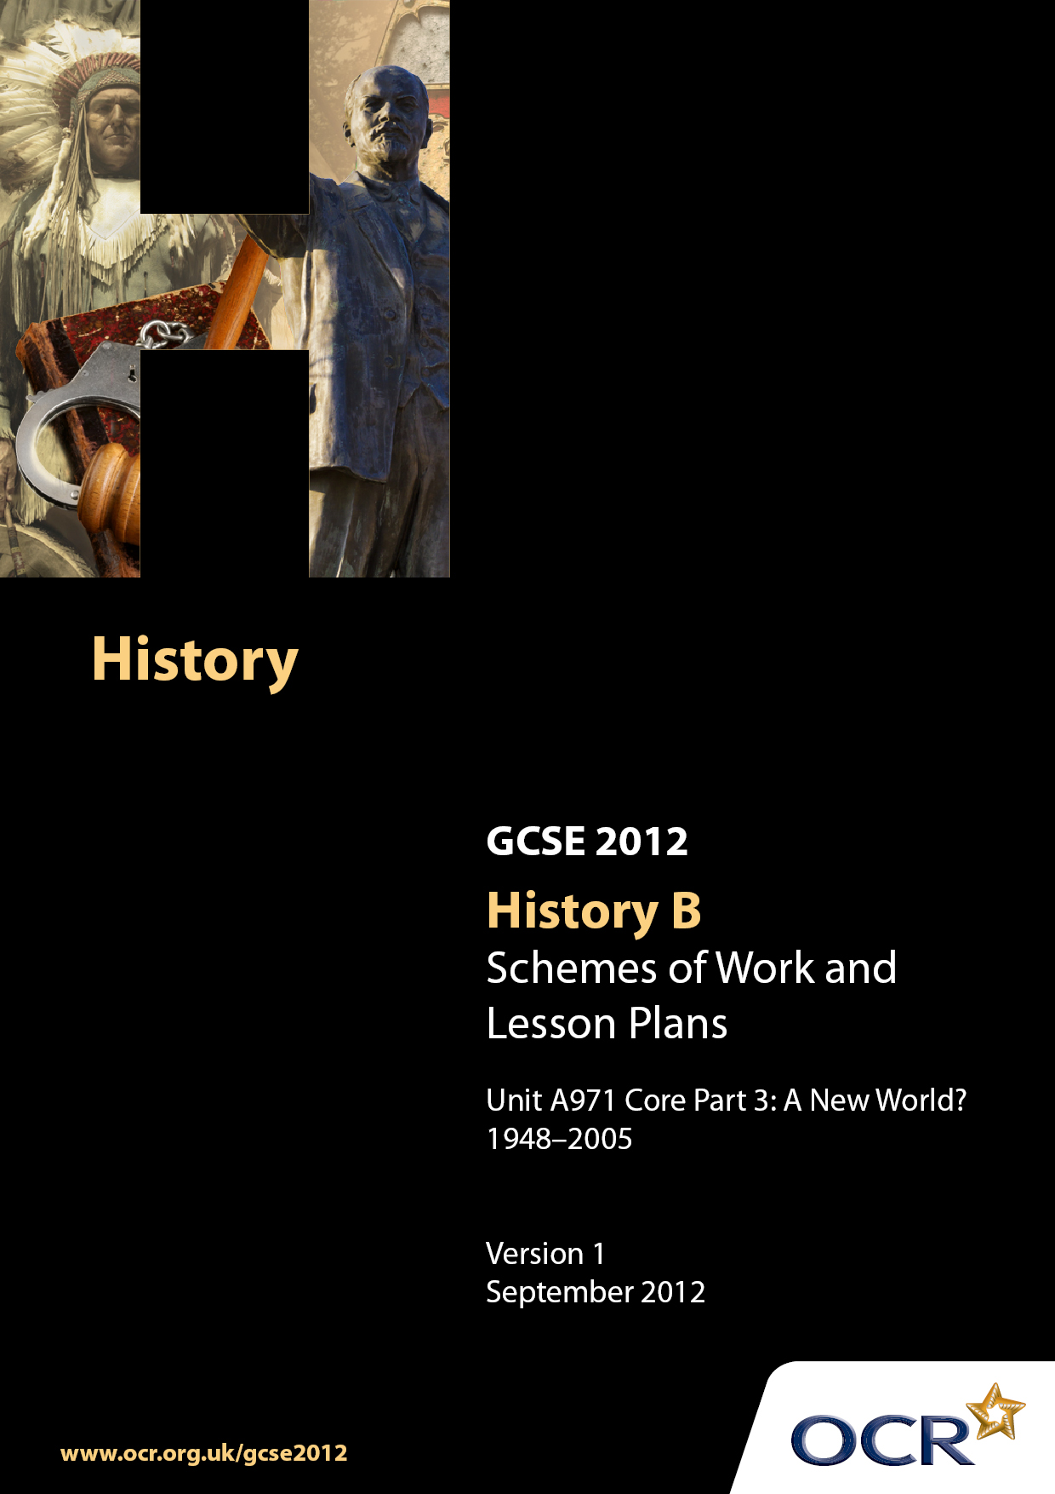

Contents
Contents 2
Introduction 3
Sample Scheme of Work: Unit A971:Core Part 3 Section C A New World? 1948-2005 5
Sample Lesson Plan: Unit A971: Core Part 3 Section C A New World? 1948-2005 20

Introduction

Background
Following a review of 14–19 education and the Secondary Curriculum Review, the Qualifications and Curriculum Authority (QCA) has revised the subject criteria for GCSEs, for first teaching in September 2009. This applies to all awarding bodies.
The new GCSEs have more up-to-date content and encourage the development of personal, learning and thinking skills in your students.
We have taken this opportunity to redevelop all our GCSEs, to ensure they meet your requirements. These changes will give you greater control of assessment activities and make the assessment process more manageable for you and your students. Controlled assessment will be introduced for most subjects.
From September 2012 assessment tasks may be undertaken at any point between release of the task and the examination series for which the task must be submitted. Centres must ensure that candidates undertake a task that is valid for submission in the year in which the candidate intends to submit it.
OCR has produced a summary brochure which summarises the changes to Modern World History B. This can be found at www.ocr.org.uk, along with the new specification.
In order to help you plan effectively for the implementation of the new specification we have produced these Schemes of Work and Sample Lesson Plans for History B. These Support Materials are designed for guidance only and play a secondary role to the Specification.

Our Ethos
OCR involves teachers in the development of new support materials to capture current teaching practices tailored to our new specifications. These support materials are designed to inspire teachers and facilitate different ideas and teaching practices.
Each Scheme of Work and set of Sample Lesson Plans is provided in Word format – so that you can use it as a foundation to build upon and amend the content to suit your teaching style and students’ needs.
The Scheme of Work and Sample Lesson Plans provide examples of how to teach this unit and the teaching hours are suggestions only. Some or all of them may be applicable to your teaching.
The Specification is the document on which assessment is based and specifies what content and skills need to be covered in delivering the course. At all times, therefore, this Support Material booklet should be read in conjunction with the Specification. If clarification on a particular point is sought then that clarification should be found in the Specification itself.

A Guided Tour through the Scheme of Work

= Innovative Teaching Idea
This icon is used to highlight exceptionally innovative ideas.


= ICT Opportunity
This icon is used to illustrate when an activity could be taught using ICT facilities.

Unit: A971 Core Part 3: Section C A New World? 1948-2005
Suggested teaching time | 2 hours | Topic | Question 8: What is the significance of the Iraq War?
Topic outline |  | Suggested teaching and homework activities |  | Suggested resources | Points to note
Why did the multi-national force invade Iraq in 2003? |  | - Introduction - Students should be given an introduction to the personalities and themes that shaped the debate leading to the invasion of Iraq  - The first Gulf War  - The debate over weapons of mass destruction  - Saddam Hussein’s human rights record  - Conditions in Iraq  - Saddam Hussein’s links to  al-Qaeda  - 9/11, Axis of Evil  - Spreading democracy  - Iraq’s oil  - Ask students to produce a timeline to illustrate the key developments leading up to the decision to invade |  | - BBC News – lots of articles, film footage  http://news.bbc.co.uk  - The National Security Archive Briefing Book no. 80  http://www.gwu.edu/~nsarchiv/NSAEBB/ NSAEBB80/ #reading  - CIA documented use of WMDs by Iraq  https://www.cia.gov/library/reports/general-reports-1/iraq_wmd/Iraq_Oct_2002.htm#02  - British Government dossier on Iraq WMDs –  http://www.number10.gov.uk/Page271  - Links to Al-Qaeda  http://www.cfr.org/publication/7702/  - Oil supplies by country  http://www.infoplease.com/ipa/A087 2964.html | - George W Bush  - Saddam Hussein  - UN Security Council  - Hans Blix  - Ba’ath Party  - Osama bin Laden  - Oil for food
 |  | - What was Iraq like before the invasion? Discuss why Iraq invaded Kuwait, the defeat in the Gulf War, the imposition of trade sanctions, the political system and culture in Iraq and the human rights record of the regime. Ask students to write diary extracts explaining what they think should change in Iraq and why during this period?  - Why were the USA and GB so sure that Iraq had WMDs? Students should produce a spider diagram illustrating the strengths and weaknesses of the USA and GB’s case |  | - Oil consumption by country  http://www.nationmaster.com/graph/ene_  oil_con-energy-oil-consumption  - Oil and the war  http://www.guardian.co.uk/world/2004  /jul/28/iraq.usa  - US National Security Strategy 2002  www.whitehouse.gov/nsc/nss.pdf  - Bush’s message to Iraqi people 10/4/03  http://www.whitehouse.gov/news/releases/2003/ 04/20030410-2.html
 |  | - The USA and GB wanted to spread democracy to Iraq. Why might some Iraqis have opposed democracy? Ask students to draw a pie-chart illustrating the composition of the Iraqi population. Who are the majority and who are the minorities?  - Why is oil so important to the world economy? Which country uses the most oil and which countries have the most reserves? Ask students to produce a mind map of the relationship between oil, the USA and GB and Iraq |  | - US foreign policy and democracy in Iraq  http://www.airpower.maxwell.af.mil/  airchronicles/cc/schwalbe3.html  - Religion within Iraqi society  http://news.bbc.co.uk/1/hi/world/middle_east/ 4750320.stm  - Tribal and social divisions in Iraq  http://www.globalsecurity.org/military/world/iraq /tribes.htm
 |  | - Produce an essay plan to answer the question – Do you agree that the USA and GB invaded Iraq to stop the threat from Saddam Hussein’s WMDs?
Was the invasion legal? Why was there opposition in many countries to the invasion? |  | - The invasion of Iraq has proved extremely controversial. Students should consider why the invasion prompted such strong opposition.  - Compare the response to the invasion of Afghanistan  - The UN Charter, resolutions  - Bush and Blair diplomacy and statements  - Opposition to the invasion in Britain and in other parts of the world  - Role of the media  - Did the UN provide the authority for the coalition forces to invade Iraq? Provide students with the preamble to the UN Charter and ask them to consider in groups which items were ignored or followed when the USA and GB invaded Iraq? |  | - BBC website  http://news.bbc.co.uk  - Shiner, P and Williams, A, 2008, The Iraq War and International Law  - Interesting ‘pro-war’ article  http://atilla89.wordpress.com/2007/06/30/effective-arguments-for-the-war-on-iraq-a-must-read/  - Thorough but simple film explanation of international law  www.youtube.com/watch?v=1Khut8xbXK8  - UN Charter  http://www.un.org/aboutun/charter/index.html  - Tumber, H and Palmer, J, 2004, Media at War: The Iraq Crisis  - ‘Sexing up’ the Iraq dossier  http://www.iraqdossier.com/ | - UN Secretary General Kofi Annan  - UN resolutions  - Anti-war protests/groups  - US/GB election results  - Anti-war candidates  - Bush second term and Obama victory  - The Christian right

Unit: A971 Core Part 3: Section C A New World? 1948-2005
Suggested teaching time | 2 hours | Topic | Question 8: What is the significance of the Iraq War?
Topic outline |  | Suggested teaching and homework activities |  | Suggested resources | Points to note
 |  | - Why did so many ordinary people feel the need to demonstrate against the war?  Ask students to design anti-war placards illustrating a particular reason why the war is wrong. How many different reasons do they come up with? What is the most popular?  - Did the opposition make any difference? Who supported the war? When did the general population turn against the war?  Both Blair and Bush won elections after the invasion. Ask students to produce some election propaganda defending the decision to invade Iraq. |  | - Guardian Online – Legal Experts  http://www.guardian.co.uk/politics/2004/  mar/02/uk.internationaleducationnews  - Lord Goldsmith’s legal advice to Blair  http://news.bbc.co.uk/1/hi/uk_politics/vote_2005/frontpage/4492439.stm  - Blair and legal advice before the war  http://news.bbc.co.uk/1/hi/  uk_politics/7734712.stm  - Blair explains the reasons to go to war  http://www.number10.gov.uk/Page3088  - Blair and Bush agree to go to war  http://news.bbc.co.uk/1/hi/world/americas/4849744.stm  - International response  http://www.globalsecurity.org/military/ops/iraq-view.htm
- Senate Report on pre-war intelligence 2006
http://en.wikipedia.org/wiki/Senate_Report_of_Pre-war_Intelligence_on_Iraq
- Anti-war protest Feb 2003
http://news.bbc.co.uk/1/hi/uk/2765041.stm
- The ‘smoking gun’ Downing Street memo
http://www.sourcewatch.org/index.php?title=The_secret_Downing_Street_memo%2C_July_23%2C_2002
- Stop the war coalition
http://www.stopwar.org.uk
- Photos of worldwide anti-war demonstrations
http://news.bbc.co.uk/1/hi/uk/2765041.stm

Unit: A971 Core Part 3: Section C A New World? 1948-2005
Suggested teaching time | 1 hour | Topic | Question 8: What is the significance of the Iraq War?
Topic outline |  | Suggested teaching and homework activities |  | Suggested resources | Points to note
How was the invasion completed so quickly? |  | - Iraqi armed forces crumbled extremely quickly to the surprise of most commentators. However, resistance has never ceased. Students need to consider why the invasion was completed so quickly yet without victory.  - Students should examine the main events of the invasion and weigh up the tactics and technological advantages of the Coalition forces against the weaknesses of the Iraqi forces. Can students think of alternative names for the ‘shock and awe’ stage of the invasion? What does ‘shock and awe’ say about Coalition tactics? |  | - Keegan, J, 2005, The Iraq War  - Allawi, A, 2008, The Occupation of Iraq: Winning the War, Losing the Peace  - Timeline of Iraq invasion  http://www.infoplease.com/spot/iraqtimeline2.html  - Military action before war was declared  http://www.bookrags.com/wiki/Operation_Southern_Focus  - Shock and awe statistics and aims  http://www.timesonline.co.uk/tol/news/world/article1120053.ece  - Iraqi military strength  http://www.nationalreview.com/comment/keegan200406280919.asp | - Republican Guard  - Fedayeen Saddam  - Thunder runs  - WMDs  - Western Front: US's 3rd Infantry Division goes through Najaf and Karbala towards Baghdad  - Central Front: US's 1st Marine Expeditionary Force goes through Nasiriyah towards Baghdad  - Eastern Front: UK's 1st Armored Division goes through Basra towards Baghdad

Unit: A971 Core Part 3: Section C A New World? 1948-2005
Suggested teaching time | 1 hour | Topic | Question 8: What is the significance of the Iraq War?
Topic outline |  | Suggested teaching and homework activities |  | Suggested resources | Points to note
 |  | - Students should also consider why the insurgency was able to develop so quickly? Ask students to draw up a list of resources they would need to control a country. This can form the basis of a class discussion relating to the problems facing coalition troops in Iraq following the invasion |  | - Iraqi military weakness  http://www.independent.co.uk/news/world/middle-east/myth-of-iraqi-military-strength-exploded-593998.html  - US military strength  www.usembassy.it/pdf/other/RL31701.pdf  - Podcast about the invasion  http://militaryhistorypodcast.blogspot.com/2007/04/invading-iraq-2003.html | - A secondary invasion in the North was led by the 10th Special Forces Group and the Kurdish Peshmerga. This force pushed through Mosul and Kirkuk towards Baghdad  - Operation Southern Focus  - Shock and awe  - Morale of troops  - Leadership  - Operation Desert Scorpion

Unit: A971 Core Part 3: Section C A New World? 1948-2005
Suggested teaching time | 2 hours | Topic | Question 8: What is the significance of the Iraq War?
Topic outline |  | Suggested teaching and homework activities |  | Suggested resources | Points to note
What were the consequences of the invasion inside Iraq and internationally |  | - Despite the US declaring an end to major combat operations on 1st May 2003, fighting in Iraq has never stopped. Students should consider how the invasion affected life in Iraq.  - Did life improve for Iraqis following the invasion? Students can produce a spider diagram illustrating whether conditions were better or worse with reference to the following issues;  - the post-invasion condition of Iraq  - breakdown in law and order  - the insurgency  - the methods used by the Americans and the British against the insurgency  - human rights abuses  - the emergence of democratic institutions |  | - US Government document explaining the transition to democracy  www.gao.gov/new.items/d04746r.pdf  - Election of Nation Assembly statistics  http://en.wikipedia.org/wiki/Council_of_Representatives_of_Iraq  - Allawi, A, 2008, The Occupation of Iraq: Winning the War, Losing the Peace  - Timeline of Iraq Insurgency  http://www.infoplease.com/spot/iraqtimeline2.html  - Iraqi perceptions of Britain and the USA  www.foreignpolicysociety.org/iraq.pdf  - Operation Desert Scorpion  http://www.globalsecurity.org/military/ops/desert_scorpion.htm  - NGO review of invasion of Iraq  http://www.globalpolicy.org/security/issues/iraq/occupation/report/index.htm | - Suicide bombings  - Operation Desert Scorpion  - Prisoner abuse  - Transitional Government  - National Assembly  - Global terrorism  - Terrorism,  international public opinion  - Civil rights

Unit: A971 Core Part 3: Section C A New World? 1948-2005
Suggested teaching time | 2 hours | Topic | Question 8: What is the significance of the Iraq War?
Topic outline |  | Suggested teaching and homework activities |  | Suggested resources | Points to note
 |  | - The invasion of Iraq was part of the USA’s war on terror. To what extent is the world a safer place thanks to the invasion? Compare the stated aims of the invasion with the outcomes.  - Another aim of the invasion of Iraq was to spread democracy. Students should consider the effect that the war has had on civil rights and democracy at home and abroad. Divide students into groups and ask them to consider what rights have been won and what rights lost, at home and in Iraq, as a result of the war. Are Britain and Iraq more democratic than before the war? |  | - Detailed analysis of humanitarian crisis in Iraq in 2004  www.medact.org/content/wmd_and_conflict/Medact%20Iraq%202004.pdf  - Wealth of reconstruction statistics and indicators about post invasion Iraq and everyday life  www.brookings.edu/fp/saban/iraq/index.pdf  - Post invasion analysis  www.usembassy.it/pdf/other/RL31701.pdf  - A range of papers investigating the insurgency including suicide bombers, Al-Qaeda, Sunni, Sectarian, Nationalist and Ethnic violence  http://www.comw.org/pda/0603insurgency.html  - Shia and Sunni conflict  http://news.bbc.co.uk/1/hi/world/middle_east/4750320.stm

Unit: A971 Core Part 3: Section C A New World? 1948-2005
Suggested teaching time | 2 hours | Topic | Question 8: What is the significance of the Iraq War?
Topic outline |  | Suggested teaching and homework activities |  | Suggested resources | Points to note
- UN Development Programme for Iraq
www.iq.undp.org/

- Religion within Iraqi society
http://news.bbc.co.uk/1/hi/world/middle_east/4750320.stm

- Tribal and social divisions in Iraq
http://www.globalsecurity.org/military/world/iraq/tribes.htm

- Abu Ghraib prison scandal
http://news.bbc.co.uk/1/hi/world/americas/5206908.stm

- Human rights violations
http://www.amnesty.org.uk/

- BBC interviews with Iraqis in 2006
http://news.bbc.co.uk/1/hi/in_depth/middle_east/2006/life_in_iraq/default.stm

Unit: A971 Core Part 3: Section C A New World? 1948-2005
Suggested teaching time | 2 hours | Topic | Question 8: What is the significance of the Iraq War?
Topic outline |  | Suggested teaching and homework activities |  | Suggested resources | Points to note
- International opposition to Iraq War
http://www.globalpolicy.org/ngos/advocacy/protest/iraq/index.htm

- London terrorist attack
http://news.bbc.co.uk/1/hi/in_depth/uk/2005/london_explosions/default.stm

- Madrid train bombings
http://news.bbc.co.uk/1/hi/in_depth/europe/2004/madrid_train_attacks/default.stm

Unit: A971 Core Part 3: Section C A New World? 1948-2005
Suggested teaching time | 1 hour | Topic | Question 8: What is the significance of the Iraq War?
Topic outline |  | Suggested teaching and homework activities |  | Suggested resources | Points to note
Was the invasion of Iraq a success? |  | - Students should examine the invasion objectives and consider whether they have been achieved.  - Who has benefited from the invasion? Assign groups of students to assume the roles of key groups during the Iraq war. Ask them to consider how their groups have been positively or negatively affected. Then ask the groups to debate with each other who has benefited the most and least from the invasion. |  | - Victory in Iraq – 2005 strategy document  http://www.whitehouse.gov/infocus/iraq/iraq_strategy_nov2005.html  - Aljazeera News – interviews and articles  http://english.aljazeera.net/focus/theiraqinvasionfiveyearson  - Everyday life in Iraq  http://news.bbc.co.uk/1/hi/in_depth/middle_east/2006/life_in_iraq/default.stm  - Is this victory?  http://www.nybooks.com/articles/21935  - 2007 NGO review of Iraq since the invasion  http://www.globalpolicy.org/security/issues/iraq/occupation/report/index.htm | - Was the invasion of Iraq a success?
- Life is getting better in Iraq – opinion poll
http://www.timesonline.co.uk/tol/news/world/iraq/article1530762.ece

- Range of Iraq opinion polls
http://www.iraqanalysis.org/INFO/55

- Future US foreign policy
www.publicaffairsjournal.com/?q=node/26

Unit: A971 Core Part 3: Section C A New World? 1948-2005

What were the consequences of the invasion inside Iraq?
OCR recognises that the teaching of this qualification will vary greatly from school to school and from teacher to teacher. With that in mind, this lesson plan is offered as a possible approach but will be subject to modification by the individual teacher.
Lesson length is assumed to be one hour.

Learning Objectives for the Lesson
Objective 1 | The positive aspects of the invasion – how successful have the Coalition forces been in achieving their goals in Iraq and have the Iraqis’ lives improved?
Objective 2 | What were the negative aspects of the invasion – which Coalition aims were not achieved and how were Iraquis’ lives made worse?

Recap of Previous Experience and Prior Knowledge
This lesson should take place once the invasion has been discussed and the reasons for the invasion thoroughly covered. The question relates to Key Question 4 and helps students to consider whether the invasion has been as success and can be justified.

Content
Time | Content
5 minutes | Ask students to brainstorm the basic human rights to which all people should be entitled.
15 minutes | Make a list of the students’ suggestions and then ask the students to compare their suggestions with the UN Declaration of Human Rights. Ask them to produce a spider diagram showing which Iraqi human rights had been positively or negatively affected by the invasion.
15 minutes | Provide students with a list of suggested requirements for the successful reconstruction of Iraq following the invasion. Ask students, in groups, to prioritise the most important items. Provide reconstruction statistics for students and ask them to note which pre-war targets had been met. How do these results compare with the students’ priorities?
15 minutes | “The goals of our coalition are clear and limited. We will end a brutal regime, whose aggression and weapons of mass destruction make it a unique threat to the world. Coalition forces will help maintain law and order, so that Iraqis can live in security. We will respect your great religious traditions, whose principles of equality and compassion are essential to Iraq’s future. We will help you build a peaceful and representative government that protects the rights of all citizens.

Time | Content
And then our military forces will leave. Iraq will go forward as a unified, independent and sovereign nation that has regained a respected place in the world.”
G W Bush 10 April 2003. Provide students with a timeline of the Iraq War. In groups ask them to create a timeline of the successful completion of Bush’s goals. Which of the goals do they consider have been achieved, wholly, partially or not at all?
10 minutes | Class discussion. Ask students to consider whether the Iraqi people would have been better off with or without the invasion.

