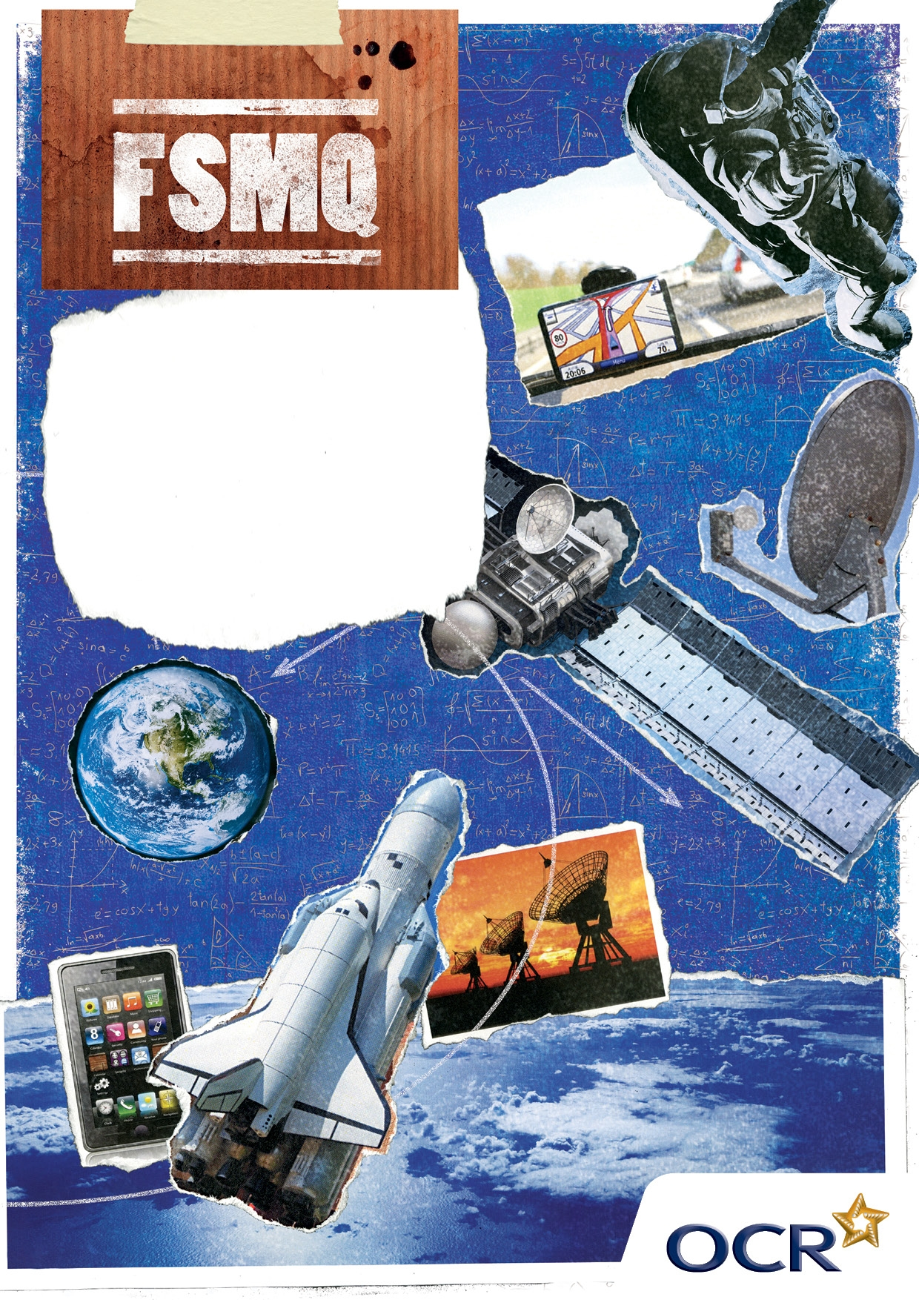
Additional
Mathematics
Sample Scheme of Work

Suggested Scheme of Work
Additional Mathematics 6993

Contents

Introduction Page 3
Outline Page 4
A Algebra
A1 Algebra review – Chapter 1 Page 6
A2 Algebra techniques – Chapter 2 Page 8
A3 Algebra polynomials – Chapter 3 Page 9
A4 Algebra applications – Chapter 4 Page 10
CG Co-ordinate Geometry
CG1 Co-ordinate Geometry 1 – Chapter 5 Page 11
CG2 Co-ordinate Geometry 2 – applications – Chapter 6 Page 12
T Trigonometry
T1 Trigonometry 1 – Chapter 7 Page 13
T2 Trigonometry 2 – Chapter 8 Page 14
C Calculus
C1 Calculus – differentiation – Chapter 9 Page 15
C2 Calculus – integration – Chapter 10 Page 16
C3 Calculus - applications to kinematics – Chapter 11 Page 17
The Specification Page 18

Suggested Scheme of Work
Additional Mathematics 6993

Every school/college will approach the teaching of this module in a different way.
The specification assumes that 60 contact hours are available. This might be up to 80 lessons.

The following suggested scheme:
- assumes 54 lessons of one hour each with 6 lessons for practice papers
- follows closely the dedicated text book
- makes reference to the dedicated revision guide.

Specification structure
The specification syllabus is split into 4 parts; Algebra, Co-ordinate Geometry, Trigonometry and Calculus. The first three topics overlap with and develop topics found in the Higher Tier of the single GCSE. Each topic has “applications” in which real life situations are assessed by contextual questions.

Topic | Hours
Algebra | 20
Co-ordinate Geometry | 11
Trigonometry | 10
Calculus | 13

Enrichment
While the specification has been written with the intention that there should be 60 contact hours, many of the hours could be spent reviewing topics already covered in the Higher Tier of GCSE. Teachers are therefore encouraged to see this specification as an Enrichment programme and to “dip into” areas of mathematics that may not be assessed. A number of “teasers” are included in this document; teachers are encouraged to find many more in order to build a bank of useable questions.

The specification
This is reproduced at the end of this document. The codes given to each competence statement do not appear in the approved specification. However, they are included here, (and in the Revision Guide, published by Hodder Education) for ease of identification.

Scheme of Work - Outline

 |  | Lessons |  | Chapters covered | Total time per topic
 |  | 1 | Introduction to and exploration of Autograph or graphic calculators.
A | A1 | 2 - 8 | Algebra 1 – review | 1
A | A2 | 9 – 13 | Algebra 2 – techniques | 2
A | A3 | 14 - 16 | Algebra 3 – polynomials | 3
A | A4 | 17 - 19 | Algebra 4 – applications  (Probability) | 4
 |  | 20 | Revision/examination question period |  | 20
CG | CG1 | 21 – 25 | Co-ordinate Geometry 1 | 5
CG | CG2 | 26 - 30 | Co-ordinate Geometry 2 – applications  (Decision Mathematics) | 6
 |  | 31 | Revision/examination question period |  | 11
T | T1 | 32 – 37 | Trigonometry 1 | 7
T | T2 | 38 – 40 | Trigonometry 2 – applications  (3D problems) | 8
 |  | 41 | Revision/examination question period |  | 10
C | C1 | 42 - 45 | Calculus 1 – differentiation | 9
C | C2 | 46 – 49 | Calculus 2 – integration | 10
C | C3 | 50 - 53 | Calculus 3 – applications  (Kinematics) | 11
 |  | 54 | Revision/examination question period |  | 13

Chapters
For each chapter of this scheme there is included:
- Main Issues
- Outline of topics with references to the Text Book and Revision Guide
- Identification of Higher Tier topics
- Identification of new topics
- Things to think about
- Common errors
- “Teasers”, bearing in mind that this is an enrichment specification rather than simply one that facilitates acceleration
- ICT opportunities.

“Thinking about” lessons
At the end of each section, a lesson has been built in to the scheme to allow for consolidation of the work covered and practice using examination style questions of the appropriate standard. These questions could be taken from the Text Book or Revision Guide which include questions from past papers.

Teachers are reminded that they have at their disposal past papers from 2003 and also the Specimen Paper (available from the OCR website) and two practice papers written by MEI (and available from them.)

The Revision Guide draws on questions from the papers 2003 - 2006. Teachers might like to consider putting aside three or four of the most recent papers for use as revision and practice in the run up to the examination which would leave a number of other papers which could be used in these lessons.
A Algebra

A1 Algebra review – Chapter 1

Lesson | Algebra – Review | Text book pages | Revision Guide pages
1 | Review of calculators and software resources
2 | Linear expressions and equations | 3-8 | 2
3 | Changing the subject of an equation | 9-10 | 3
4 | Factorising quadratics | 11-15 | 4
5 | Solving quadratic equations 1 | 16 | 4
6 | Solving quadratic equations 2 | 17-22 | 4,5
7 | Simultaneous equations | 23 | 6,7
8 | Thinking about Algebra 1

The main issues
Much of this work is covered at GCSE. In order to avoid students becoming bored at the start, the first lesson (before starting Algebra 1) could be spent exploring either the graphic calculator or software packages such as “Autograph”. Algebraic and graphical techniques often run parallel to each other and familiarity with a graph-plotting device will allow the students to explore the ideas in this section in more depth. It is important for students to feel a sense of progression here; whilst those with a less confident GCSE background may be happy to recap, more able students will need to be made aware that they are required to think about these ideas in more depth.
In the dedicated text book, linear equations are covered in two chapters. In this chapter simple equations are covered, while those involving fractions are covered in chapter 2. Since all linear equations are covered in the GCSE Higher Tier, teachers might like to consider whether to cover the chapter 2 material here.

Higher Tier topics
a1, a4, a5, a6, a8, a9

New material
a10

Things to think about
- When dividing fractions why do you turn the second fraction upside down and multiply?
- Is 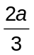 the same as 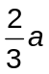?
- What is the difference between 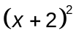 and 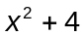?
- What is the link between factorising numbers and factorising quadratics?
- How could you draw the difference of two squares?
- How would you prove the quadratic formula?
- How do you know that all quadratic graphs are symmetrical?
- With linear and quadratic simultaneous equations, why do I have to substitute back into the linear equation?
- In general how should I factorise a quadratic in which the coefficient of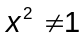? Or how would I complete the square for such a quadratic?
- Can the method of elimination be used when one of the simultaneous equations is not linear?

A “Teaser”
Is the mean of the squares of two numbers greater than or less than the square of the mean of the two numbers?

Common errors to watch out for
Basic errors such as
.
- Not realising how to use factorisation to solve 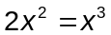 and resorting to the quadratic formula for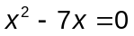.

- Failure to “take out” a common factor of a quadratic (eg 2x² + 4x – 6 = 0).

- Completing the square:
Finding the constant term when the coefficient of. For example:
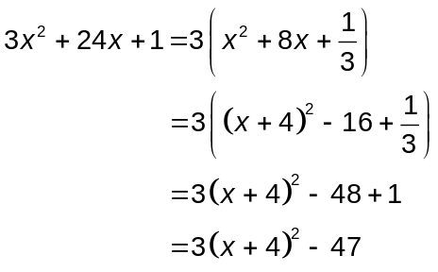 This step causes problems.

- With simultaneous equations where one equation is non-linear, finding the values of x but forgetting to find the corresponding values of y, or choosing the difficult option when eliminating a variable.

- If the values of the first variable are found and then substituted into the quadratic to obtain the values of the second variable then some “extra” values are found.

ICT opportunities
Graphic calculators or Autograph can be used to think about the link between:

The factorised form of a quadratic and The completed square form of the
the axes intercepts of the graph: quadratic and the turning point:
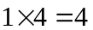
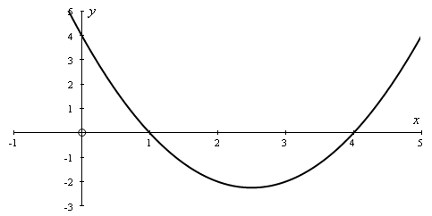
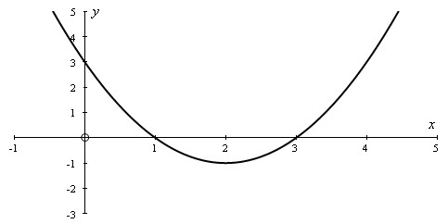
y = (x −1)(x− 4)
y = (x − 2)² − 1

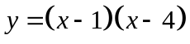

(2, − 1)
−1 × −4 = 4

Similarly, a graphical approach to simultaneous equations will prepare the students for Chapter 5 and give students a visual insight into why, with linear and quadratic simultaneous equations, it is necessary to substitute back into the linear equation.

A2 Algebra techniques – Chapter 2

Lesson | Algebra techniques | Text book pages | Revision Guide pages
9 | Inequalities | 31 - 35 | 10
10 | Simplifying algebraic fractions | 35 – 38
11 | Solving linear equations | 39 – 42
12 | Square roots, surds, simplifying fractions | 42 – 44 | 11
13 | Thinking about Algebra 2

The main issues
Much of this work is also covered at GCSE. Relationships between inequalities and equations should be explored in more depth both algebraically and graphically.
Working with square roots is a topic which does not fit obviously anywhere, except perhaps alongside the use of calculators. It is placed here in this document because the programme follows the Text Book and Revision Guide and this is where it is placed in these books. Teachers might like to consider using this material alongside a general lesson on the use of calculators.

Higher Tier topics
a1, a5, a6, a11, a12

New material
None

Things to think about
- How to explain why the inequality sign changes when you divide or multiply by a negative number.
- The relationship between algebraic and graphical solutions.
- What does “irrational” mean? If numbers can be split into three groups, integers, fractions and irrational numbers, into which group(s) do the square roots of integers fall?
- When can a square root be simplified (eg 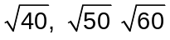)?
- Can you prove that 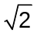 is irrational?
- 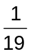 expressed as a decimal has a recurring sequence of 18 digits. Can you find those 18 digits, given that a calculator display will not show the recurrence?

A “Teaser”
For how many values of n is n² – 1 prime?

Common errors to watch out for
- Not changing the sign of the inequality when dividing or multiplying by a negative number.
- Attempts to combine inequalities inappropriately, eg 2 > x > 5.
- Incorrect statement or use of the formula to solve a quadratic equation, possibly due to poor handwriting.
For example, solving the equation 2x² + 3x – 4 = 0 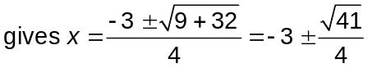.
- Use of a calculator to approximate when an exact answer is required.
- Trying to deal with quadratic inequalities inappropriately – eg x² + 4x >5 giving x(x + 4) > 5.

A3 Algebra polynomials – Chapter 3

Lesson | Algebra polynomials | Text book pages | Revision Guide pages
14 | Addition, subtraction and multiplication of polynomials | 45 – 50 | 12
15 | The Factor and Remainder theorems | 51 – 58 | 13
16 | Thinking about Algebra 3

The main issues
“Polynomials” in this specification means quadratics or cubic functions. Properties of polynomials are developed and, in particular, ways to factorise cubic functions and solve factorisable cubic equations are shown.

Higher Tier topics
a4

New material
a2, a3, a7

Things to think about
- Does a polynomial have to be factorised by long division?
- What is the link between algebraic long division and arithmetic long division?

A “Teaser”
(i) Show that 17³ – 8³ is divisible by 9.
(ii) Give a factor of a³ – b³.
(iii) Find a similar result for a³ + b³.

Common errors to watch out for
- When long division is used to factorise a polynomial, gaps need to be left if the coefficient of one power is 0.
- Use of calculator to approximate, when exact answers are required.
- The inability to “spot” roots of a polynomial by trial by not looking at the constant term.
For instance, f(x) = x³ – 9x² + 23x –15; try f(2).

ICT opportunities
A software package ( such as “Autograph”) that has a constant controller will enable students to see what graphs of cubic functions look like and how changing one of the coefficients changes the shape of the graph.
A4 Algebra applications – Chapter 4

Lesson | Algebra applications | Text book pages | Revision Guide pages
17 | Binomial expansions | 59 – 64 | 14
18 | Binomial distributions | 64 – 70 | 15
19 | Thinking about Algebra 4
20 | Examination practice questions for Algebra

The main issues
The multiplication of brackets is extended to include the binomial expansion. Ways of finding the coefficient are shown for different situations. The topic is extended to include applications in probability theory for the binomial distribution.

Higher Tier topics
None

New material
a13, a14, a15, a16

Things to think about
- Although selections are not in the specification it would help if students had an understanding of making selections in order to understand the coefficient.
- Questions will be set that involve (a + bx)^{n} involving algebra and arithmetic as well as probabilities from (p + q)^{n}.
- How many terms are there in the expansion of (a + bx)^{n} ?

A “Teaser”
An English Cricket Captain once asserted that, the coin tossed to determine who batted first, having come down tails five times in a row was “almost certain” to come down heads on the sixth toss. Discuss.

Common errors to watch out for
- Omitting to consider the coefficient.
- Failure to understand the meaning of “at least”.
- Misuse of brackets to evaluate terms. eg in the expansion of (1 + 2x)⁶ the third term is written 15(2x²) rather than 15(2x)².
- Not including enough or the right terms.
- Failure to deal with the negative sign properly, eg in 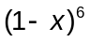the fourth term is written
–20(x⁴) rather than +20(–x)⁴.
- Using Pascal’s Triangle for large values of n.

CG – Co-ordinate Geometry

CG1 Co-ordinate Geometry 1 – Chapter 5

Lesson | Co-ordinate Geometry 1 | Text book pages | Revision Guide pages
21 | The straight line | 73 – 81 | 18
22 | Equations of lines | 82 – 93 | 19
23 | Intersections of lines | 93 – 96 | 20
24 | The circle | 96 - 100 | 21
25 | Thinking about CG1

The main issues
Students should be familiar with most of this work. There is the opportunity to develop idea of the straight line and particularly about different ways of obtaining the equation for given information.

Higher Tier topics
g1, g2, g3, g4, g5, g6, g7

New material
g8, g9

Things to think about
- How many ways are there to obtain the equation of a straight line? Is there any point in offering to students any more than y = mx + c?
- In what ways can the graphical methods to solve equations be related to the algebraic methods?
- Can you ever be sure that a graphical solution is correct?

A “Teaser”
- Find the points of intersection of the circle x² + y² = 50 with the line y + 2x = 15.
- You will notice that the points have integer co-ordinates.
- If you want to set questions about such intersections with integer solutions then you have to create the question by “working backwards” – ie you need to choose the points on the circle with integer values and form the equation of the line through those points.
- So if the equation of the circle is x² + y² = r² then what property should r² possess in order to make this possible without asking a trivial question?

Common errors to watch out for
- Geometrical assumptions from a graph. Perpendicular lines do not look perpendicular if the scales on the axes are not the same.
- Use of incorrect formulae to find the midpoint (eg using x₁ – x₂).
- Algebraic errors resulting from the need to manipulate the equation of a line into the form
y = mx + c in order to find the gradient.

ICT opportunities
“Families” of parallel lines can be seen using a constant controller that some packages have.

CG2 Co-ordinate Geometry 2 – applications – Chapter 6

Lesson | Co-ordinate Geometry 2 | Text book pages | Revision Guide pages
26 | Inequalities graphically | 102 - 106 | 22
27 | Linear programming – 1 | 107 – 110 | 22
28 | Linear programming – 2 | 110 – 117 | 23
29 | Linear programming – 3 | 110 – 117 | 24
30 | Thinking about CG2
31 | Examination practice questions for Co-ordinate Geometry

The main issues
The region of points satisfying a linear inequality in two variables is the region one side of the line. Conventionally
- if the line is included then it is drawn bold and if not then it is drawn dotted,
- the region that does not satisfy the inequality is shaded.
Problems in context will include more than one inequality. The region that satisfies all the inequalities is known as the feasible region. If a function is to be maximised (or minimised) in that region, the function is called the objective function.

Higher Tier topics
None

New material
g10, g11, g12

Things to think about
- Are the points on the boundary line to be included in the feasible region or not?
- If the vertex in the feasible region that maximises an objective function does not have integer co-ordinates which is a requirement of a particular problem then how should the point be found that does maximise the objective function?

A “Teaser”
Three items in a shop cost £8, £5 and 20p respectively. How many of each should I buy so that the cost is £75 for a total of 75 items?

Common errors to watch out for
- Incorrect or incomplete shading of acceptable and unacceptable regions. (It is expected in this specification for regions not fulfilling the inequality to be shaded.)

Not identifying whether the points on the boundary line are to be included or not.

Shading the wrong side of a line, particularly when the line is of the form y = mx.

ICT opportunities
Some software packages will enable inequalities to be drawn and the appropriate region will be shaded. As a result, a problem can be developed and drawn graphically. Using a constant controller the value of the objective function can be slowly increased (or decreased) demonstrating the significance of the gradient of those lines in determining the maximum or minimum value.

T - Trigonometry

T1 Trigonometry 1 – Chapter 7

Lesson | Trigonometry 1 | Text book pages | Revision Guide pages
32 | Revision of the use of trigonometrical ratios | 121 – 126 | 28
33 | Ratios for any angle | 127 - 131 | 29
34 | Solution of equations | 131 – 135 | 29
35 | Identities, solving equations | 136 – 139 | 30,31
36 | Area of a triangle, sine rule, cosine rule | 140 - 154 | 32,33
37 | Thinking about T1

The main issues
Students should be familiar with the trigonometrical ratios and their value in solving problems involving triangles, with and without a right angle.

This specification develops the definitions of the ratios to include all angles up to 360° and the solution of trigonometrical equations.

Higher Tier topics
t2, t3, t4

New material
t1, t5, t6, t7

Things to think about
- Making sure that calculators are in the right mode.
- Making sure that students are aware of the Principal Angle range of their particular calculator and this may vary from make to make.
- How many angles satisfy the equation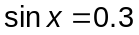?
- How can a graphical calculator help to identify all the roots of an equation?

A “Teaser”
How many ways are there to prove the sine rule?
One way includes drawing the circumscribed circle and using circle properties. This will produce the “complete” sine rule which is
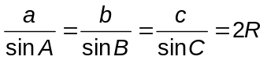
What is R and how is it proved this way?

Common errors to watch out for
- Calculator not in the correct mode. (Only degrees are used in this specification.)
- Dividing incorrectly (eg 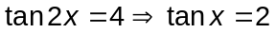).
- Failure to find all roots (ie 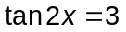 has 4 roots in the range 0° < x < 360°).
- Making an assumption that a triangle contains a right angle.
- Failure to take the square root for the value of a side when using the cosine formula.
- Not dealing with the manipulation of the cosine rule correctly – eg 25 – 24cos34 = cos34.
- Trying to solve equations by trial.

ICT opportunities
The graphs of the trigonometrical functions show values over the whole number line (except for the discontinuities of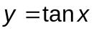). How does this relate to the understanding of the ratios in a right-angled triangle which are therefore only in the range 0° < x < 90° ?
How does, for instance, the graph of 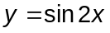 relate to the graph of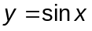? Does this have implications for the solution of equations such as 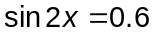?

T2 Trigonometry 2 – Chapter 8

Lesson | Trigonometry 2 | Text book pages | Revision Guide pages
38 | 3 - D trigonometry – 1 | 155 – 165 | 34
39 | 3 - D trigonometry – 2 | 155 - 165 | 35
40 | Thinking about T2
41 | Examination practice questions for trigonometry

The main issues
Contextual problems in 3D are used to develop understanding of the use of Trigonometry. Drawings of a
3-dimensional situation are sometimes misunderstood by students. They should be encouraged to draw
2-dimensional “cross sections” wherever possible in order to see how they can apply their knowledge of trigonometry.

Higher Tier topics
t8

New material
None

Things to think about
- How best can students “visualise” 3-D problems?
- Is it a good idea to encourage students to draw cross-sections to identify the triangles they are using to find lengths and angles, or will more diagrams merely confuse?

A “Teaser”
A pyramid has a square base, ABCD of side 10 cm. The vertex is directly above the centre, O, of the square such that VO = 12 cm.
What is the shortest distance form A to C on the surface of the pyramid?

Common errors to watch out for
- Working out half the diagonal of a rectangular base incorrectly. .
- Failure to identify the angle of greatest slope or the angle between a line and a plane.

C - Calculus

C1 Calculus – differentiation – Chapter 9

Lesson | Calculus – differentiation | Text book pages | Revision Guide pages
42 | Gradient functions | 169 - 177 | 38
43 | Tangents and normals | 177 – 182 | 39,40
44 | Stationary points | 182 – 190 | 41,42
45 | Thinking about C1

The main issues
This is a new topic and a very important one in Advanced level Mathematics (and other subjects). Students need to develop a thorough understanding of the principles of rates of change.

Higher Tier topics
None

New material
c1, c2, c3, c4, c5, c6, c7

Things to think about
- How important is it to develop rates of change from first principles?
- “Rate of change” of y with x gives the gradient of the curve. What other variables will be used in this specification?

A “Teaser”
Drawing a tangent to a quadratic curve at a given point, P.
Let the stationary point on the curve be A.
From P draw a line perpendicular to the x-axis and draw the tangent at the point A (parallel to the
x-axis).
Let these two lines meet at N.
Determine the midpoint, M of AN.
The tangent to the curve at P is the line PM.
Prove this result.

Common errors to watch out for
- Not multiplying out brackets before differentiating term by term.
- Terms with coefficients not being differentiated properly.

C2 Calculus – integration – Chapter 10

Lesson | Calculus – integration | Text book pages | Revision Guide pages
46 | The reverse of differentiation | 191 - 196 | 44,45
47 | Definite integrals and areas | 196 – 207 | 46
48 | Area between 2 curves | 207 – 212 | 47
49 | Thinking about C2

The main issues
Integration as the reverse of differentiation often creates difficulties, especially that the general rule of integration for a term ax^{n} is for that term and nothing else.

Higher Tier topics
None

New material
c8, c9, c10, c11, c12, c13, c14, c15

Things to think about
- How can you best encourage “good practice” in writing mathematical notation eg integrals in which the integral sign is never written without a “dx” or equivalent?
- How can the inclusion of a constant of integration (often missed) be emphasised?

A “Teaser”

Find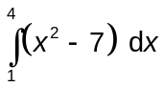.
Give a geometric interpretation of your answer.

Common errors to watch out for
- Failure to incorporate the constant of integration.
- Failure to multiply out brackets before integrating term by term.
- “integrating” numbers - eg 3 gives 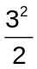.
- “integrating” the number in the denominator of a fraction, eg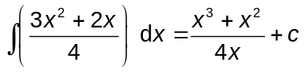.
C3 Calculus - applications to kinematics – Chapter 11

Lesson | Calculus – applications to kinematics | Text book pages | Revision Guide pages
50 | Motion and definitions | 213 – 223 | 49,50
51 | Variable acceleration | 223 – 232 | 51
52 | Telling the difference | 213 – 223 | 51
53 | Thinking about C3
54 | Examination practice questions for calculus

The main issues
There are two situations in this specification – constant acceleration and variable acceleration. Students need to know the difference and the ways to handle each situation.

Higher Tier topics
None

New material
c16, c17, c18

Things to think about
- How can students tell when a problem to be solved involves constant acceleration or variable acceleration?
- Connections with graphical interpretations - What are the graphs of acceleration and velocity when you have constant acceleration?
- What is the connection between areas under curves and lines and velocity/displacement?

A “Teaser”
A driver completes the first half (in distance) of his journey at an average aped of 30 mph. He completes the second half at an average speed of 70 mph. What is his average speed for the whole journey?

Common errors to watch out for
- Failure to recognise the situations where constant acceleration formulae can be used.
- Sign problems in finding the area between two curves.

The Specification

Topic | Code | Competence Statement
Algebra
Manipulation of algebraic expressions | a1 | Be able to simplify expressions including algebraic fractions, square roots and polynomials.
The remainder theorem | a2 | Be able to find the remainder of a polynomial up to order 3 when divided by a linear factor.
The factor theorem | a3 | Be able to find linear factors of a polynomial up to order 3.
 | a4 | Be confident in the use of brackets.
Solution of equations | a5 | Be able to solve a linear equation in one unknown.
 | a6 | Be able to solve quadratic equations by factorisation, the use of the formula and by completing the square.
 | a7 | Be able to solve a cubic equation by factorisation.
 | a8 | Be able to solve two linear simultaneous equations in 2 unknowns.
 | a9 | Be able to solve two simultaneous equations in 2 unknowns where one equation is linear and the other is quadratic.
 | a10 | Be able to set up and solve problems leading to linear, quadratic and cubic equations in one unknown, and simultaneous linear equations in two unknowns.
Inequalities | a11 | Be able to manipulate inequalities.
 | a12 | Be able to solve linear and quadratic inequalities algebraically and graphically.
The binomial expansion | a13 | Understand and be able to apply the binomial expansion of  (a + b)^{n} where n is a positive integer.
Application to probability | a14 | Recognise probability situations which give rise to the binomial distribution.
 | a15 | Be able to identify the binomial parameter, p, the probability of success.
 | a16 | Be able to calculate probabilities using the binomial distribution.

Topic |  | Code |  | Competence Statement
Co-ordinate Geometry (2 dimensions only)
The Straight line |  | g1 |  | Know the definition of the gradient of a line.
 |  | g2 |  | Know the relationship between the gradients of parallel and perpendicular lines.
 |  | g3 |  | Be able to calculate the distance between two points.
 |  | g4 |  | Be able to find the midpoint of a line segment.
 |  | g5 |  | Be able to form the equation of a straight line.
 |  | g6 |  | Be able to draw a straight line given its equation.
 |  | g7 |  | Be able to solve simultaneous equations graphically.
The co-ordinate geometry of circles |  | g8 |  | Know that the equation of a circle, centre (0, 0), radius r is  x² + y² = r².
 |  | g9 |  | Know that (x – a)² + (y – b)² = r² is the equation of a circle with centre (a, b) and radius r.
Inequalities |  | g10 |  | Be able to illustrate linear inequalities in two variables.
Applications to linear programming |  | g11 |  | Be able to express real situations in terms of linear inequalities.
 |  | g12 |  | Be able to use graphs of linear inequalities to solve  2-dimensional maximisation and minimisation problems, know the definition of objective function and be able to find it in  2-dimensional cases.
Trigonometry
Ratios of any angles and their graphs | t1 |  | Be able to use the definitions of 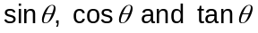 for any angle (measured in degrees only).
 | t2 |  | Be able to apply trigonometry to right angled triangles.
 | t3 |  | Know the sine and cosine rules and be able to apply them.
 | t4 |  | Be able to apply trigonometry to triangles with any angles.
 | t5 |  | Know and be able to use the identity 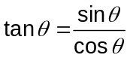.
 | t6 |  | Know and be able to use the identity 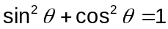.
 | t7 |  | Be able to solve simple trigonometrical equations in given intervals.
 | t8 |  | Be able to apply trigonometry to 2 and 3 dimensional problems.

Topic | Code | Competence Statement
Calculus
Differentiation | c1 | Be able to differentiate kx^{n} where n is a positive integer or 0, and the sum of such functions.
 | c2 | Know that the gradient function 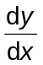 gives the gradient of the curve and measures the rate of change of y with x.
 | c3 | Know that the gradient of the function is the gradient of the tangent at that point.
 | c4 | Be able to find the equation of a tangent and normal at any point on a curve.
 | c5 | Be able to use differentiation to find stationary points on a curve.
 | c6 | Be able to determine the nature of a stationary point.
 | c7 | Be able to sketch a curve with known stationary points.
Integration | c8 | Be aware that integration is the reverse of differentiation.
 | c9 | Be able to integrate kx^{n} where n is a positive integer or 0, and the sum of such functions.
 | c10 | Be able to find a constant of integration.
 | c11 | Be able to find the equation of a curve, given its gradient function and one point.
Definite integrals | c12 | Know what is meant by an indefinite and a definite integral.
 | c13 | Be able to evaluate definite integrals.
 | c14 | Be able to find the area between a curve, two ordinates and the  x-axis.
 | c15 | Be able to find the area between two curves.
Application to kinematics | c16 | Be able to use differentiation and integration with respect to time to solve simple problems involving variable acceleration.
 | c17 | Be able to recognise the special case where the use of constant acceleration formulae is appropriate.
 | c18 | Be able to solve problems using these formulae.

