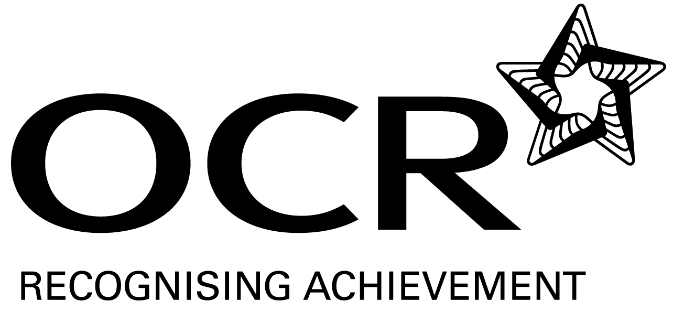

OCR Level 3 NVQ Diploma in Personal Training
(48 credits required from Mandatory Units)

Record of Achievement

Candidate name:

UNITS |  |  |  | Date | Assessor signature
Mandatory units  (48 credits from Mandatory Units) |  | Level | Credit
1 | Anatomy and physiology for exercise and health | 3 | 6
2 | Principles of exercise, fitness and health | 2 | 4
3 | Promote health, safety and welfare in active leisure and recreation | 2 | 4
4 | Reflect on and develop own practice in providing exercise and physical activity | 2 | 4
5 | Motivate clients to maintain long term adherence to exercise and physical activity | 3 | 4
6 | Evaluate exercise and physical activity programmes | 3 | 3
7 | Design, manage and adapt a personal training programme with clients | 3 | 6
8 | Deliver exercise and physical activity as part of a personal training programme | 3 | 10
9 | Apply the principles of nutrition to support client goals as part of an exercise and physical activity programme | 3 | 7
An additional unit is available but credit from this unit is not required to achieve the full qualification

10 | Plan, market and sell services | 3 | 5

