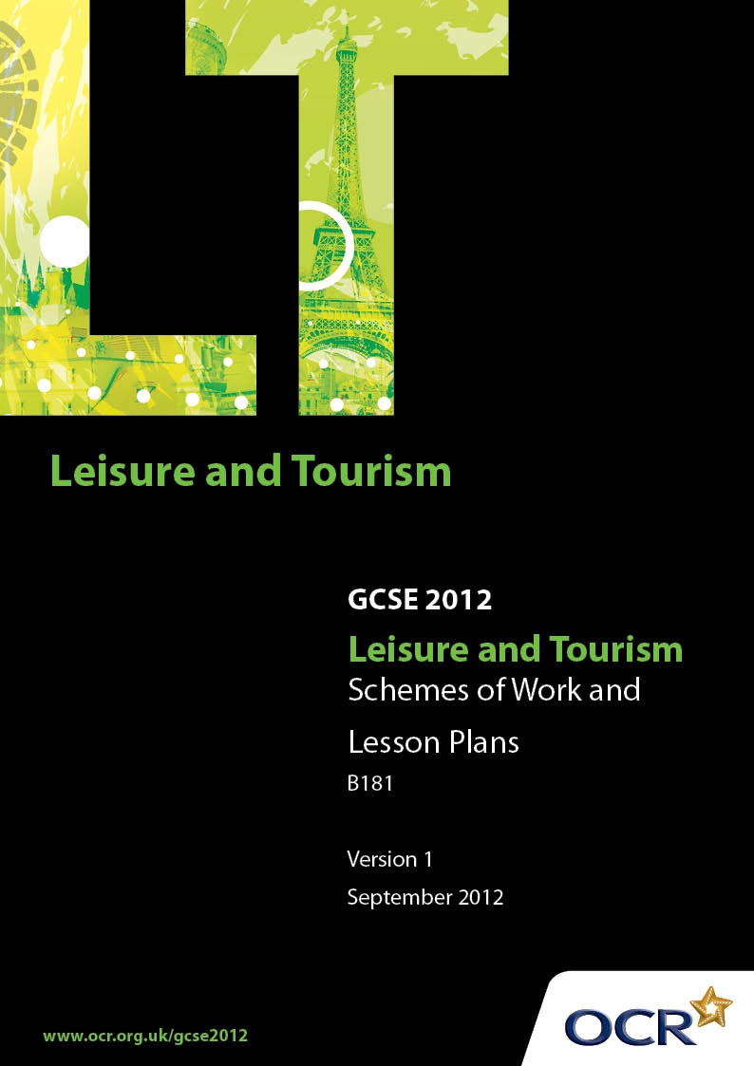

Contents
Introduction 3
OCR GCSE Scheme of Work Leisure and Tourism Unit B181:
Understanding the Leisure and Tourism Industries 5
OCR GCSE Lesson Plan Leisure and Tourism Unit B181:
Understanding the Leisure and Tourism Industries 21

Introduction

Background
OCR has produced a summary brochure, which summarises the Leisure and Tourism GCSE. This can be found at www.ocr.org.uk, along with the new specification.
In response to reforms announced by the Government and in response to Ofqual mandated changes to GCSEs, unitised assessment of this qualification is being replaced by linear assessment from September 2012. This means that candidates commencing a two year course from September 2012 will take all of their GCSE units at the end of the course in June 2014.
In order to help you plan effectively for the implementation of the specification we have produced these Schemes of Work and Sample Lesson Plans for Leisure and Tourism. These Support Materials are designed for guidance only and play a secondary role to the Specification.

Our Ethos
OCR involves teachers in the development of new support materials to capture current teaching practices tailored to our new specifications. These support materials are designed to inspire teachers and facilitate different ideas and teaching practices.
Each Scheme of Work and set of sample Lesson Plans is provided in Word format – so that you can use it as a foundation to build upon and amend the content to suit your teaching style and students’ needs.
The Scheme of Work and sample Lesson plans provide examples of how to teach this unit and the teaching hours are suggestions only. Some or all of it may be applicable to your teaching.
The Specification is the document on which assessment is based and specifies what content and skills need to be covered in delivering the course. At all times, therefore, this Support Material booklet should be read in conjunction with the Specification. If clarification on a particular point is sought then that clarification should be found in the Specification itself.

A Guided Tour through the Scheme of Work

= Innovative Teaching Idea
This icon is used to highlight exceptionally innovative ideas.


= ICT Opportunity
This icon is used to illustrate when an activity could be taught using ICT facilities.

OCR GCSE Leisure and Tourism Unit B181: Understanding the Leisure and Tourism Industries
Suggested teaching time | 20 hours | Topic | Different Types of Leisure and Tourism Activities
Topic outline |  | Suggested teaching and homework activities |  | Suggested resources | Points to note
Entertainment  - Cinema  - Ten pin bowling  - Theatre  - Bingo  - Night club  - Concert venue  - Laser quest  - Pubs and bars  - Restaurant |  | - Research each type of entertainment organisation. Draw a table that shows an example of each organisation and what it offers  - Your table headings could be: products, services and facilities |  | - Visit to a venue  - Website ie  http://www.cineworld.co.uk | - The knowledge should be based around the types of organisations ie national chains, small private, large multinational. The further study will be around the products and services offered by each type. Candidates will need real examples  - Most websites give information as to products, services and facilities offered. Visits are excellent for placing the material in context
Visitor attractions |  | - Students should choose a Zoo, aquarium and safari park. Idea – storm the range of products services and facilities that each offers and explain what type of organisation owns the facility  - Choose one themed amusement park such as Alton Towers, Thorpe Park, Chessington Word of Adventures etc and draw a table that identifies its products services and facilities  - Select one gallery to study. Create a poster that identifies its products, services and facilities and then write a summary of the organisation that owns the facility |  | - Visits to relevant venues  - Marketing materials supplied by provider organisations.  - Websites such as:  http://www.zsl.org/zsl-london-zoo  http://www.aquariumofthelakes.co.uk  http://www.woburnsafari.co.uk  http://www.thorpepark.com/  http://www.nationalgallery.org.uk
Cultural |  | - Create a PowerPoint presentation that shows each type of cultural organisation. The presentation should show an example of each organisation and what it offers. Your presentation headings could be: products, services and facilities |  | - Visits  - Marketing materials  - TV programmes  - Websites such as:  http://www.statelyhome.co.uk/  http://www.warwick-castle.co.uk/  http://www.nhm.ac.uk/
Leisure  - Sports and recreation centre  - Health club and spa  - Sports club  - Indoor winter sports facility  - Outdoor activity centre  - Sports arena  - Paintballing |  | - Research each type of leisure organisation. Draw a table that shows an example of each organisation and what it offers.  Your table headings could be: products, services and facilities |  | - Visits  - Marketing materials  Websites such as:  Sports arena  http://www.thestadiumtour.com/Home.aspx  Indoor winter sports facility  http://www.snozonemiltonkeynes.com/ | - The time allocation represents the depth of research required
Accommodation  - Hotel  - Hostel  - B&B and guest house  - Holiday cottage  - Holiday park  - Campsite  - Caravan park  - Conference centre |  | - Individually research each type of accommodation provider, draw a table that shows an example of each provider and what it offers  - The table headings should include: products, services and facilities  - In small groups/partners: research one type of accommodation that interests you, for example Premier Inn. Discuss what type of accommodation it is and what it offers within your group/partners. Feedback your chosen accommodation and try to sell the idea of staying there to the rest of the class |  | - Visits  - Marketing material  - Websites such as:  - Brochures  Hotel group  http://www.qhotels.co.uk/default.aspx  Hostel  http://www.yha.org.uk/  Holiday cottages  http://www.holidaycottages.co.uk/  Holiday park  http://www.butlinsonline.co.uk/  caravan park  http://www.haven.com/  Campsite  http://www.ukcampsite.co.uk/  Conference centre  http://www.apollohotels.com/ | - There are many accommodation providers that can be classified across two or more headings. Candidates will need to have an understanding of the main features of a typical provider in each category
Travel  - Airline  - Rail operator  - Coach operator  - Car hire  - Ferry  - Cruise liner |  | - Look at all the possible transport methods available to someone travelling to a destination such as Spain. Create a poster presentation showing all the possible methods of travel to the destination. |  | - Airline  http://www.britishairways.com/  Rail Operator  http://www.londonmidland.com/  Coach operator  http://www.coach-tours.co.uk/  car hire  http://www.avis.co.uk/  ferry operator  http://www.brittany-ferries.co.uk/  Cruise liner  http://www.pocruises.com/
Tourism  - Travel agent  - Tour operator  - Guiding and information services |  | - Use the websites to research the key duties, role and services provided by the travel agent, tour operator, guiding and information services. Present your findings on a table under the relevant headings |  | - Travel agent  http://www.barrheadtravel.co.uk/  - Tour operator  http://www.thomascook.com/  - Information services  http://www.enjoyengland.com/  http://www.tourist-information-uk.com/  - Guiding services  http://www.blue-badge-guides.com/

OCR GCSE Leisure and Tourism Unit B181: Understanding the Leisure and Tourism Industries
Suggested teaching time | 2 hours | Topic | The reasons why people use Leisure and Tourism Facilities
Topic outline |  | Suggested teaching and homework activities |  | Suggested resources | Points to note
Reasons |  | - Create a table that shows categories of visitor types such as school groups, adult groups, adult individuals, business people etc  - In small groups, discuss why people use each category of leisure facility listed in the specification  - Design a questionnaire that will ask people of different groups, why they use leisure and tourism facilities

OCR GCSE Leisure and Tourism Unit B181: Understanding the Leisure and Tourism Industries
Suggested teaching time | 5 hours | Topic | Employment Opportunities in the Leisure and Tourism Industry
Topic outline |  | Suggested teaching and homework activities |  | Suggested resources | Points to note
 |  | - Idea-storm to produce a checklist of the generic skills and personal qualities required of people working in these industries. Compare the checklist with skills or qualities identified in person specifications or job descriptions for industry – specific vacancies  - Create a careers guide booklet for the leisure and tourism industry. The guide should cover each of the job categories listed in the specification and should cover career prospects within each category |  | - Websites such as:  http://www.leisurejobs.com/  http://www.careersinleisure.com/  http://www.ca.courses-careers.com/  - Careers offices and libraries  - Job descriptions obtained from employers or the internet | - This section requires candidates to consider a wide range of employment opportunities. Candidates must know progression routes within job categories and a basic list of duties and responsibilities for each job role considered. They are not required to know every job in great detail or to learn example job specifications in depth

OCR GCSE Leisure and Tourism Unit B181: Understanding the Leisure and Tourism Industries
Suggested teaching time | 6 hours | Topic | How Leisure and Tourism Organisations operate as businesses
Topic outline |  | Suggested teaching and homework activities |  | Suggested resources | Points to note
Organisational structures  - Managerial  - Supervisory  - Operative |  | - Choose 3 organisations. For each organisation research and draw their organisational chart |  | - Websites such as:  http://www.learnmanagement2.com/  http://www.bized.co.uk/educators/16-19/business/strategy/lesson/orgstructures.htm  - Business studies text books
Functional areas  - Human resources  - Marketing  - Sale  - operations |  | - Introduce the key functional areas.  - Create a spider diagram with each area represented |  | - http://www.bized.co.uk/educators/level2/busactivity/lesson/functional1.htm | - At this level an outline understanding is required so that areas are distinguishable within the L&T context
Operational tasks  - recruitment & selection  - market research  - product development  - keeping sales records  - regular maintenance routines |  | - Investigate the operational tasks of 2 organisations |  | - http://www.bized.co.uk/educators/16-19/business/strategy/lesson/orgfunctions1.htm | - The materials developed on the bized site although written for BTEC are very useful for this section of the course

OCR GCSE Leisure and Tourism Unit B181: Understanding the Leisure and Tourism Industries
Suggested teaching time | 2 hours |  | Topic | Health and Safety Issues
Topic outline |  | Suggested teaching and homework activities |  |  | Suggested resources | Points to note
Acts/regulations  - Activities centres Act 1995  - Children Act 2004  - HSAW Act 1974  - Fire Precautions Act 1971  - COSHH Regulations 1994 |  | - Identify the key points from each of the listed pieces of legislation. Create key point cards and carry out a matching activity with the cards  - Create short case studies for each law and identify hazards in a variety of situations or research/find newspaper/online articles which report on health and safety regulation breaches by companies and other organisations. Discuss your news article with the rest of the group  - With notepaper, walk around the school. Describe and explain any risks and hazards you can see which are associated with activity participation. Next, design a poster which includes the potential risks for an activity participant |  |  | - http://www.opsi.gov.uk/Acts/acts1995/ukpga_19950015_en_1  - http://www.iain.co.uk/aala.htm  - http://www.workingwithkids.co.uk/childrens-act.html  - http://www.widgit.com/resources/classroom/children_act_2004/index.htm  - http://www.hse.gov.uk/pubns/hsc13.pdf  - http://www.healthandsafety.co.uk/firep.htm  - Watch a Health and Safety video/DVD if the organisation holds one | - At this level a very brief overview is required. Candidates may be expected to apply basic ideas in contextual situations but will not need a detailed knowledge of the laws involved  - The HSAWA is complex and as such candidates will need to be aware of the basic requirement of risk assessment

OCR GCSE Leisure and Tourism Unit B181: Understanding the Leisure and Tourism Industries
Suggested teaching time | 5 hours | Topic | How people travel and why they select their chosen method
Topic outline |  | Suggested teaching and homework activities |  | Suggested resources | Points to note
Main methods of travel  - Air  - Road  - Rail  - sea |  | - Choose a resort that could involve any of the four transport methods. Describe the advantages and disadvantages of each method of travel for different tourist types |  | - http://www.geocities.com/jason_firestone/studenttext1.rtf | - Candidates will need to be able to apply their knowledge to a variety of situations with a range of tourist types. Application practice is vital in this task

OCR GCSE Leisure and Tourism Unit B181: Understanding the Leisure and Tourism Industries
Suggested teaching time | 2 hours | Topic | Where people go in their leisure time and why they select their chosen destination(s)
Topic outline |  | Suggested teaching and homework activities |  | Suggested resources | Points to note
Understand the range of visitor types listed in the specification |  | - For each visitor type create a profile that could include – likes and dislikes, income, age range and location |  | - http://www.bized.co.uk/educators/16-19/tourism/index.htm#industry  - Magazines/brochures, guides  - Smartboard/interactive white board use | - Understand the range of visitor types listed in the specification

OCR GCSE Leisure and Tourism Unit B181: Understanding the Leisure and Tourism Industries
Suggested teaching time | 10 hours | Topic | Visitor attractions and activities, both in the UK and internationally
Topic outline |  | Suggested teaching and homework activities |  | Suggested resources | Points to note
Study the range of destinations given in the specification. Candidates need to have destination and be able to understand the reason for visiting. |  | - Create a destination profile for each destination given – this could be a marketing leaflet, a web page download or a text book research exercise  - In groups/pairs, choose a destination that appeals to you. Research your destination and include any tourist hotspots. Present your chosen destination to the rest of the group and try to ‘sell’ your chosen destination to them |  | - http://www.travelchinaguide.com/silk-road/  - http://www.zambia-the-african-safari.com/victoria-falls.html

OCR GCSE Leisure and Tourism Unit B181: Understanding the Leisure and Tourism Industries
Suggested teaching time | 5 hours | Topic | Rapid pace of change in the UK leisure and tourism industry
Topic outline |  | Suggested teaching and homework activities |  | Suggested resources | Points to note
The study of trends using a statistical evidence base. Candidates will need to read charts and graphs and be able to interpret them at an appropriate level. |  | Choose 1 destination and create a graph for each of the following for the past 5 years:  - Number of visitors  - How much visitors spend  - Number of hotel beds available  - Average most popular activities  - Occupancy rate of hotels |  | - http://www.statistics.gov.uk/statbase/Product.asp?vlnk=1391  - http://www.statistics.gov.uk/CCI/nscl.asp?ID=8257  - http://www.tourismtrade.org.uk/MarketIntelligenceResearch/?url=/research | - The complexity of the data available is likely to mean that teachers will need to be selective in what they guide candidates to research

OCR GCSE Leisure and Tourism Unit B181: Understanding the Leisure and Tourism Industries
Suggested teaching time | 5 hours | Topic | The importance of sustainability, both in the uk and international leisure and tourism / the importance of recognising similarities and differences of attitudes and cultures
Topic outline |  | Suggested teaching and homework activities |  | Suggested resources | Points to note
Candidates will need to study sustainable practices as identified in the specification for at least one UK example and one international example. |  | - In groups create a PowerPoint presentation for each destination showing the importance of sustainable practice |  | - http://www.defra.gov.uk/sustainable/government/  - http://www.sd-commission.org.uk/pages/what-you-can-do.html  - http://www.world-tourism.org/frameset/frame_sustainable.html
Exam Preparation |  | 6 hours
Candidates will need to practise examination techniques. |  | - Sit specimen paper |  | - Specimen paper | - It is important that candidates practise the use of command words and develop strategies for extended writing

OCR GCSE Leisure and Tourism Unit B181: Understanding the Leisure and Tourism Industries

Cinema
OCR recognises that the teaching of this qualification above will vary greatly from school to school and from teacher to teacher. With that in mind this lesson plan is offered as a possible approach but will be subject to modifications by the individual teacher.
Lesson length is assumed to be one hour.

Learning Objectives for the Lesson
The candidate will need:

Objective 1 | to understand the types of organisations which make up the cinema industry
Objective 2 | to understand the range of products, services and facilities that a cinema offers
Objective 3 | to explain and discuss the range of products, services and facilities that a cinema offers.

Recap of Previous Experience and Prior Knowledge
- Candidates are going to consolidate their learning by generating a list of cinemas and then to create a list of products, services and facilities that a cinema may offer. Explain that you are going to consider the range of cinemas from single screen independents to multi screen complexes

Content
Time | Content
10 minutes | Introduce the idea of entertainment being an experience and highlight the differences between products, services and facilities.
5 minutes | Ask the candidates to ‘thought shower’ a list of cinemas
20 minutes | Ask each candidate to research one cinema from the list generated. From their research findings they can create a list of products, services and facilities that the cinema offers.
10 minutes | Put the candidates into groups of four and ask them to generate one comprehensive list of all the products, services and facilities that can be provided by a cinema.

15 minutes | Candidates come together as a class and with teacher guidance discuss their favourite cinema and which products, services and facilities each of the following groups use  - Teenagers use.  - Young single people in their twenties might use  - Their parents might use  - Retire people might use  Candidates should note the results of the discussion for their course notes summary.

Consolidation
Time | Content
 | For homework prepare a cinema guide that gives full details all the cinemas in one area. The guide should include all the products, services and facilities available. The guide could be a tri-fold A4 leaflet or an A5 leaflet.

Extension activity
Candidates could analyse why particular cinema based activities are popular with different groups of people.

Success criteria
- Students will have discussed the range of cinemas in an area and will have gained a clear understanding of the products, services and facilities available.

Key words/vocabulary
- Corporate
- Conferencing
- Megaplex (more than sixteen screens)
- Multiplex (between two and sixteen screens)

Facilities and equipment required
- PC with internet access

Resources
Pre- lesson visit to a cinema
Useful web addresses:
http://www.odeon.co.uk/fanatic/corporate/
http://www.cineworld.co.uk/Cms.jgi?RUBRIQUE_CMS=SERVICES
http://www.myvue.com/index.asp
http://www.showcasecinemas.co.uk/siteindex.html
http://www.prnewswire.co.uk/cgi/news/release?id=37187
http://www.building.co.uk/story.asp?sectioncode=113&storycode=1779&c=3

