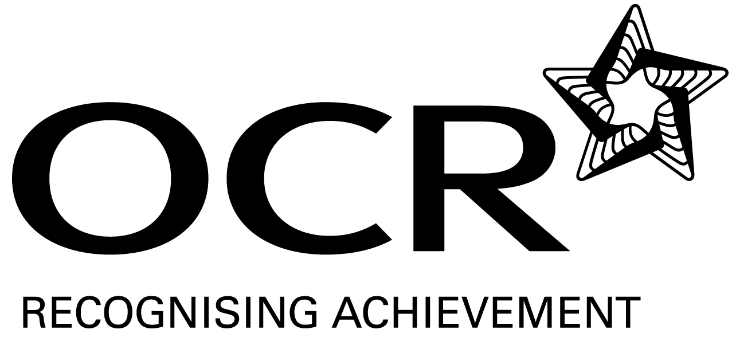

OCR Level 1 nvq cERTIFICATE in BUSINESS AND administration
Record of Achievement

Candidate name:

Total minimum of 15 credits required |  | Credits | Assessor | Date
Mandatory Units – Group A (7 credits)
Unit 103 | Work in a business environment | 3
 | Centre informed YES/NO Date
Unit 106 | Communicate in a business environment | 4
 | Centre informed YES/NO Date
Optional Units – Group B (Minimum of 4 credits)
Unit 101 | Manage own performance in a business environment | 2
 | Centre informed YES/NO Date
Unit 102 | Improve own performance in a business environment | 1
 | Centre informed YES/NO Date
Unit 105 | Work with other people in a business environment | 2
 | Centre informed YES/NO Date
Unit 107 | Make and receive telephone calls | 3
 | Centre informed YES/NO Date
Unit 108 | Assist in handling mail | 2
 | Centre informed YES/NO Date
Unit 256 | Meet and welcome visitors | 3
 | Centre informed YES/NO Date
Unit 110 | Prepare text from notes using touch typing (20 wpm) | 2
 | Centre informed YES/NO Date
Unit 111 | Use a filing system | 2
 | Centre informed YES/NO Date
Unit 225 | Support the organisation of business travel and accommodation | 3
 | Centre informed YES/NO Date
Unit 221 | Use office equipment | 4
 | Centre informed YES/NO Date
Unit 112 | Archive information | 2
 | Centre informed YES/NO Date
Unit 221 | Use office equipment | 4
 | Centre informed YES/NO Date
Optional Units – Group C (Minimum of 4 credits)
Unit 114 | Using email | 2
 | Centre informed YES/NO Date
Unit 125 | Word processing software | 3
 | Centre informed YES/NO Date
Unit 113 | Use occupational and safety guidelines when using keyboards | 2
 | Centre informed YES/NO Date

NB : Rules of Combination may apply please refer to the Centre Handbook for OCR Level 1 Award/Certificate NVQ in Business and Administration.

