Unit R082 – Creating digital graphics

Technical Compatibility of Images

Task 1a
Working on your own or in a small group, you will learn why it is important to check the technical compatibility of images.

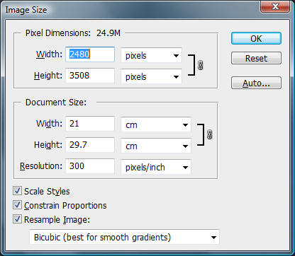
Look at the screenshot of an Image Properties below. The image it relates to is intended to be the background picture for a digital graphic montage at A4 size.

1. Is the print size correct for A4?

2. Is the dpi resolution suitable for print purposes?

Now consider a smaller image that will be positioned on the main background picture. The properties for this image are shown in the screenshot below:

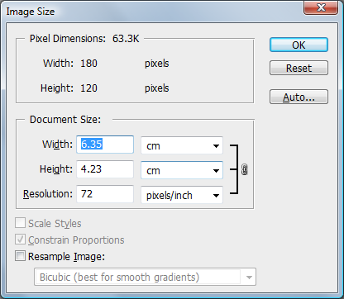

3. What is the dpi resolution of this image?

Let’s convert this to a suitable print resolution of 300 dpi to be compatible with our background picture:
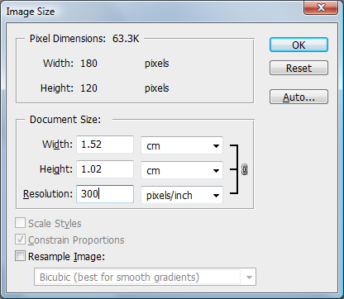

4. What will be the size of this smaller image on our A4 page?

Task 1b
Another option when changing the image properties is to resample the image. This will increase the number of pixels so it is possible to use a lower resolution web file in a print based product. There are some limitations to this – if the detail was not in the original image then it cannot be created by the image editing software. Practice with an image at 72dpi and resample this up to 300 dpi using the option to ‘Resample image’. A suggested image is ‘Nuts.jpg’ from the OCR Resources Image library located in the Planning and teaching/Teaching activities section of the Creative iMedia Qualifications page http://www.ocr.org.uk/qualifications/creative-imedia-level-1-2-award-certificate-j807-j817/:

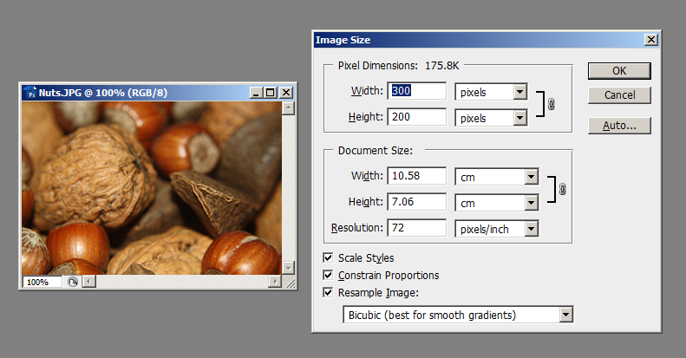
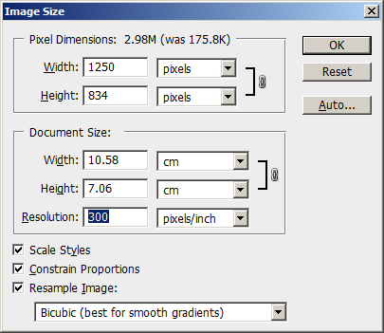
Resampled to 300dpi – note the change in pixel dimensions:

Can you tell the difference? Zoom in to 100% - is it still sharp?

Task 2
Look at the two images below.

Image 1 is a high resolution image.
Image 2 is a low resolution image.

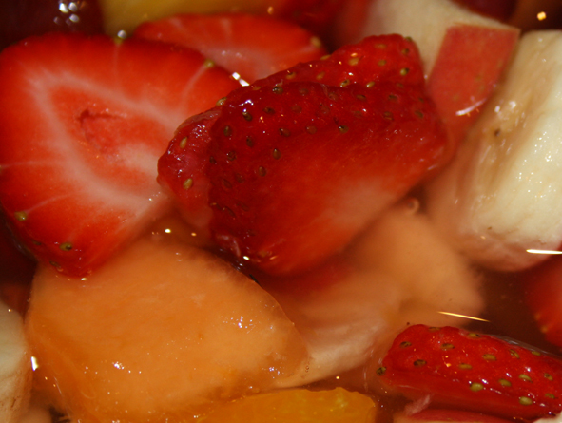
Image 1 Image 2

Comment on the image quality for the two images. What differences are there? Add your comments to the box below.

These two images can be downloaded from the OCR Resources Image library located in the Planning and teaching/Teaching activities section of the Creative iMedia Qualifications page http://www.ocr.org.uk/qualifications/creative-imedia-level-1-2-award-certificate-j807-j817/:

You can open these two images in your image editing software to compare them. Experiment with scaling by enlarging Image 2 – drag one of the corners outwards using the move tool (or equivalent).

Task 3
Search for and save some copyright free images from the internet, or access some of the Internet-alternative images from the OCR Resources Image library (located in the Planning and teaching/Teaching activities section of the Creative iMedia Qualifications page http://www.ocr.org.uk/qualifications/creative-imedia-level-1-2-award-certificate-j807-j817/). Remember to right click as Save Image As, rather than copy and paste the image.

These images will probably be 72 dpi. Look at the Image properties to examine the number of pixels in the image and see how big they could be when used in a montage for a print product. Use the table below to summarise your results:
Image name | Original resolution/size | Converted resolution/size

