Unit 1 – Principles of anatomy and physiology in sport

The Cardiovascular System

Activity 1

The heart is a powerful organ about the size of a clenched fist. It operates as two coordinated pumps that send blood around the body.

Research the heart and answer the questions in the table below.

Muscle type
Muscle structure
Primary function of the muscle
Control mechanism of the muscle
Location of the muscle

Activity 2

On the diagram below, label the main features of the heart.

Activity 3

Having learnt about the blood vessels, use your knowledge to complete the table below. You must describe the function and structure of the: arteries, veins and capillaries. You may want to use additional resources such as the internet, books and diagrams.

Vessel name | Structure and function
Arteries
Veins
Capillaries

Now label the diagram below:
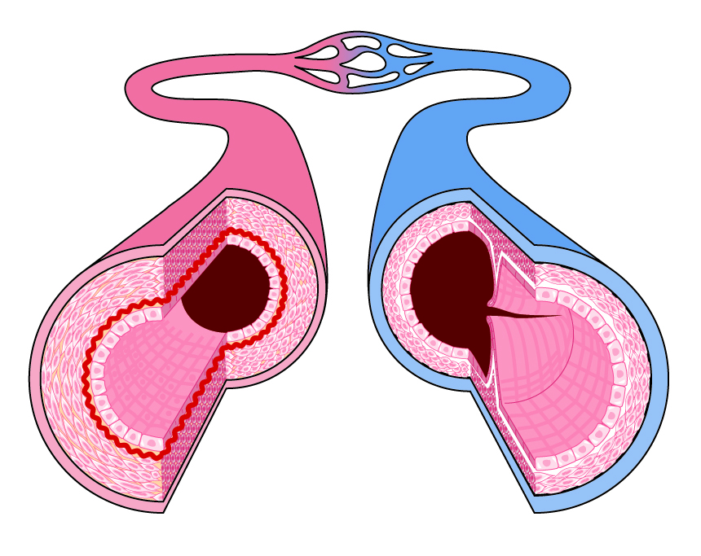

Activity 4

Having learnt about the function of the cardiovascular system during exercise, use your knowledge to complete this worksheet.

You must describe: stroke volume, cardiac output and heart rate. You may want to use additional resources such as the internet, books and diagrams.

Stroke volume
Cardiac output
Heart rate
Resting heart rate
Maximum heart rate

My resting heart rate is:
My maximum heart rate is:
My stroke volume is:

