Lesson Element

Social Relationships and Social Media

Objectives
- To understand the impact that social media is having on personal and public social relationships in a global context
- To consider social media in terms of power and control: who has access and who controls these social media?
- To consider how such relationships might be researched and explained sociologically.

There are currently nearly one billion users of the social networking site, Facebook. This means that the number of Facebook users is nearly three times the population of the United States. This shows the extent of globalisation of social media that has occurred in the internet age. Four percent of all the photos ever taken are on Facebook. Approximately 200 million people who use Facebook are mobile only. In other words, nearly a fifth of Facebook’s user-base does not own a PC. Therefore they are accessing their favourite website through their smartphones. This underlines the growing importance of smartphones and mobile devices in general. Facebook works by inviting people to become your ‘friend’ and then posting regular ‘status updates’.

Interestingly over five million Facebook users are under the age of ten. This shows that young children have easy access to social media. This is a new demographic that can be tapped by social media marketers. Companies can offer discounts and prizes that are directly targeted at a young demographic

Task 1 – Getting you thinking
- Think about the possible effects of network sites such as Facebook on people’s relationships.
- Working in pairs, create a list of the benefits and the potential problems of Facebook.

Task 2 – Research project
- Design and carry out a research project on the ways that your peers use Facebook (or not).
- Carefully, choose a research method and think about why you have picked this method (consider the strengths and weaknesses). Consider the size and nature of your sample.
- Once you have carried out your research, analyse your results and write them up.
- Consider the variables of class and gender, how might these impact upon the use of Facebook?
- Reflect on your research. How effective was your method in finding out what you wanted to know?
- What does your study tell you about the impact of Facebook on people’s social relationships?
- What do your results suggest about the impact of globalisation on social relationships?

In your write up make sure that you use the following concepts:
Globalisation Validity Reliability Representativeness Sampling Practical

Ethical Theoretical Social Relationships Interpretivism Positivism

Task 3 – New patterns of technology based social relations: Tales from Facebook
Daniel Miller’s ethnographic study explores the effect that social media is having on social relationships between friends and family members. In his study of Facebook in Trinidad and Tobago, Miller uses a number of individual narratives to explore the impact that it has on the lives of those who use it. Miller shows how Facebook use in this society plays a strong role in the relationships of a whole range of people. Interestingly, Miller describes how Facebook can not only become the means by which people find and cultivate relationships but can also be instrumental in breaking up relationships or in some cases, marriages.

Miller describes how in Trinidad, the word friending means to have sex with someone in a non marital relationship. On Facebook, to friend someone implies something rather different, but Miller points out that this linguistic difference in meaning leads some people to become very suspicious of their partners activities on Facebook. Promiscuous activities, which before might have been equally frequent, but were private, suddenly become visible because of Facebook.

Miller concludes by saying that Facebook has contributed to the process of reconstruction of peoples’ orientation to kinship relationships as well as other close social relationships, with technology compensating for increasing distance and absence. In other words, Miller claims that Facebook allows individuals to continue to network socially in traditional ways. This finding contradicts the general idea today that there is a tendency towards less communication between people.

- What are the benefits of studying Facebook using the ethnographic method?

- What do Miller’s findings suggest about different cultural interpretations of Facebook?

- What implications might Facebook have for social relationships, according to Miller?

Task 4 – Sociological interpretations of Facebook
Postmodernism – a new way to understand the ‘self’
In the past, the ‘self’ (the way we see ourselves and how others might see us) has been understood through interpretivist sociologists such as Mead and Goffman and then Foucault. More recently, postmodernism has attempted to make sense of how identity is created, negotiated and confirmed. The ways in which people use Facebook reveals much about how individuals create their own identity, how they see themselves and how others see them. Postmodernists, such as Collins (2005) suggest that to understand society, the chains of interaction between people must be understood. He suggests that by looking closely at how individuals construct their identity through social network sites such as Facebook, using a ‘micro’ sociological approach, it may be possible to learn about how people see the world around them.

Facebook as a new form of autobiography?
Bjorklund (1998) explains that people used to describe their lives through autobiographies towards the end of their lives. However in a postmodern world, she suggests that people take a different view of defining the self. Facebook, she suggests, is like an autobiography in that it keeps a record of how people see their lives. Similarly, according to Hart (2011) individuals today are writing and rewriting their autobiographies on a daily basis, which reflect their own values and the values of their particular society. Identity, therefore is now created both online and offline, in multiple ways. For example, by posting a picture on Facebook the construction of the self occurs and from this, communities develop.

Evaluation
Some sociologists such as Elliot (2001) are pessimistic about the fragmented nature of identity as a result of sites such as Facebook, whilst others prefer to see new ways of seeing the self as only problematic when considered using ‘modern’ theories. Hart suggests for example that there is a tendency of traditional interpretations of the self to regard postings of status on Facebook as trivial or superficial. However if one is to take a postmodern approach, events on Facebook such as status updates can be understood as culturally significant.

- According to some postmodernists, how is Facebook useful for understanding identity?

- What might be difficult about trying to apply traditional theories to sites such as Facebook?

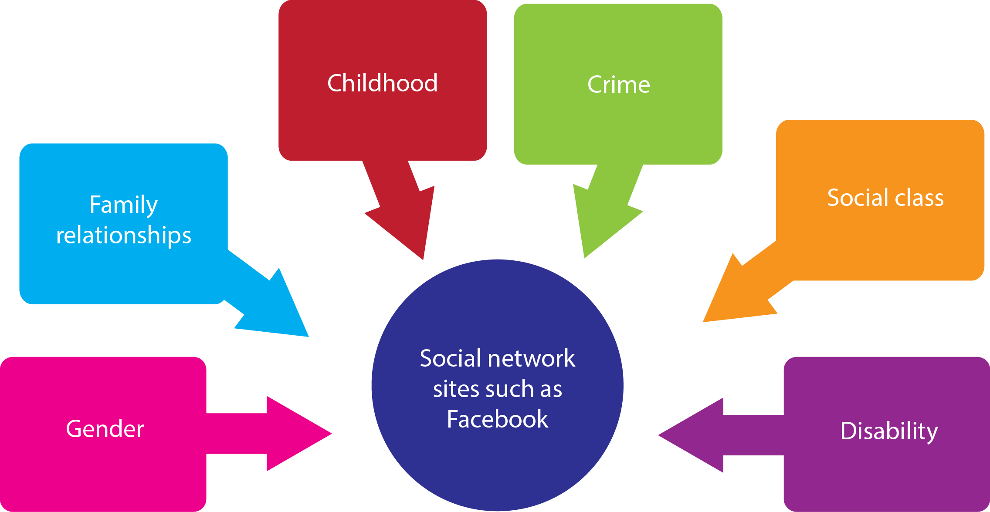

Consider the impact of social network sites such as Facebook on the topics above. Make notes and add them to the diagram. Consider:
- the potential varying usage of Facebook by different groups
- suggest reasons for the different patterns
- suggest possible future trends and effects.

Task 5 – Social media and social protest
One interesting emergent areas of sociology is the exploration of the effects of social media on social protest, which have been particularly notable in the Middle East. Before the revolutions in the Arab World, the use of social media was described as limited and confined to the social elite, mainly due to the fact that access to the internet had been so restricted. However the events across the Arab world in 2011 brought social media to the forefront, with many claiming that Facebook, weblogs, Twitter and YouTube, had an important role to play in the revolutions that have taken place.

It is quite difficult to clearly understand the ways in which social media have affected events, either through actual protest on the streets or through influencing mainstream forms of media. It is also not clear why social media was particularly effective in mobilizing protest in some contexts and not others. These events present a real challenge to sociologists trying to research the relationship between events and the role of social media.

In Egypt, through the spread of information online, internet activists were able to establish networks of resistance within Egyptian political society. Despite the relative weakness of the ties between members of these networks, social media emerged as an effective tool to facilitate collective action. Through being permanently connected to each other, activists were able to access an infinite number of networks of trust and multiply the impact of social protest through the creation of an insurgent community. Internet activism made political action easier, faster and more universal in Egypt. Social media sites became a place where many could express their anxieties and vocalise their feelings. But it was not, of course, in any way a complete solution to the problems there.

http://www.nytimes.com/2012/02/19/books/review/how-an-egyptian-revolution-began-on-facebook.html?_r=0

Watch the following documentary and take notes on the impact of new social media on reshaping the narrative of western media in its portrayal of events.
http://www.bbc.co.uk/programmes/b014grsr

Evaluation
It is important not to over emphasise the role of technology in the revolutions in Egypt or indeed anywhere else. Political activists use new forms of communication, especially digital and online social media, such as Twitter, Facebook, and the video-sharing portal YouTube, as a means of highlighting the government abuses of their citizens, promoting citizen journalism, shaping public opinion, and organising and mobilizing people to protest against repression. Activists integrate these online activities with offline activities, such as staging demonstrations and protests and launching on-the-ground campaigns. The regimes in both Egypt and Syria also use communication tools to protect their interests and to counter the political activists’ efforts, whether via traditional, state-owned media avenues or new media tools.

- Summarise the impact of social media in political movements and social protest using the concepts below.

- What are the challenges for sociologists trying to understand these new forms of media and the impact that they might have?

Identity social relationships postmodernism the self gender

Family relationships peer groups childhood crime disability

positive negative

