Checkpoint Task

Assessment Activities

Task 1 (KS4)

Statement | True () | False ()
The cash flow forecast shows the profit made by a business over a period of time
The cash flow forecast shows what has happened in the past

[2 marks]
Checkpoint

Mark

0-1 marks go to Cash Flow Activity
2 marks go to Task 2 (KS4)

Task 2 (KS4)

Cash Flow Forecast – Wright’s Farm – July–September 2011

 | July  £s | August  £s | September  £s
Balance brought forward | 2,000 | 1,400 | (1,000)
INCOME
Sales of goods | 10,000 | ????? | 11,000
TOTAL INCOME | 12,000 | 9,400 | 10,000
EXPENDITURE
Materials | 3,000 | 3,000 | 3,000
Energy costs and other costs | 600 | 400 | 700
Wages | ????? | 6,000 | 6,000
Transport | 400 | 400 | 400
Interest payments | 600 | 600 | 600
TOTAL EXPENDITURE | 10,600 | 10,400 | 10,700
Balance carried forward | 1,400 | ????? | (700)

Statement | True () | False ()
The cash flow forecast shows the expected income and expenditure for Wright’s Farm for the three months July to September 2011
In July income from sales of goods will be greater than total expenditure
In September, Wright’s Farm is forecast to have £1000 to carry forward to start trading in October
The balance carried forward at the end of July shows a profit of £1400

[4 marks]
Checkpoint

Mark

0-5 marks go to Personal Cash Flow Forecast Activity
6-7 marks go to Task 3 (KS4)

Task 3 (KS4)

Lathom's Dairy

One industry badly affected by the recession was cheese-making. Three out of the seven local producers closed during the period 2007 to 2009. Lathom’s Dairy was one cheese-maker which survived. Partner and manager, Eric Lathom, said, ‘Surviving the recession was a painful business. Some tough decisions had to be made to cut costs including making redundancies’. Eric is, however, cautiously optimistic about the future. ‘There are some positive signs which are encouraging us but there are still a lot of unknowns. The closure of three competitors producing world-famous Moorshire cheeses was not at all good news for the industry.’

East Moorshire is famous for its cheeses. There are now just four local producers, the biggest of which is Lathom’s Dairy. It is a partnership owned and run by Eric and Alice Lathom. Lathom’s Dairy has won awards for the quality of its cheeses.

In December 2010, in order to increase its product range, Lathom’s Dairy took over a small competitor – Wright’s Farm. Wright’s Farm produces only a goat’s milk cheese. Eric and Alice have decided to operate Wright’s Farm as a separate business which will only produce Moorshire Goat’s Milk Cheese as its existing dairy.

Cash Flow Forecast – Wright’s Farm – July–September 2011

 | July  £s | August  £s | September  £s
Balance brought forward | 2,000 | 1,400 | (1,000)
INCOME
Sales of goods | 10,000 | 8,000 | 11,000
TOTAL INCOME | 12,000 | 9,400 | 10,000
EXPENDITURE
Materials | 3,000 | 3,000 | 3,000
Energy costs and other costs | 600 | 400 | 700
Wages | 6,000 | 6,000 | 6,000
Transport | 400 | 400 | 400
Interest payments | 600 | 600 | 600
TOTAL EXPENDITURE | 10,600 | 10,400 | 10,700
Balance carried forward | 1,400 | (1,000) | (700)

Evaluate the usefulness of the cash flow forecast to Eric and Alice.

[8 marks]
Checkpoint

Mark

0-6 marks go to Benefits and Limitations Activity
7-8 marks go to Cash Flow Problems Extension Activity

Task 4 (KS5)

Item | October (£) | November (£)
Opening balance | 40
Inflows
Sales revenue | 100 | 150
Outflows
Wages | 54 | 50
Raw materials | 28 | 25
Rent & fuel | 22 | 38
Net cash flow
Closing balance

Calculate the closing balance for November. Show your working.

[4 marks]

Explain why it is important for a business to maintain a positive cash flow.

[2 marks]
Explain one action a business could take if they predict a negative cash flow for one month.

[2 marks]
Checkpoint

Mark

0-6 marks go to Cash Flow Activity
7-8 marks go to Task 5 (KS5)

Task 5 (KS5)
Just4Kids Ltd (JKL)

Harriet Hayes always stresses that she is a mother first and a businesswoman second. It is this, she believes, which ensures she focuses on making Just4Kids Ltd (JKL) the best childcare centre on the market. Back in 2005, frustrated in trying to find a suitable nursery for her own child, Harrier came up with the idea of setting up a nursery business. She turned her back on a career and large salary as a Human Resources Direction and set about making JKL a reality. For a weekly fee, starting at £195, JKL provides stimulating and educational day care for babies and pre-school children, as well as an after-school club for children aged between 5 and 11. It also provides a babysitting service in the evenings, hosts and runs children’s birthday parties at the weekend, and evening classes for parents and toddlers.

JKL has three childcare centres in Birmingham. Each currently has a maximum of 100 places and they are all operating at 100% capacity utilisation. Each centre is a single storey, purpose built building. “This was the only way to deliver our vision, with award winning designed centres based around the needs of the family,” said Harriet. This was not cheap, costing a total of £5 million; £750,000 from Harriet and her family, the maximum £250,000 from the Small Firms Loan Guaranteed Scheme and the remainder from a property developer who invested as an equity partner. Each of the three childcare centres includes age specific rooms, a Sensory Theatre, Music Room and Studio, outdoor play areas accessed directly from each room and an area for parents to relax and have refreshments whilst visiting. Safety and security are also vital, with CCTV and biometric entry systems in all three centres. A fourth childcare centre is planned to open in the next five years with her medium-term target being to open another 10 centres within a 100-mile radius of Birmingham. Looking further to the future, Harriet has already had enquiries from Europe and the Middle East which may lead to an overseas franchise eventually being set up.

JKL’s Marketing and Sales Director is Harriet’s husband, Matthew Albie. As well as working on the plans for opening the fourth childcare centre in 2011, Matthew is looking into the business behaviour of just one of the growing number of nursery companies which operate in JKL’s target market. This competitor, called ‘TotsatPlay’, has recently opened new venues in Birmingham, in direct competition to two of JKL’s centres and with similar services to those provided by JKL, Matthew is concerned that any changes to JKL’s marketing strategy, in response to the increased competition, will have an impact on cash-flow (see Appendix 2). Up to now, JKL has been able to rely on the initial start-up capital and its equity partner’s ability to secure a substantial overdraft. At a recent board meeting, Harriet had a conversation with JKL’s Finance Director, Jordan McTear, on this subject.

“Having more and more sites is going to create a real drain on resources for us,” said Jordan, “With the planned rate of growth, we really need to find a new financial partner with deeper pockets. We are still at least two years away from achieving break-even.”

“How much more capital do we need?” asked Harriet.

“Well, it may be £4 million, or it may be £20 million,” replied Jordan, “the problem is, Harriet, that growth was not in your original business plan and so the business has not really had a clear growth strategy. We need to make a decision about where we want to be in 10 years’ time. This will make it easier to decide how much extra finance is needed and where the best place to get it from is. Do we want to keep an equity partner which has a significant minority stake or do we want to explore options which give us, the board, more freedom to make decisions, such as franchising?”

“What about getting a venture capitalist involved?” asked Harriet.

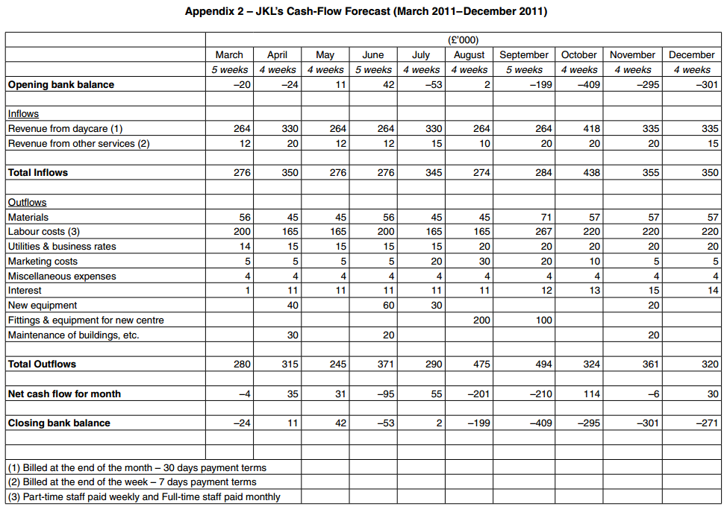
Before Jordan could reply, Matthew interrupted. “I am sure that this is all very important for the long-term future of this business but it does not deal with the shorter term cash-flow problems. We need to do something which will have an effect in the next six months, rather than the next six years, otherwise all these grand plans will be irrelevant.”

Discuss how JKL may improve its cash flow in the future.

[16 marks]
Checkpoint

Mark

0-11 marks go to Cash Flow Problems Activity
12-16 marks go to Cash Flow Extension Activity

