Lesson Element

Responding to unseen data

Task 1 – Scale matters: class discussion
Graph A
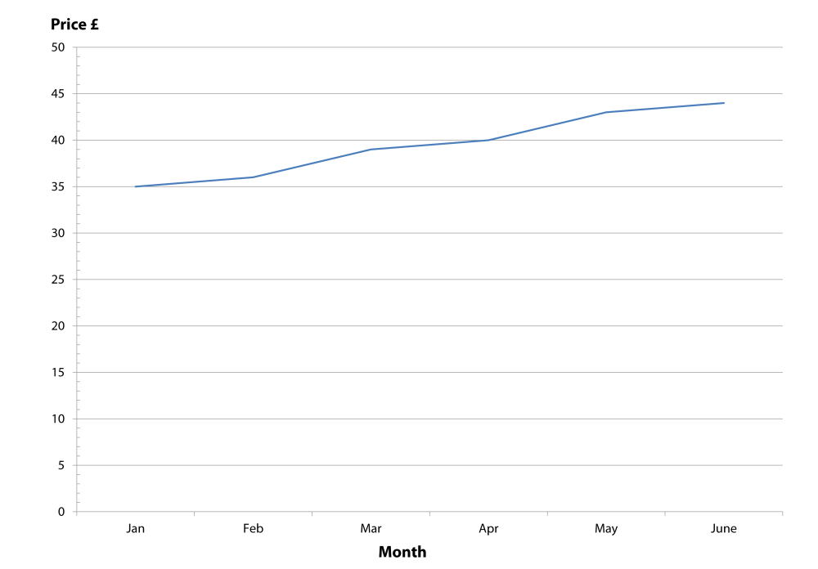
Graph B
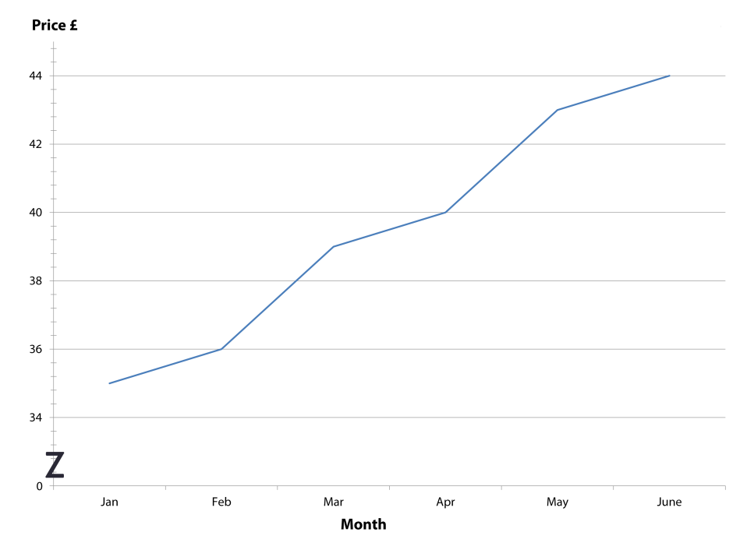

Bar chart A
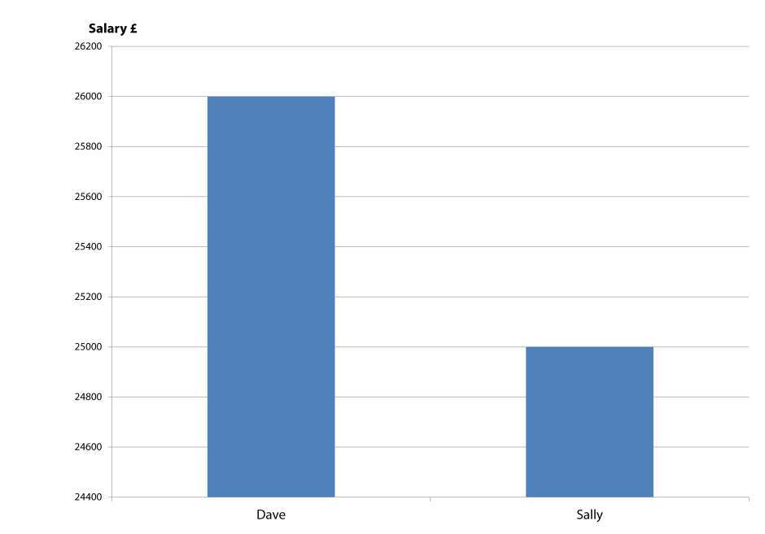
Bar chart B
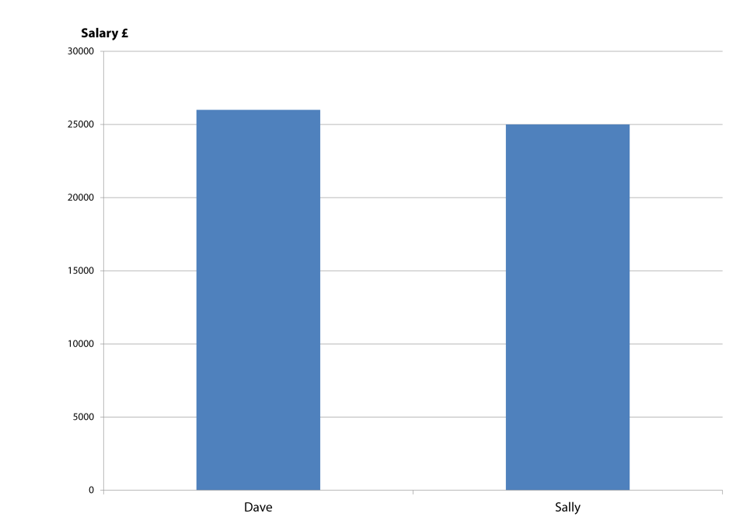

Discuss the following:

- What does Graph A show?

- What impression do you get? What message does it give?

- What does Graph B show?

- What impression do you get? What message does it give?

- What is the difference between Graph A and Graph B?

- What does Bar chart A show?

- What impression do you get? What message does it give?

- What does Bar chart B show?

- What impression do you get? What message does it give?

- What is the difference between Bar chart A and Bar chart B?

- Why is it important to take note of the vertical scale (especially in an exam)?

Task 2 – Identifying graphical trends: card sorting activity
Cut out the following cards to create a matching activity.
Identify which graph matches which description.
E  There has been a dramatic downturn in the market | I  The market is extremely volatile | L
L  Sales fell slightly in the final quarter | J  The share price has bottomed out | A
C  The sudden collapse in wheat prices has surprised everyone | H  The market is showing some signs of growth | K
K  The price reached a peak before falling a little and then maintained the same level | D  Sugar prices peaked at £300 a tonne | B
G  The marketing budget has stabilised over the past few years | H | E
B  There has been a steady increase in fuel costs over several years | C | D
A  The value of shares has shown a steady decline | F | J
F  The investment level rose sharply | G | I

Task 3 – Describing graphical trends: resource sheet
Data types

Number
Quantity
Amount
Level
Value
Absolute
Relative
Proportion
Percentage
Fraction
Ratio
Real
Nominal

Upwards movement

went up
increased
grew
rose
pushed up
expanded
extended
sky rocketed

Downwards movement

dropped
fell
slumped
plunged
declined
decreased
sank
went down
downturn
collapsed
plummeted

Change in direction

reached a peak
peaked
reached its highest level

fell to a low
bottomed out

reversal
volatility

levelled off
flattened out
stabilised

Size of movement

slightly
a little
a lot
sharply
suddenly
dramatically
steeply
gradually
gently
steadily

No movement

remained steady
did not change
remained constant
remained stable
maintained

Task 3 – Describing graphical trends: newspaper activity
Take a newspaper and look at the business/financial section. Find at least 2 different types of graphs/charts. Cut the graphs from the newspaper and paste into your notes. Complete the questions for each graph.

Graph/chart 1

Read the title, what is the graph about? Are the figures absolute or relative? What are the units?

What type of graph is it? For what purpose is this type of graph normally used?

Which features of the graph make it difficult to interpret?

Look at the source, what bias, if any, could there be?

Using the appropriate words on the resource sheet, carefully describe what the data on the
graph shows.

Task 4 – Handling complex unseen data

Tips to improve your performance:

- Spend time getting a feel for the data provided
- Read titles and headings carefully
- Note the source and possibility of bias
- If primary data, note the method of collection and size of sample – they affect validity
- Note whether the numbers are absolutes or relative
- Note whether real or nominal values are shown (if appropriate)
- Note the units and magnitude
- Read any foot notes
- Consider the impact the scale has on the interpretation of the data
- Identify any trends: upwards, downwards, cyclical, seasonal
- Look for correlation and relationships (do not assume that they are causal)
- Extract important points from the data
- Do not reproduce the data, use it to support your points
- Remember that description is not analysis – if you are asked to analyse then you must
consider the impact of the data on the organisation or its stakeholders.

Task 4 – Rate of change: ‘give me five’
Study the rate of change graph displayed. Take care it is quite complicated.
Write down 5 statements about what the graph shows – ensure that you have not made assumptions – be prepared to share your answers.
1

5

5

4

3

2

