Lesson Element

Practice in responding to unseen data

Developments in the global economy
The global economy is gradually recovering from the worst financial crisis since the Great Depression, business and consumer confidence is rising and politicians are beginning to talk about a sustained period of growth for most economies rather than nervously referring to green shoots. Fig.1 shows forecasted world economic growth for 2014 and 2015.
Fig.1 – World GDP growth, 2008 – 2015 (forecast)
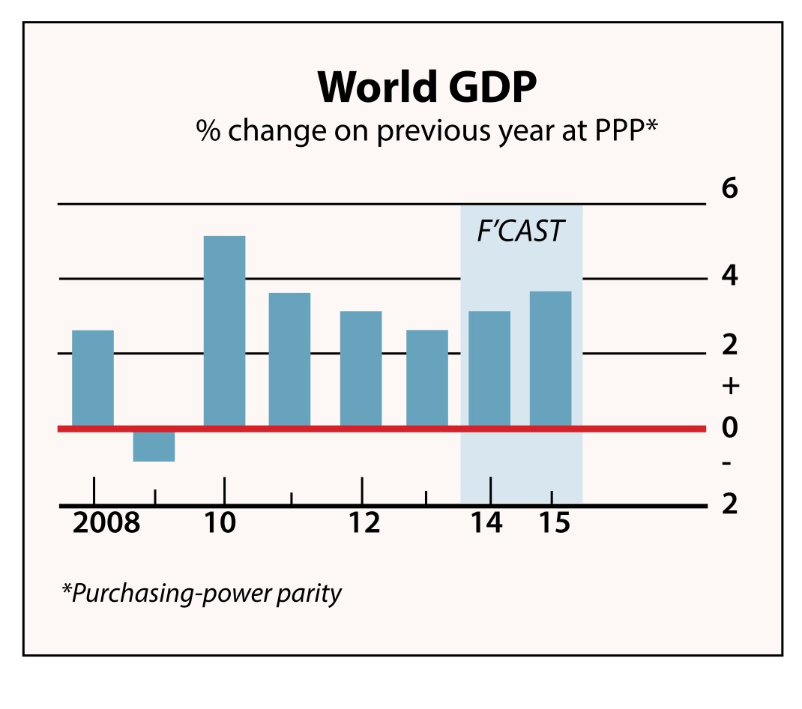

However, many economists warn that economic recovery could be hindered by the rising tide of income inequality. In this year’s survey members of the World Economic Forum identified the growing gap between the rich and poor as the biggest threat to global prosperity. The Gini Coefficient is one way of measuring income inequality. The Gini coefficient for a range of countries is shown in fig. 2. A coefficient above 0.4 is regarded as a signal of dangerous levels of inequality.

Fig. 2 – Gini Coefficients for selected countries between 1985 and 2008
Country | Gini Coefficient 1985 | Gini Coefficient 2008
USA | 0.34 | 0.38
China | 0.28* | 0.42
UK | 0.32 | 0.34
Hungary | 0.21* | 0.26
Mexico | 0.46* | 0.47
Brazil | 0.56 | 0.55

*Estimated from 1984 data
The changes in income distribution that have led to many countries experiencing rising income inequality is illustrated in fig. 3, however, not all countries have had the same experience.
Fig. 3 – The average annual income change for selected economies, 1985-2008

Economists have long been engaged in discussions regarding the consequences of income inequalities, one notable economist – Joseph Stiglitz believes that there is a strong link between rising income inequality and the rate of economic recovery.
Extract 1 - Joseph Stiglitz discusses the problem of inequality in America.
http://opinionator.blogs.nytimes.com/2013/01/19/inequality-is-holding-back-the-recovery/?_php=true&_type=blogs&_r=0
A slower economic recovery isn’t the only consequence of rising inequality. Some economists believe that there are negative consequences for living standards, intergenerational social mobility, health and well-being and labour productivity. Rising levels of inequality can be linked to falling social mobility as those at the lower end of the income spectrum aren’t as likely to afford higher education and will have fewer employment opportunities than those at the higher end. This can reduce labour mobility and so add supply-side constraints into the economy.
The worry is that this may have long term implications for the macroeconomic performance of the economy as a whole, not just economic growth.

Task 1
Working independently at first, read through the stimulus material in its entirety and write down the key economic concept(s)/theme(s) covered in the stimulus material.

Task 2
Without showing anyone else, write what you consider to be the main theme onto a piece of paper or a post-it and stick it on to the classroom white board.

Task 3
Read through the data again and this time, in the left hand margin, write down key economic terms as you come across them.

Task 4
A paired activity
On a sheet of A3/flip chart paper, write an exam question that you think could be asked concerning the stimulus material. Make sure that it is a ‘discuss/evaluate’ question.

