Carbon-13 NMR

Activity 1 – Carbon environments in organic molecules

In chemistry, it is important to be able to identify atoms in molecules which are chemically equivalent to each other. The way that chemical structures are drawn can be misleading, and chemists need to be able to visualise structures correctly in their minds to be able to perform this task.

Introduction: carbon environments in simple alkanes

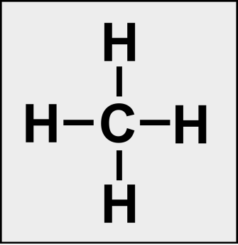
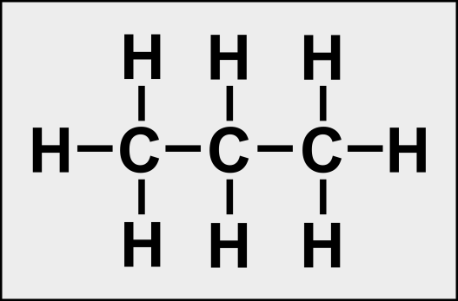
Methane has one carbon environment.
In propane, the two terminal carbon atoms are identical.
The central carbon atom is different from the others, hence there are two carbon environments in propane.

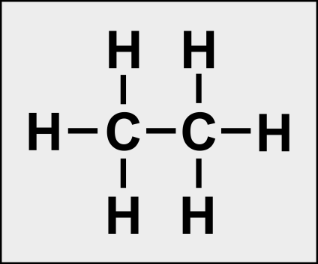
In ethane, the two carbon atoms are identical, hence there is only one carbon environment.

Task 1
Your task is to identify how many different carbon environments are present in the compounds illustrated below. Label the structures to show carbon atoms which are in the same environment (take care with the third structure).
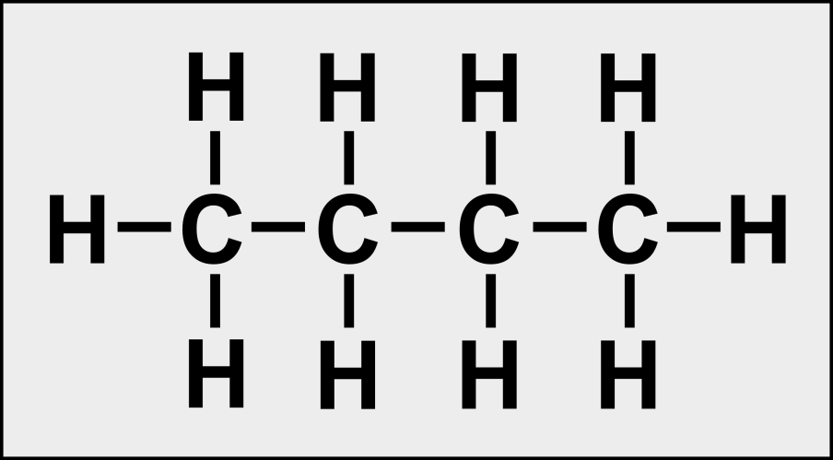

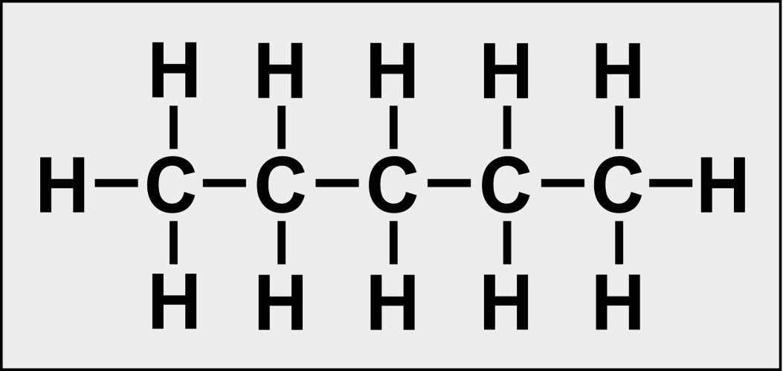

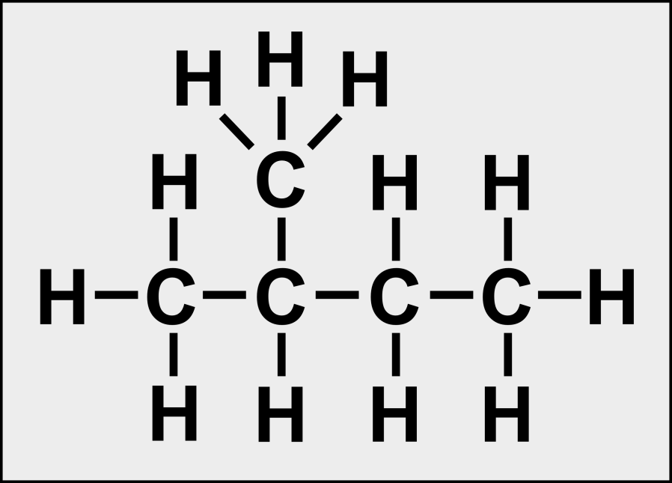

Task 2
Draw the structures of the following compounds and identify how many different carbon environments are present. Label the structures to show carbon atoms which are in the same environment.

- 2,5-Dimethylhexane

- 3-Ethylpentane

- Benzene

- Methylbenzene

- 1,2-Dimethylbenzene

- 1,3-Dimethylbenzene

