Carbon-13 NMR
Activity 2 - Introduction to carbon-13 NMR spectroscopy

An example of a carbon-13 NMR spectrum is illustrated below. The compound which gave rise to this spectrum is bromoethane, a simple halogenoalkane which has two distinct carbon environments.
A
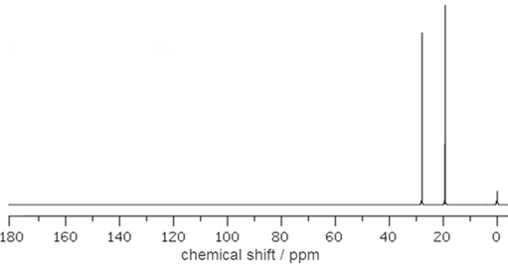
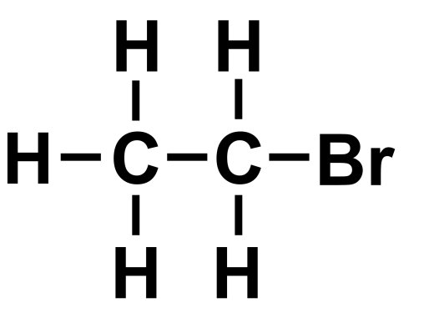
B

A
B

Each carbon environment in a molecule gives rise to a signal (or peak) in the carbon-13 NMR spectrum. The peaks occur at different chemical shift values, which are measured relative to the reference compound tetramethylsilane (TMS), which is responsible for the small peak observed at 0 ppm in the above spectrum. As one would expect for a molecule containing two carbon environments, the carbon-13 NMR spectrum of bromoethane contains two signals, one at 19.4 ppm and one at 27.9 ppm.

When electronegative atoms are attached to carbon atoms in molecules, this tends to lead to those carbon atoms having higher chemical shift values. Hence it can be determined that the signal at 27.9 ppm corresponds to the carbon atom which is bonded to the electronegative bromine atom

(CBr). Carbon atoms in different chemical environments tend to produce NMR signals at characteristic chemical values, which are illustrated in datasheets such as that shown below.
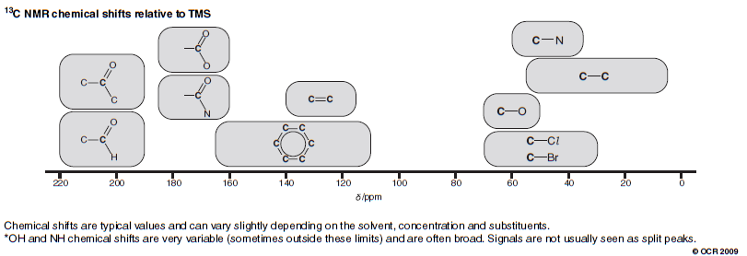

Spectra of simple molecules
In Activity 1, you identified the number of carbon environments present in several molecules. The carbon-13 NMR spectra of these compounds contain the same number of peaks as there are carbon environments in the molecules. The compound 3-ethylpentane was found to contain three different carbon environments. All of the carbon atoms are bonded to other carbon atoms, and reference to the datasheet on the previous page would lead to the prediction that the 3 signals would be in the range ~5−55 ppm. As can be seen in the carbon-13 NMR spectrum below, there are in fact 3 signals in this range. The assignment of the peaks to specific carbon atoms is shown.
B
C
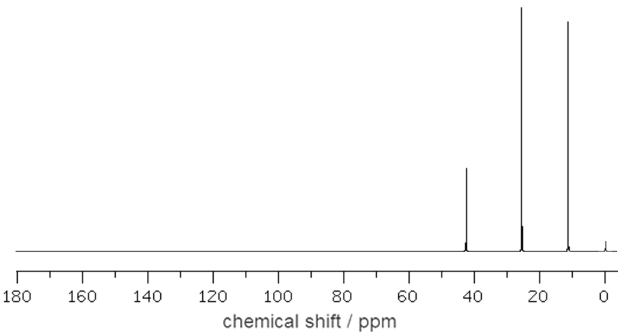
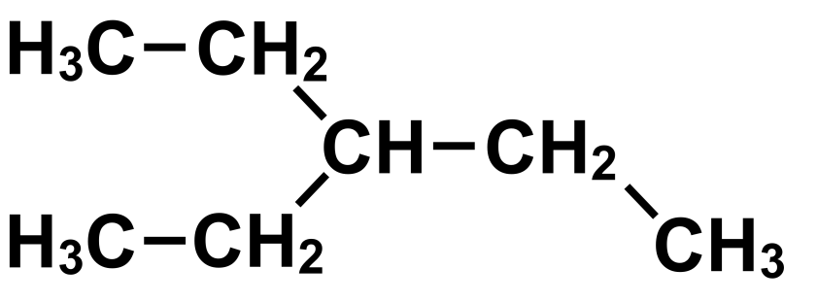
B
C

A
B
A
B
C
C

Another compound considered in Activity 1 was 1,2-dimethylbenzene, which was found to contain four carbon environments. In this case, three of those carbon environments are in the aromatic ring system, and the signals corresponding to these atoms would be predicted to be in the range ~130−165 ppm. The remaining carbon environment, being bonded to another carbon, would be predicted to give a signal in the range 5–55 ppm. Again, these predictions are borne out in the actual carbon-13 NMR spectrum of 1,2-dimethyl benzene which is shown below.
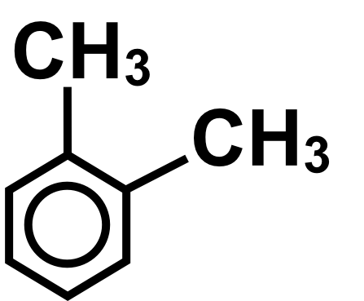
C
D
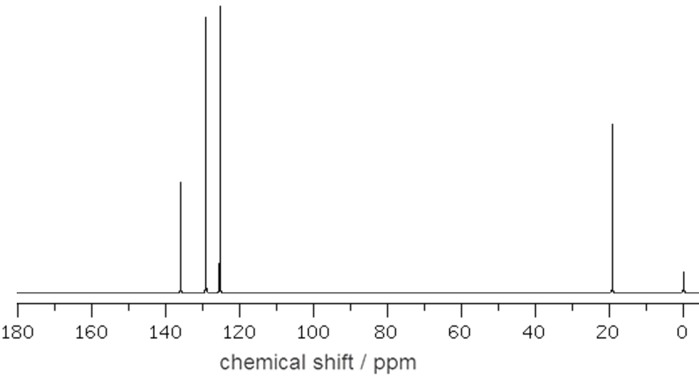
A
B
C
A
B
A

C
D
B
D

Task 1 Predicting spectra
Your task is to predict the appearance of the carbon-13 NMR spectra of the following compounds. If you don’t know the structures of these compounds, you can look them up using the internet:

1) Propanal
2) 2-Aminobutane
3) cis-Hex-3-ene
4) Methylbenzoate

Once you have predicted the appearance of the carbon-13 NMR spectra of these compounds, you should then try to identify which of the spectra labelled A–D below corresponds to each of the four compounds.

