Lesson Element

Cell Division

Task 1 The Cell Cycle
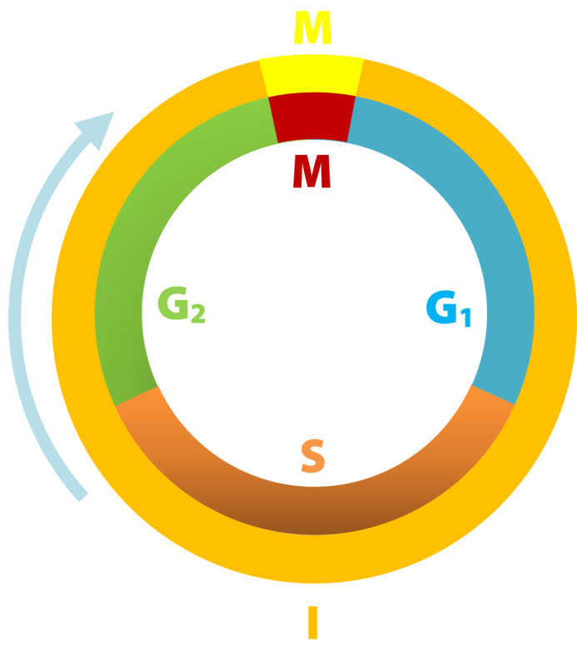

The diagram above shows the cell cycle.
- Explain what is meant by the term “The Cell Cycle”; describing what is taking place in each of the phases shown.

2. Outline the controls that regulate the cell cycle.

Task 2 Cell Division Vocabulary
Produce a set of flash cards of the technical terms used in cell division. For each term provide a definition and one or two sentences stating the role of the term in cell division.

Task 3 Mitosis and Meiosis
Design and complete a table showing similarities and differences between mitosis and meiosis. It should include:
- The number of divisions
- The products
- The chromosome number
- The formation of bivalents and chiasma
- Role in the body

Task 4 Importance of Mitosis and Meiosis
Plant breeders use both sexual and asexual reproduction to produce commercial quantities of new varieties of a plant.
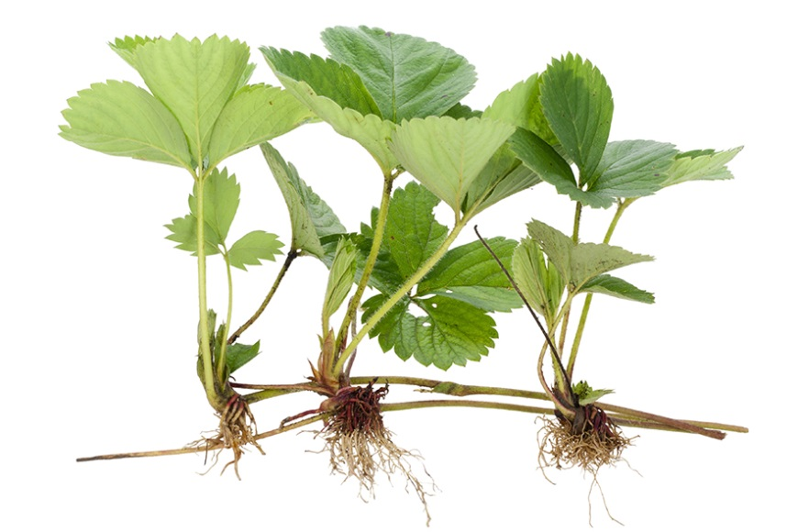
Runner with daughter plant developing

Strawberries can reproduce sexually by producing gametes in flowers and asexually by producing new plants at the end of runners. Modern strawberry plants have been bred so that the fruit is much larger than in original the wild varieties. In order to produce plants that bear larger fruit the breeder will take pollen (male gamete) from one plant and artificially transfer this to the female sexual organs in the flower so that fertilisation can occur. If the breeder is lucky then one or more of the offspring will produce larger fruit. This strawberry plant is prevented from reproducing sexually and maintained in conditions that encourage the productions of runners.
The daughter plants are then separated from the parent plant and the process of producing runners repeated until sufficient are available for commercial use.

- Explain the role of meiosis and mitosis in the production of commercial quantities of strawberry plants with the desired characteristics.

- Discuss why growers should only use plants produced from runners not use plants produced from sexual reproduction.

