Lesson Element

Identity and hybrid identity

Aims and Objectives
- To understand what is meant by identity and group identity
- To understand that identity is made up of many different parts, some of which are ascribed and some of which are achieved
- To begin to understand theoretical perspectives on identity, structure and agency
- To explore the relationship between identity and culture.
- To understand what is meant by hybrid identity and explore the relevance of hybrid identity in the context of postmodern society.

Task 1 – Defining identity
In small groups discuss the following questions:
- What do you think is meant by the word identity?
- What influences a person’s identity?
- How is identity related to culture?

Definition of identity:

Two types of identity:

.

Task 2 – What factors shape a person’s identity?
Look at the first diagram below. Explain each box and then think about what factors informs your own identity
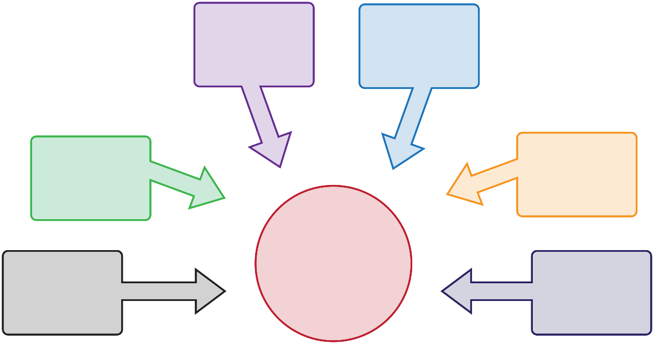
Identity
Location
Sexuality
Ethnicity
Nationality
Class
Gender

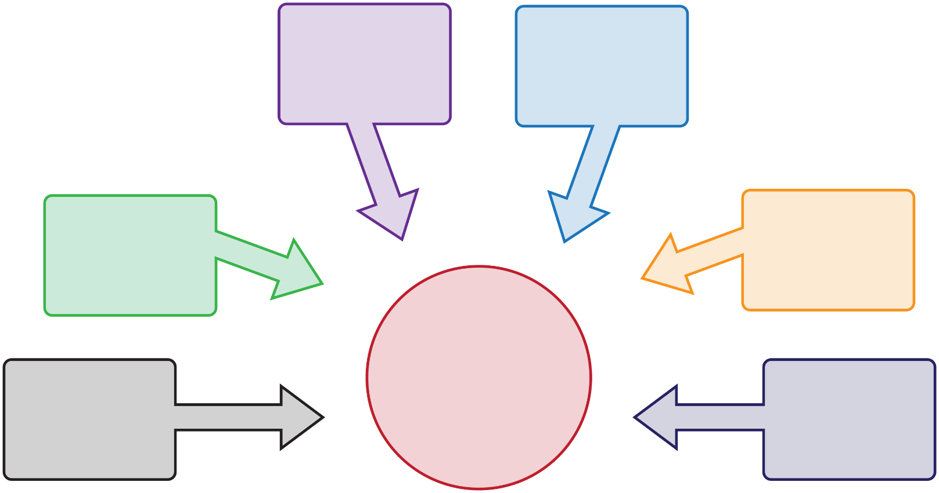
My Identity

Task 3 – Types of identity
Description | Type of identity
The choices a person makes about how to spend their free time which shape their sense of who they are.
Socioeconomic position, according to Marx, the most significant part of your identity that is ascribed.
How people express their identity through their choices of relationships.
The idea that the country belongs to plays a significant part in defining who they are as a person.
Where a person lives determines their identity.
A shared sense of identity deriving from dress, language or beliefs for example.
How peoples employment patterns shape their identity.
Expressing identity through patterns in buying certain products or services.
Specific ideas about what it means to be a man or a woman shape a person’s identity.
The way that identity is dependent upon the life stage a person is at.

Social class | Gender | Sexuality | Location
Nationality | Consumption | Leisure based identity | Work related identity
 | Age | Ethnicity

Task 4 – How does a person acquire an identity?
Ascribed identity:

Achieved identity:

Examples of ascribed identity | Examples of achieved identity

Stretch and challenge:
Which of the above are possible to change and which might not be? Why?

Task 5 – Sociological theoretical perspectives on identity

Structure
The idea that identity is ascribed, individuals are passive and cannot change their identity, eg Marxism

Agency
The idea that individuals and groups can and will change aspects of their identity, eg Neo Marxism

Marxism:

Neo Marxism:

Summarise the postmodern perspective of identity.

In your own words, using the PowerPoint slide, describe the difference between identity in a modern era with identity in a postmodern era:

What is the relationship between culture and identity?

What is hybrid identity?

In your own words summarise the key reasons why hybrid identities form:

Hybrid identity:

Examples:

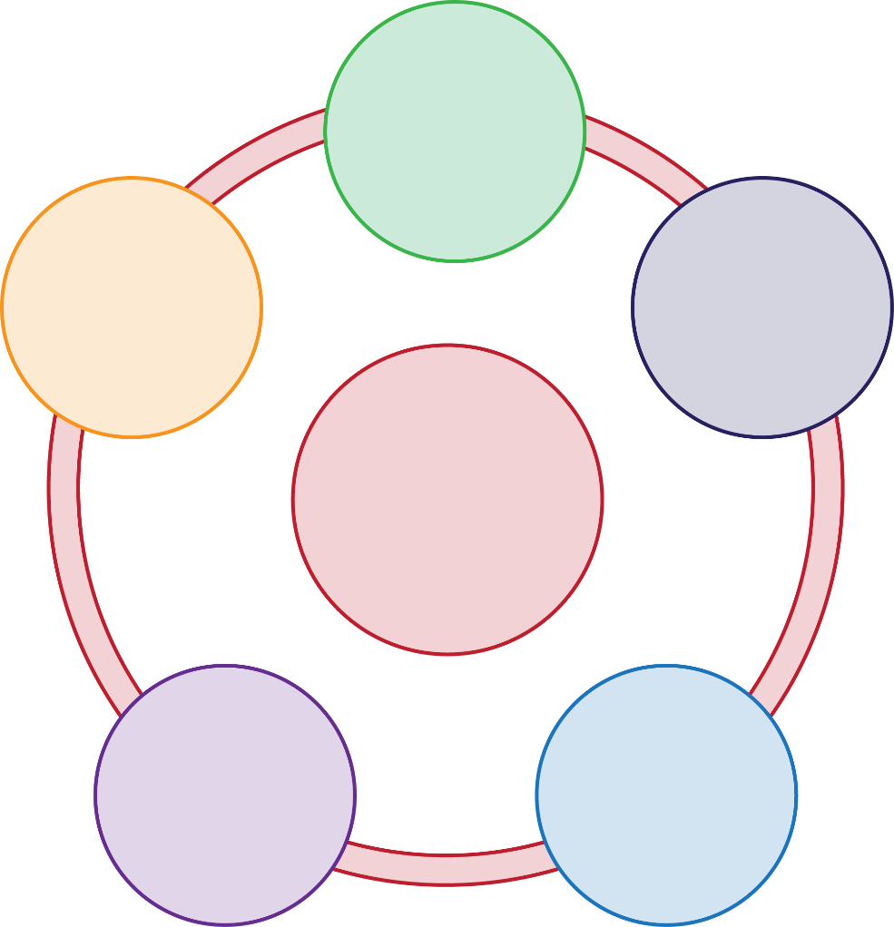
Hybrid Identity
Increasing population movement
Postmodernism
Mass media
Globalisation
Agency

In your own words, explain how each concept relates to the idea of hybrid identity, giving examples.

Task 6 – Card sorting activity
Using the diagram below, link the correct concepts and ideas to the correct image.

Image 1 Image 2

Concepts and ideas | Image 1 or 2?
Working class
Fragmented identity
Fluid identity
Hybrid identity
Social class is important
Gender identity as fluid
1980’s–today
Modernity

Concepts and ideas | Image 1 or 2?
Agency
Marxism
1950’s–1980’s
Gender identity as fixed
Sexuality as a key part of identity
Globalisation
Post modernity
Identity stable
Structure
Ascribed identity
Increasing movement of people
Nationalism
Achieved identity
Neo Marxism
Mass media

Task 6 – Card sorting activity
Using the diagram below, link the correct concepts and ideas to the correct image.

Image 1 Image 2

Working class | 1980’s–today | Sexuality as a key part of identity | Increasing movement of people
Fragmented identity | Modernity | Globalisation | Nationalism
Fluid identity | Agency | Post modernity | Achieved identity
Hybrid identity | Marxism | Identity stable | Neo Marxism
Social class is important | 1950’s–1980’s | Structure | Mass media
Gender identity as fluid | Gender identity as fixed | Ascribed identity

