A Level Sociology

The impact of digital forms of communication on social equality

Task 1 – Getting you thinking
- In pairs, make a list of the people in the UK who you think are the least likely to have access to a computer or the internet.
- Next to each one write why you think those individuals may have limited access.
- Finally, think about what impact not having access to a computer or the internet may have on their lives.

People with limited access to computers and the internet | Why? | How will this affect them?

Task 2 – Using the internet to research the digital divide in the UK
Using the internet research the following questions. If your answer requires a statistic, try to find the most recent or up to date research possible and make sure you only take statistics from reliable sources. Think about the validity, reliability and representativeness of the research your chosen statistic is from.

- What is meant by the Digital Divide in the UK?

- How many/What percentage of people in the UK have access to a computer?

- How many/What percentage of people in the UK have access to the internet?

- Is internet usage increasing or decreasing in the UK? How do you know this?

- Which area of the UK has the highest proportion of internet users?

- Which area of the UK has the lowest proportion of internet users?

- Are men or women more likely to be internet users in the UK? What do the statistics show?

- Using your list of people from task 1, find a statistic that proves you were right and they are the least likely to have access to a computer or internet in the UK

Task 3 – Focusing on the digital divide between young people and children in the UK
Little academic research has addressed the ‘digital divide’ among children and young people. Most research has focused on the divide in access to and use of the internet amongst adults, even though young people’s lives are increasingly influenced by digital communication technologies at home, at school and socially. Little research has addressed children and young people’s access to the internet or the reasons why some of them make low or no use of the internet. This could be because young people are perceived to be ‘ahead’ of the adult population and are often referred to in the media as ‘the internet generation’. However does the lack of research mean that young people have no difficulties accessing and using the internet and there is therefore no digital divide between them?

As part of a broader, quantitative and qualitative research project on children and young people’s use of the internet in the UK, ‘UK Children Go Online’ (UKCGO), Livingstone and Helsper (2007) conducted 40 minute, face to face, computer-assisted interviews with 1,511 children and young people aged 9-19 in their own homes, as well as 906 questionnaires completed by some of their parents. Random Location sampling across the UK was used to gain respondents.

Livingstone and Helsper’s findings reveal inequalities amongst young people by age, gender and class status in relation to their quality of access to and use of the internet. For example, boys, older children and middle class children all benefit from more and better quality access to the internet than girls, younger and working class children. Interestingly even among those young people who don’t have internet access at home, boys and older children can still be seen to use the internet more. However, the greater use of the internet among middle class children appears to be a result of their increased home access. Therefore, according to Livingstone and Helsper, policy should focus on reducing the differences across households to improve internet access for working class young people, but not focus on inequalities within households such as the age or gender gap in internet usage.

- Why is the digital divide and young people an under researched area?

- What are the strengths of conducting 40 minute, face to face, computer assisted interviews when researching children and young people? Think practically and ethically.

- What are the weaknesses of conducting 40 minute, face to face, computer assisted interviews when researching children and young people? Think practically and ethically.

- Which young people are least likely to have access to and use the internet according to Livingstone and Helsper?

- Why might these groups of young people be the ones that use the internet the least? Try to give different reasons for each group.

- Livingstone and Helsper suggest that policy should focus on the class divide in internet access and use amongst young people. Why might this be?

Task 4 – The digital divide globally
Complete the spider diagram by finding examples of countries who experience digital divides because of the reasons included. Your teacher may also give you a country to create a case study about the use of computers and the internet in that country. You should use the headings to consider why there is a digital divide in that country.
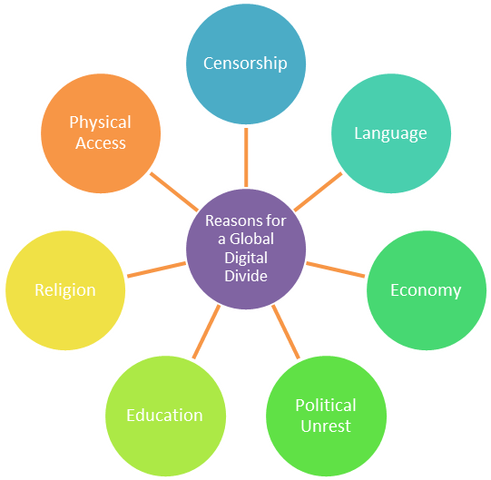

Task 5 – Applying traditional theoretical explanations to the digital divide
Apply the following Functionalist, Feminist, Marxist and Weberian concepts to the global digital divide. How can these traditional modernist theoretical concepts be applied to such a current global issue?
- Functionalist - Value Consensus and Social Solidarity
- Feminist - Patriarchy and Gender role Socialisation
- Marxist - Alienation
- Marxist - Ideological Control
- Weberian - Status/Consumption
- Weberian - Party

