Lesson Element

Wells’ Key Study

Task 1
Congratulations, you’ve just got a job at IBM. You will be spending 235 days per year in your state of the art office cubicle. How would you personalise your work space? Draw on the plan below and label each object.
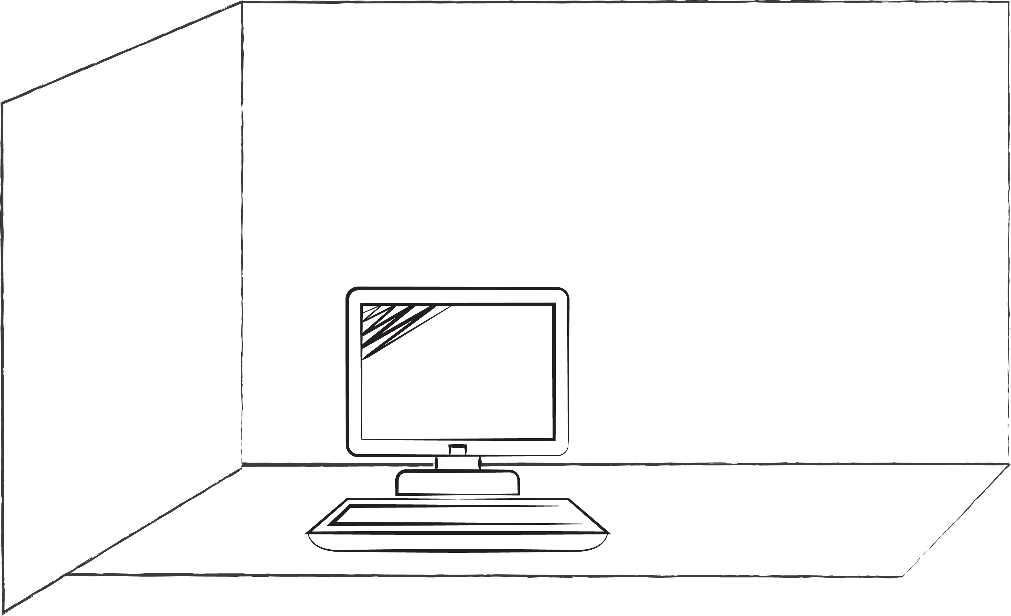

Task 2
Now count how many items from each category of personalisation your partner has used in their cubicle.

Number of items
Personal relationships
Family
Friends
Romance
Pets
Art
Entertainment
Values
Trinkets
Cartoons
Plants
Sports
Achievements
Total

Task 3
Compare the different results from your group. Can you see any trends? Are there gender differences?

Task 4
What could be the psychological effects upon an employee of allowing them to personalise their workspace?

Task 5
What could be the effects upon an organisation of allowing employees to personalise their workspace?

