Unit 5 – The marketing plan

Market research – using customer feedback
Knowing your customers – who they are, what they want, how they like to shop – is essential for any retail business. But how can the business find out this information? One way is to use marketing research surveys, putting questions to a representative sample of people. But another way is for the business to talk directly to the customer.

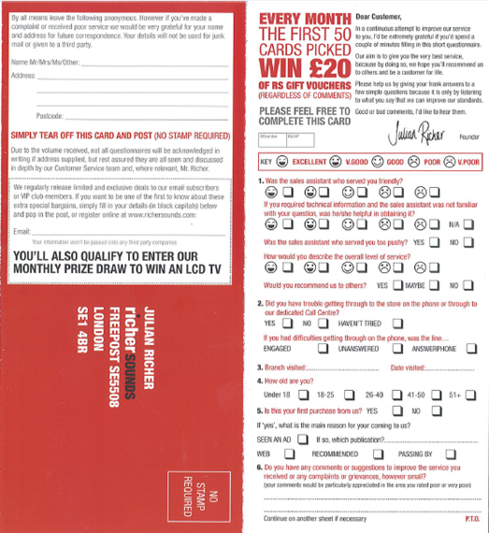
This is the approach used by Richer Sounds, the electricals retail chain. “We rarely commission market research on the whole, because we already have a massive engagement with the customer,” explains the company’s Marketing Director Claudia Vernon. “We hear from customers all the time.”

Richer Sounds invites feedback from everyone who buys something in its stores, whether that is an expensive home cinema system or a cable costing a few pounds. With the receipt, each customer gets a feedback card, known as a Customer Receipt Questionnaire (CRQ), with questions on one side and Richer Sounds’ freepost address on the other. To give customers an incentive to fill in and return the card, all returned cards are entered into a monthly draw and can win Richer Sounds products.

The stores hand out around 600,000 feedback cards a year and in 2013 they received 23,497 back. This 4% return rate gives the company a huge amount of marketing data to use.

The questions ask for two types of information. Firstly, Richer Sounds wants to know what the customer thinks of the service he or she received. The customer is asked to rate aspects of the service by ticking a box, from ‘Excellent’ to ‘Poor’. This data feeds back into staff performance figures.

Secondly, the company wants to know about the customer and their buying habits: their age, whether this was their first purchase from Richer Sounds and what prompted them to come into the store – did they see an advert and if so where? Did they look on the Richer Sounds website first? There is also space on the form for the customer to add specific comments.

There is no point collecting data unless it is used to inform the company’s operations in some way. Richer Sounds does this systematically. Each feedback form is filed into the customer service category: Excellent, Very Good, Good, Mediocre/Poor, Very Poor. The Excellents trigger a reward payment to the sales colleague who served that customer. Comments are looked at and any which could be classed as a complaint are referred to the Operations Director, who has responsibility for customer service. Customers who have complained always receive a response from the company.

The various data from the CRQs are collated and then studied at Richer Sounds’ Customer Service Group meetings, which are held every three months and attended by the Chairman, David Robinson, the Operations Director, Training Director and Service Manager, amongst others including Store Managers. This means that the information is discussed at a very high level in the company, so that feedback from customers feeds into strategic decisions about the business.

The CRQs are not the only channel of communication between the business and the customer. “We get letters, emails, calls to customer service,” says Operations Director John Clayton. Richer Sounds also has feedback forms called ‘We’re Listening Cards’ on every counter. “These ‘We’re Listening Cards’ are available in store for any customer, not just customers who purchase goods. This way if a customer receives poor service and decides not to purchase from us, they can still use the ‘We’re Listening Card’ to make us aware of this,” John Clayton explains.

Richer Sounds also invites feedback through its Facebook and Twitter sites, as well as numerous web forums like AVForums and Google reviews. All of these are monitored on a daily basis and critical comments are passed to the Operations Director and responded to as a priority.

Marketing Director Claudia Vernon notes that social media is a growing source of market data. “A conversation about your company might be taking place between people, on Twitter, Facebook or a forum,” she says. It is important to know about this, even if – or especially if – the business is being criticised. “You can’t control the conversation, but you can find out about it and respond to it and if comments are negative, try to turn it round. What you mustn’t do is ignore it.”

Questions
- Why do you think Richer Sounds use Customer Receipt Questionnaires as well as the ‘We’re Listening Cards’?

- Why do you think Richer Sounds wants to know ‘about the customer and their buying habits’?

- How might the 4% response rate for the Customer Receipt Questionnaires be improved?

- Why do you think it is important for a business like Richer Sounds to gain feedback through online sources such as Facebook and Twitter?

- In addition to the market research methods mentioned in the case study, recommend one other method of market research Richer Sounds could use, justifying your choice.

- How might the market research methods used by Richer Sounds help them to plan their marketing?

OCR Resources: the small print
OCR’s resources are provided to support the teaching of OCR specifications, but in no way constitute an endorsed teaching method that is required by the Board, and the decision to use them lies with the individual teacher. Whilst every effort is made to ensure the accuracy of the content, OCR cannot be held responsible for any errors or omissions within these resources.

© OCR 2013 - This resource may be freely copied and distributed, as long as the OCR logo and this message remain intact and OCR is acknowledged as the originator of this work.

OCR acknowledges the use of the following content:
Case Study: Richer Sounds
Slides 4 and 5 cinema items: graphit/Shutterstock.com  Slide 6 cinema screen: Leszek Glasner/Shutterstock.com  Slide 8 train: vertyr/Shutterstock.com

