Student Worksheets: 19th Century Texts

Marriage

Activity 1: Recognising themes
Certain ideas always interest us. They repeat through time, appearing in literature and non-fiction, film and music.
Think about the theme of dual identity:

The Strange
Case of
Dr Jekyll and
Mr Hyde

The Story of
Ziggy Stardust
David Bowie as his stage persona, Ziggy Stardust.
http://www.vam.ac.uk/__data/assets/image/0011/172559/bowie_aladin_sane_1000px.jpg
In the BBC4 documentary, David Bowie and the Story of Ziggy Stardust, Bowie describes how his alien alter-ego became a monster and started to take over.
1896 1972

?

Beyoncé Knowles and Sasha Fierce

http://www.youtube.com/watch?v=KrMl_eW9P6w
2008

Think about the theme of invasion:

1898 1951

The Day
of the
Triffids

The War
of the
Worlds
2002
Newspaper headline:

Iraq: 45 MINUTES FROM ATTACK
?

Sometimes themes overlap and give rise to hybrids:

The dual identity theme in The Strange Case of Dr Jekyll and Mr Hyde merged with the theme of alien invasion in The War of the Worlds in the 1956 film Invasion of the Bodysnatchers (based on Jack Finney’s 1954 novel The Body Snatchers). The extra-terrestrial invaders replace the human beings they invade with clones that have no emotions.

The Strange
Case of
Dr Jekyll and
Mr Hyde

The War
of the
Worlds

Invasion of the Body Snatchers
Click here to see the official trailer from 1956.
https://www.youtube.com/watch?v=WFnSxeDfENk

Activity 2
a) Read the Jane Eyre extract.
Can you identify the different themes in this extract?
Imagine you are looking at the page through a thermal imaging camera – highlight the text in red and green to show the different themes.
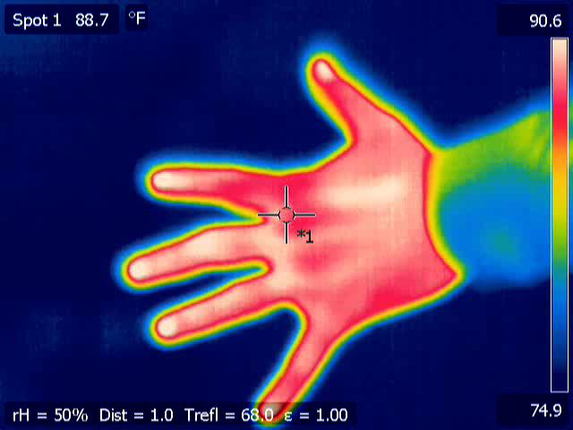
Alex and Jarek Tuszynski (Own work) [CC BY-SA 3.0 (http://creativecommons.org/licenses/by-sa/3.0)], via Wikimedia Commons.

Theme | Colour

b) Look through the rest of Jane Eyre wearing the thermal vision goggles. What pages do these themes appear on again?

Theme | Page number | Quotation

c) Look at the extract again and change the highlight to yellow where the theme of Jane’s religious views appears.
Clue
d) Choose a theme and trace its development through the novel using quotes.
Start with the development of Jane’s religious views.
Green = cold (undeveloped theme)
Yellow = warm (developing theme)
Red = hot (developed theme)
Write the quotes you’ve found in the relevant coloured boxes below.

Activity 3
a) Read the extract from Pride and Prejudice.
Highlight in green the parts of the text that relate to marriage.

b) Now read the McFarland-Richardson extract.
Highlight in red the parts of the text that are in the spirit of Jane Eyre and in green the parts that are in the spirit of Charlotte Lucas. Bear in mind who wrote the McFarland-Richardson text.
Write the quotations in the table below.
£

c) In pairs discuss the following:
To what degree would Charlotte Lucas and Jane Eyre approve of the wedding service between Abby Sage and Albert Richardson?
Use evidence from the three texts to support your answer.

Writing Activity
1. Write a short story in which Jane Eyre and Charlotte Lucas discuss the death-bed wedding of Abby Sage and Albert Richardson.
- You can use the extract from Elizabeth Cady Stanton’s autobiography to give you some ideas.

OR

2. Compare Abby Sage and Albert Richardson’s motives for marriage with Jane Eyre and Charlotte Lucas’s feelings about the subject.
- Use evidence from the three texts to support your answer.
- Remember that when a question asks you to compare, it also means contrast.

