Unit 2: Science for Engineering

LO4: Understand properties of materials

Force-extension graphs

Task 1
A force-extension graph shows the extension of a material with an increasing applied load. It can be used to determine and predict the properties of the material.

Materials can be classified as brittle, ductile and polymeric. These classes of material each possess different properties and have different force-extension characteristics.

Begin this task by watching the following video. The video shows automatic tensile testing of sample materials, including the production of force-extension graphs (described as force-elongation graphs in the video). It explains the characteristics that can be identified from the graph.

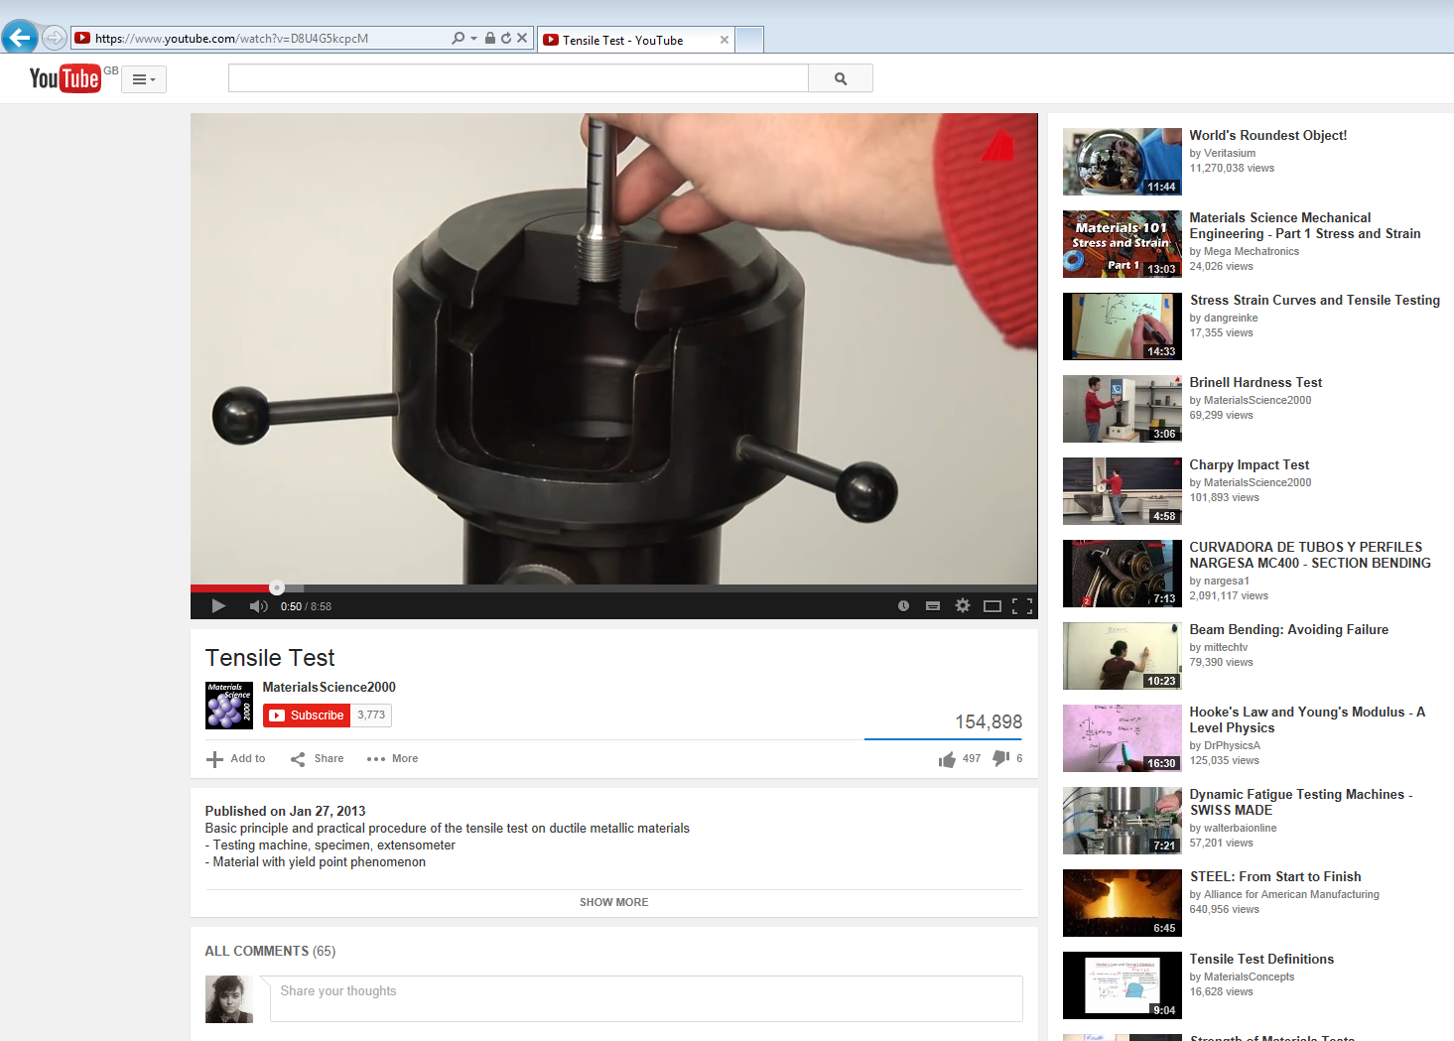

http://www.youtube.com/watch?v=D8U4G5kcpcM

Now explain the following terms (you may need to do some more research):

Term | Explanation
Force-extension or force-elongation graph
Extensometer
Gauge length
Yield Point
Elastic behaviour
Plastic behaviour
Breaking point
Tensile strength
Permanent strain after fracture

Task 2
The diagram below shows force-extension graphs for three different material types – brittle, ductile and polymeric.

- Identify which graph would typically relate to each type of material.

- Label on the graph for Material B:

- Elastic region
- Yield point
- Plastic region
- Breaking point

- Complete Task 2 by filling in the following table:

Material | Type of material  (brittle/ductile/ polymeric) | Examples of this type of material | Properties (referring to force-extension graph)
Material A
Material B
Material C

