Checkpoint Task

Particles, Atoms and Elements

Instructions and answers for teachers

These instructions cover the student activity section which can be found on page 9. This Checkpoint Task should be used in conjunction with the KS3–4 GCSE (9-1) Gateway Science Chemistry A and Twenty First Century Science Chemistry B Transition Guide: Particles, Atoms and Elements, which supports OCR GCSE (9-1) Gateway Science Chemistry A and Twenty First Century Science Chemistry B.
When distributing the activity section to the students either as a printed copy or as a Word file you will need to remove the teacher instructions section.

Introduction
This activity provides a check to see if the concepts of atoms and the periodic table taught at KS3 have been fully understood by students. It consists of 15 multiple choice questions giving the students the opportunity to show their understanding of element classification and the structure of the atom.
ABC – This activity offers an opportunity for English skills development.
Put a tick in the box next to the correct answer for each question.
Question 1
How many protons does Lithium have?

4

7

10

3

Question 2
Which element has two electrons in its first shell and four in the next shell?
Nitrogen


Carbon

Berylium

Fluorine

Question 3
Which is group 1 on the periodic table?

Alkali metals

Halogens

Noble Gases

Transition metals
Question 4
How many neutrons does Fluorine have?

28

19

10


9

Question 5
Which is not found in the middle of an atom?

Protons

Nucleus

Neutrons

Electrons

Question 6
Which is not a Noble Gas?

Argon

Neon

Bromine

Helium
Question 7
Which is in the same group as Magnesium?
Calcium


Iron

Carbon

Potassium

Question 8
Which has a positive charge?
Neutron

Electron

Protons

Nucleus

Question 9
Roughly how many elements are on the periodic table?

100

200

300

900

Question 10
How many electrons can the first shell hold?

2

4

8

10

Question 11
Which element has a total of 32 protons and neutrons?

Aluminium

Sulphur

Sodium

Germanium

Question 12
Which element is a Noble gas found in balloons?

Neon

Oxygen

Argon


Helium

Question 13
Which of the following is not a compound?
Carbon Dioxide

Sodium Chloride

Nitrogen

Water

Question 14
Which is not a transition metal?

Zn

Hg


Sn

Rh

Question 15
Which atom is the smallest non-metal?

Lithium

Helium

Boron


Hydrogen

Quiz follow on
Nucleus
Electron
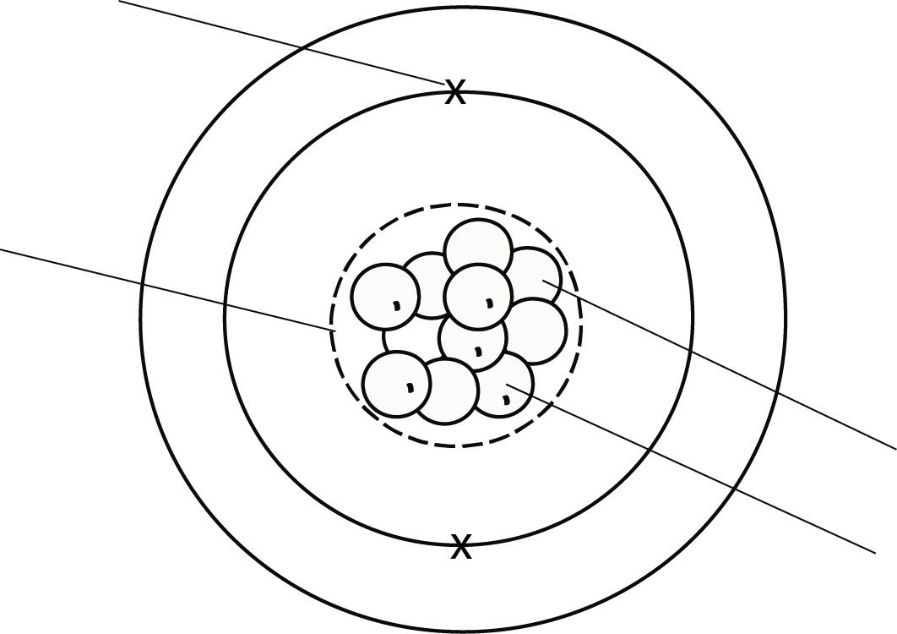
Proton
Neutron

- Label the diagram with the following words:

Proton Neutron Nucleus Electron
- Complete the sentences:

- The element in the picture is
Boron

three
- The element is in group on the periodic table.

- Is this the same group as Be or Al or C?
Same as Al.

- What is the atomic mass of this element?
Mass of 11.

- Complete the diagram by adding more electrons in the correct place.
Further three electrons added to the outer shell.

- Explain whether you think the element is a metal or a non-metal.
It is a non-metal even though other elements in the group are metals and metalloids.

We’d like to know your view on the resources we produce. By clicking on ‘Like’ or ‘Dislike’ you can help us to ensure that our resources work for you. When the email template pops up please add additional comments if you wish and then just click ‘Send’. Thank you.
Whether you already offer OCR qualifications, are new to OCR, or are considering switching from your current provider/awarding organisation, you can request more information by completing the Expression of Interest form which can be found here: www.ocr.org.uk/expression-of-interest
Looking for a resource? There is now a quick and easy search tool to help find free resources for your qualification:
www.ocr.org.uk/i-want-to/find-resources/

OCR Resources: the small print
OCR’s resources are provided to support the delivery of OCR qualifications, but in no way constitute an endorsed teaching method that is required by the Board, and the decision to use them lies with the individual teacher. Whilst every effort is made to ensure the accuracy of the content, OCR cannot be held responsible for any errors or omissions within these resources.
© OCR 2017 - This resource may be freely copied and distributed, as long as the OCR logo and this message remain intact and OCR is acknowledged as the originator of this work.
OCR acknowledges the use of the following content: n/a
Please get in touch if you want to discuss the accessibility of resources we offer to support delivery of our qualifications: resources.feedback@ocr.org.uk

Checkpoint Task

Particles, Atoms and Elements

Learner Activity

Put a tick in the box next to the correct answer for each question.
Question 1
How many protons does Lithium have?

4

7

10

3

Question 2
Which element has two electrons in its first shell and four in the next shell?
Nitrogen

Carbon

Berylium

Fluorine

Question 3
Which is group 1 on the periodic table?

Alkali metals

Halogens

Noble Gases

Transition metals

Question 4
How many neutrons does Fluorine have?

28

19

10

9

Question 5
Which is not found in the middle of an atom?

Protons

Nucleus

Neutrons

Electrons

Question 6
Which is not a Noble Gas?

Argon

Neon

Bromine

Helium

Question 7
Which is in the same group as Magnesium?
Calcium

Iron

Carbon

Potassium

Question 8
Which has a positive charge?
Neutron

Electron

Protons

Nucleus

Question 9
Roughly how many elements are on the periodic table?

100

200

300

900

Question 10
How many electrons can the first shell hold?

2

4

8

10

Question 11
Which element has a total of 32 protons and neutrons?

Aluminium

Sulphur

Sodium

Germanium

Question 12
Which element is a Noble gas found in balloons?

Neon

Oxygen

Argon

Helium

Question 13
Which of the following is not a compound?
Carbon Dioxide

Sodium Chloride

Nitrogen

Water

Question 14
Which is not a transition metal?

Zn

Hg

Sn

Rh
Question 15
Which atom is the smallest non-metal?

Lithium

Helium

Boron

Hydrogen

Quiz follow on

- Label the diagram with the following words:

Proton Neutron Nucleus Electron

- Complete the sentences:

- The element in the picture is

- The element is in group on the periodic table.

- Is this the same group as Be or Al or C?

- What is the atomic mass of this element?

- Complete the diagram by adding more electrons in the correct place.

- Explain whether you think the element is a metal or a non-metal.

