Topic Exploration Pack

Area of Study 1: The Instrumental Music of Haydn, Mozart and Beethoven

Introduction 3
Area of Study 1: The Instrumental Music of Haydn, Mozart and Beethoven 3
Suggested activities 3
Learner activities 4
Listening Question 1: Mozart – Answers 5
Listening Question 2: Mozart Symphony No.35 K.385 in D major The Haffner 7
Listening Question 3: Beethoven – Answers 9
Listening Question 4: Haydn 12
Listening Question 4: Haydn – Answers 13
Online resources 15
Books 16
Appendices 17
Mozart Symphony No.35 K.385 in D major The Haffner 17
Beethoven Piano Concerto No.3 in C minor Op.37 Movement 3: Rondo 20
Student activity………………………………………………………………………………………… …..24
Listening Question 1: Mozart – Learner Sheet 24
Listening Question 2: Mozart Symphony No.35 K.385 in D major The Haffner 26
Listening Question 3: Beethoven – Learner Sheet 27
Listening Question 4: Haydn – Learner Sheet 30

Instructions and answers for teachers

These instructions cover the student activity section which can be found on page 24. This Topic Exploration Pack supports OCR A Level Music.
When distributing the activity section to the students either as a printed copy or as a Word file you will need to remove the teacher instructions section.

Introduction

Area of Study 1: The Instrumental Music of Haydn, Mozart and Beethoven
Symphony, Concerto and Sonata as found in the music of Haydn, Mozart and Beethoven
The period of music from 1750-1830, as represented by the music of Haydn, Mozart and Beethoven, has long been the focus of attention by students of music. The instrumental music composed during this time allows detailed consideration to be given to a large number of important musical ideas that shape the understanding of works composed both before and after this era.
The music of this period shows a certain level of consistency in the use of tonality. Working alongside students’ work in composition, the analysis of functional harmony, including primary and secondary triads, their inversions, cadences and modulations are all an integral part of this music. This knowledge will then form a foundation for understanding secondary dominants and the chromatic chords used by composers at this time.
Students also encounter or deepen their understanding of sonata form. It is important here to understand tonal implications establishing, leaving and returning to a key centre and the possibilities opened up by motivic development. They are then in a position to understand how composers take the sonata principle and use it in specific contexts, namely the first movements of concertos, in abridged form in slow movements and amalgamated with the rondo in last movements. On a smaller scale, the use of periodic phrase structure, that learners will be familiar with from GCSE, can now be broadened out to consider where composers stretch phrases.
1750-1830 was a time of growth for the orchestra. The understanding of such matters as the standard layout of an orchestral score, the common use of different instruments in an orchestral texture and transposing instruments all have their place in the study of music of this time.
The piano also began its ascendancy as the keyboard instrument, par excellence. Consider the instruments of the time; their range, tone quality, the variety of sustaining mechanisms available and the range of instruments.
The comparison of recordings on period and modern instruments as a means of encouraging students to develop their aural perception as well as to enable them to take greater care with their own performances.

Suggested activities
Students may be familiar with sonata form from GCSE, but a revision of the basic plan and the names of the sections, the key relationships and the shape of a movement in this form is an important starting point at the beginning of the A Level course.
The first movement of a piano sonata, by Mozart or Haydn or Eine kleine Nachtmusik, may be useful starting points as they are short, making it easier for learners to memorise and visualise where they are in the form.
Students will then be in a clearer position to deal with variants such as the specific use of sonata form in the first movement of a concerto, where the orchestral introduction does not modulate, abridged sonata form found in some slow movements and the sonata-rondo used in some last movements.
Since modulation to related and unrelated keys is of primary importance in sonata form, a revision of key signatures and the circle of fifths will also form an important element in the study of musical techniques and links very clearly with this Area of Study. Some students imagine that when music modulates, there will be a new key signature. And of course, there rarely is.
Many candidates require help to establish the key of the music at any given point. They may be helped by:
- Establishing the original key from the key signature
- Looking for a consistent use of a particular accidental
- Looking for key-clinching perfect cadences at the end of phrases.
In an orchestral score, it is best to start with the string parts, since aside from the viola part, students will be dealing only with the treble and bass clefs and will not be faced with transposing instruments.
The study of the symphony and concerto means that learners must become competent following an orchestral score and interpreting the musical information being communicated. For candidates who begin the A Level course without experience of doing this, repertoire for smaller numbers of instruments may be useful. Mozart Violin Concertos No.3-5 are scored for solo violin, two oboes, two horns and strings, for example. Some candidates may appreciate following the score of a string quartet as a preparatory exercise to this. Free online score and recording libraries make it a possibility for learners to undertake listening with a score outside lesson time.
Transposing instruments also provide a challenge for many candidates. A familiarity with intervals is necessary here. The phrase, 'See a C, hear a -, ' can be useful. It can be consoling for learners to realise that since horns and trumpets rarely stray from the harmonic series, if they can accurately transpose C,E and G to the correct letter and octave, they will have most of the notes dealt with. Clarinet and viola parts give more scope for practice. For some candidates, it can be useful to play individual lines on the piano, or another instrument. This also helps in experiencing a piece of music from the perspective of the individual player; something that is very helpful when composing.

Learner activities
Ask learners to complete the Worksheets that follow. Links are provided where the specific full scores used can be found and downloaded.

Listening Question 1: Mozart – Answers
- This movement comes from a symphony by Mozart. Which of the four movements of a symphony is it most likely to be?
Second movement
Tempo indication Andante

- What is the structure of this movement?
Binary
Ternary
Rondo
Through-composed
Binary - according to the repeat marks

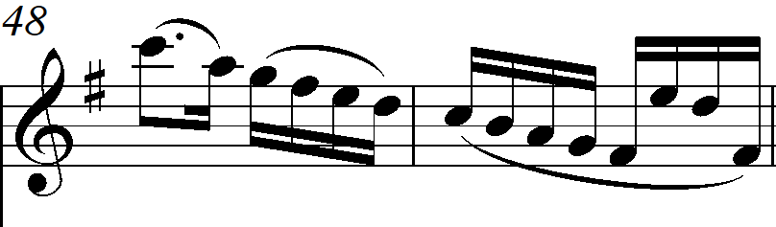
- On the score, complete the violin melody from bar 5 to the end of bar 8. The rhythm of this passage is indicated above the stave. (Score starts on page 28.)

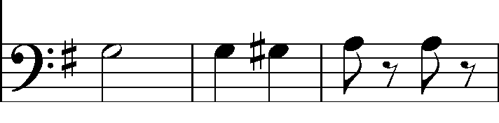
- On the score, complete the bass line played by the 'cello from bar 29 to the end of bar 31. The rhythm of this passage is indicated above the stave. (Score starts on page 28.)
Dominant pedal
- What device is heard in the bass from bar 12 to bar 16?
- Which of the following devices is heard in the woodwind in bars 9 and 10?
Acciaccatura
Appoggiatura
Passing note
Suspension
Appoggiatura - an unprepared accented dissonance, which here resolves downwards by step. Both oboe and bassoon entries make a minor ninth with the bass.
- What type of cadence occurs from bar 15 to 16?
Imperfect
Interrupted
Perfect
Plagal
Imperfect Ic V
Syncopation
- What rhythmic device is used in the upper strings in bars 36-41?

- Compare bars 66-70 with bars 17-21. What are the similarities and differences between these two passages?
The music is the same, but transposed up a perfect 4th, from D major (the dominant) to G major (the tonic). This corresponds to the appearance of the second subject of a sonata form being heard in the tonic in the recapitulation.
- The following chords are used in the section from bar 79-82 beat 1:
I(G)
Ic(G/D)
II7b(Am7/C)
V7 (D7)
On the score indicate where these chords occur.
bar 79 II7b, bar 80 Ic, bar 81 V7 ( 4-3), bar 82 I

Listening Question 1 Additional teacher guidance: Mozart Symphony No.35 K.385 in D major
The Haffner
This symphony was first performed in 1782 and is named after a prominent Salzburg family. It was originally the Haffner Serenade, which Mozart reworked on the occasion of the ennoblement of Sigmund Haffner.
Movement 2: Andante

A score may be found at:
http://imslp.org/wiki/Symphony_No.35_in_D_major,_K.385_(Mozart,_Wolfgang_Amadeus)
A number of harmonic devices are used by Mozart in the opening passage.
Bars 9-12 sees a descending chromatic line in the first violin part, harmonised using the circle of fifths.
Bar 9 and 10 contain interjections from Oboe I and Bassoon 1. Both entries are appoggiaturas - unprepared, accented dissonances which resolve here, downwards by step and in both cases the appoggiatura is a minor ninth above the bass.
Bar 11 beat 2 is a diminished 7th. The C sharp in the bass is a very common harmonic turn. (Moving through the leading-note of the dominant key, when ending a phrase on an imperfect cadence.)
Bar 12-16 a dominant pedal in the violas, cellos, basses and horns.
Horns in G, sound a perfect 4th lower than written.
The harmony here alternates between V and Ic and is therefore an example of the auxiliary 6/4.
Texture
The opening twelve bars could serve as a useful example for candidates learning to score their compositional ideas. A lyrical melody in the violin I is accompanied by an arpeggio figure in Violin II. The violas, cellos and bass initially follow the melody, but in bars 5 and 7 play a descending arpeggio.
In bar 11, where the semiquavers cease in the Violin II part, they are taken up by the woodwind, so the rhythmic momentum is sustained.
In bar 12 the melody is played in octaves by the violins and the semiquaver pattern is taken up by the bassoons.
This movement is an example of abridged sonata form.
Exposition bars 1-35
First subject bars 1-16 Tonic G major.
Second subject bars 17-35 Dominant D major.
'Development' Section bars 36-49
Instead of a development section, there are chorale-like chords in the wind against, syncopated upper string chords and quaver bassline.
Recapitulation bars 50-84
First subject bars 50-65 Tonic G major.
Second subject bars 66-84 Tonic G major.
There is also a shift briefly to the subdominant, C major, from bars 71-77.

Listening Question 2: Beethoven – Answers

Beethoven Piano Concerto No.3 in C minor Op.37 Movement 3: Rondo
This extract comes from the last movement of a piano concerto by Beethoven. This extract can be found on page 30.
- Which movement in a three movement concerto do you think that this comes from?
Give two reasons for your answer.
Rondo, fast tempo, piano plays solo at the opening.
C minor
- In which key does this extract begin?

- Bars 1-8 are repeated by the orchestra in bars 9-16. Describe how this theme is orchestrated in bars 9-16.

- The following chords are used in the section from bar 142-161 where the music is in G minor.
I (G minor)
Ic (Gm/D)
IVb(Cm/Eb)
V7(D7)
On the score indicate where these chords occur.
Chords 15-16 Cadencial 6/4 in G minor

- Bar 26 is an example of what type of music for the solo instrument in a concerto?
Cadenza

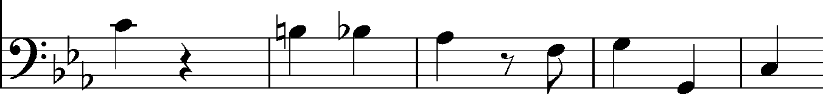
- On the score, write down the bass part from bars 28-32.
A dominant pedal in octaves.
Horns in Eb transpose down a major 6th: see a C, hear and Eb.
- Which device is found in the horns in bars 27-29?
First and second violins play G semiquavers in octaves.
Chords in bars 56 and 60
C minor, F minor
- This same device is found in bars 42-46. How does Beethoven use it differently?
E flat major
- What key is the music in at bar 68?

- What is the relationship with the key at the opening of the movement?
Relative major
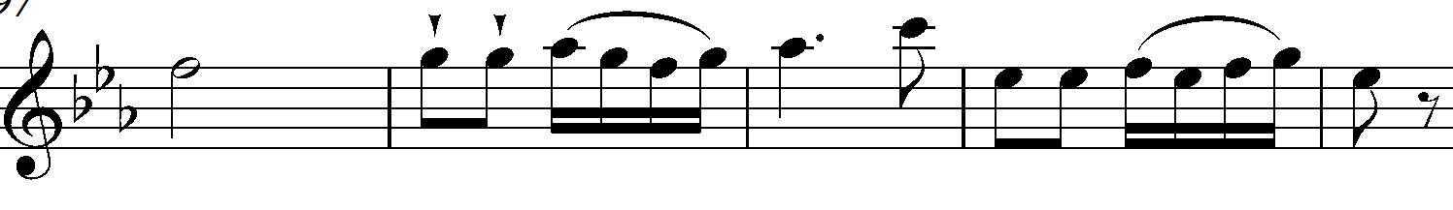
- On the score, write down the bass part from bars 79-83¹.
- What melodic device is used in the woodwind from bars 83-5?
Syncopation
Bar 56 ascending arpeggios – hand a 10th apart
Bar 68 monophonic right hand melody
Bar 70 2 part contrapuntal texture
Bar 83 right hand triplet quaver ascending figure, Eb pedal in left hand
Bar 87 triplet semiquavers in both hands
bar 91 descending melodic sequence in right hand
bar 922 sequence continues in 8ves
bar 97 melody in right hand featuring octave displacement, left hand off-beat quaver chords
- Describe the piano textures in the section from bars 56-101.

Additional teacher notes
A full score may be found at:
http://petrucci.mus.auth.gr/imglnks/usimg/d/d0/IMSLP01285-Piano_Concerto_No._3_in_C_Minor__Op._37-III._Rondo__Allegro.pdf
This concerto was first performed in 1803, with the composer as soloist.
The last movement of concertos in this period are often rondos, which may display elements of sonata form. That is, they contain passages of development of motivic material and also a sense of recapitulation.
Other examples of concertos that end with rondos include Mozart Piano Concerto No.23 K.488, Beethoven Violin Concerto, Mozart Clarinet Concerto and all four Mozart Horn Concertos.
BBC Discovering Music Beethoven Piano Concerto No.3, Steven Johnson explores the concerto in detail.

Listening Question 3: Haydn
These activities are based on the first movement of Haydn Piano Sonata in G Hob.XVI:27 (number 42 according to H.C. Robbins-Landon).
The date of composition is given as 1776.
A score, in the public domain in the EU, may be found at http://IMSLP.org:
http://imslp.org/wiki/Keyboard_Sonata_in_G_major,_Hob.XVI:27_(Haydn,_Joseph)
There are a number of recordings of this sonata on YouTube, some of which use the fortepiano.

Suggested activities
- This movement provides examples of a number of very common features of piano writing in this period.
After revising or teaching learners the trill, turn, mordent and acciaccatura, students could be provided with a copy of the first page of the score with the ornaments removed and be asked to write them in, whilst listening to a recording.
The first page uses, turns (b.1), trill (b.8) mordents (b.10), and acciaccatura (b.22)
For learners who need practice following a score, this would also provide support in this area.
- The development section
Learners will need a copy of the first movement of this sonata to answer the questions.
Learners sometimes struggle to hear how the music in a development section sounds or feels, particularly different from the more thematically and tonally stable outer sections of a movement in sonata form. This work provides an example of a development section that is sufficiently contrasted with the outer sections to make the difference in writing apparent and yet sufficiently straightforward that notions of motivic development, tonal instability and so forth can be assimilated.

Additional teacher notes
Other features of piano writing or musical style that this work provides useful examples of include:
- Contrary motion b. 31
- Alberti bass beginning in b.26
- Sturm und Drang The suggested date of composition place this work at a point in time when the ‘Storm and Stress’ movement was still exerting an influence. The exposition ends in a harmonically content D major, marked piano. In contrast, the development section is marked forte, contains a number of chromatic chords, a striking arpeggio figure as the main melodic interest and some angular descending leaps of a diminished 7th (b.59-60.)

Listening Question 3: Haydn – Answers
This question is based on the first movement of a piano sonata by Haydn, which he wrote in the 1770s.
The development section of this movement is from bar 59-87.
This passage starts after a repeat mark and expositions in this era are usually repeated.
The dynamic marking is forte in contrast to the piano in the previous three bars.
It is in a different key.
- How do we know that it starts in bar 59²?
The music comes to a halt on the dominant 7th chord of G major, the tonic.
There is a pause.
When the music begins again it is in G major and the first subject is played.
- How do we know that it ends in bar 87¹?

- In the development section of a movement in sonata form, the composer uses motifs from the exposition.
Where does Haydn take these motifs from?
Based on which ideas in the exposition? Give bar numbers.
Idea in the development | Bar number
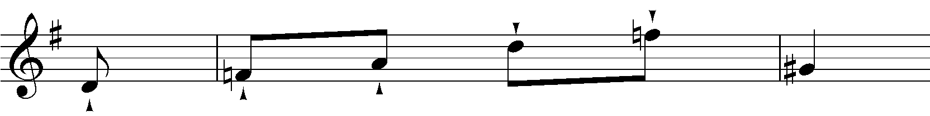 | Right hand bar 31
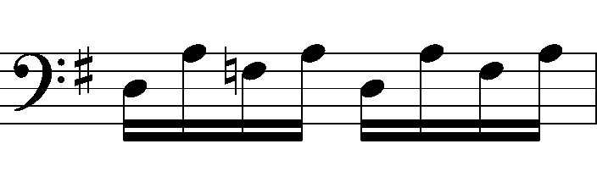 | Left hand bar 26
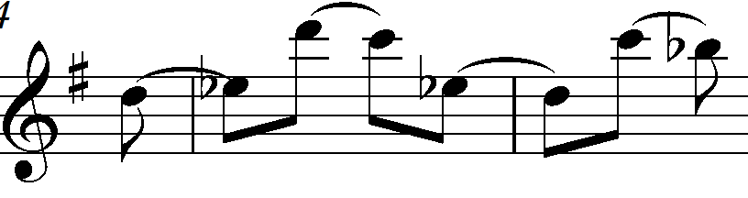 | Bar 37 right hand, pairs of tied quavers.
- What is the name given to this type of left hand figuration in the piano?
Alberti bass

- In a development section, the tonality and harmony are often very fluid. The music may not be settled in a particular key.
In this example Haydn alters the harmonic rhythm, that is how often the chord changes.
Complete the table to show how Haydn changes the harmonic rhythm.
 | Bar numbers
One chord every 2 bars | 59-71
One chord every bar | 72-80
One chord every beat | 81-83

- What effect does this change in the harmonic rhythm have?

- Name the chords in bars 69, 70, 83², 84¹ and 85² giving their inversion
Bar 69 B major 7, first inversion
Bar 70 E minor, root position
Bar 832 D major, first inversion
Bar 841 G minor, root position
Bar 852 D minor, first inversion

More advanced students may be interested in the Italian 6th in bar 72 and 85. We would expect that the augmented 6th would resolve outwards to an octave. In fact, in both cases, each note forming the augmented sixth chord descends by a semitone and is respelt as a dominant 7th.

Bars 72-3
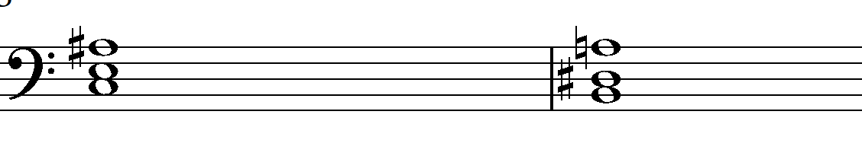
Diminished 7th
- What is the interval in 59-60, between F natural and G sharp?

- Give three other ways that Haydn makes the development section sound very different from the exposition and recapitulations.
- Haydn uses a continuous semiquaver Alberti bass for the whole of the development section.
- The right hand melody consists entirely of quavers, apart from bar 862.
- Haydn makes use of very short phrases, compared to the exposition and recapitulation.

Online resources
http://imslp.org/ provides a huge free library of scores and recordings.
http://www.naxosmusiclibrary.com/ Naxos Music Library. Requires a subscription to be paid.
https://www.youtube.com/ YouTube recordings and live performances. Live performances have the advantage of allowing learners to see the instruments that they are hearing, the standard seating positions within an orchestra, many significant performance venues, some of which date to the time of the period under study. Seeing and hearing a performance makes the experience far more engaging for learners.
Eine kleine Nachtmusik – a useful introduction to the musical style of this period
http://www.bbc.co.uk/programmes/p02306mb
Sonata Form BBC Bitesize – aimed at GCSE, but useful also for AS and A Level students.
http://www.bbc.co.uk/schools/gcsebitesize/music/western_tradition/sonata2.shtml
http://www.bbc.co.uk/programmes/b006tn54 BBC Radio 3 Discovering Music. A wealth of archived programmes, many of which are about individual works from this topic.
BBC Series The Symphony, Episode 1: Genesis and Genius, features the work of Haydn, Mozart and Beethoven. First broadcast 3rd Nov 2011. It reappears on iPlayer periodically.

http://www.oae.co.uk/ The Orchestra of the Age of the Enlightenment website contains information about instruments in this era and often produces short informative films on repertoire and performance practice.
http://www.theguardian.com/music/series/50-greatest-symphonies
Tom Service's series of blogs for The Guardian on the top fifty symphonies includes:
- Haydn Symphony No.102
- Mozart Symphonies No. 38 and 41
- Beethoven Symphonies No. 3, 6 and 9
http://www.philharmonia.co.uk/explore/films/listening_guides
Short films exploring:
- Beethoven Symphony No.5
- Beethoven Piano Concerto No.5
- Haydn Symphony No.6
http://lso.co.uk/video-player
A Level Seminar 2012: Mozart Piano Sonata in Bb major
A Level Music Seminar 2013 Overview of musical styles part II: Classical and Romantic periods
Also available from the LSO, videos of Beethoven Symphony No.6 movements 3 and 4, conducted by Bernard Haitink.

Books
Bennett, R. (1987). History of Music. Cambridge University Press. ISBN 9780521336819.
A useful starting point.

Appendices

Mozart Symphony No.35 K.385 in D major The Haffner
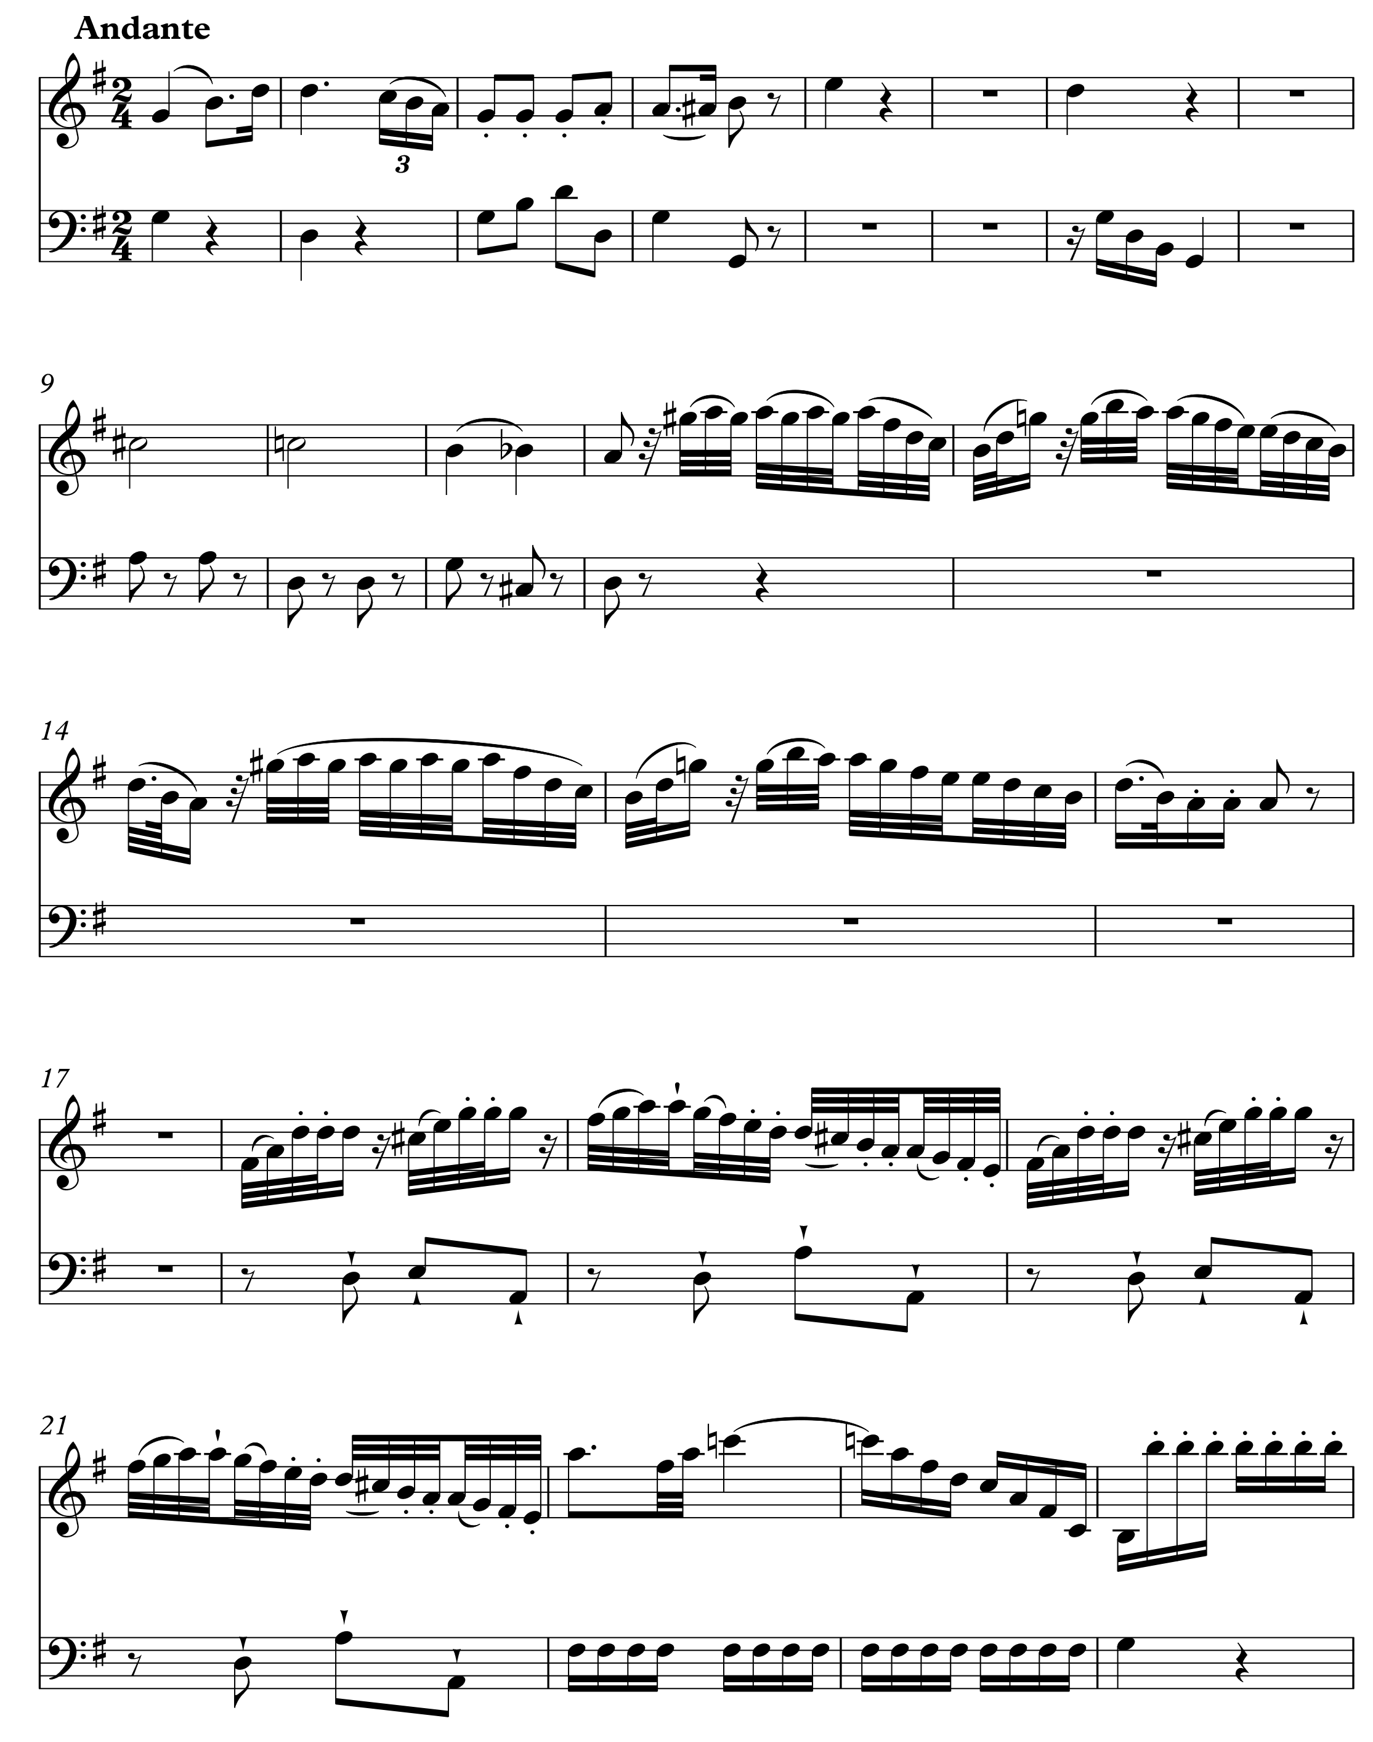
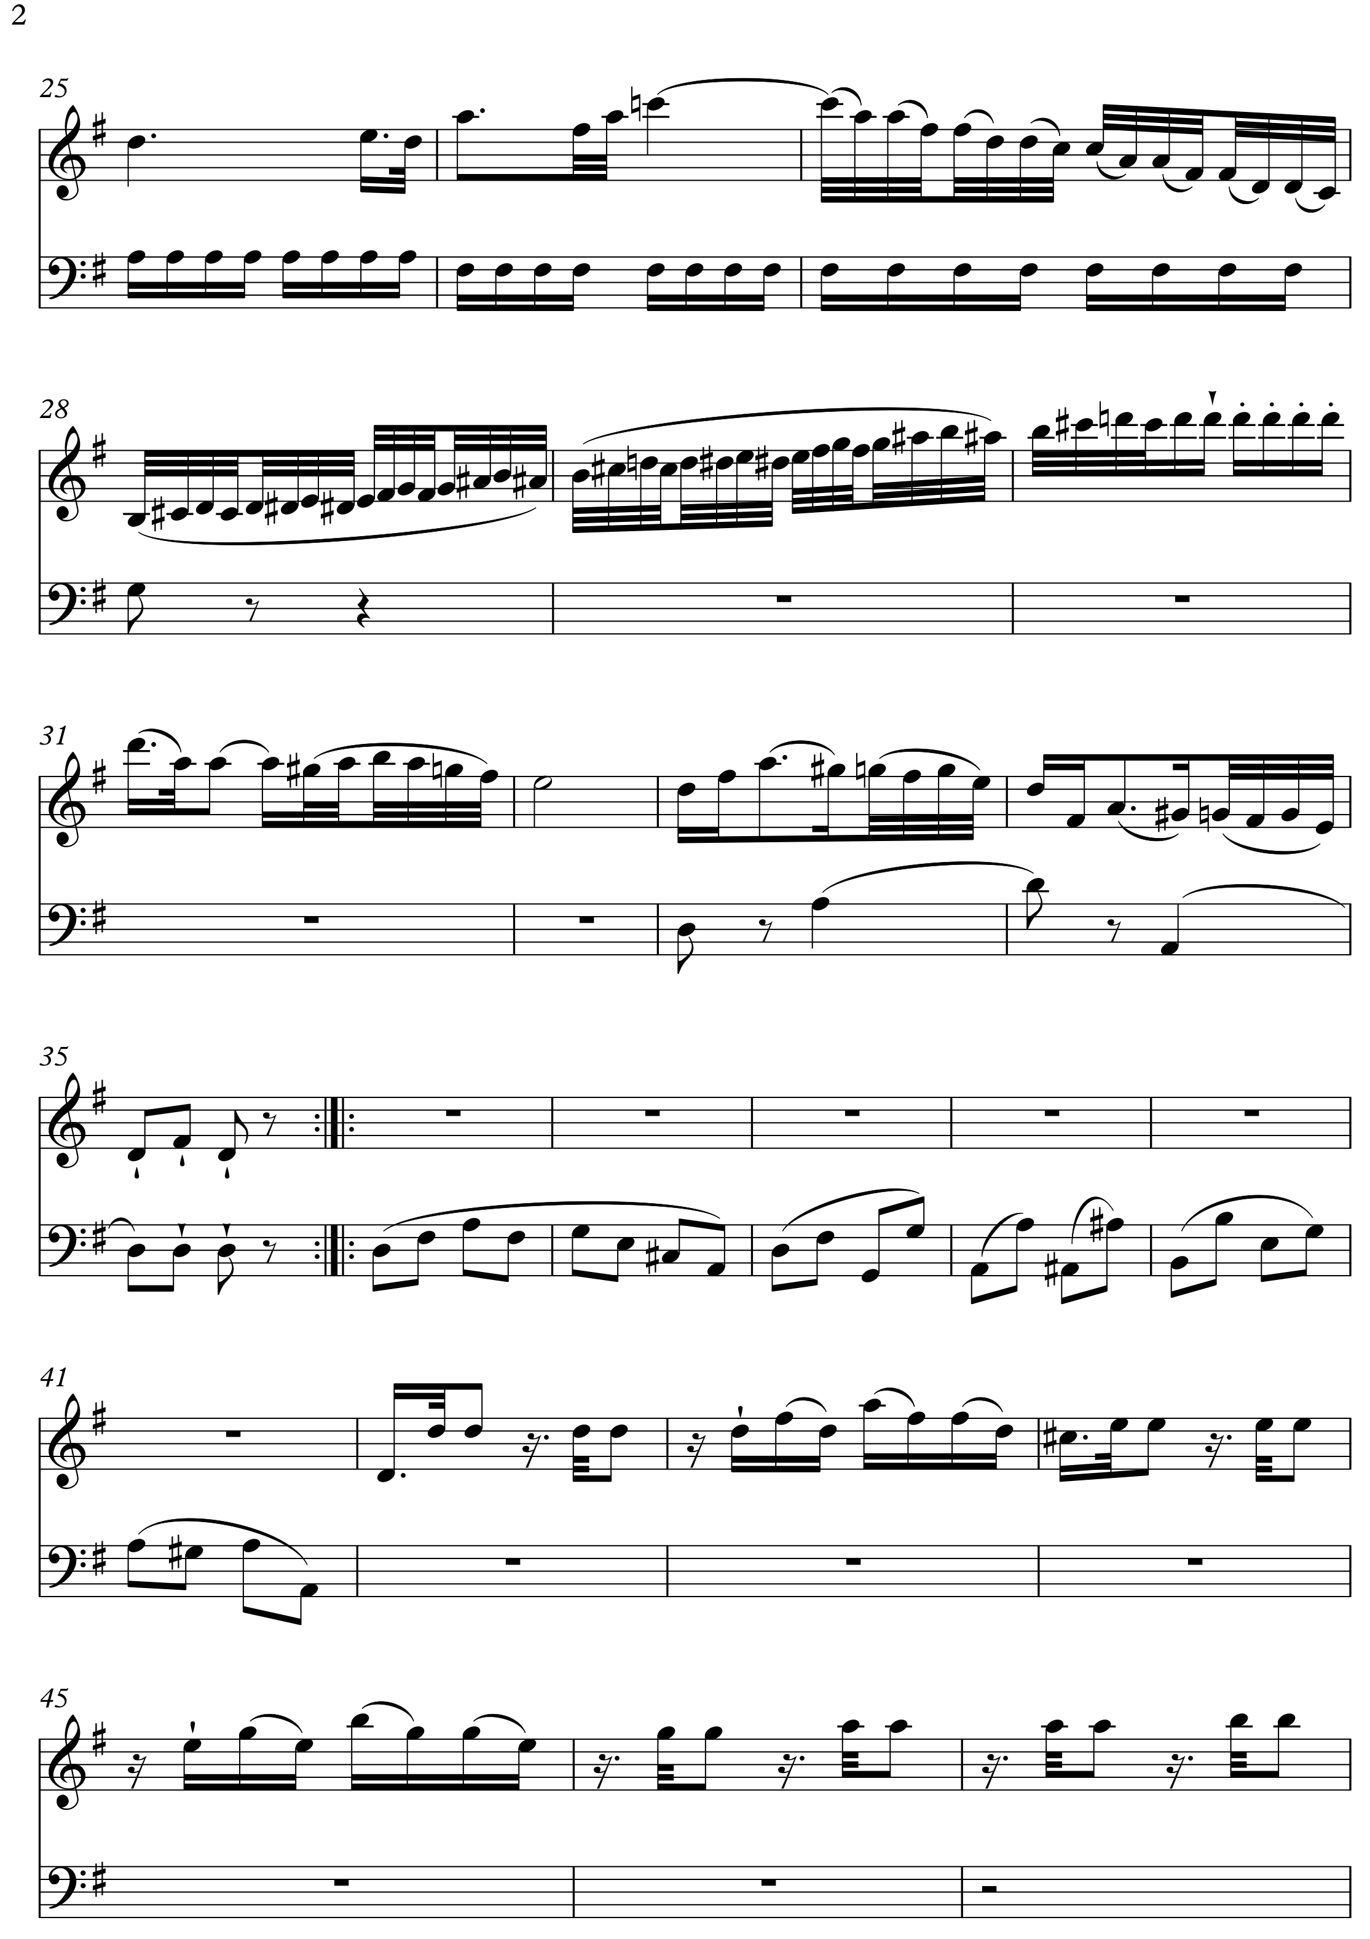
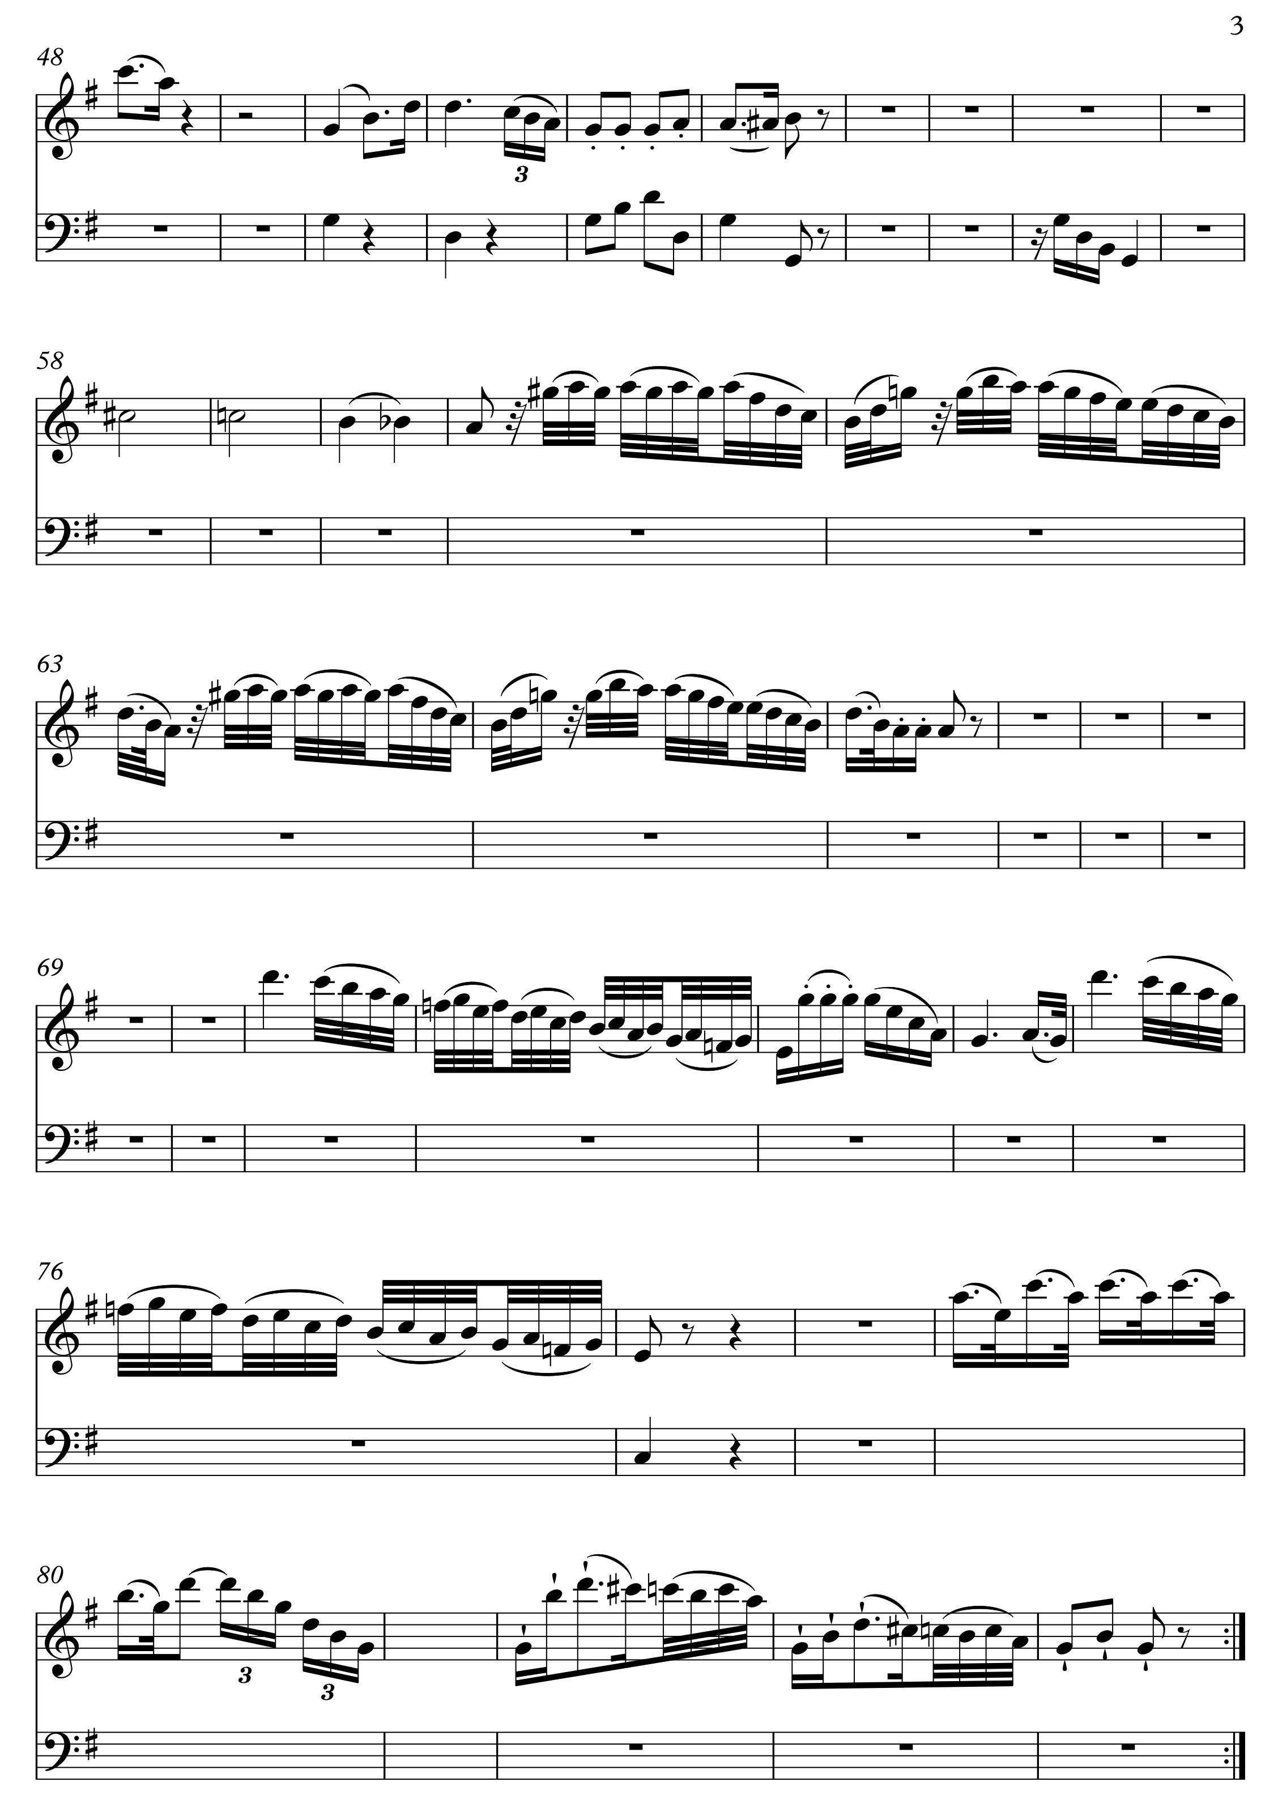

Beethoven Piano Concerto No.3 in C minor Op.37 Movement 3: Rondo

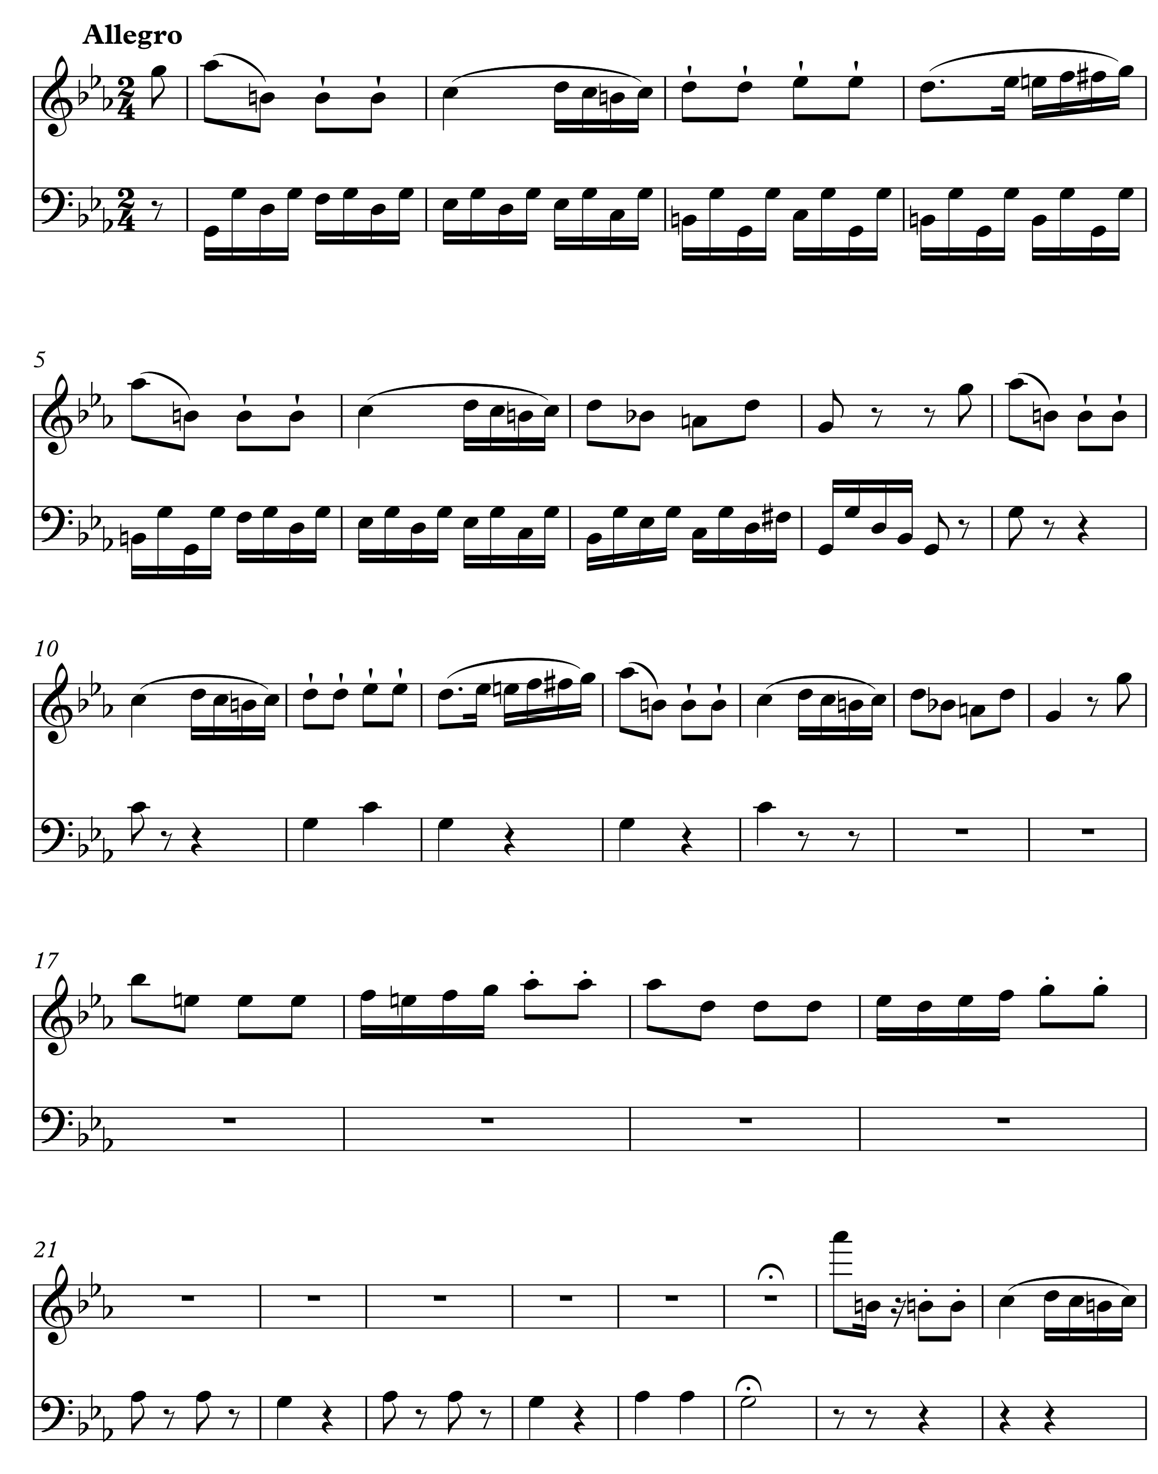
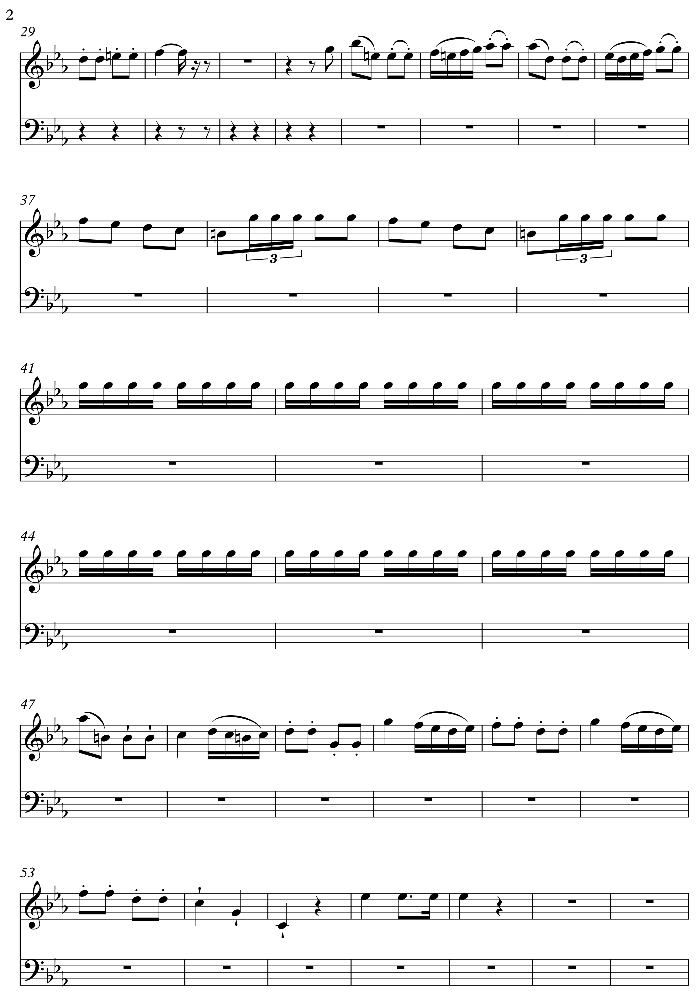
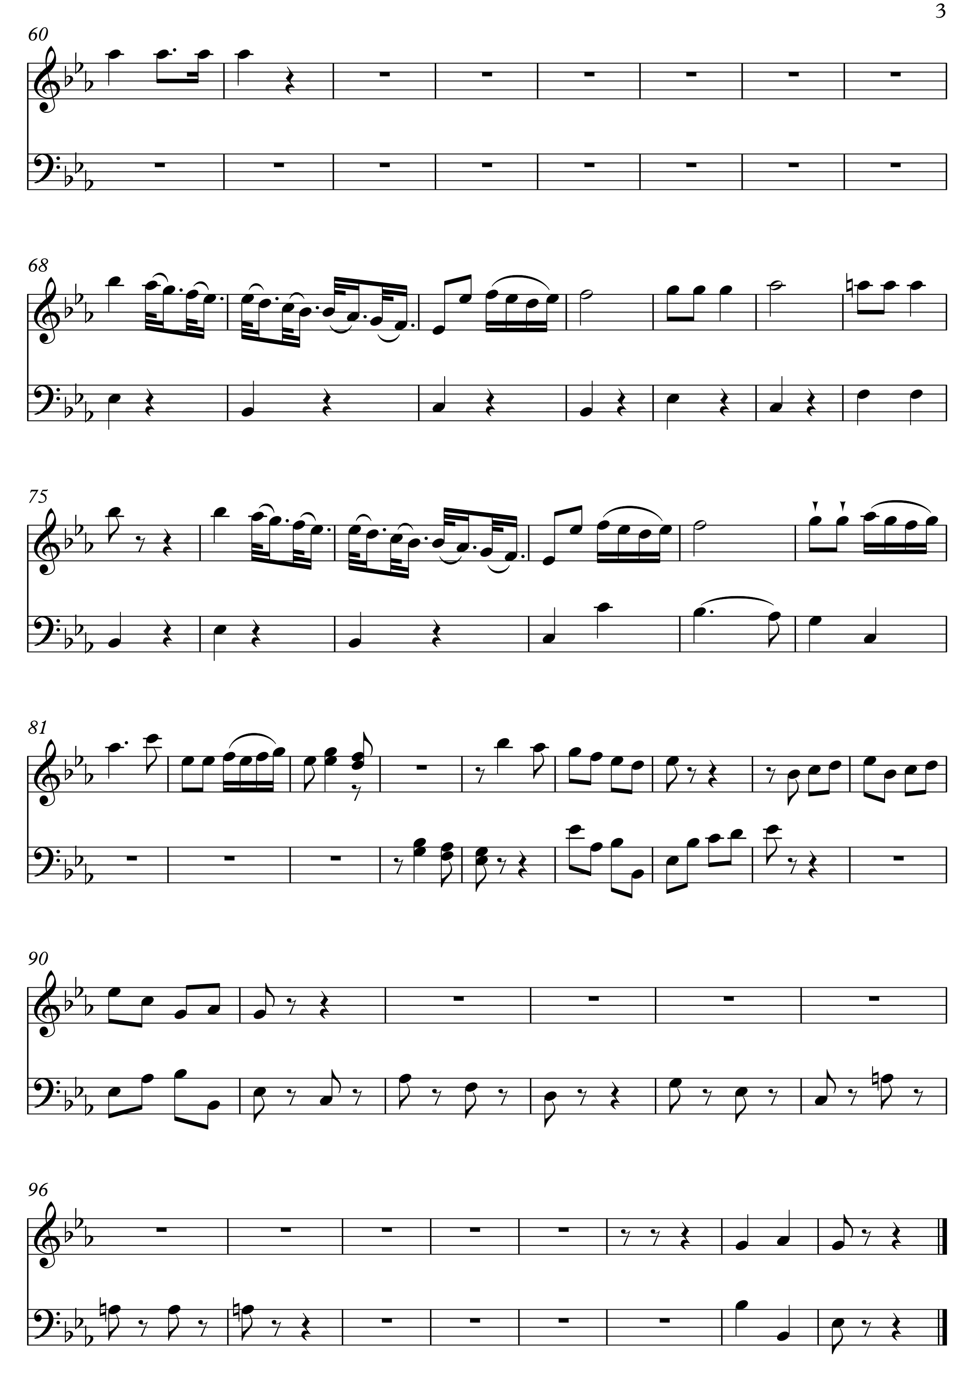
OCR Resources: the small print
OCR’s resources are provided to support the teaching of OCR specifications, but in no way constitute an endorsed teaching method that is required by the Board, and the decision to use them lies with the individual teacher. Whilst every effort is made to ensure the accuracy of the content, OCR cannot be held responsible for any errors or omissions within these resources.
© OCR 2016OCR 2017 - This resource may be freely copied and distributed, as long as the OCR logo and this message remain intact and OCR is acknowledged as the originator of this work.
OCR acknowledges the use of the following content: n/a
Please get in touch if you want to discuss the accessibility of resources we offer to support delivery of our qualifications: resources.feedback@ocr.org.uk
We’d like to know your view on the resources we produce. By clicking on ‘Like’ or ‘Dislike’ you can help us to ensure that our resources work for you. When the email template pops up please add additional comments if you wish and then just click ‘Send’. Thank you.
If you do not currently offer this OCR qualification but would like to do so, please complete the Expression of Interest Form which can be found here: www.ocr.org.uk/expression-of-interest

Topic Exploration Pack

Area of Study 1: The Instrumental Music of Haydn, Mozart and Beethoven

Student Activity

Listening Question 1: Mozart – Learner Sheet
- This movement comes from a symphony by Mozart. Which of the four movements of a symphony is it most likely to be?

- What is the structure of this movement?
Binary
Ternary
Rondo
Through-composed

- On the score, complete the violin melody from bar 5 to the end of bar 8. The rhythm of this passage is indicated above the stave.

- On the score, complete the bass line played by the 'cello from bar 29 to the end of bar 31. The rhythm of this passage is indicated above the stave.

- What device is heard in the bass from bar 12 to bar 16?

- Which of the following devices is heard in the woodwind in bars 9 and 10?
Acciaccatura
Appoggiatura
Passing note
Suspension

- What type of cadence occurs from bar 15 to 16?
Imperfect
Interrupted
Perfect
Plagal

- What rhythmic device is used in the upper strings in bars 36-41?

- Compare bars 66-70 with bars 17-21. What are the similarities and differences between these two passages?

- The following chords are used in the section from bar 79-82 beat 1:
I(G)
Ic(G/D)
II7b(Am7/C)
V7 (D7)
On the score indicate where these chords occur.

Listening Question 2: Beethoven – Learner Sheet

Beethoven Piano Concerto No.3 in C minor Op.37 Movement 3: Rondo
This extract comes from the last movement of a piano concerto by Beethoven.

- Which movement in a three movement concerto do you think that this comes from?
Give two reasons for your answer.

- In which key does this extract begin?

- Bars 1-8 are repeated by the orchestra in bars 9-16. Describe how this theme is orchestrated in bars 9-16.

- The following chords are used in the section from bar 142-161 where the music is in G minor.
I (G minor)
Ic (Gm/D)
IVb(Cm/Eb)
V7(D7)
On the score indicate where these chords occur.

- Bar 26 is an example of what type of music for the solo instrument in a concerto?

- On the score, write down the bass part from bars 28-32.

- Which device is found in the horns in bars 27-29?

- This same device is found in bars 42-46. How does Beethoven use it differently?

- What key is the music in at bar 68?

- What is the relationship with the key at the opening of the movement?

- On the score, write down the bass part from bars 79-831.

- What melodic device is used in the woodwind from bars 83-5?
- Describe the piano textures in the section from bars 56-101.

Listening Question 3: Haydn – Learner Sheet
This question is based on the first movement of a piano sonata by Haydn, which he wrote in the 1770s.

The development section of this movement is from bar 59-87.

- How do we know that it starts in bar 59²?
- How do we know that it ends in bar 87¹?

- In the development section of a movement in sonata form, the composer uses motifs from the exposition.
Where does Haydn take these motifs from?
Based on which ideas in the exposition? Give bar numbers.
Idea in the development | Bar number

- What is the name given to this type of left hand figuration in the piano?

- In a development section, the tonality and harmony are often very fluid. The music may not be settled in a particular key.
In this example Haydn alters the harmonic rhythm, that is how often the chord changes.
Complete the table to show how Haydn changes the harmonic rhythm.
 | Bar numbers
One chord every 2 bars | 59-
One chord every bar
One chord every beat | -83
- What effect does this change in the harmonic rhythm have?

- Name the chords in bars 69, 70, 83², 84¹ and 85² giving their inversion.

- What is the interval in 59-60, between F natural and G sharp?

- Give three other ways that Haydn makes the development section sound very different from the exposition and recapitulations.

