Be able to prepare a simple budget

Unit 2 – Learn about managing money

Task 1 – Sources of income

There is a range of sources of income that a person could have.

These are two sources of household income:

- Wage
- Pension.
Working in pairs, look at the following pie chart and answer the two questions below.

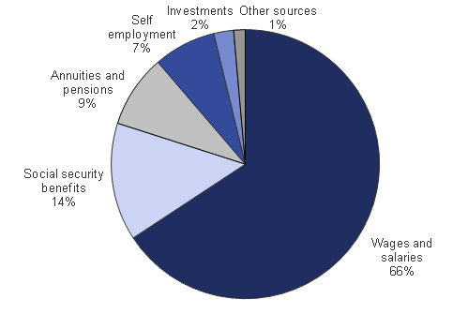

http://www.ons.gov.uk/ons/resources/figure14final2011v2_tcm77-284672.png

Question 1: What is the largest percentage of income?
______________________________________________________________________________
Question 2: What is the next largest percentage of income?
______________________________________________________________________________

Working in a small group, discuss and produce a mind map of the group’s own household sources of income.

Decide upon the four most common sources of household income and write these in the following diagram.

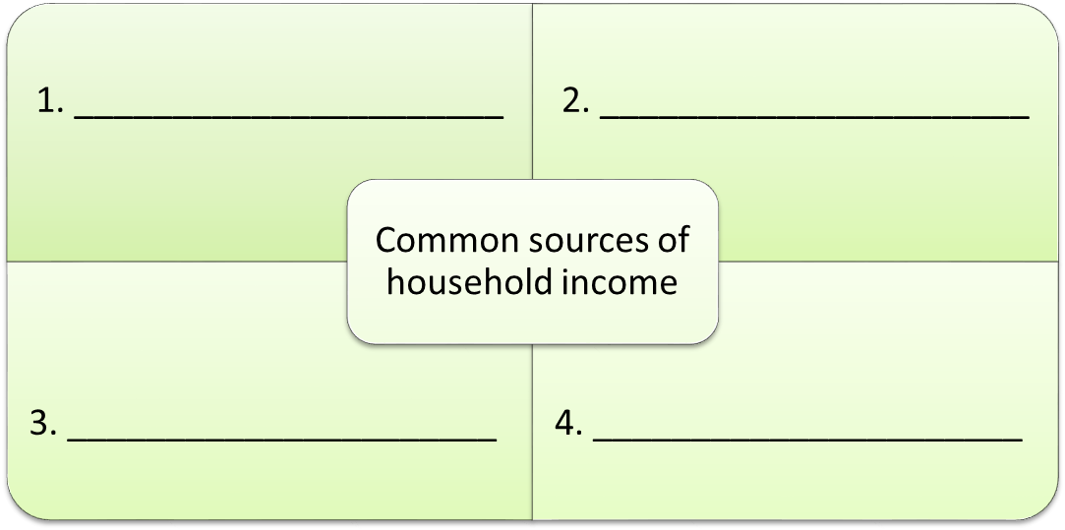

Feedback this information to the rest of the class.
Common Sources of
Household Income

Task 2 – Outgoings

The term ‘outgoings’ means money going out or money being spent.
This is a list of a person’s common outgoings:
- Travel
- Food
- Toiletries
- Rent or Mortgage
- Council tax.
Work in small groups to discuss people’s outgoings. Record the information in a spider-diagram and feedback your ideas to the rest of the class.
Now think about your own outgoings and complete the following ‘outgoings’ table.

My Outgoings
Rent/Mortgage | £
Council tax | £
Gas | £
Electricity | £
Water | £
Phone | £
Credit card | £
Loans | £
Insurance | £
Savings | £
Travel | £
Food | £
Childcare | £
Going out | £
Toiletries | £
Sport | £
Car maintenance and petrol | £
Clothes | £
Birthday presents | £
Other | £

Task 3 – Simple budgeting

To be good at managing money it is important to work out income, outgoings and money left over.
This is the calculation you need to use to work out what amount of money is left over.
Total income – Total spending = Money left over
If the money left over is a minus number then this means over-spending has happened.

Below is a copy of Sarah’s weekly budget planner. Work out Sarah’s total outgoings, total income and money left.
Weekly Budget Planner

Outgoings
Rent/Mortgage£ 20.00Council tax£ Gas£ 10.00Electricity £ 10.00Water£Phone£ 15.00Credit card£Loans£Insurance£Savings£Travel£ 12.00Food£ 20.00Childcare£Going out£ 18.00Toiletries£ 5.00Sport£ 5.00Car maintenance and petrol£Clothes£ 15.00Birthday presents£ 10.00Other£
Total spending
£
Name: Sarah Smith

Income
Wages£ 110.00Money from mum£ 20.00Total Income

Money left

Total income = £
minus

Total outgoings = £
equals

Money left = £

Has Sarah over-spent? YES or NO (circle the correct answer)
Now, complete a budget plan of your own, making use of the total spending amount in the ‘My outgoings’ table that you completed in Task 2. Tick (✓) the correct box to say whether you have money left over each week or if you are over-spending.

Weekly Budget Planner

Name: __________________________

Outgoings

Total spending£

Income
££££££Total Income£
Money left

Total income = £
minus

Total outgoings = £
equals

Money left = £

I have money left over each week

I am over-spending each week

