Topic Exploration Pack

Software Development

Activity 1: rapid prototyping and user feedback
Agile/spiral development model: Use VBA builder in Excel (press Alt+F11 once Excel is open; right-click to insert a Form) or Designer in App Inventor to create 3 prototype screens for a social network client mobile app – it will have all the relevant widgets and buttons, but wouldn’t actually do anything. Let a few classmates ‘test’ it and fill out this questionnaire, so that the best prototype is chosen.
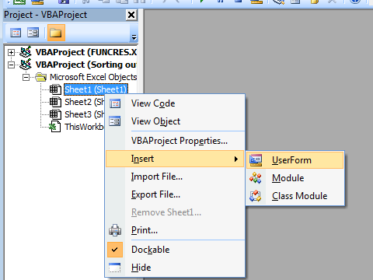
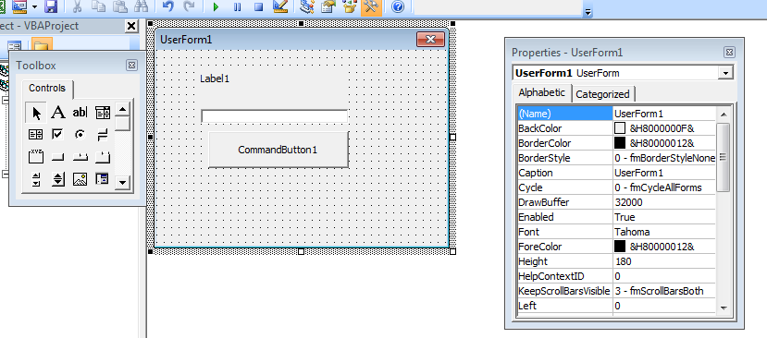

Name ______________ Prototype A/B/C (circle the correct one)
On the scale of 1–10 (1 being the least experienced and 10 being the most experienced), how would you rate your general confidence and experience with computers?
Are you a social network user currently?
What did you like about the prototype design?
What did you not like about the prototype?
On the scale of 1–5 (1 is ‘hate it’ and 5 is
‘love it’), how would you rate your overall experience with the interface?
On the scale of 1–5 (1 is ‘felt too small’ and 5 is ‘felt too large’), how would you rate the size of fonts?
On the scale of 1–5 (1 is ‘felt too small’ and 5 is ‘felt too large’), how would you rate the size of text boxes?
On the scale of 1–5 (1 is ‘felt too small’ and 5 is ‘felt too large’), how would you rate the size of buttons?
Did you feel at any point you didn’t know what an element did?

Activity 2: development model
Websites like https://www.kickstarter.com/ or https://www.indiegogo.com/ are used for crowdsourcing of a lot of rapidly prototyped products, software and hardware. Research five different software products currently on Kickstarter and comment on the best development model for them.
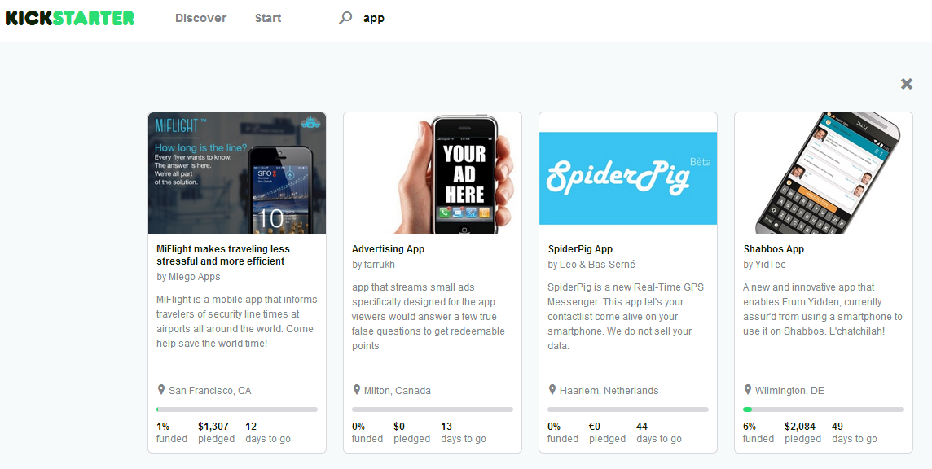

Activity 3: development and prototyping
Research into the following sites: http://jsbin.com/, http://codepen.io/, https://www.lucidchart.com –
what is the common purpose between the three?
Do Activity 1 again (on using Visual Basic for Applications or App Inventor) using these tools and
using the information given on the crowdsourcing sites (https://www.kickstarter.com/ and https://www.indiegogo.com/) write a letter to potential crowd investors who you would like to
pledge money towards your fundraising goal.
Do you see yourself doing something like this at some later date?

Activity 4: writing and following algorithms
Consider the game of 21 (Blackjack). The program will generate up to four cards for the user drawn
out from a deck, giving the user the option to stop when they think they got as close to 21 as possible. Then the program will generate the cards for itself, trying to exceed the user’s score but without going over 21. Picture cards are worth 10 and Ace can be worth either 1 or 11.
Create an algorithm (using Lucidchart or shapes in PowerPoint, for example, or pseudocode) for the game play, including the deciding of the winner.
Give this algorithm to another pupil who will give you their algorithm. Implement each other’s algorithm without modifying it – is their algorithm correct? Better than yours?

