Topic Exploration Pack

Systems Software

Activity 1: studying virtual CPUs
For each of the implementations below… | Briefly explain how software replaces some hardware/CPU functions | What was the rationale behind doing it this way?
Dalvik
Java virtual machine
QEMU
Amazon’s cloud servers
Microsoft Azure
DOSBox

Activity 2: reading BIOS
On a home laptop or a desktop, enter BIOS setup (the screen that comes up right as a computer is restarted). Briefly list all the options found and who would use such a feature (regular user, tech support, administrator, gamer, corporation, programmer …)
You might see something similar to this:
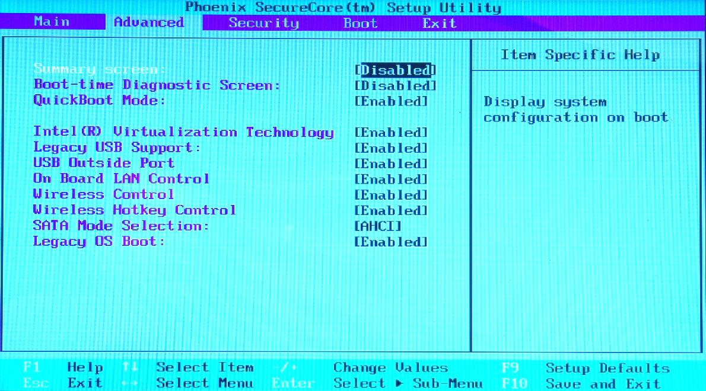

Feature | Used by… | Used for…

Activity 3: optimising performance
Background reading: 10+ Windows 7 services you may not need (http://www.techrepublic.com/blog/10-things/10-plus-windows-7-services-you-may-not-need/) or equivalent services on Mac. Find out what Windows services do and why some of them can be disabled.
Task A: Comment on how services are scheduled.
Another excellent resource on the topic comes from the music software company Native Instruments:
http://www.native-instruments.com/en/support/knowledge-base/show/752/windows-7-tuning-tips-for-audio-processing/
Task B: Using a freeware sound editor like Audacity or a demo version of Studio One Free (http://www.presonus.com/products/studio-one/compare-versions), try to overburden the system by running too many tracks of audio. Then perform troubleshooting as outlined in the guides above to improve the performance.
List the processes that made the biggest difference:
The process that you  enabled/disabled | Explain what changed in the running  of the software

Activity 4: timing system performance with Python
The code below runs some pointless processing and times how long it took to complete. This will be affected by other processes running in the system.
import time
st=time.time()#read system time before
for i in range(1000):
print(i*5/3+100)#random nonsense processing
en=time.time()#read system time after
t= en-st #calculate the difference b/w end and start time
print("Process completed in {} seconds".format(t) )
The output:
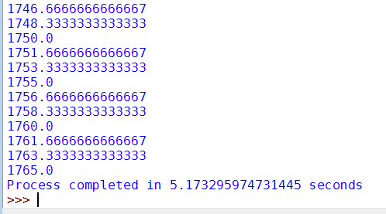
Same program run with a USB microphone plugged in (all other things left same):
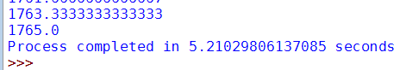
Task: Try rerunning your timing script while engaging or disengaging other activities, for example playing a YouTube video, running a file search, zipping a folder.

List your experiment conditions and the difference in time:
Experiment | Time difference

