Normal and skewed distribution curves
As part of the data recording, analysis and presentation section of research methods, you are required to demonstrate knowledge and understanding of the analysis and presentation of normal and skewed distribution curves.

Activity 1 – Revision of Different types of graphs and charts
When studying descriptive statistics, you will have come across some useful techniques to help you illustrate your data.

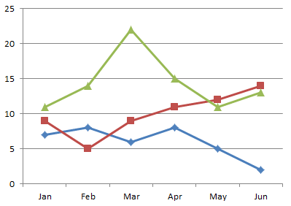
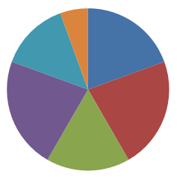

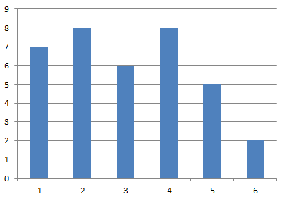

- Name each of the three graphs and charts shown on the previous page. When should you use each of them? Give an example of each.

- Which two other graphs should you know for the exam? When should they be used?

- Discussion - Why do Psychologists use graphs?

The why
One of the reasons is visual representations of data, in the form of charts, which allow psychologists and students to see if data is . . . . . . . . . . . . . . .

If stuck with the blank, below are the clues:
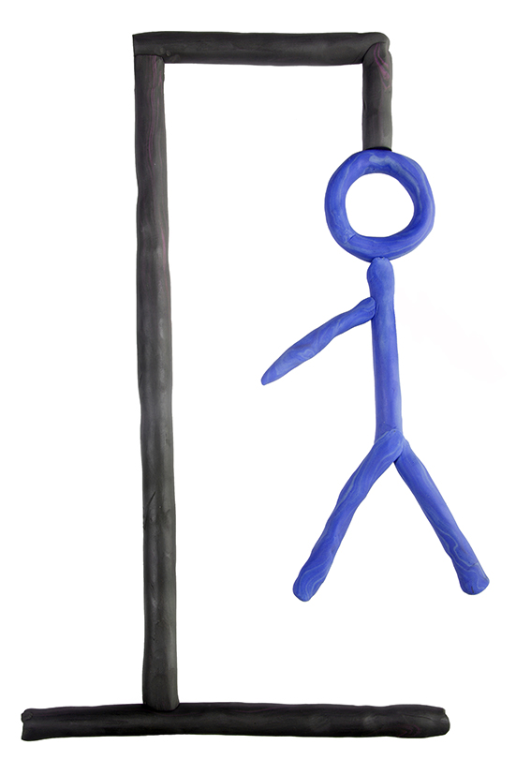

Eleven letter word _ _ _ _ _ _ _ _ _ _ _

However, remember that most importantly is that a number of statistical tests make assumptions or have criteria of how data is distributed. To fulfil the majority of these criterions for statistical tests, the most important distribution to look out for in your data is the normal distribution.

Normal Distribution
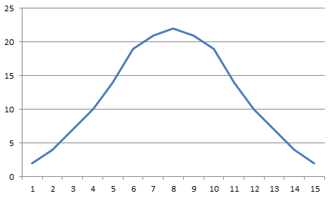

What does a normal distribution look like? What features do these distributions have?
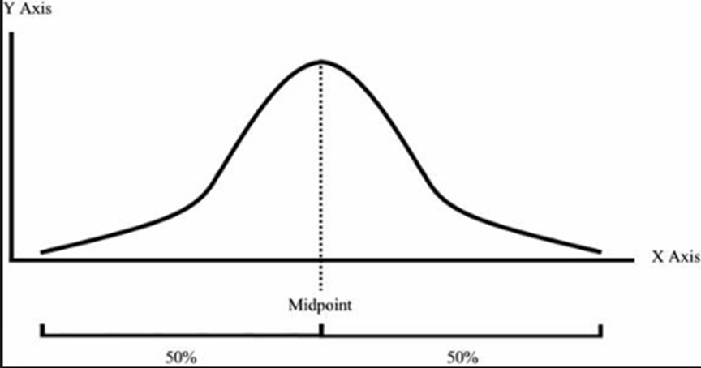
Figure 1 – normal distribution curve
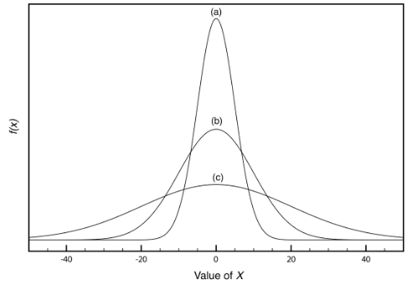

Figure 2 – normal distribution

Comments

The normal distribution
In real life situations, variables such as height, weight, shoe size, exam results, and IQ scores – all tend to show normal distribution when plotted on graphs.

In psychological research, this information can help researchers make assumptions about the way in which populations are distributed. Some of the most powerful statistical tests that researchers and students use assume that samples obtained from populations are normally distributed.

Characteristics of normal distributions
Classification of normal distributions should have the following features:

- Symmetry at the mean value
- The curve end points or “tails” meet the x-axis
- The shape of the curve should be bell-shaped.
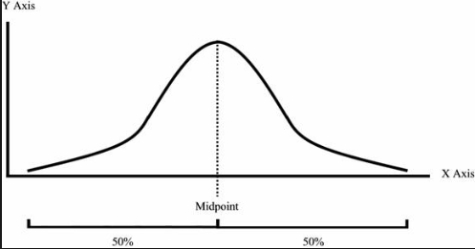
The dotted line – represents the mean, median and mode

Curve end points or “tails” of the distribution

Figure 3 – annotation of normal distribution curve

In Figure 2, all the distributions (a), (b) and (c) are normal. Even though the curves differ in terms of height (peak) and width (flat), they do meet the assumptions for normal distribution.

Also, another important feature when there is a normal distribution is that the mean, mode and median are exactly the same – see Figure (3). Furthermore, the normal distribution is the function of two core concepts of Descriptive Statistics: the mean and the standard deviation. If both of these values are calculated into a formula, these values can help plot a normal distribution.

Activity 2 – Application of knowledge to a novel situation
A class of students gained the following marks on their end of unit AS Psychology test.

63, 68, 77, 94, 88, 76, 75, 79, 79, 46, 98, 52, 92, 81, 81, 82, 86, 92, 82, 77, 87, 77, 81, 81, 83, 84, 87, 77, 78, 70, 49, 70, 70, 74, 68, 66, 60, 61

a) Calculate the mean, median, mode and standard deviation.

b) Create a frequency table of the scores from the participants.

c) Draw a histogram using the data from the psychology test and using the three characteristics of normal distribution, can you identify whether your graph illustrates normal distribution? Ensure that you label your graph appropriately.
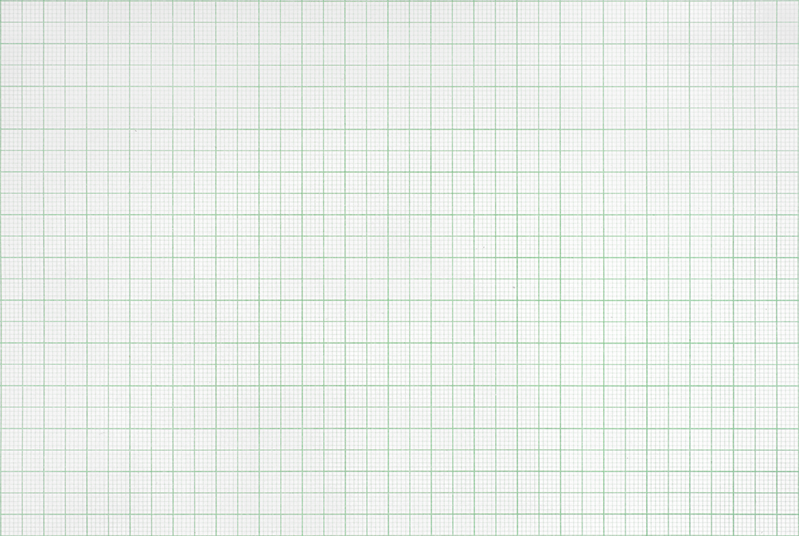


Practical Activity
Find out the different shoe sizes (or something even more interesting such as a rating from 0-10 on how much people like Marmite, Peanut Butter or Celery) of those in your class and record them on a tally chart.

Shoe size/rating | Frequency

Once you have recorded your data, plot your results into a graph – shoe size should be across the x-axis and frequency of each shoe size on the y-axis, and then join your points to make a line graph. Ensure that you label your graph appropriately.
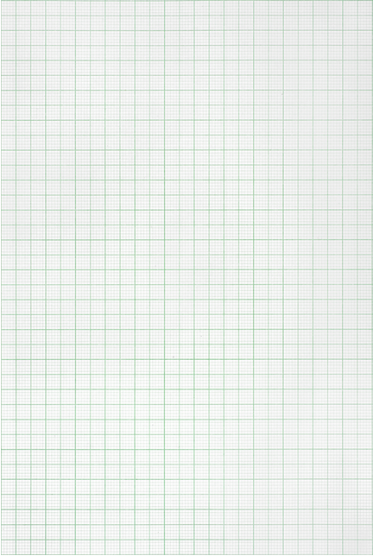

What can you conclude from you results? Are the scores in your class normally distributed? Does your distribution have any of the characteristics of a normal distribution? If not it may be skewed……

Activity 3 – Skewed distribution curves
What image would you draw or what words would you associate with the word ‘skewed’?

Definition: Skewed distribution curves are called skewed when it is not symmetrical at the mean
(or median or mode) point. A skew can be positive or negative.
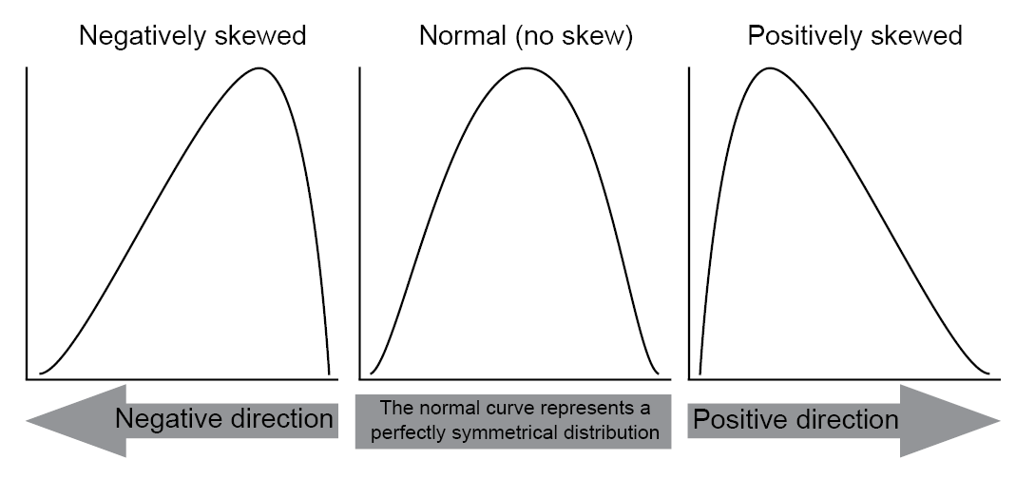
Figure 4 – Negatively Skewed Distributions, Normal Distributions and Positively Skewed Distributions

Definition: Skewed distribution curves are called skewed when it is not symmetrical at the mean
(or median or mode) point. A skew can be positive or negative. Where there is skewed data, the mean is dragged in the direct of the skew.

If the distribution of data is skewed to the left, the mean is less than the median, which is often less than the mode. If the distribution of data is skewed to the right, the mode is often less than the median, which is less than the mean.

Positive skew
In a positively skewed distribution, the curve point ends or “tail” will be longer where a majority of scores (of either exam tests, memory tests) are larger.

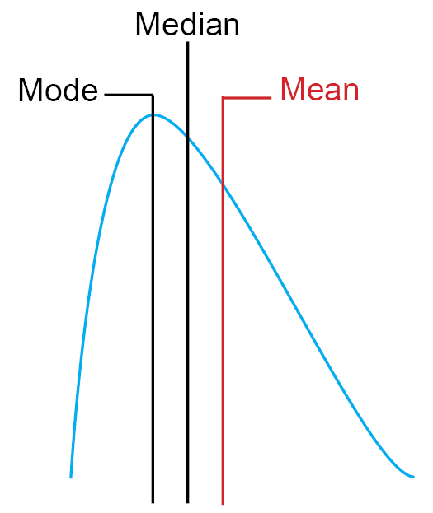
In such cases of positively skewed distribution, the measures of central tendency (mean, median and mode) will decrease in value. Unlike normal distribution, the values of all three measures of central tendency are not the same.

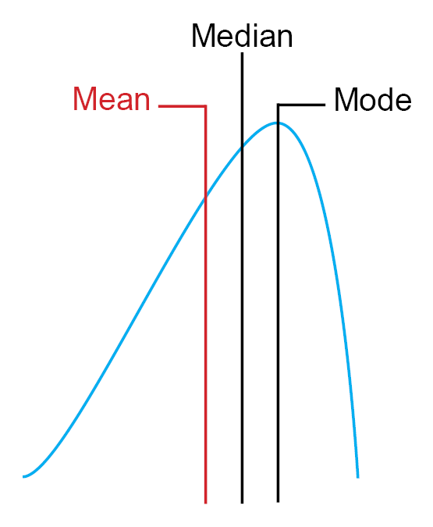
Figure 5 Positive Skew

Negative skew
In a negatively skewed distribution, the curve point ends or “tail” will be longer where scores (of either exam tests, memory tests) are the smallest.

In such cases of a negative skew, the measures of central tendency (mean, median and mode) will increase in value.

Activity 4 – Mean, mode and median
Have a look at the results obtained about shoe sizes or marmite and calculate the mean, mode and median (remember, you need to know these calculations for the exam). Once you have done this, add where they fall within your distribution. What can you now say about your results? Do you have a skewed distribution?

How much do you remember?
- What shaped curve is a normal distribution?

How

- What can you say about the mean, mode and median within a normal distribution?

How

- What can we conclude about data is a) negatively skewed b) positively skewed?

How

