Lesson Element

Unit 1: Building positive relationships in health and social care

A Person Centred Approach

Instructions and answers for tutors

These instructions cover the learner activity section which can be found on page 5. This Lesson Element supports Cambridge Technicals in Health and Social Care Level 3.
When distributing the activity section to the learners either as a printed copy or as a Word file you will need to remove the tutor instructions section.

The activity
In this Lesson Element the learners are tasked with understanding what person-centred care is, why it is important and the values that underpin a person-centred approach.

Suggested timings
Activity 1
- 60 minutes
Activity 2
- 60 minutes
WORK – This activity offers an opportunity for work experience.
ABC – This activity offers an opportunity for English skills development.
123 – This activity offers an opportunity for maths skills development.

Activity 1
Ask your learners to access the Health Foundation’s Guide: Person-centred care made simple; available from website link: http://personcentredcare.health.org.uk/sites/default/files/resources/person-centred_care_made_simple_1.pdf
Ask learners to design a poster about what person-centred care in health care means. Explain to your learners that they can use words, pictures and diagrams to design their poster.
Explain to learners that their poster must provide the following information:
What person-centred care is.
Why person-centred care is important.
Learners’ answers must include the following key points – these can be represented in words, pictures and/or diagrams:
What person-centred care is:
- Person-centred care is unique for each individual as each individual has needs, preferences, abilities, values and wishes.
- Treating individuals with respect.
- Respecting what is important to individuals i.e. respecting their values.
- Treating individuals with dignity and compassion.
- Providing care and support that is designed to meet an individual’s needs and reflects their wishes, preferences and abilities.
- Working together to enable and support individuals to live their lives how they prefer to.
Why person-centred care is important:
- To ensure individuals are being listened to and treated with respect.
- To enable professionals to focus on individuals’ strengths and abilities.
- To ensure individuals lead fulfilling lives.
- Enables positive working relationships to develop.
- To improve the quality of care and support.
- Motivates professionals to see individuals lead fulfilling lives.

Activity 2
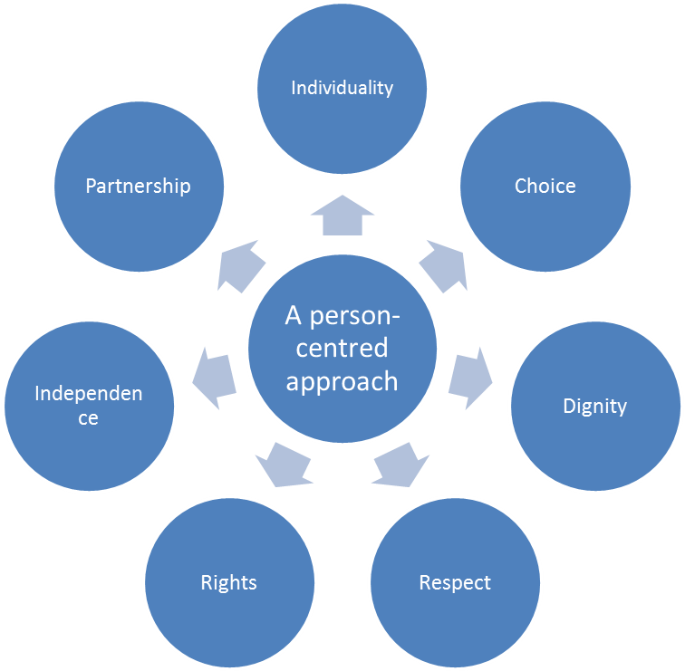
Ask your learners to look at the diagram below and read through the eight person-centred values

Explain to your learners that they must show their understanding of person-centred values by explaining what each one means and providing examples.
Explain to your learners that they can use examples from real scenarios or from the scenarios discussed in class activities. Ensure that your learners understand that the examples provided must relate to the correct person-centred value and that a minimum of two examples must be provided.
As well as a minimum of two examples, learners’ answers must also include the following key points:
- Individuality involves respecting the person for who they are, getting to know the individual and their uniqueness.
- Choice involves providing individuals with the opportunity to make their own decisions.
- Privacy involves providing an individual with their own space and respecting this i.e. not only physically but also emotionally and spiritually.
- Dignity involves enabling individuals to maintain their self-respect.
- Respect involves listening to and taking into account who an individual is, including their beliefs, values and preferences.
- Rights involve providing individuals with the opportunity to make decisions about wanting or not wanting to do something.
- Independence involves enabling individuals to lead their lives like they want to.
- Partnership involves working alongside individuals and developing good working relationships to support and enable individuals to lead their lives how they prefer.


OCR Resources: the small print
OCR’s resources are provided to support the teaching of OCR specifications, but in no way constitute an endorsed teaching method that is required by the Board, and the decision to use them lies with the individual teacher. Whilst every effort is made to ensure the accuracy of the content, OCR cannot be held responsible for any errors or omissions within these resources.
© OCR 2015 - This resource may be freely copied and distributed, as long as the OCR logo and this message remain intact and OCR is acknowledged as the originator of this work.
Please get in touch if you want to discuss the accessibility of resources we offer to support delivery of our qualifications: resources.feedback@ocr.org.uk
We’d like to know your view on the resources we produce. By clicking on ‘Like’ or ‘Dislike’ you can help us to ensure that our resources work for you. When the email template pops up please add additional comments if you wish and then just click ‘Send’. Thank you.
If you do not currently offer this OCR qualification but would like to do so, please complete the Expression of Interest Form which can be found here: www.ocr.org.uk/expression-of-interest

Lesson Element

A Person Centred Approach

Learner Activity

Introduction
Good working relationships in health, social care and child care environments are underpinned by person-centred ways of working. You are going to complete two activities: designing a poster and then completing a table to show your understanding of a person-centred approach.

Activity 1
A person-centred approach involves supporting and enabling individuals to live their lives how they want to. To do this, individuals’ needs, preferences, abilities, values and wishes must always be taken into account.
Below is a resource that has been developed by the Health Foundation, a charity whose aim is to improve the quality of health care in the UK so that all health care is safe, effective, person-centred, timely, efficient and equitable: ‘Person-centred care made simple’.
Website Link: http://personcentredcare.health.org.uk/sites/default/files/resources/person-centred_care_made_simple_1.pdf
Read through the Health Foundation’s Guide and then design a poster to explain what person-centred care in health care means.
You can use words, pictures and diagrams to design your poster. Your poster must provide the following information:
What person-centred care is.
Why person-centred care is important.

Activity 2
Ensuring a person-centred approach is used is essential to building positive relationships in health, social care or child care environments. Read through the eight person centred values that underpin a person-centred approach in the diagram below:

Explain with examples what each of these person-centred values means by completing the table below:
Person Centred Value
- Individuality | Meaning:
- Choice | Meaning:
- Privacy | Meaning:
- Dignity | Meaning:
- Respect | Meaning:
- Rights | Meaning:
- Independence | Meaning:
- Partnership | Meaning:

