Lesson Element

The Biological Area

Instructions and answers for teachers
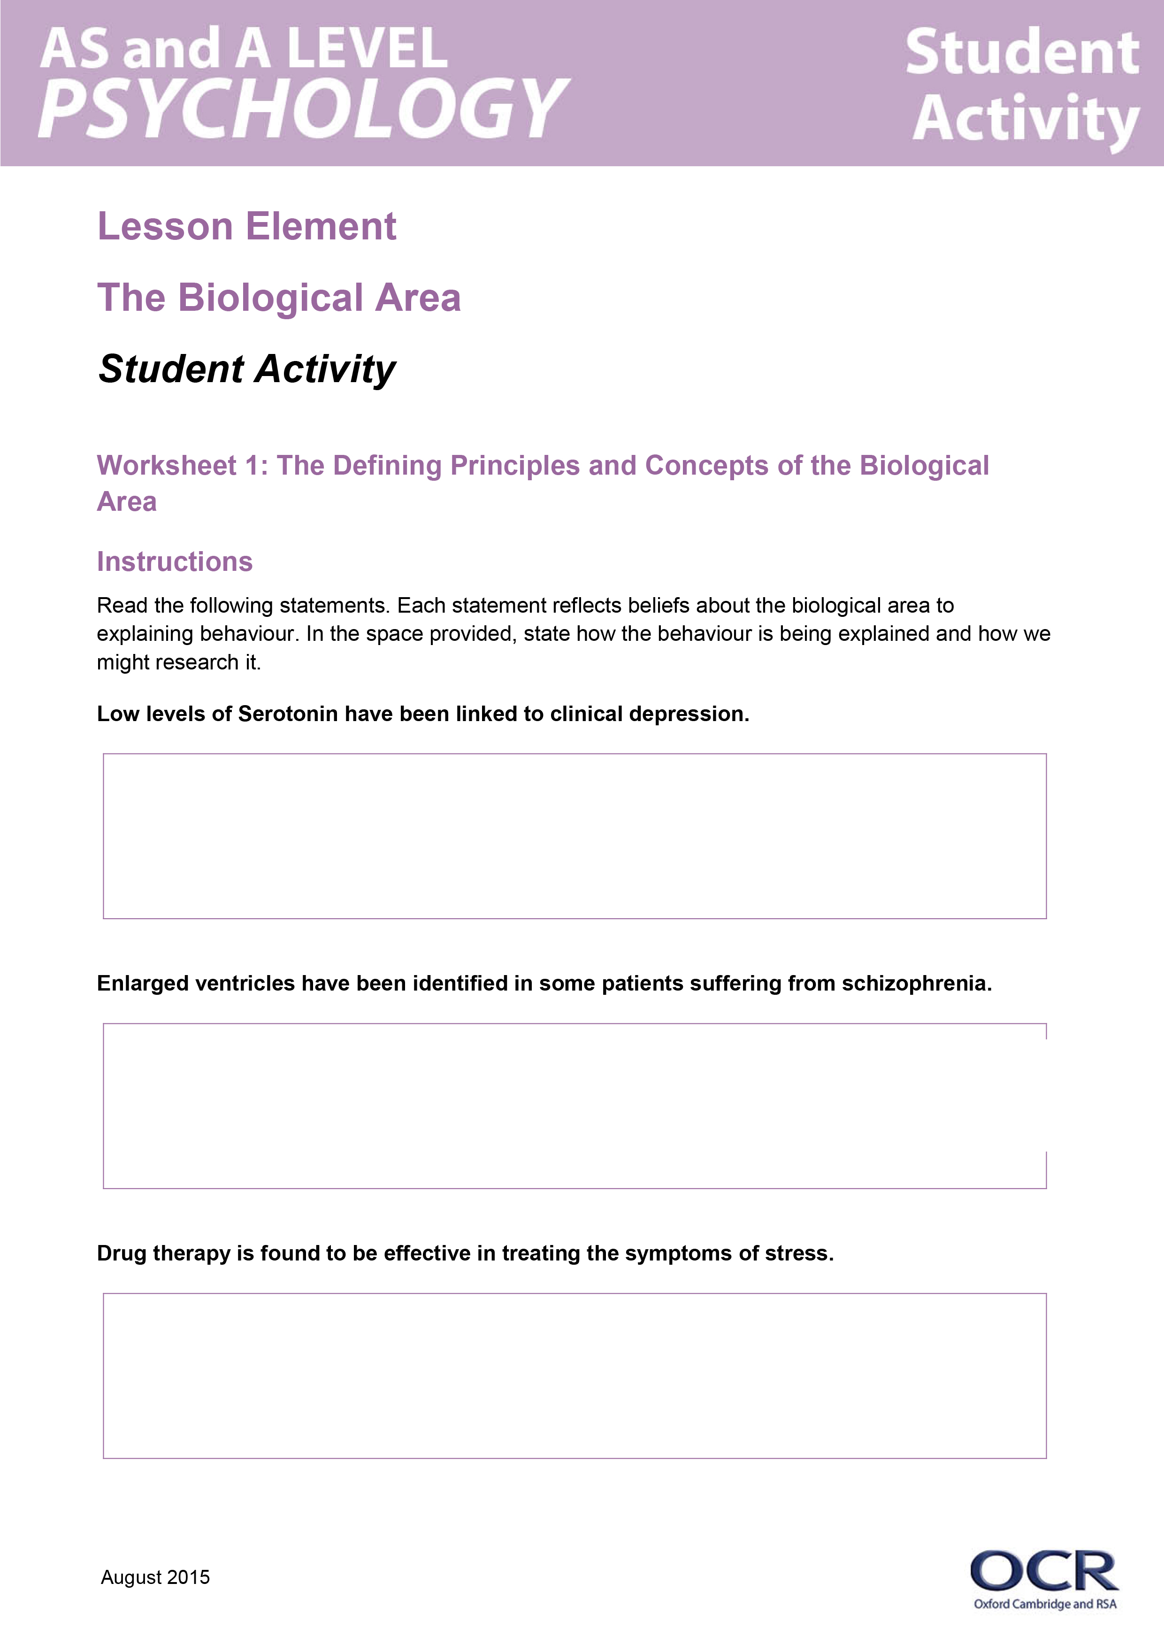
These instructions cover the student activity section which can be found on page 7 . This Lesson element supports OCR AS and A Level Psychology.
When distributing the activity section to the students either as a printed copy or as a Word file you will need to remove the teacher instructions section.

Background
An area of psychology provides a way of explaining behaviour. Each area brings something different to our understanding of human behaviour.

Objectives
Students are required to have knowledge and understanding of the Biological Area in Psychology.
They should know:
- The defining principles and concepts of the biological area.
- Strengths and weaknesses of the biological area.
- Research to illustrate the biological area.
- Applications of the biological area.
- How the biological area is different from, and similar to, other areas.

Introduction
The biological area is sometimes called biopsychology or the physiological area.
The biological area focuses on genetic, neurochemical and how the brain and nervous system work as explanations of behaviour and assumes the following:
- All that is psychological is first physiological:
  - The mind resides in the brain and so all thoughts, feelings and behaviours have a biological cause.
- Much behaviour has a genetic basis:
  - Genes have evolved over a million years to adapt our physiology to our environment.
The biological area therefore states that psychology should investigate the brain, neurochemistry, the nervous and endocrine system and genetics.

Common misconceptions
Learners often confuse the approaches and struggle to see how research supports different areas in psychology.
The worksheets are designed to be used after the teacher has given some background and briefly outlined the area. Each worksheet contains an activity to reinforce and check learning. The area has been divided into three sections: The Genetic Basis of Behaviour, Neuroanatomy and Neurochemistry.
Learners could be asked to list all the possible ways in which our biology may influence our behaviour. This will open up discussion about causes of behaviour, how we might investigate it and the nature nurture debate in psychology.

Worksheet 1: The defining principles and concepts of the Biological Area
This worksheet is designed to get learners to use the examples provided to isolate the key assumptions and defining features of the area, as well as stimulating thought into the methods used by the area.

The genetic basis of behaviour - How genes work and influence behaviour
Genetics refer to how we get our characteristics from our parents. Psychologists use Twin studies and Adoption studies to measure the influence of genetics.

Worksheet 2(a): Neuroanatomy - How the brain and nervous system works
Introduce learners to the role of genetics, with the use twin research and concordance rates to explain behaviour. There is also an exercise on Adoption studies.

Neuroanatomy - How the brain and nervous system works
The central nervous system comprises of the brain and spinal cord. Two very famous cases illustrating the influence of brain structure on behaviour is that of Charles Whitman and Phineas Gage. Both cases can be easily accessed on the internet:
http://www.bbc.co.uk/news/health-12649555
http://www.biography.com/people/charles-whitman-11495598
http://murderpedia.org/male.W/w/whitman-charles.htm

Worksheet 2(b) Neuroanatomy - How biological structures influence behaviour
Whilst it is not necessary for learners to know parts of the brain beyond those in the core studies, finding out how behaviour is influenced by our anatomy is crucial to understanding how the biological area explains behaviour.
This is an independent research activity designed to get learners finding out about behaviour. They could use the internet or textbooks to help them. This could be used as a homework activity or as an extension task.
Useful websites include:
http://www.brainline.org/multimedia/interactive_brain/the_human_brain.html?gclid=CPCEuJmI-8YCFe-WtAodQPQN8A
http://www.g2conline.org/2022

Worksheet 2(c): Neurochemistry - How chemicals work in our body
Examples of neurotransmitters and hormones that play a role in our behaviour are: serotonin, dopamine, testosterone and cortisol. Neurochemistry has been shown to affect behaviours such as depression, addiction, aggression, and the stress response.
This is a consolidation task with an exercise to get learners to think about the practical application in the real world.

Worksheet 3: Research to illustrate the Biological Area
Learners should know research to illustrate each area. This activity could be designed get learners to think about how the named research – Sperry and Casey et al (AS and A Level) and Blakemore and Cooper and Maguire et al (A Level only) all illustrate the biological area.
Learners could be placed into groups and have copies of the worksheet printed. Each group uses the worksheet for one of the studies. Once complete, they could share their work with the class, this will enable other learners to have a complete set of worksheets. Differentiation could be achieved by manipulating which learner receives which piece of research to apply the area to.
How the studies reflect the biological area can be through the way the behaviour is being explained, the results, or the methodology.
For example, Sperry (1968) demonstrates the different functions of the two hemispheres in the brain (localisation of function) and how, under highly controlled conditions, split brain patients respond when one hemisphere is isolated from the other. One finding shows how verbal language is isolated to the left hemisphere of the brain.
Casey et al (2011) uses MRI scans to determine if there is a neural basis to self-regulation. The biological area is reflected in both the explanation of behaviour (neurons) and in its methodology (use of scanning techniques)
Maguire et al (2000) demonstrates brain plasticity through the use of MRI brain scanning. Result show how the Hippocampi can change in relation to experience in a sample of London Taxi drivers.
Blakemore and Cooper (1970) focus on neurons and how visual neurons can impact on a cat’s brain. This study also facilitates the debate between biology and behaviour and which precedes the other.

Worksheet 4: Strengths and weaknesses of the Biological Area
Learners are required to know the strengths and weaknesses of areas. Worksheet 4 provides a summary of these.
Instructions are provided on the worksheet and suggested answers are below:
Strengths | Weaknesses | Research to illustrate
Very scientific – the biological approach adopts all the features of science including objectivity and reliability. Brain imaging techniques are not open to subjective interpretation. | Reductionist by way of reducing the cause of complex behaviours to a physiological basis, ignoring other possible causes of behaviour. | Maguire et al can be used to illustrate the scientific approach here with the use of MRI scanning to demonstrate plasticity in the hippocampi of taxi drivers.  Any of the core studies can be used to illustrate reductionism
Usefulness of research – provided in the extensive application of treatments. | Deterministic by way of assuming biology is the cause of behaviour would imply individuals have no free will in how they behave. | Casey et al can be used here, the use of fMRI scans to assess whether there is a neural basis to self -regulation  Any of the core studies can be used to illustrate determinism.

Worksheet 5: Applications of the Biological Area

Introduction
Plasticity, the brain’s ability to change as a result of experience forms the basis of biological treatments.
By way of introduction, the incredible story of Jody could be shown to learners as an excellent illustration of plasticity. Having suffered from epileptic seizures since birth, doctors had no choice but to remove her right hemisphere. The seizures originated in her right hemisphere and caused such violent fits that this became their only option.
Jody’s story can be seen on YouTube: https://www.youtube.com/watch?v=VaDlLD97CLM
The worksheet introduces learners to the concept that if a mental disorder has a biological cause, it may be possible to treat its symptoms by changing or interfering with the way the body works.
The introduction of Chlorpromazine in the 1950s marked the beginning of biological treatments in the field of psychopathology (abnormality).
Learners are introduced to four main drugs that are used in the treatment of mental disorders:
- Anti-psychotics – used in the treatment of schizophrenia by reducing psychotic symptoms such as hallucinations and delusions.
- Anti-anxiety drugs – used to reduce the symptoms of anxiety. An example is Valium
- Anti-depressants – mainly used in the treatment of depression but sometimes used for OCD, some phobias and panic disorder. Examples include MAOI’s and SSRI’s
- Anti-mania drugs – used in the treatment for states of mania (e.g. bipolar disorder). An example is Lithium.
There are opportunities for independent research activities here whereby learners could be asked to research how influential biological treatments are in relieving the symptoms of addictive behaviour such as NRT (Nicotine Replacement Therapy) in smoking.
Learners could be directed to appropriate websites (the NHS website is ideal) to research how two drugs used to help individuals cease smoking work. Both Zyban (bupropion) and Champiz (varenicline) were first introduced as a treatment for depression, but shortly after it was recognised that they assisted in relieving the withdrawal symptoms of smoking addiction by changing the way the brain receives nicotine.

Worksheet 6: How the biological area is different from and similar to different areas
An additional worksheet is provided to get learners to think about the similarities and differences between the areas. Ideally this should be used after all the areas have been covered.

OCR Resources: the small print
OCR’s resources are provided to support the teaching of OCR specifications, but in no way constitute an endorsed teaching method that is required by the Board, and the decision to use them lies with the individual teacher. Whilst every effort is made to ensure the accuracy of the content, OCR cannot be held responsible for any errors or omissions within these resources.
© OCR 2015 - This resource may be freely copied and distributed, as long as the OCR logo and this message remain intact and OCR is acknowledged as the originator of this work.
OCR acknowledges the use of the following content PET scans of a developmental study: Science Source / Photo Researchers / Universal Images Group
Please get in touch if you want to discuss the accessibility of resources we offer to support delivery of our qualifications: resources.feedback@ocr.org.uk
We’d like to know your view on the resources we produce. By clicking on ‘Like’ or ‘Dislike’ you can help us to ensure that our resources work for you. When the email template pops up please add additional comments if you wish and then just click ‘Send’. Thank you.
If you do not currently offer this OCR qualification but would like to do so, please complete the Expression of Interest Form which can be found here: www.ocr.org.uk/expression-of-interest

Lesson Element

The Biological Area

Student Activity

Worksheet 1: The Defining Principles and Concepts of the Biological Area

Instructions
Read the following statements. Each statement reflects beliefs about the biological area in explaining behaviour. In the space provided, state how the behaviour is being explained and how we might research it.
Low levels of Serotonin have been linked to clinical depression.

Enlarged ventricles have been identified in some patients suffering from schizophrenia.

Drug therapy is found to be effective in treating the symptoms of stress.

Males are said to be more aggressive than females.

Cats deprived of sleep developed abnormal behaviours and eventually died.

A study of 7000 twins found a concordance rate for aggressiveness of 35% for identical twins and 13% for non-identical twins.

The assumptions of the biological area are:

The methods used by the biological area are:

Worksheet 3: Research to illustrate the Biological Area
Aims / Background of Research |  | Results / Conclusions | How these illustrate the biological area
Assumptions of biological area - these illustrate | Method(s) used
How these illustrate the biological area | Method(s) used

Worksheet 2(a): The genetic basis of behaviour – How our genes work and influence behaviour
Genetics refer to how we get our characteristics from our parents. Every human has 46 chromosomes (DNA) divided into 23 pairs. During reproduction, 23 chromosomes come from the mother and 23 come from the father.
The biological area proposes that behavioural characteristics such as personality and abnormality are inherited in the same way as physical characteristics such as eye colour.

Measuring the influence of genetics
Twin studies are used to determine the likelihood that any given behaviour has a genetic basis. Identical twins (also called monozygotic twins) share 100% identical genes.
Non-identical twins (dizygotic twins) are 50% genetically the same, that is in terms of genetics they are no more similar than siblings born years apart.
Psychologists compare the likelihood if one twin has a behavioural characteristic, so does the other. This is called concordance rates. For example, if behaviour is entirely inherited, we would expect to find a concordance rate of 100% between identical twins.
Adoption studies are also used to determine the likelihood that behaviour may have a genetic cause.
Explain how adoption studies may help us to determine a biological cause.

Activity
Read the following and answer the questions that follow.
- Gottesman (1991) did a Meta-analysis of 40 twin studies in schizophrenia and found a concordance rate of 48% for identical twins and 17% for non-identical twins.
This shows....

- This link is to a scan of 2 MZ twins’ brains. https://faculty.washington.edu/chudler/gif/scan2.gif
The one on the right has schizophrenia. Why is this evidence that Schizophrenia is not purely a genetic disorder?

- McGuffin and Gottesman (1985) found a concordance rate of 87% between MZ twins and 72% between DZ twins. What does this suggest about genetics and aggression?

- Why are twin and adoption studies useful for investigating the Nature Nurture Debate?

Worksheet 2(b): Neuroanatomy – How biological structure influences behaviour

Independent research activity
Research the following to find out which parts of the brain are involved in each behaviour. Explain how the behaviour is characterised.
Part(s) of brain | Responsible for:
 | Personality…
 | Aggression …
 | Memory…
 | Sleep…
 | Emotion…

Extension Activity: Find out how damage to these parts of the brain influence behaviours.

Worksheet 2(c): Neurochemistry – How chemicals work in our body
Much of our behaviour can be explained by neurotransmitters or hormones. Circle high or low to complete the following statements to show how levels of chemicals and hormones can affect behaviour.

High / Low levels of serotonin is associated with depression.

High / Low levels of serotonin are associated with Obsessive Compulsive disorder (OCD).

High / Low levels of dopamine are associated with addiction (pleasurable feelings).

High / Low levels of dopamine are associated with schizophrenia.

High / Low levels of testosterone are associated with aggression.

High / Low levels of cortisol are associated with stress

High / Low levels of melatonin are associated with the symptoms of SAD (Seasonal Affective Disorder).

Worksheet 4: Strengths and weaknesses of the Biological Area
Complete the following with strengths and weaknesses of the biological area using research from the biological area to illustrate the issue.
Strength | Limitation | Research to illustrate

Worksheet 5 - Applications of the Biological Area
Advances in brain scanning techniques have helped to explain the causes and mechanisms involved in mental disorders and vulnerability to addiction.
What differences can you see between the image on the left (depressed individual) and the image on the right (not depressed)?
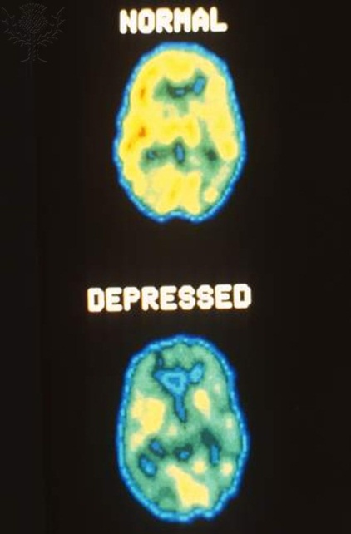

Now visit this link: http://img.webmd.com/dtmcms/live/webmd/consumer_assets/site_images/articles/health_tools/schizophrenia_overview_slideshow/webmd_rf_photo_of_mri_brain_scans.jpg
What differences can you see between the image on the left and the image on the right?

If a disorder has a biological cause, it may be possible to treat it by changing or interfering with the way the brain or body works.
Drugs that change the way a person thinks or behaves are called psychoactive drugs.
There are four main drugs used to treat mental disorders:
Name of Drug | Used to treat… | Example(s)
Anti-psychotics
Anti-depressants
Anti-anxiety drugs
Anti-mania drugs

Extension Activity: The biological area has many applications to the real world. One such area is in depression. Antidepressants are used treat depression. Write a paragraph to explain how they regulate levels of serotonin in the brain to reduce the symptoms of depression.

Worksheet 6: Similarities and differences between the Biological Area and the other areas
Using the following key features of the Biological Area, compare and contrast the area with at least one other area to show the similarities or differences between them.
The biological area can be considered reductionist in its approach. This is because it breaks complex processes down into more fundamental ones. For example, the biological area explains behaviour through the consequences of genetics and physiology and rejects the influence of the environment on our behaviour.
By contrast, areas which take a more holistic view of behaviour include…..

The biological area offers a good counter argument to the nurture side of the nature vs. nurture debate. For example, the biological area seeks to explain mental processes and behaviour by focusing on the function of the brain and nervous system.
By contrast, other areas offer a more interactionalist view, accepting the influence of both nature and nurture on behaviour, for example…..
The biological area can be considered deterministic. One of its basic assumptions is that all that is psychological is first physiological. This reduces the amount of free will an individual has in their behaviour. For example, vulnerability to abnormality is explained by genetics.
Many other areas are similar in that they can also be considered deterministic, for example…

The biological area adopts many features of science in its approach. For example, objectivity is achieved through the use of brain scanning techniques. The biological area employs the experimental method which increases the reliability of its results.
Similarity: Describe one other area which also adopts features of science..…

Difference: Now contrast it with a different area that is less scientific…..

STRETCH AND CHALLENGE: Can you think of your own feature of the biological area and compare and contrast it?
The biological area..…

