Lesson Element

Freud (1909): Little Hans – a case study of a phobia

Instructions and answers for teachers
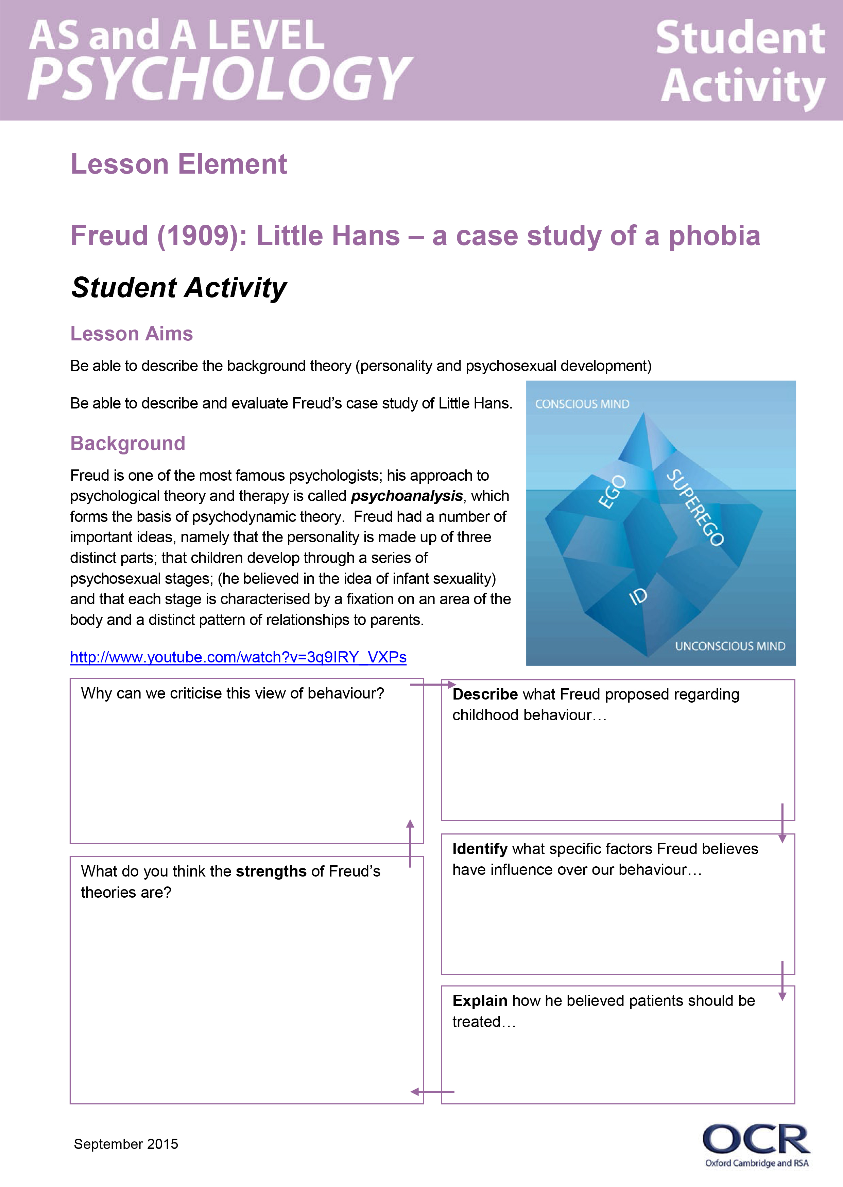
These instructions cover the student activity section which can be found on page 10. This lesson element supports OCR AS and A Level Psychology.
When distributing the activity section to the students either as a printed copy or as a Word file you will need to remove the teacher instructions section.

Introduction
This resource provides teaching and learning ideas for the Little Hans core study. This includes content from the specification including background, method, results and conclusions, as well as methodological issues and how the research illustrates the psychodynamic perspective.



This activity offers an opportunity for English skills development.
This activity offers an opportunity for maths skills development.

Background
This is a case study that focuses on a single child participant, for two years of his life between the ages of three and five. It contains detailed transcripts of conversations between Little Hans and his father- the study was very important to Freud as it provided him with the opportunity to work with a child and to test his Psychoanalytic theory relating to infant sexuality, resolving the Oedipus complex and how phobic behaviours may originate.
Psychoanalysis involves the interpretation of thoughts and fantasies with the intention of bringing the unconscious into awareness and by doing so, helping the patient to develop a better understanding of their behaviour. Hans’ father recorded conversations he had with his son and sent them to Freud. Hans’ father had been writing to Freud for a while, before the phobia developed, which allowed Freud to draw some conclusions on causes from his childhood experiences.

Student tasks
Start with a brief introduction using the background above.
Students watch the clip and answer the questions on the mind-map sheet (see student activity section which follows).
Students then research the theory of tripartite personality and psychosexual stages of development (use information below) and then reflect by summarising on the mind-map the key beliefs held by Freud.
Introduction to study: students work in pairs / small groups to collect research on each aspect of Freud’s case study (text book will be needed,) students feedback to each other, and teacher models using resources provided in this guide.
Evaluation, key questions and application to disorders activity to complete.
Students will each need a copy of the resources in the lesson element - and will then require feedback using the teacher resources within this guide.

Psychosexual stages of development
ORAL (0-1) | ANAL (1-3) | PHALLIC (3-5) | LATENCY (5-13) | GENITAL (13+)
Pleasure zone - mouth | Pleasure zone – bladder and bowel | Pleasure zone – genitals | Pleasure zone – sexual feelings are inactive | Pleasure zone – maturing sexual interests
The mouth is vital for eating, and the infant derives pleasure from oral stimulation through gratifying activities such as tasting and sucking. Fixation in this stage results in dependency and aggression. Drinking, smoking and nail biting are examples of problems. | The major conflict is toilet training. Developing control leads to feelings of accomplishment and independence. Inappropriate parental responses lead to negative outcomes. Laid back parents make the child anal expulsive meaning they have a destructive personality. Strict parents make the child anal retentive meaning they are obsessive and rigid. | Children begin to notice the difference between males and females. Boys go through the Oedipus complex where they have unconscious sexual feelings towards their mother. Girls go through the Electra complex where they develop sexual feelings for their father and have penis envy. | Sexual energy is still present, but it is directed to developing socially and intellectually. This stage is vital in the development of communication skills and self-confidence. | During this stage the individual develops strong feelings for the opposite sex. This starts in puberty but lasts for the rest of the person’s life. Interest in the welfare of others also grows in this stage. If the other stages have been completed successfully, then a person will be warm, caring and well balanced.

Freud’s theory

Tripartite structure of the mind: Freud proposed a theoretical account of the structure of the mind. | ID – Pleasure Principle | EGO – reality principle | SUPEREGO – Values and morals
 | This is present at birth. It is the seat of our instincts and it is unconscious. It tries to get immediate gratification and avoid pain. It includes the sex (life) instinct – Eros (which contains the libido), and aggressive (death) instinct – Thanatos. | This develops in childhood out of the id, as the child learns that immediate gratification is not always possible and pain cannot be avoided. It works on the reality principle. It tries to balance the demands of the id and the superego. | This consists of the values and morals of the child, and develops at the age of 5. It is the child’s conscious and ego – ideal, a model of what the child would like to be.

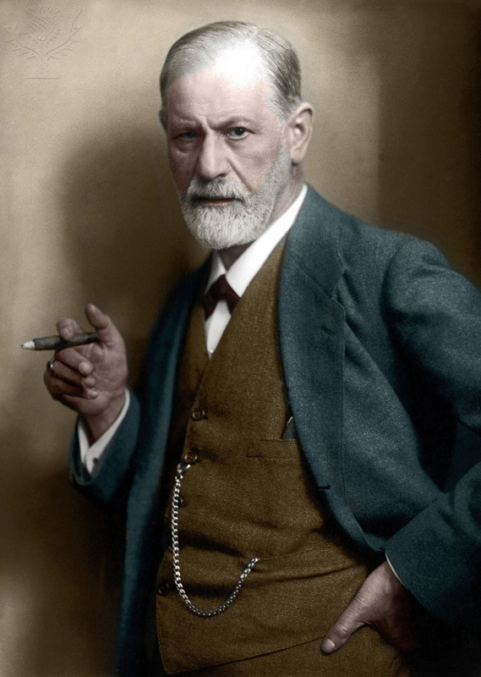

Key Questions on the study
FREUD: Analysis of a phobia in a 5 year old boy
Aims: To give an account of a boy who was suffering from a phobia of horses and range of other symptoms, and to use this case to illustrate the existence of the Oedipus Complex. | Design: A clinical case study – the participant is a patient undergoing therapy. In this case, Freud’s direct input was very limited, Freud met Hans no more than twice. Han’s father conducted regular discussions with Freud, who analysed the information in line with his theory.
Participant: A Jewish boy from Vienna named Hans, aged 5 years old at the start of the study ( real name Herbert Graf). Little Hans was suffering with a phobia of horses, his father, a fan of Freud, referred the case to Freud and went on to provide the case information.

Case History:
- When the child took an interest in his ‘widdler’ – he played with it regularly, his mother became cross and threatened to send for a doctor to cut it off. This upset Hans and he developed a fear of castration – which meant he had to repress his feelings of pleasure.
- At around the same time, he saw a horse collapse and die in the street and was very distressed by this.
- Noticed that animals had large ones i.e. horses, assumed both his parents must have large ones.
- At 3 ½ his sister was born.
- At 4, Hans developed a fear of horses, specifically that a white horse would bite him. Han’s father noted to Freud that his fear seemed to relate to the size of the horses penis and his dissatisfaction with the size of his own penis.
- At around the same time his phobia developed, a conflict also developed with his father over Han’s climbing into his parents bed in the morning to cuddle his mother, Han’s father objected to this. Han’s phobia worsened to the extent that he did not want to leave the house. He also suffered attacks of generalised anxiety.
- Hans had a fantasy about two giraffes, one cried out to the other.
- By age 5 Hans’ phobia lessened, becoming limited to white horses who wore a noseband and blinkers, which were likened by Freud to Hans’ father’s moustache and glasses. The phobia then disappeared altogether.
- The end of the phobia was marked by two fantasies: he fantasised he had several children: when his father asked who the other was, Hans’ replied “Mummy, and you’re the Granddaddy”.
- The next day Hans’ fantasised that plumber had come and removed his bottom and penis replacing them with new and larger ones.

Results:
Freud interpreted the case as an example of the Oedipus complex, specifically:
- Horses represented Hans’ father
- Horses made good father symbols because they have large penises
- The anxiety Hans felt was really castration anxiety, triggered by his mother’s threat to ‘cut off his penis’ and a fear of his father caused by his banishing of Hans from the marital bed.
- The giraffes in Hans’s fantasy represent his parents. The large giraffe that cries out represented Hans’ father objecting to having Hans in the bed, and the crumpled giraffe was his mother, crumpled representing her genitals. The large giraffe with its erect neck could have symbolised his father’s penis.
- The children fantasy represents a friendly resolution of the Oedipus complex in which Hans replaces his father as his mother’s main love object, but the father still had a role.
- The plumber fantasy represents identification with the father – he sees himself growing a large penis like his father and becoming like him.

1. What causes Hans to develop a fear of castration?
His mother threatened to call a doctor to ‘cut-it off’ because he had been playing with it.

2. What real-life event could be linked to his phobia of horses?
Hans saw a horse collapse in the street, and was very distressed by this.

3. What was the conflict that had developed between Hans and his father?
Hans liked to climb into his parent’s bed each morning and cuddle his mother- his father objected to this, and stopped Hans from doing it.

4. Describe why Freud suggested that Hans’ fear of horses represented his father?
The horse that Hans was scared of was white, with blinkers and a nose strap- this was though to symbolise his father’s pale skin, glasses and moustache.

5. Outline one dream had by Little Hans.
Little Hans dreamed that two giraffes were in his room one night, a tall one and a crumpled one. Hans took the crumpled giraffe away from the large one, which cried out.

6. Outline one fantasy had by Little Hans.
Hans had a fantasy that a plumber came and removed his bottom and penis, and replaced them with larger ones.

Evaluation of the case study
Point/ Theme | Explain (How/ why is it a strength/ weakness? Use key terminology) | Example (Give a specific example from the study…)
The research method (case study | A strength of a case study is that we can collect lots of rich detailed information on the participants, which develops understanding of development | For example, we are able to study Little Hans in lots of detail in order to understand how his phobia developed and was resolved.
And Sampling Bias | A disadvantage of a case study is that it is non-experimental, and therefore we cannot infer cause and effect due to the lack of control over other variables that could have caused the behaviour.  A case study also relies on a very small sample, and therefore we cannot generalise beyond the sample- there is a lack of external validity | For example, we cannot conclude that the phobia was caused by the Oedipus complex, and we do not have enough control over other things such as his experience with the horse in the street.  Little Hans, was one boy from Vienna, therefore we cannot generalise beyond this- he does not represent all other children.
Qualitative data | Rich in detail- allowing insightful interpretations of development | For example, we are able to study Little Hans in lots of detail in order to understand how his phobia developed and was resolved.
Qualitative data | However, qualitative data is subjective and therefore can be prone to bias which reduces the internal validity of the data. | For example, Freud could have interpreted the evidence in line with his theory- researcher bias
Ethics | As the research was conducted on a child, informed consent is required from a parent. | For example, Hans’ father provided informed consented and gave Freud lots of information on his son.
Ethics | Due to the nature of the study, there may have been an invasion of privacy and psychological harm. | For example, Han’s father gathered lots of data from his son through intense questioning over personal matters.
Validity | Lack of external validity | The sample of consisted of a single individual, with a specific phobia. Therefore, we cannot generalise the findings to other disorders and to a wider population.
Validity | Lack of internal validity caused by demand characteristics, and also researcher bias (see above.) | For example, Little Hans may have been affected by leading questions from his father (a follower of Freud) and therefore answered in a way that would please his father (demand characteristics.) This reduces the internal validity, as his answers may not have been a true reflection of his thoughts/ desires.

Applications
Good example of in-depth qualitative research- this is a very useful method for psychotherapists working with people that may be suffering with a particular disorder.

Understanding Disorders: How is Freud’s research useful?

Demonstrates how childhood disorders such as phobias/ the Oedipus complex can develop and affect behaviour, and how we can study it.
The case study method was ground-breaking at the time, and has influenced everyone who has studies psychological disorders since.

Student misconceptions
How was data gathered? Through observations of Little Hans and conversations with Hans conducted by Hans’ father and sent to Freud via letter. Freud met Hans a maximum of two occasions.
How did Freud interpret the dreams/fantasies?
Giraffe daydream – A re-enactment of what happened in the morning when Hans climbed into bed with his parents. His father (the big giraffe) objected and called out because Hans took his mother (the little giraffe) away from him.
Plumber fantasy – Hans’ small bottom and ‘widdler’ were replaced by bigger ones, like his father’s, indicating Hans wanted to be like his father.
Parenting fantasy – Hans’ sexual desires for his mother are apparent as he fantasises about being married to her and having children with her. This could also be interpreted as conflict resolution, he fantasises about being like his father.

What does the Oedipus complex involve?
During the phallic stage of development a boy subconsciously wants to sexually possess his mother.
- He recognises there is a competition with his father.
- So he wants his father out of the way because he fears that if his father finds out about this desire, he will be castrated.
- He resolves this conflict by identifying with his father and adopting his values and behaviours.
What evidence is there to say Little Hans was experiencing the Oedipus complex? His phobia of horses because they resembled his father.
- His jealousy of his baby sister / at her birth.
- His fascination for his ‘widdler’ (links to phallic stage).
- His fear of being bitten by a horse, symbolising his fear of castration.
- His fantasy about the giraffes (explained).
- His dream about being married to his mother (explained).
- Wishing his father was dead.

OCR Resources: the small print
OCR’s resources are provided to support the teaching of OCR specifications, but in no way constitute an endorsed teaching method that is required by the Board, and the decision to use them lies with the individual teacher. Whilst every effort is made to ensure the accuracy of the content, OCR cannot be held responsible for any errors or omissions within these resources.
© OCR 2015 - This resource may be freely copied and distributed, as long as the OCR logo and this message remain intact and OCR is acknowledged as the originator of this work.
OCR acknowledges the use of the following content: Maths and English icons: Air0ne/Shutterstock.com, Freud’s ‘ego’ theory: T and Z/Shutterstock.com, Freud: Lee / leemage / Universal Images Group/Shutterstock.com
Please get in touch if you want to discuss the accessibility of resources we offer to support delivery of our qualifications: resources.feedback@ocr.org.uk
We’d like to know your view on the resources we produce. By clicking on ‘Like’ or ‘Dislike’ you can help us to ensure that our resources work for you. When the email template pops up please add additional comments if you wish and then just click ‘Send’. Thank you.
If you do not currently offer this OCR qualification but would like to do so, please complete the Expression of Interest Form which can be found here: www.ocr.org.uk/expression-of-interest

Lesson Element

Freud (1909): Little Hans – a case study of a phobia

Student Activity

Lesson Aims

Be able to describe the background theory (personality and psychosexual development).
Be able to describe and evaluate Freud’s case study of Little Hans.

Background
Freud is one of the most famous psychologists; his approach to psychological theory and therapy is called psychoanalysis, which forms the basis of psychodynamic theory. Freud had a number of important ideas, namely that the personality is made up of three distinct parts; that children develop through a series of psychosexual stages; (he believed in the idea of infant sexuality) and that each stage is characterised by a fixation on an area of the body and a distinct pattern of relationships to parents.
http://www.youtube.com/watch?v=3q9IRY_VXPs
Why can we criticise this view of behaviour?
Describe what Freud proposed regarding childhood behaviour…

Identify what specific factors Freud believes have influence over our behaviour…
What do you think the strengths of Freud’s theories are?

Explain how he believed patients should be treated…

Freud’s Theory
Tripartite structure of the mind: Freud proposed a theoretical account of the structure of the mind. | ID – Pleasure Principle | EGO – reality principle | SUPEREGO – Values and morals
 | This is present at birth. It is the seat of our instincts and it is unconscious. It tries to get immediate gratification and avoid pain. It includes the sex (life) instinct – Eros (which contains the libido), and aggressive (death) instinct – Thanatos. | This develops in childhood out of the id, as the child learns that immediate gratification is not always possible and pain cannot be avoided. It works on the reality principle. It tries to balance the demands of the id and the superego. | This consists of the values and morals of the child, and develops at the age of 5. It is the child’s conscious and ego – ideal, a model of what the child would like to be.

Using the information around the room, complete the table.
Using the internet, research the stages of psychosexual development.

Psychosexual stages of development
ORAL (0-1) | ANAL (1-3) | PHALLIC (3-5) | LATENCY (5-13) | GENITAL (13+)
Pleasure zone - mouth | Pleasure zone – bladder and bowel | Pleasure zone – genitals | Pleasure zone – sexual feelings are inactive | Pleasure zone – maturing sexual interests

Summarise Freud’s key beliefs…

FREUD: Analysis of a phobia in a 5 year old boy
Aims: | Design:
Participant:
Case History:

Results:

Conclusion: Hans suffered a phobia of horses because he was suffering from castration anxiety and going through the Oedipus complex. Dreams, fantasies helped express this conflict and eventually he resolved his Oedipus complex by fantasising himself taking on his father’s role and placing his father in the role of grandfather.

Key questions on the study
1. What causes Hans to develop a fear of castration?

2. What real-life event could be linked to his phobia of horses?

3. What was the conflict that had developed between Hans and his father?

4. Describe why Freud suggested that Hans’ fear of horses represented his father?

5. Outline one dream had by Little Hans.

6. Outline one fantasy had by Little Hans.

Evaluation of the Case Study
Point/ Theme | Explain (How/ why is it a strength/ weakness? Use key terminology) | Example (Give a specific example from the study…)
The research method (case study
Data
Ethics
Validity
Reliability
Sampling Bias
Ethnocentrism

Applications:
Understanding Disorders: How is Freud’s research useful?

