Lesson Element

The Social Area

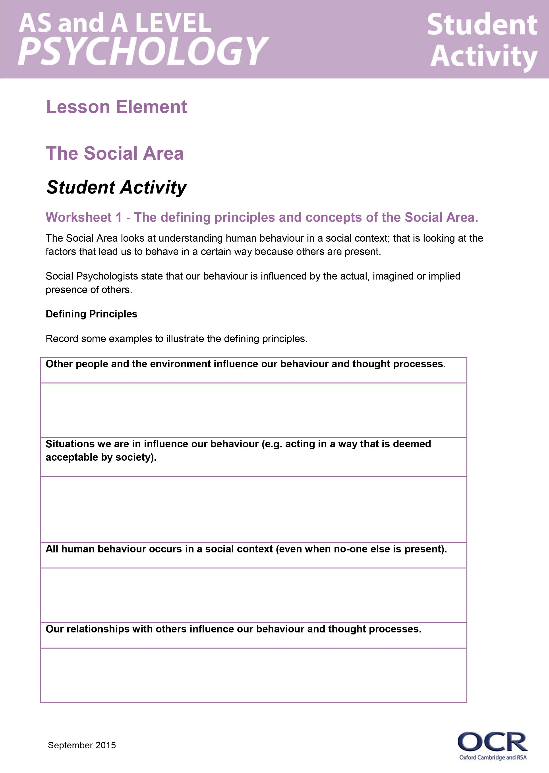
Instructions and answers for teachers

These instructions cover the student activity section which can be found on page 6. This Lesson element supports OCR AS and A Level Psychology.
When distributing the activity section to the students either as a printed copy or as a Word file you will need to remove the teacher instructions section.

Background
An area is a way of explaining behaviour. Each area brings something different to our understanding of human behaviour.

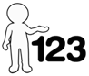
This activity offers an opportunity for English skills development.
This activity offers an opportunity for maths skills development.

Objectives
Students are required to have knowledge and understanding of the Social Area in Psychology.
They should know:
- The defining principles and concepts of the social area.
- Strengths and weaknesses of the social area.
- Research to illustrate the social area.
- Applications of the social area.
- How the social area is different from, and similar to, other areas.

Introduction
The Social Area looks at understanding human behaviour in a social context; that is looking at the factors that lead to us to behave in a given way due to the presence of others.
Social psychologists state that our behaviour is influenced by the actual, imagined or implied presence of others.
The key assumptions are:
- Other people and the environment influence our behaviour and thought processes.
- All human behaviour occurs in a social context (even in the absence of others).
- Our relationships with others influence our behaviour and thought processes.

Common misconceptions
Learners often confuse the areas and struggle to see how research supports the different areas in psychology.
The worksheets are designed to be used after the teacher has given some background and briefly outlined the approach. Each worksheet contains an activity to reinforce and check learning.
Learners could be asked to list all the ways they think other people may influence their behaviour. This is likely to stimulate discussion into type of conformity and obedience for example.

Worksheet 1 – Defining principles of the Social Area
This worksheet is designed to introduce learners to the key assumptions of the area and for them to think of their own examples to illustrate them to reinforce their understanding.

Applications of the Social Area
By way of introduction, learners could watch Jane Elliot’s famous ‘A class divided’ experiment. As a first grade teacher, following the death of Martin Luther King, Jane Elliot carried out an experiment into prejudice to demonstrate the power of discrimination based on eye colour. Her ‘blue eyed – brown eyed’ experiment shows social psychology in action.
There are numerous versions of this experiment on the internet for example http://www.pbs.org/wgbh/pages/frontline/shows/divided/etc/view.html
There are many areas of applications of the social approach; all focus on how the situation with the presence, (even implied presence) of others affects our behaviour. They include (among others):
- Conformity and obedience
- Social identity
- Attitudes
- Attribution
- Discrimination and stereotypes
- Pro and anti-social behaviour.
After watching ‘A class divided’, learners could be guided to think about their own self-image. Based on Tajfel’s self-identity theory, a self-image has two components:
- A personal identity
- A social identity which is formed by the social groups we belong to.
Jane Elliot creates social categorisation which successfully leads to the formation of in groups/out groups and finally in group favouritism (out group bias).
Learners could be challenged to think about how the social groups we belong to can create social categorisation and how the presence (or implied presence) of these groups can create social beliefs and attitudes that generate different behaviour.

Alternative / Extension activity
A more recent example that could be used is the Abu Ghraib prison torture and prisoner abuse.
Learners could be introduced to the Lucifer effect (Zimbardo) describing the process by which an ordinary person crosses the boundary between good and evil behaviour to engage in what he describes as evil action. This transformation occurs as the result of situational forces which are powerful enough to (temporarily) remove the attitudes of morality or a sense of justice.
https://www.youtube.com/watch?v=-IVHoeUGiVg
Zimbardo refers to his own famous Stanford Prison experiment and to Milgram’s obedience study to demonstrate the power of the situation on behaviour.

Research activity
As an independent research activity, learners could be asked to research the London Riots which occurred in 2011 and to apply the principles and assumptions of the social approach to explain the behaviours. There is scope for group work here, or an individual activity for differentiation. Learners could be asked to present their findings or to write a newspaper article from the perspective of a social psychologist.

Worksheet 2 – Applications of the Social Area
Gives two real life examples from which learners are to apply the defining principles and concepts of the social approach to.

Worksheet 3 – Research to illustrate the Social Area
Learners should know research to illustrate each approach. This activity is designed to get learners to think about how the core studies – Milgram and Bocchiaro et al. (AS and A Level) and Piliavin et al. and Levine (A Level only) all illustrate the Social area.
Milgram has been started as an example.
Ideas to be included in the table:
Milgram - because the results show how pressure from another person could lead to people administering potentially fatal electric shocks to another individual and how they could do this despite of their evident discomfort. Milgram emphasised situational rather than individual explanations including the location of Yale University contributing the high obedience rate.
Bocchiaro et al - because they also revealed high levels of obedience and seeking to investigate whether there were personality differences distinguishing those who were obedient / disobedient or prepared to be whistle-blowers. The study challenges a purely social approach by considering individual explanations.
Piliavin et al - because they sought to investigate the impact of other people on helping behaviour in a real life setting.
Levine - because this also investigated helping behaviour, this time cross culturally and in non-confined settings.

Extension activity
In addition to the core studies, learners should be encouraged to widen their knowledge beyond the specification, this will give them a wider knowledge of the social area. As an independent research task, learners could research some of the key figures from the social area.
For example, learners could be guided toward:
- Allport (Social facilitation).
- Tajfel (Social Identity Theory).
- Weiner (Attribution Theory).
- Haney, Banks and Zimbardo (Prison study).
This would make an ideal extension task, homework activity, cover lesson exercise or part of flipped learning.

Worksheet 4
Learners are required to know the strengths and weaknesses of the social area. A few key terms have been supplied and the suggestion is that learners must use all of the words provided. The list is not designed to be endless and so learners should be encouraged to develop their evaluations. This would be a good differentiation task allowing stretch and challenge to more able learners.

Worksheet 5
Learners are required to show an understanding of the similarities and differences between the areas.
This worksheet has been designed to be printed and cut out. One table should be used for comparisons to each of the other four areas.
Worksheet 5 has been copied to allow any of the areas to be compared. Ideally this should be used after all the areas have been covered.

OCR Resources: the small print
OCR’s resources are provided to support the teaching of OCR specifications, but in no way constitute an endorsed teaching method that is required by the Board, and the decision to use them lies with the individual teacher. Whilst every effort is made to ensure the accuracy of the content, OCR cannot be held responsible for any errors or omissions within these resources.
© OCR 2015 - This resource may be freely copied and distributed, as long as the OCR logo and this message remain intact and OCR is acknowledged as the originator of this work.
OCR acknowledges the use of the following content: Maths and English icons: Air0ne/Shutterstock.com
Please get in touch if you want to discuss the accessibility of resources we offer to support delivery of our qualifications: resources.feedback@ocr.org.uk
We’d like to know your view on the resources we produce. By clicking on ‘Like’ or ‘Dislike’ you can help us to ensure that our resources work for you. When the email template pops up please add additional comments if you wish and then just click ‘Send’. Thank you.
If you do not currently offer this OCR qualification but would like to do so, please complete the Expression of Interest Form which can be found here: www.ocr.org.uk/expression-of-interest

Lesson Element

The Social Area

Student Activity

Worksheet 1 – The defining principles and concepts of the Social Area.
The Social Area looks at understanding human behaviour in a social context; that is looking at the factors that lead us to behave in a certain way because others are present.
Social Psychologists state that our behaviour is influenced by the actual, imagined or implied presence of others.
Defining Principles
Record some examples to illustrate the defining principles.
Other people and the environment influence our behaviour and thought processes.
Situations we are in influence our behaviour (e.g. acting in a way that is deemed acceptable by society).
All human behaviour occurs in a social context (even when no-one else is present).
Our relationships with others influence our behaviour and thought processes.

Worksheet 2 – Applications of the Social Area
1) Mass psychogenic illness, also known as mass sociogenic illness, is the occurrence, in a group of people, of similar physical symptoms with no known physical cause.
A recent case occurred in Tennessee in 1998 when a teacher and many students experienced a variety of symptoms that led to their being hospitalised and the school evacuated. No physical cause for the incident was found. Jones et al. (2000) determined that mass psychogenic illness was the cause. http://www.aafp.org/afp/2000/1215/p2649.html
Cases of mass psychogenic illness typically begin with just one or a few people, and typically these people are experiencing some kind of stress in their lives. As a reasonable explanation for the illness is developed, it becomes more credible and thus more widespread.
Such occurrences can spread more rapidly today than formerly because of instantaneously available media.
How would the Social Area explain this?

2) David R. Stewart who is accused of calling fast food restaurants, posing as a police officer, and instructing the manager on duty to conduct a strip search of an employee. https://en.wikipedia.org/wiki/Strip_search_phone_call_scam
How would the Social Area explain this?

Worksheet 3 – Using research to illustrate the Social Area
Complete the following. Milgram (1963) has been started for you.
Core Study | Behaviour representing the Social Area | Describe how the Social Area can be used to explain the behaviour.
Milgram (1963) | Obedience | The environment (Yale University) may have influenced the participants as to the worthiness of the study and the competence of the experimenter may have resulted in high levels of obedience.  The presence of what appeared to be a legitimate authority figure……
Bocchiaro, Zimbardo and Van Lange (2012)
Piliavin, Rodin and Piliavin (1969)
Levine (2001)

Worksheet 4 – Evaluating the Social Area
Write a detailed evaluation of the Social Area. You must include both strengths and weaknesses in your answer.
Your task is to use all of the following words in your evaluation. Of course you can use more if you want to. You are not limited to just those here. The words are not presented in any specific order.
You must go beyond writing statements; instead fully elaborate saying how or why it is a strength or weakness using examples to illustrate your answer.

Deterministic | Ecological validity | Useful applications
Ethical issues | Demand characteristics | Experimental realism
Field experiments | Generalisability | Reductionist
Scientific |  | Individual differences

Worksheet 5 – Similarities and Differences
Similarities and differences between the Social Area and the …………………… Area
 | Similarities | Differences
Social Area and

……………………..… Area

Similarities and differences between the Social Area and the …………………………… Area
 | Similarities | Differences
Social Area and

………………...……… Area

Similarities and differences between the ………........... Area and the …………………… Area
 | Similarities | Differences
……..………………….. Area
and
…….……...…………… Area
Similarities and differences between the ………............. Area and the ………………..…… Area
 | Similarities | Differences
……………..………….. Area
and
………………………… Area

