Lesson Element

Chaney et al. (2004)

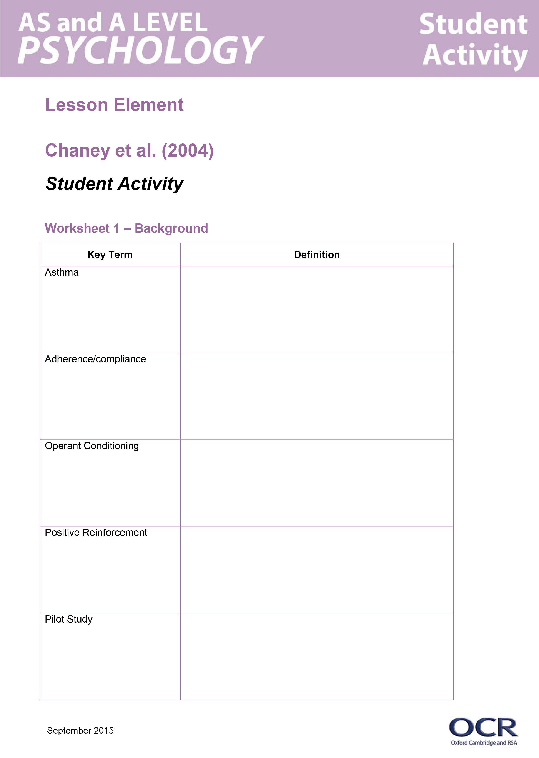
Instructions and answers for teachers

These instructions cover the student activity section which can be found on page 4. This Lesson element supports OCR AS and A Level Psychology.
When distributing the activity section to the students either as a printed copy or as a Word file you will need to remove the teacher instructions section.

Aim
The aim of this lesson element is to provide structured activities that will enable students to cover the specification requirements for Chaney et al.’s core study.

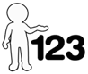
This activity offers an opportunity for English skills development.
This activity offers an opportunity for maths skills development.

Objectives
- Identity the sample.
- Explain the procedure of the study.
- Evaluate issues in relation to Chaney’s study.
- Apply the knowledge of the study to external influences on children’s behaviour and the area of developmental psychology.
- Explain how Chaney’s study pairs with Bandura’s.
- Explain how Chaney’s study applies to the behaviourist perspective.

Introduction to the task
Background and Summary
Chaney states that there is poor adherence to prescribed medication for asthmatics and that adherence doesn’t always improve with severity of illness. Chaney investigated a method of improving adherence to using inhalers in asthmatics by using the Funhaler – this incorporates incentive toys and so adopts the behaviourist perspective, particularly utilising operant conditioning and positive reinforcement.

Task Instructions
A copy of all 5 worksheets should be printed for each student.
For reference, the teacher should have a textbook/presentation/original articles/core study guide when students are completing these activities.

Task 1
The specification states that learners must know how to ‘tell a story’ of each core study. In order to support learners with this, task 1 requires them to research the participants used in the study. This could be done using textbooks, the OCR Guide to Core Studies, the internet, or the original article (particularly for high ability students). This worksheet also requires students to research key terms such as ‘asthma’ and ‘adherence’.
Worksheet 1 which follows, could also accompany a discussion. The class could discuss reasons why they have or have not adhered to medical regimes in the past. E.g. lack of education - if someone finishes their antibiotics before they were prescribed until, or because they no longer have any symptoms.
In addition, students can write a rationale for Chaney’s study and also note down the aim.

Task 2
Worksheet 2 also requires students to apply their previous knowledge of identifying the research method and design to Chaney’s study.
Learners can also record information about the participants used and should make note that in addition to the children used, the parents completed a questionnaire and participated in a phone interview.
To support learners with understanding the procedure of Chaney’s study, this worksheet requires learners to describe the procedure used. Teachers could create a ‘fill in the gaps’ exercise for this, or learners could research the procedure (using a textbook, core studies guide, or the original journal) to complete this.

Task 3
Worksheet 3 gives learners the chance to record four key findings and conclusions about the study. Learners could complete this task through the use of other resources.

Task 4
The specification requires learners to be able to evaluate the core studies using methodological issues. Worksheet 4 considers some of these issues and asks learners to define the key issues (by applying prior knowledge) and then apply the issues to Chaney’s study. Students could be asked to contextualise each answer as an extension activity. Alternatively, this table could also be made in to a mind-map and additional issues could be added as an extension.
This resource could be completed without a textbook, although some lower ability students may benefit from using one.

Task 5
The specification requires learners to be able to apply their knowledge of the study to a key theme (in this case, ‘external influences on children’s behaviour,) an area (developmental psychology) and a perspective (behaviourism). Worksheet 5 provides some questions that learners can answer in pairs, these can be used as a basis for class discussion.
OCR Resources: the small print
OCR’s resources are provided to support the teaching of OCR specifications, but in no way constitute an endorsed teaching method that is required by the Board, and the decision to use them lies with the individual teacher. Whilst every effort is made to ensure the accuracy of the content, OCR cannot be held responsible for any errors or omissions within these resources.
© OCR 2015 - This resource may be freely copied and distributed, as long as the OCR logo and this message remain intact and OCR is acknowledged as the originator of this work.
OCR acknowledges the use of the following content: Maths icon: Air0ne/Shutterstock.com
Please get in touch if you want to discuss the accessibility of resources we offer to support delivery of our qualifications: resources.feedback@ocr.org.uk
OCR Resources: the small print
OCR’s resources are provided to support the teaching of OCR specifications, but in no way constitute an endorsed teaching method that is required by the Board, and the decision to use them lies with the individual teacher. Whilst every effort is made to ensure the accuracy of the content, OCR cannot be held responsible for any errors or omissions within these resources.
© OCR 2015 - This resource may be freely copied and distributed, as long as the OCR logo and this message remain intact and OCR is acknowledged as the originator of this work.
OCR acknowledges the use of the following content: Maths icon: Air0ne/Shutterstock.com
Please get in touch if you want to discuss the accessibility of resources we offer to support delivery of our qualifications: resources.feedback@ocr.org.uk
OCR Resources: the small print
OCR’s resources are provided to support the teaching of OCR specifications, but in no way constitute an endorsed teaching method that is required by the Board, and the decision to use them lies with the individual teacher. Whilst every effort is made to ensure the accuracy of the content, OCR cannot be held responsible for any errors or omissions within these resources.
© OCR 2015 - This resource may be freely copied and distributed, as long as the OCR logo and this message remain intact and OCR is acknowledged as the originator of this work.
OCR acknowledges the use of the following content: Maths icon: Air0ne/Shutterstock.com
Please get in touch if you want to discuss the accessibility of resources we offer to support delivery of our qualifications: resources.feedback@ocr.org.uk
OCR Resources: the small print
OCR’s resources are provided to support the teaching of OCR specifications, but in no way constitute an endorsed teaching method that is required by the Board, and the decision to use them lies with the individual teacher. Whilst every effort is made to ensure the accuracy of the content, OCR cannot be held responsible for any errors or omissions within these resources.
© OCR 2015 - This resource may be freely copied and distributed, as long as the OCR logo and this message remain intact and OCR is acknowledged as the originator of this work.
OCR acknowledges the use of the following content: Maths and English icons: Air0ne/Shutterstock.com, Funhaler image taken from http://psychyogi.org/
Please get in touch if you want to discuss the accessibility of resources we offer to support delivery of our qualifications: resources.feedback@ocr.org.uk
We’d like to know your view on the resources we produce. By clicking on ‘Like’ or ‘Dislike’ you can help us to ensure that our resources work for you. When the email template pops up please add additional comments if you wish and then just click ‘Send’. Thank you.
If you do not currently offer this OCR qualification but would like to do so, please complete the Expression of Interest Form which can be found here: www.ocr.org.uk/expression-of-interest
We’d like to know your view on the resources we produce. By clicking on ‘Like’ or ‘Dislike’ you can help us to ensure that our resources work for you. When the email template pops up please add additional comments if you wish and then just click ‘Send’. Thank you.
If you do not currently offer this OCR qualification but would like to do so, please complete the Expression of Interest Form which can be found here: www.ocr.org.uk/expression-of-interest
We’d like to know your view on the resources we produce. By clicking on ‘Like’ or ‘Dislike’ you can help us to ensure that our resources work for you. When the email template pops up please add additional comments if you wish and then just click ‘Send’. Thank you.
If you do not currently offer this OCR qualification but would like to do so, please complete the Expression of Interest Form which can be found here: www.ocr.org.uk/expression-of-interest
We’d like to know your view on the resources we produce. By clicking on ‘Like’ or ‘Dislike’ you can help us to ensure that our resources work for you. When the email template pops up please add additional comments if you wish and then just click ‘Send’. Thank you.
If you do not currently offer this OCR qualification but would like to do so, please complete the Expression of Interest Form which can be found here: www.ocr.org.uk/expression-of-interest

Lesson Element

Chaney et al. (2004)

Student Activity

Worksheet 1 – Background
Key Term | Definition
Asthma
Adherence/compliance
Operant Conditioning
Positive Reinforcement
Pilot Study
Why people adhere to medical regimes | Why people don’t adhere to medical regimes
Rationale for Chaney’s study (why the study was conducted?)
Aim of Chaney’s study

Worksheet 2 – Procedure
Research Method (lab/field/quasi)

Research Design

Participants

Procedure
https://www.youtube.com/watch?v=6xhh8PowaKs

Worksheet 3 – Findings and conclusions
Finding 1
Finding 2
Finding 3
Finding 4
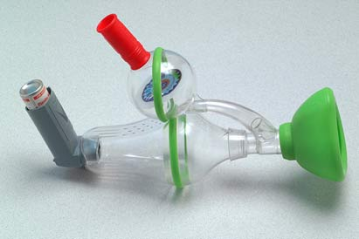
Figure 1: Photo of funhaler device
(Image taken from http://psychyogi.org/)

Conclusion

Worksheet 4 – Methodological issues
Ethics | How the study is ethical and why | How the study is unethical and why
Definition:
Validity | How the study is valid and why | How the study is invalid and why
Definition:
Reliability | How the study is reliable and why | How the study is unreliable and why
Definition:
Ethnocentrism | How the study is ethnocentric | How the study is cross-cultural
Definition:
Sampling Bias | How the sampling method doesn’t have bias | How the sampling method has bias
Definition:

Worksheet 5 – Key questions
How does the study apply to the key theme of ‘external influences on children’s behaviour’?
How does the study apply to the area of ‘Developmental Psychology’?
How does the study apply to the Behaviourist Perspective?
What is one similarity between Bandura’s study and Chaney’s study?
What is one difference between Bandura’s study and Chaney’s study?

