Lesson Element

Component 3 – Applied Psychology

Section A: Issues in Mental Health (Compulsory Topic)

Topic: The Historical Context of Mental

Key Research: Rosenhan (1973) – On being sane in insane places.

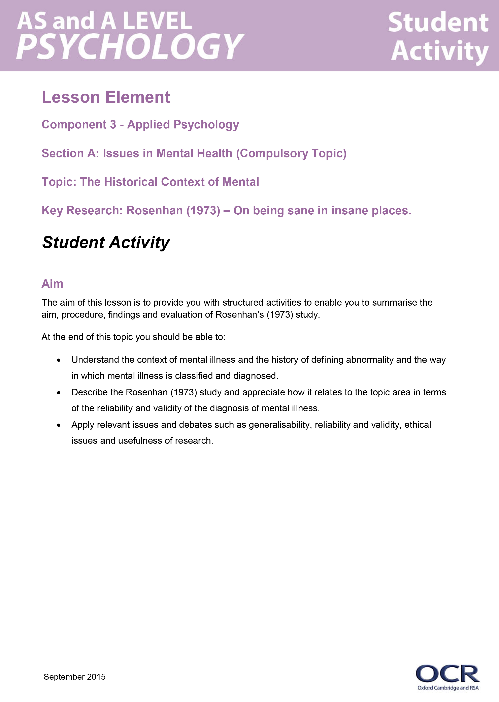
Instructions and answers for teachers

These instructions cover the student activity section which can be found on page 5. This Lesson element supports OCR AS and A Level Psychology.
When distributing the activity section to the students either as a printed copy or as a Word file you will need to remove the teacher instructions section.

Aims
The aim of this lesson is to provide structured activities to enable students to summarise the aim, procedure, findings and evaluation of Rosenhan’s (1973) study.
Students should be able to:
- Understand the context of mental illness and the history of defining abnormality and the way in which mental illness is classified and diagnosed.
- Describe the Rosenhan (1973) study and appreciate how it relates to the topic area in terms of the reliability and validity of the diagnosis of mental illness.

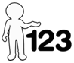
- Apply relevant issues and debates such as generalisability, reliability and validity, ethical issues and usefulness of research.
This activity offers an opportunity for English skills development.
This activity offers an opportunity for maths skills development.

Summary and Background
Rosenhan’s 1973 study aimed to investigate the reliability of staff in psychiatric hospitals to identify the sane from the insane. He wanted to see if people who posed as mentally ill would be identified by staff in psychiatric hospitals as sane rather than insane. The participants he used had never been diagnosed with a mental illness.
Rosenhan asked eight ‘sane’ people to telephone psychiatric hospitals for urgent appointments, complaining of hearing unclear voices saying ‘thud, hollow, empty’. All eight were admitted to hospital and all but one was diagnosed with schizophrenia, the other with manic-depressive psychosis. Upon admission, all pseudo-patients stopped showing any symptoms and took part in ward activities.
The average length of stay was 19 days. All participants had agreed to stay until they had convinced staff they were no longer ill. On release, the pseudo-patients were given the diagnosis of schizophrenia ‘in remission’. In a second follow up study one hospital was told that sometime over the next three months, one or more pseudo-patients would try to be admitted, and hospital staff were asked to rate the patients who presented themselves on a scale of 1-10 on the likelihood of them being a pseudo-patient. 44% were judged by at least one member of staff to be a pseudo patient. Rosenhan concluded that we cannot reliably distinguish the sane from the insane, and that hospitalisation and labelling can lead to depersonalisation, powerlessness and segregation which are counter-therapeutic.

Student misconceptions
Whilst the procedure in this study might seem straightforward, this is probably one of the few studies students will encounter which is a field study. It also has elements of participant observation, as well as self-report. Rosenhan himself was one of the participants in the study and participated as a pseudo patient. It must be stressed that the participants did not have, nor had any mental illness previously. They changed their names and some changed their profession (some were psychiatrists and psychologists). They all complained only once of hearing a voice saying ‘thud, empty, hollow’ but once admitted to hospital behaved normally, apart from taking notes whilst in there.

Teacher preparation
Possible student questions:
Q: What happened if the pseudo patients were given medication?
All the patients were prescribed medication, however they did not swallow it. They also noted that many of the actual patients did not take their medication either.

Q: How did the pseudo patients get out?
The pseudo patients were told by Rosenhan that in order to get released they had to convince staff they were sane. The stay in hospital ranged from 7 – 52 days. The average stay was 19 days.

Q: Were the other patients suspicious?
Visitors and other patients believed they were sane and voiced their suspicions. ‘The fact that the patients often recognised normality when staff did not raises important questions’ (Rosenhan, D.L. (January 19, 1973). "On Being Sane in Insane Places". Science (American Association for the Advancement of Science) 179 (4070): p385). This suggests a Type 1 error (although Rosenhan referenced it as a type 2), where Doctors were more likely to be biased in diagnosing the healthy as sick and to err on the side of caution.

Q: What happened during their stay in hospital?
It was noted that there was very little contact with doctors during their stay and there was a lot of segregation between staff and patients. Doctors were rarely seen on the wards, and the higher status they had the less likely they were to be seen. Their behaviour was often interpreted in light of the label of ‘schizophrenia’, such as waiting by the café before lunch was seen as ‘oral-acquisitive nature’, for which excessive note taking was seen as a symptom. There was also a lack of normal interaction between patients and staff, who often gave brief or irrelevant answers to courteous questions.

Q: What happened to the pseudo patients when they were released?
7/8 pseudo patients were given the diagnosis of schizophrenia in remission. This means that even though they showed no further signs of illness it was assumed that it was lying dormant and may reappear at some point. This labelling, Rosenhan believed, was ‘sticky’ and once labelled with a mental disorder, other’s perception of a person is clouded by that label and behaviour interpreted in light of the label. Additionally the label is extremely difficult to get rid of.

Q: Could this happen today?
The way schizophrenia is diagnosed today is different to when Rosenhan carried out his study. Patients would have to show more symptoms and over a longer period of time for this diagnosis to be made now.

Teacher Guidance for Student Activities

Activity 1
The specification requires that students can describe the piece of research and how it relates to the topic area. The Rosenhan study relates to the historical context of mental health, in particular the way in which mental illness is diagnosed and how patients who have been diagnosed with a mental illness are subsequently treated.
To support learners with an understanding of the context of this study, task 1 requires them to research the key terms and concepts within the medical model of mental illness. This could be done using textbooks or the internet. Students requiring stretch and challenge could read the original article.
There are clips from a documentary on the Rosenhan study on YouTube, for example:
https://www.youtube.com/watch?v=D8OxdGV_7lo
Additionally, the episode of The Simpsons: Stark Raving Dad illustrates very clearly the ‘stickiness’ of being labelled with a psychiatric illness. Read the plot summary here:
https://en.wikipedia.org/wiki/Stark_Raving_Dad

Activity 2
You may wish to present a brief outline of the study and its findings and discuss some of the issues that arise from the study. In particular, issues of reliability and validity.
Students work in pairs, using textbook resources, the internet, or a copy of the original study, and fill in the study outline sheet. They should take it in turns for each point, write out the point and if necessary have prompts from their partner. This leads to more co-operative learning and they can often get more detail.

Activity 3
Fan and Pick Activity
Students work in groups of four. If possible, in each group, have a mix of ability. Make cards using the questions on the sheet. The answers can be printed on the back as exemplars or for prompts.
Player 1 fans out the cards and player 2 picks one and reads the question. Player 3 answers the question and player 4 paraphrases the answer. The pack is then passed on and the process repeated.

OCR Resources: the small print
OCR’s resources are provided to support the teaching of OCR specifications, but in no way constitute an endorsed teaching method that is required by the Board, and the decision to use them lies with the individual teacher. Whilst every effort is made to ensure the accuracy of the content, OCR cannot be held responsible for any errors or omissions within these resources.
© OCR 2015 - This resource may be freely copied and distributed, as long as the OCR logo and this message remain intact and OCR is acknowledged as the originator of this work.
OCR acknowledges the use of the following content: Maths icon: Air0ne/Shutterstock.com
Please get in touch if you want to discuss the accessibility of resources we offer to support delivery of our qualifications: resources.feedback@ocr.org.uk
We’d like to know your view on the resources we produce. By clicking on ‘Like’ or ‘Dislike’ you can help us to ensure that our resources work for you. When the email template pops up please add additional comments if you wish and then just click ‘Send’. Thank you.
If you do not currently offer this OCR qualification but would like to do so, please complete the Expression of Interest Form which can be found here: www.ocr.org.uk/expression-of-interest

Lesson Element

Component 3 - Applied Psychology

Section A: Issues in Mental Health (Compulsory Topic)

Topic: The Historical Context of Mental

Key Research: Rosenhan (1973) – On being sane in insane places.

Student Activity

Aim
The aim of this lesson is to provide you with structured activities to enable you to summarise the aim, procedure, findings and evaluation of Rosenhan’s (1973) study.
At the end of this topic you should be able to:
- Understand the context of mental illness and the history of defining abnormality and the way in which mental illness is classified and diagnosed.
- Describe the Rosenhan (1973) study and appreciate how it relates to the topic area in terms of the reliability and validity of the diagnosis of mental illness.
- Apply relevant issues and debates such as generalisability, reliability and validity, ethical issues and usefulness of research.

Task 1: Background and context of Rosenhan’s (1973) study ‘On being sane in insane places.’
Rosenhan’s study is based on the historical context of mental health. In order to understand the background to the study it will be helpful to be aware of some of the concepts and issues on which this study is based. Using the resources available to you complete the table of key terms and explain what is meant by each term.
Medical model of mental illness
Psychiatry
Diagnostic and Statistical Manual of Mental Illness (DSM)
Main features of schizophrenia
Labelling
Institutionalisation
Pseudo Patient

Task 2: Key points of the study
Work with a partner to complete the boxes to summarise the key points in the study.
Aim of the study – include the terms 8, 12, sane, insane, reliability and diagnosis in your description of the aim.

Sample (include description of the pseudo patients and the hospital staff):
Setting:
Procedure for gaining access to hospital:
Procedure once in hospital:
How information was gathered:

Findings
Diagnoses given:
Response of other patients:
Length of stays:
Staff/patient interaction notes:
An example of how the pseudo patients’ behaviour was seen as an aspect of mental illness:

Procedure 2 (no pseudo patients) - description and findings

Conclusions:

Evaluation
Method (strengths and weaknesses)

Generalisability:

Reliability:

Validity:

Ethics:

Task 3: Fan and Pick
Work in a group of four.
Player 1 fans out the cards containing questions relating to the Rosenhan study.
Player 2 picks a card and reads out the question, Player 3 Answers the question, Player 4 paraphrases the answer and adds further detail to the answer. Player 1 passes cards to player 2 and repeats the process until all the cards have been answered.
Set of cards containing the following questions
Q: What is the name of the diagnostic tool used in the USA? | A: Diagnostic and statistical manual of mental disorders (DSM1V).

Q: Give a general aim of Rosenhan’s study. | A: To test the reliability and validity of psychiatric diagnosis.

Q: What type of method was used? | A: Naturalistic/participant Observation.

Q: Who were the participant observers? | A: 8 pseudo patients, 5 men, 3 women, various ages and occupations. Rosenhan was one of them.

Q: How many hospitals were involved in the first study? | A: 12, across different states. Some were well off and had many staff, some were less well off with fewer staff.

Q: What was the aim of the first study? | A: To see if sane people who presented themselves to a psychiatric hospital demonstrating one symptom would be diagnosed as insane.

Q: What was the aim of the second study? | A: To see if hospital staff would suspect genuinely insane patients as sane.

Q: How many hospitals were involved in the 2nd study? | A: 1.

Q: What symptom did the pseudo patients present with in the first study? | A: Hearing a voice say ‘Thud’, ‘empty’, ‘hollow’.

Q: Once the pseudo patients had been admitted, what did they do? | A: Stopped pretending to hear voices, told staff they felt well, and took part in activities.

Q: How did the pseudo patients collect data? | A: By making notes of what they observed, firstly in secret then openly. This was interpreted as a symptom of their illness.

Q: How many pseudo patients were admitted to hospital? | A: 7 out of 8.
Q: How long did the pseudo patients stay in hospital? | A: 7 – 52 days, 19 days being the average.

Q: How did they get out of hospital? | A: They had to convince staff they were sane.

Q: What diagnosis was given to the pseudo patients? | A: Schizophrenia in remission.

Q: How did the other patients respond to the pseudo patients? | A: They accused them of being sane, and that they were a ‘journalist’ or ‘professor checking up on the hospital’.

Q: What is a type 1 error? | A: Calling a healthy person sick.

Q: Why do you think the staff were more likely to make a type 1 error? | A: Due to the situation. The pseudo patients did present with a symptom, and it is less risky to call a healthy person sick than a sick person healthy.

Q: What results were found in relation to staff-patient interaction? | A: Staff spent most of their time segregated. Doctors were hardly seen. When asked questions, staff only have short answers and little eye contact.

Q: What can be concluded from the first study? | A: Diagnosis is reliable as they were all given the diagnosis of schizophrenia. However it is not a valid diagnosis as there were not enough symptoms. Doctors cannot detect the sane from the insane.

Q: What did Rosenhan tell the hospital used in the second study? | A: That over the next three months one or more pseudo patients would present themselves. They were to rate all new patients on a scale of 1-10 on whether they were genuine or not.

Q: How many pseudo patients were sent in the second study? | A: None.

Q: In what way is Rosenhan’s study generalisable? | A: 12 hospitals were used across 5 states so could be said to be fairly representative, but not to the rest of the world.

Q: Give a problem with this study being done in the field? | A: Although high in ecological validity, there is a lack of control which could make the results less valid. For example, differences in staff could affect the results.

Q: In what ways could the study be said to be unethical? | A: The hospital staff was unaware of the pseudo patients so were deceived. The pseudo patients were told to stay in hospital until they were released, so could be said to have been unable to withdraw from the study. They could also have suffered harm.

Q: How could Rosenhan’s study be improved? | A: Replicating it today and across different countries.

Q: How were the pseudo patients depersonalised? | A: Staff ignored direct questions, avoided eye contact.

Q: Explain how useful this study is in terms of improving the way we diagnose and treat people with mental illness? | A: It is useful for staff in hospitals as they can treat patients with more humanity, spend more time with them and be aware not to interpret all behaviour in terms of the illness. Diagnoses have become more rigorous and patients have to show more symptoms over a longer period to be diagnosed today.

