Lesson Element

Communication skills in the workplace

Instructions and answers for tutors

(Activities 1-6)

These instructions cover the learner activity section which can be found on page 17. This Lesson element supports Cambridge Progression and Life Skills.
When distributing the activity section to the learners either as a printed copy or as a Word file you will need to remove the tutor instructions section.

The activity
This Lesson Element supports the Project Approach, Effective communication for work,
Pre-employment Skills. This Lesson Element contains six activities. A further six activities (Activities 7-12) are contained within the Lesson Element Personal skills and qualities which also support the Project Approach, Effective communication for work, Pre-employment Skills.
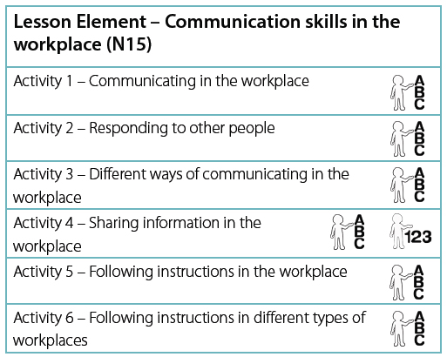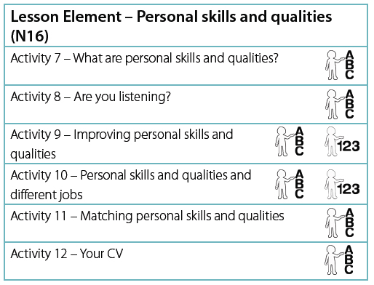
In this Lesson Element, learners could complete a number of activities which will enable them to consider different aspects of communication in the workplace.
ABC – This activity offers an opportunity for English skills development.
123 – This activity offers an opportunity for maths skills development.
WORK – This activity offers an opportunity for work experience.

Activity 1 – Communicating in the workplace
Tell the learners that, to be effective in the workplace, people have to communicate with other people. Write the following list of things they may need to do at work:
- Speak to others in a friendly and polite way.
- Listen carefully to people and follow instructions.
- Use verbal and non-verbal ways of showing that you are listening to others.
- Ask and answer questions.
- Be involved in discussions.
- Read and write information, e.g. instructions, emails, messages and letters.

Put the following three answer options on the whiteboard and ask them to choose the best way (by ticking the box) to show that you are NOT listening to someone who is talking to you at work:
Make eye contact.
Look at the floor.
Sit up straight.

Ask the learners to suggest ways of showing that you are listening to someone who is speaking to you at work. Use the suggestions to promote a group discussion on the topic.
Ask the learners to work in pairs. Give each pair a set of ‘Dos and Don’ts’ cards (on the next page) and ask them to organise them under the two headings – ‘Do this at work’ and ‘Do not do this at work’.

Headings:
Do this at work | Do not do this at work

Cards (to be cut out):

Say ‘Hello. How can I help you?’ to a customer. | Hang up the telephone without saying goodbye. | Read a set of instructions to help you work a new piece of office equipment.
Sleep at the computer. | Sit up straight to show that you are paying attention. | Give a polite response to someone’s opinion in a discussion.
Send text messages to your friends all day. | Shout gossip to other employees. | Smile at a customer.
Listen carefully to your manager in a staff meeting. | On a Monday morning, ask another employee if they had a nice weekend. | Eat chips while talking to a customer on the telephone.
Look bored. | Play rock music loudly on your phone. | Ask another employee for help if you are not sure about something.
Allow other people to talk during a discussion. | Put your feet up on your office desk. | Say ‘this is a rubbish place to work’ to a customer.

Ask the learners to work in pairs to create a poster about effective communication in the workplace.
Activity 2 – Responding to other people
Remind the learners of the importance of responding appropriately to other people who are speaking to you at work, e.g., sit up straight to show that you are paying attention.
Tell the learners that you are going to show them a short video clip that demonstrates poor communication and behaviour in a hotel. (You could also use an alternative suitable resource for this activity.)
Link to a clip:
www.youtube.com/watch?v=TFMpySg_UrM
Ask them to identify poor behaviour and communication from the clip. Write their suggestions on the whiteboard.
Ask the learners to work in pairs. Identify who will be Person A and who will be Person B. Give the learners the appropriate scenario card and ask them to read it and carry out a role-play.
Scenario Card – Person A  You are a nice customer at a restaurant.  You have been a customer for two years. The food and service at the restaurant has always been very good.  Today, the food and service is poor.  You have not been seated at your usual table.  You have had to wait 30 minutes before being given the menu.  You have had to wait another 30 minutes for your food to arrive.  The food is not what you ordered and it is cold.  You are not happy!  You decide to tell the waiter why you are not happy.  You do not want to pay for this meal.  You try your best to stay polite at all times. | Scenarion Card – Person B  You started working as a waiter at the restaurant one week ago.  You don’t like the job.  Today, the chef is ill and you have been left to cook and serve all of the food.  You are doing your best, but one of the customers is complaining.  You really can’t be bothered with this.  You look at the ceiling while the customer is talking to you.  You take out a piece of gum and start chewing it.  You sigh, huff and puff.  You keep shaking your head.  You then put your fingers in your ears while the customer is talking.  You give the customer the bill and tell him (very loudly and rudely) that you will call the police if he does not pay

Learners can be encouraged to repeat their role-play to the rest of the group, if they feel comfortable enough to do this.
Explain to the learners, that the role-play demonstrated ineffective communications skills when dealing with a customer’s complaint.
Ask the learners to work in small groups to brainstorm how the waiter should have behaved and communicated and to record their ideas in the diagram in the learner activity booklet.
These are some sample answers:
The waiter should have:
- Made eye contact with the customer.
- Nodded his head to show that he was listening and understanding of the issues.
- Apologised politely to the customer.
- Suggested that he could ask the manager about reducing the cost of the meal.
The waiter should not have:
- Chewed gum whilst speaking and listening to the customer.
- Signed, huffed and puffed and shook his head.
- Put his fingers in his ears.
- Been loud and rude.
Explain to the learners that it is important to give appropriate and polite verbal and non-verbal responses to views that are different to their own. Write the following two examples on the whiteboard:
You think: | Your friend thinks: | Your verbal response is:
Classical music is boring | Classical music is relaxing | “I can understand why you think that.”

You think: | Your friend thinks: | Your non-verbal response is:
Running is the best way to keep fit | Running is hard work and boring | Nod and smile

Ask the learners to work in pairs to think of views that may differ from their own. Ask them to think of polite verbal and non-verbal ways that they could respond to these different views. Ask the learners to feedback their ideas to the whole group.

Activity 3 – Different ways of communicating in the workplace
Explain to the learners that we use different ways of communicating information for different purposes at work.
Write the following ways of communicating information for different purposes at work on the whiteboard:
- Invitation – used to invite customers to a special event.
- Telephone call – to ask another company if a product is in stock.
Ask the learners to work in pairs to discuss other different ways of passing on information to others at work.
Ways of passing information onto customers or other employees at work
For example,
1. Make a telephone call.
2.
3.
4.
5.

Ask the learners to work alone to complete the three questions (in the learner activity booklet) about choosing the best ways of passing on information to others.

Question 1
You want to tell your boss that you are going to be ten minutes late for work.
Tick the best way of passing on this information.
Put a leaflet in the post
Send a text message

Question 2
You want to tell a customer that an item they have ordered is ready for collection.
Tick the best way of passing on this information.
Make a telephone call
Send a birthday card

Question 3
You want to tell your colleague that his dad called in while he was out of the office.
Tick the best way of passing on this information.
Send him a formal letter
Write a message on a post-it note

Ask the learners to work in pairs to develop a presentation about the different ways of communicating information at work and what they could be used for. Ask the learners to deliver the presentation to the rest of the group.
Explain to the learners that it is important to change ‘how you speak’ or ‘what you say’ depending on the situation you are in at work. Write these examples on the whiteboard:
A new customer says: | You say: | The situation is:
Hello | “Good morning. How can I help you?” | Formal

A friend calls in to see you at work and says: | You say: | The situation is:
Hi Jo | “Hi, it’s great to see you!” | Informal

Ask the learners to work in pairs to think of one formal and one informal situation at work and to write down what might be said in each one of them.
Example answer:
Formal
The supervisor says: “Please can you work late tonight?”
The new employee says: “I don’t think that will be a problem. What time would you like me to work until?”

Activity 4 – Sharing information in the workplace
Tell the learners that when we are at work we often have to share information with other employees. Write the following example on the whiteboard:
- Email a colleague to tell them about a staff meeting.
Explain that a job acceptance letter is a formal letter and a text message to a friend is informal. Emails between people who work together tend to be written in a semi-formal way.
Go through the list of ‘Dos and ‘Do Nots’ for writing emails with the learners below.
Ask them to underline or highlight key information in the lists.
Example of key information highlighted.
DO | DO NOT
Say what the email is about in the subject line. | Give personal information (the email could end up in the wrong hands)
Write in short sentences. | Use capital letters to write whole words, as this may be seen as shouting.
Write in paragraphs to make sure the message is clear. | Use exclamation marks.
Use ‘Hello …. (person’s name)’ to start the message. | Use shortened words like ‘u’ and ‘cos’, as the reader of the email may not understand them.
Use ‘Regards …… (your name)’ to end the message. | Use emoticon icons, as they are not professional.  For example. ☺

Ask them to write an email to a work colleague. They can either use the template in their learner task sheet or use ICT equipment to complete the task.
Tell them that their co-worker is called Ali Smith and he needs to know the following:
- There is a staff meeting this week.
- It will take place on Friday at 1pm.
- The meeting will be held in the conference room.
- A free lunch will be provided.
- Staff will need to bring a pen and paper to make notes.
- The meeting will last one hour.
- All staff must attend.
Ask the learners to proof read the work. Explain that this means that they should correct any errors in punctuation, spelling and grammar.
Ask the learners to work in small groups to think of other times when staff may need to communicate with each other and to identify the best method of communicating the information.
Encourage them to record their thoughts and ideas in the diagram in their learner task sheet and to feedback these back to the group.

Example answers:
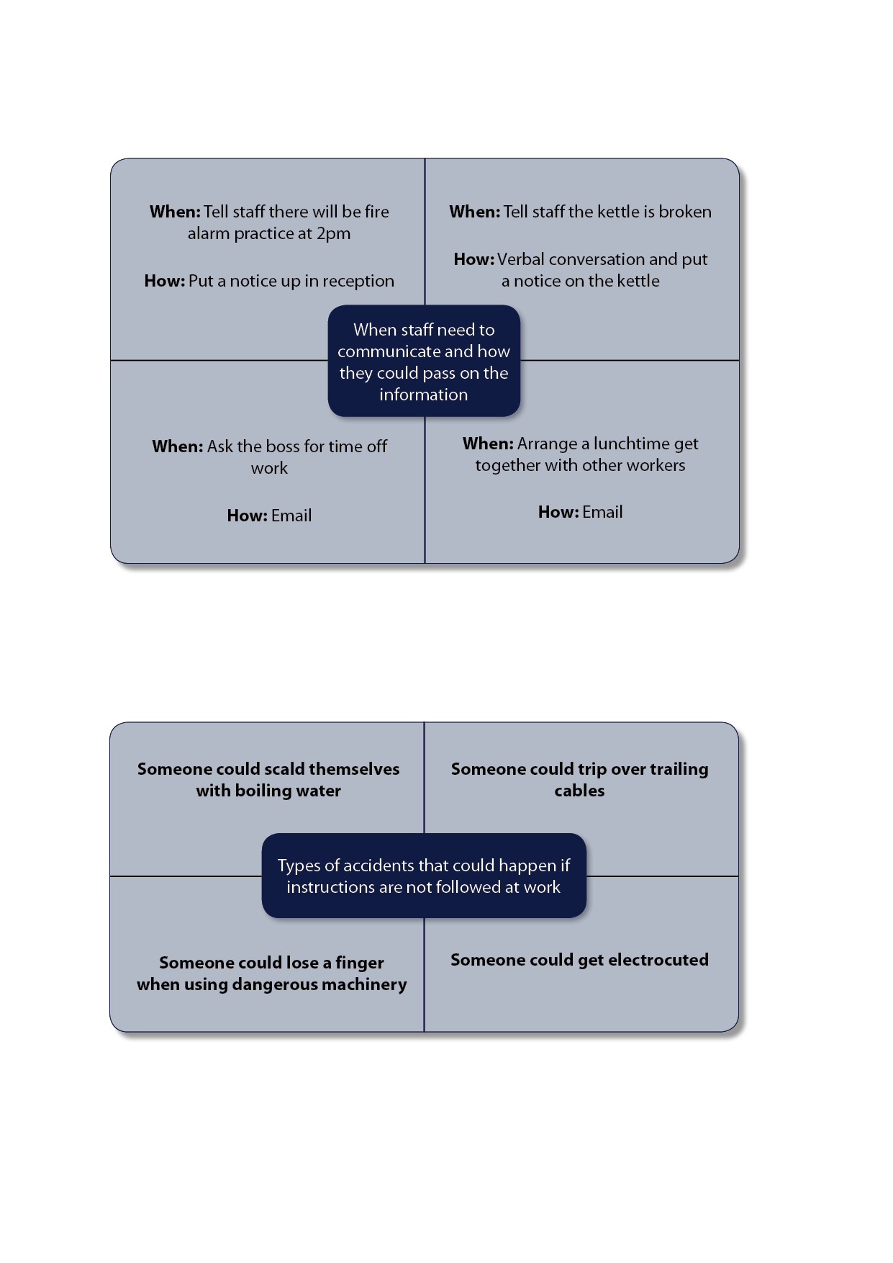

Activity 5 – Following instructions in the workplace
Explain to the learners that when people are at work they often have to follow instructions. Tell them that instructions can be spoken or written down. Explain that the purpose of written instructions is to describe how something is done through a series of steps.
Write the following titles of written instructions on the whiteboard and tell the learners that these are often found in an office workplace.
- How to use a photocopier.
- How to use computer equipment safely.
Write the following key features of instructional texts on the whiteboard:
- Titles often start with ‘How to…’
- Numbered points are used to sequence/order the steps.
- Sentences start with a verb (e.g. Use oven gloves to remove the tray from the oven).
Read out the following set of instructions to the group and ask the learners to answer the three questions in their learner task sheet. Answers highlighted.
Car World UK

How to deal with a customer collecting a new car

- Greet the customer, by saying ‘Good morning’ or ‘Good afternoon’.
- Ask the customer his or her name.
- Ask the customer to take a seat in the waiting area.
- Ask the customer whether they would like a cup of tea or coffee while they wait for their new car to be driven to the front of the showroom.
- Make the customer a drink, if required.
- Call the driver and ask him to drive the customer’s car onto the forecourt.
- Once the car has arrived, give the customer the car keys.
- Last, wish the customer a safe and enjoyable drive home in their new car.
REMEMBER to be polite at all times.
Ask the learners to work in pairs. Give each pair a set of cut out instructions (below) and ask them to put the instructions in the correct order.

Set of instructions to be cut out.
Greet the customer, by saying ‘Good morning’ or ‘Good afternoon’.

Ask the customer his or her name.

Ask the customer to take a seat in the waiting area.

Ask the customer whether they would like a cup of tea or coffee while they wait for their new car to be driven to the front of the showroom.

Make the customer a drink, if required.

Call the driver and ask him to drive the customer’s car onto the forecourt.

Once the car has arrived, give the customer the car keys.

Last, wish the customer a safe and enjoyable drive home in their new car.

Activity 6 – Following instructions in different types of workplaces
Explain to the learners that there are many different types of work place, e.g. building sites, offices, restaurants etc. Ask the learners to work in pairs to discuss and list the different types of working environments.
In their paired groups, ask the learners to think of instructions that may need to be followed in each of the work places. Ask the learners to write these down and feedback their ideas to the group.
Explain to the learners that instructions at work need to be followed accurately. Talk about what could happen if an employee did not follow instructions, e.g. someone could have a serious accident if they do not follow instructions about how to use a ladder correctly/safely.
Show the learners a video clip about accidents at work. (You could also use an alternative suitable resource for this activity.)
Video link:
www.hse.gov.uk/aboutus/realpeople.htm
Ask the learners to work in small groups to identify the types of accidents that could happen if instructions are not followed carefully. Ask them to record their thoughts and ideas using the diagram in their learner task sheet.
Example answers:
Give each learner the ‘Safety at Work’ activity instructions and the ‘Safety at work’ cards (below).
Ask them to follow the instructions to carry out the activity.
Safety at Work activity instructions
Look at the cards.
Match each ‘Instruction’ card to the correct ‘Employee’ card.
Show your tutor your work when you have finished.
‘Safety at work’ cards – to be cut up
Employee:  Jim works in a kitchen. | Instruction:  Turn pot handles away from the front of the cooker. | Employee:  Ali works on a building site. | Instruction:  Safety helmets must be worn at all times.
Employee:  Nadeem works in a hospital. | Instruction:  Wash your hands using the anti-bacterial soap provided. | Employee:  Petra works in an office. | Instruction:  Close filing cabinet drawers when not in use.
Employee:  Phil works on a boat. | Instruction:  Wear a lifejacket when on board. | Employee:  Jo works in a hair salon. | Instruction:  Handle scissors carefully to avoid cuts.

Once the activity is completed, explain to the learners that, in carrying out the task, they have followed instructions.
Provide feedback to the learners about how accurately the instructions were followed.

OCR Resources: the small print
OCR’s resources are provided to support the teaching of OCR specifications, but in no way constitute an endorsed teaching method that is required by the Board, and the decision to use them lies with the individual teacher. Whilst every effort is made to ensure the accuracy of the content, OCR cannot be held responsible for any errors or omissions within these resources.
© OCR 2015 - This resource may be freely copied and distributed, as long as the OCR logo and this message remain intact and OCR is acknowledged as the originator of this work.
Please get in touch if you want to discuss the accessibility of resources we offer to support delivery of our qualifications: resources.feedback@ocr.org.uk
We’d like to know your view on the resources we produce. By clicking on ‘Like’ or ‘Dislike’ you can help us to ensure that our resources work for you. When the email template pops up please add additional comments if you wish and then just click ‘Send’. Thank you.
If you do not currently offer this OCR qualification but would like to do so, please complete the Expression of Interest Form which can be found here: www.ocr.org.uk/expression-of-interest

Lesson Element

Communication skills in the workplace
Learner activity booklet

Activity 1 – Communicating in the workplace

To be successful in the workplace, people have to communicate with other people.
This is a list of things you need to do at work:
- Speak to others in a friendly and polite way.
- Listen carefully to people and follow instructions.
- Use verbal and non-verbal ways of showing that you are listening to others.
- Ask and answer questions.
- Be involved in discussions.
- Read and write information, e.g. instructions, emails, message and letters.
Tick the best way to show that you are NOT listening to someone who is talking to you at work:
Make eye contact.
Look at the floor.
Sit up straight.

Can you think of two other ways of showing that you are listening to someone who is speaking to you at work?
1
2
Your tutor will give you a set of ‘Dos and Do nots’ cards. Work in pairs and put them under the two headings:

Do this at work | Do not do this at work

Work in pairs to create a poster about effective communication in the workplace.

Activity 2 – Responding to other people
It is important to respond appropriately to other people who are speaking to you at work. For example, you should sit up straight to show that you are paying attention.
Your tutor will show you a short video clip that demonstrates poor communication and behaviour in a hotel.
Can you spot any poor behaviour or communication in the video clip?
Poor behaviour or poor communication in the video clip
1.
2.
3.
4.
Work in pairs to carry out a role-play. Your tutor will tell you who will be Person A and who will be Person B and give each of you a card that tells you what your role is.
Practise your role-play.
Act out your role-play to the rest of the group, if you are happy to do this.
Your role-play demonstrated poor communications skills when dealing with a customer who has a complaint.
Work in small groups to brainstorm how the waiter should have behaved and communicated and record your ideas in the diagram below.
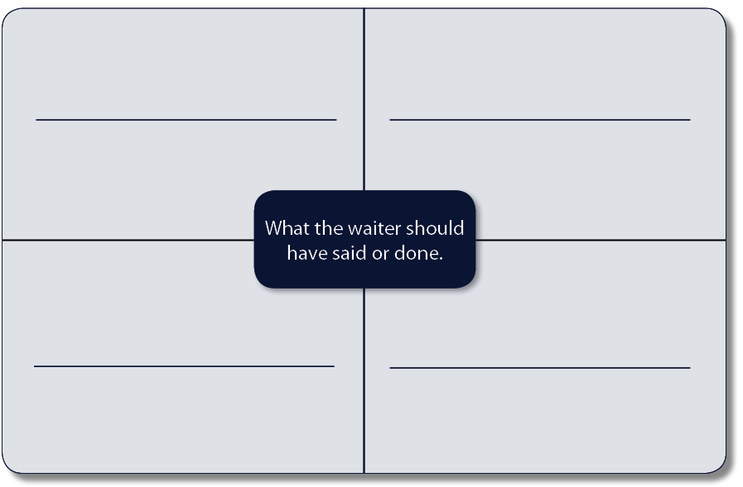
It is important to give appropriate and polite verbal and non-verbal responses to views that are different to your own. These are two examples:
You think: | Your friend thinks: | Your verbal response is:
Classical music is boring | Classical music is relaxing | “I can understand why you think that.”

You think: | Your friend thinks: | Your non-verbal response is:
Running is the best way to keep fit | Running is hard work and boring | Nod and smile

Work in pairs to think of views that may differ from your own and identify polite verbal and non-verbal ways that you could respond to these different views. Be prepared to feedback your ideas to the whole group.

Activity 3 – Different ways of communicating in the workplace
We use different ways of communicating information for different reasons at work.
These are some of the ways of communicating information for different reasons at work on the whiteboard:
- Invitation – used to invite customers to a special event.
- Telephone call – to ask another company if a product is in stock.
Work in pairs to discuss other ways of passing on information to others at work.
Ways of passing information onto customers or other employees at work
For example,
1. Make a telephone call.
2.
3.
4.
5.

Work alone to complete these three questions about choosing the best ways of passing on information to others.

Question 1
You want to tell your boss that you are going to be ten minutes late for work.
Tick the best way of passing on this information.
Put a leaflet in the post
Send a text message

Question 2
You want to tell a customer that an item they have ordered is ready for collection.
Tick the best way of passing on this information.
Make a telephone call
Send a birthday card

Question 3
You want to tell your colleague that his dad called in while he was out of the office.
Tick the best way of passing on this information.
Send him a formal letter
Write a message on a post-it note

In pairs, develop a presentation about the different ways of communicating information at work and what they could be used for.
Deliver the presentation to the rest of the group.
It is important to change ‘how you speak’ or ‘what you say’ depending on the situation you are in at work. These are two examples:
A new customer says: | You say: | The situation is:
Hello | “Good morning. How can I help you?” | Formal

A friend calls in to see you at work and says: | You say: | The situation is:
Hi Jo | “Hi, it’s great to see you!” | Informal

Work in pairs to think of one formal and one informal situation at work and write down what might be said.
__________________ says: | ____________________says: | The situation is:
 |  | Informal

__________________ says: | ____________________says: | The situation is:
 |  | Formal

Activity 4 – Sharing information in the workplace
When we are at work we often have to share information with other people that we work with.
For example, we might have to:
- Email a colleague to tell them about a staff meeting.
Emails between people who work together tend to be written in a semi-formal way.
A job acceptance letter is a formal letter.
A text message to a friend is informal.
This is a list of ‘Dos and ‘Don’ts’ for writing emails. Your tutor will go through the list with you. Underline or highlight key information in the lists.
DO | DON’T
Say what the email is about in the subject line. | Give personal information (the email could end up in the wrong hands)
Write in short sentences. | Use capital letters to write whole words, as this may be seen as shouting.
Write in paragraphs to make sure the message is clear. | Use exclamation marks.
Use ‘Hello …. (person’s name)’ to start the message. | Use shortened words like ‘u’ and ‘cos’, as the reader of the email may not understand them.
Use ‘Regards …… (your name)’ to end the message. | Use emoticon icons, as they are not professional.  For example ☺

Write an email to a work colleague. You can either use the template on the next page or use ICT equipment to complete the task.
Your co-worker is called Ali Smith and he needs to know the following:
- There is a staff meeting this week.
- It will take place on Friday at 1pm.
- The meeting will be held in the conference room.
- A free lunch will be provided.
- Staff will need to bring a pen and paper to make notes.
- The meeting will last one hour.
- All staff must attend.
You should proof read the work - this means that you should correct any errors in punctuation, spelling and grammar.

Email template

To:

Subject:

Work in small groups to think of other times when staff may need to communicate with each other and to identify the best method of communicating the information.
Record your thoughts and ideas in the diagram below.

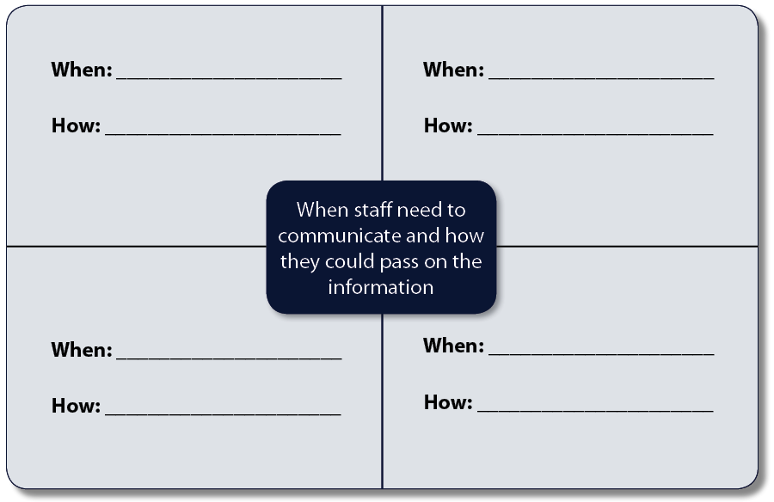

Tell the group about your ideas.

Activity 5 – Following instructions in the workplace

When people are at work they often have to follow instructions.
Instructions can be spoken or written down. The purpose of written instructions is to describe how something is done through a series of steps.
These are some examples of titles of written instructions:
- How to use a photocopier.
- How to use computer equipment safely.
These key features of instructional texts:
- Titles often start with ‘How to…’
- Numbered points are used to order the steps.
- Sentences start with a verb (e.g. Use oven gloves to remove the tray from the oven).
Your tutor will read out a set of instructions.
Listen to the instructions and answer the three questions below.

Question 1

Where should you ask the customer to take a seat?

Answer _________________________________________________

Question 2

What type of drink should you offer the customer?

Answer _________________________________________________
Question 3

What should you remember to be at all times?

Answer _________________________________________________

Your tutor will give you a set of instructions. Work in pairs to put the instructions in the correct order.

Activity 6 – Following instructions in different types of workplaces

There are many different types of work place, e.g. building sites, offices, restaurants etc.
Work in pairs to discuss and list the different types of workplaces.

Different types of workplaces

e.g. Restaurant

In your paired group, think of instructions that may need to be followed in each of the work places. Feedback your ideas to the group.

Workplace | Instructions that may need to be followed
Restaurant | How to set a table

Instructions at work need to be followed accurately. As a group, talk about what could happen if an employee did not follow instructions. For example, someone could have a serious accident if they do not follow instructions about how to use a ladder safely.
Your tutor will show you a video clip about accidents at work.
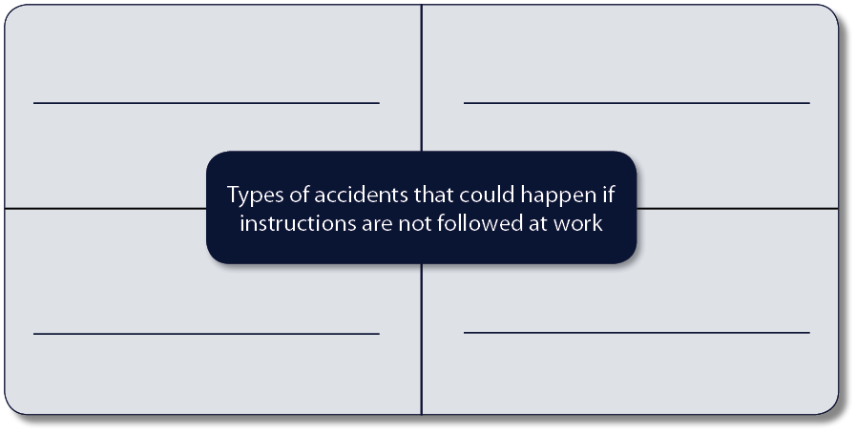
Work in a small group to identify the types of accidents that could happen if instructions are not followed carefully. Record your thoughts and ideas using the diagram below.

Your tutor will give you a set of ‘Instruction’ and ‘Employee’ cards.
- Look at the cards.
- Match each ‘Instruction’ card to the correct ‘Employee’ card.
- Show your tutor your work when you have finished.
Once the activity is completed, your tutor will give you feedback about how well you followed the instructions.

