Lesson Element

Plant diseases

Instructions and answers for teachers

These instructions cover the learner activity section which can be found on page 11. This Lesson Element supports OCR GCSE (9–1) Gateway Science Biology A and the Twenty First Century Science Biology B qualifications.
When distributing the activity section to the learners either as a printed copy or as a Word file you will need to remove the teacher instructions section.

Mapping to specification level (Learning outcomes)
GCSE (9–1) Gateway Science Biology A/Combined Science A
B6.3f describe a minimum of one common human infection, one plant disease and sexually transmitted infections in humans including HIV/AIDS
B6.3i describe different ways plant diseases can be detected and identified, in the lab and in the field

GCSE (9–1) Twenty First Century Science Biology B/Combined Science B
B2.2 How do organisms protect themselves against pathogens?
B2.2.3 3. describe physical plant defences, including leaf cuticle and cell wall (separate science only)

Introduction
Below is guidance regarding the suggested activities that can be used to develop the learning and understanding of the plant disease topic. This topic can be difficult to make engaging and memorable for learners. This is mainly due to lack of interest and links to areas they have previously studied, and also due to the fact that it is not often linked to any context that they can relate to.

Expected prior knowledge
Learners should have prior knowledge on the different types of pathogens and plant cell structure before embarking on this unit of work.

Teaching notes

Task 1: ‘A blight on our economy’- could history be repeating itself?
Specification
B2.2 How do organisms protect themselves against pathogens?
B2.2.3 Describe physical plant defences, including leaf cuticle and cell wall.
This is a good introduction to plants and diseases using an easy to understand article linked to a historical context. It also links past historical events of the Irish potato famine to modern day concerns that potato blight could be making a comeback. As it is literacy based, this task also develops managing information and comprehension skills.
This is a literacy based activity where learners should read the article and then demonstrate their understanding by answering the questions. The questions enable different ability learners to progress and challenge themselves.

Expected answers:
1 Use the information in the article to creatively summarise how plants defend themselves. This can take the form of a flow chart, animation, or story board.
Learners should be encouraged to produce a creative learning resource demonstrating how plants defend themselves from pathogens to stretch and challenge them.

2 The UK could shortly be exposed to another potato blight - what are the signs that a pathogen has begun to act on a plant?
Learners should use the clues given in the quote about the potato famine in Ireland - clues such as smell, colour and ‘withered’. More able learners could be questioned on what the withering is and should be able to relate this to hypersensitivity response.

3 What can farmers do to help prevent pathogens attacking their crops?
They can use sprays such as fungicides, and isolate plants that are showing signs of disease.

Task 2: Tobacco plant Farmville
This game can be played to introduce learners to some of the difficulties faced by plantation farmers.
Specification
B2.2.3 describe physical plant defences, including leaf cuticle and cell wall
B2.2.6 describe chemical plant defence responses, including antimicrobial substances
B3.4.1 explain how some abiotic and biotic factors affect communities, including environmental conditions, toxic chemicals, availability of food and other resources, and the presence of predators and pathogens
B6.6.4 describe and explain some possible biotechnological and agricultural solutions, including genetic modification, to the demands of the growing human population
An alternative game can be downloaded here: https://www.tes.co.uk/teaching-resource/crop-ability-a-probability-risk-game-6116158
This game makes learners aware of the issues farmers have across the world, and also in the UK in trying to prevent disease affecting their crops. Learners will be able to see first-hand as they play as farmers the impact of growing crops using different farming methods.

Aim of the game: To be the group with the most money at the end of their 3 years
(3 rounds), by selling perfect crops to the supermarket.
Resources:
Colouring pencils
Scissors
Bank notes
1 x dice (or use the dice counters selected randomly face-down)
Genetically modified plants printed on A4 sheets
Normal sized plants printed on A4 sheets
C’est la vie cards
NB: Learners can work through the plants and bank notes quicker than expected so ensure lots are printed for the lesson.
Rules:
1 The teacher or a learner should be nominated as the supermarket. They are in charge of the class bank. Depending on the size of the class this may require more than one person.
2 Learners should be split into groups of no more than five.
3 Each group has a ‘balancing the books’ learner sheet and £50 start-up cost.
4 Each group is to look at the price list for the tobacco plantation raw materials and decide what resources they would like to purchase. Crops vary in size and price, and also sell at different rates - they should take this into consideration using the selling costs section.
5 Each group throws one dice - if they throw an even number then they must sell their crops in groups of 10, if they throw an odd number then they must sell their crops in groups of 5.
6 Each round (year) lasts 10 minutes. During this time the group can bring up their crops as they reach the correct multiple (5 or 10) and sell them to the supermarket in return for the bank notes.
7 At the end of each round each group must take a ‘C’est la vie’ card. These have different scenarios that may be beneficial or detrimental to their business.
8 Groups can purchase further resources before the next round begins but must keep their accounts up to date on the ‘balancing the books’ learner sheet. Any unsold coloured cards can be kept in play for the next round unless the ‘C’est la vie’ card states they are to be destroyed.
8 The rounds are repeated until three rounds are played (or more if the teacher sees fit). Each group then calculates their bank balance and the winning team can be announced.

NB: It is at the supermarket’s discretion to reject any crops that have not been cut out carefully following the picture border, and that are not fully coloured in. The entire plant should be coloured in, not the square that they are in.

C’est la vie cards
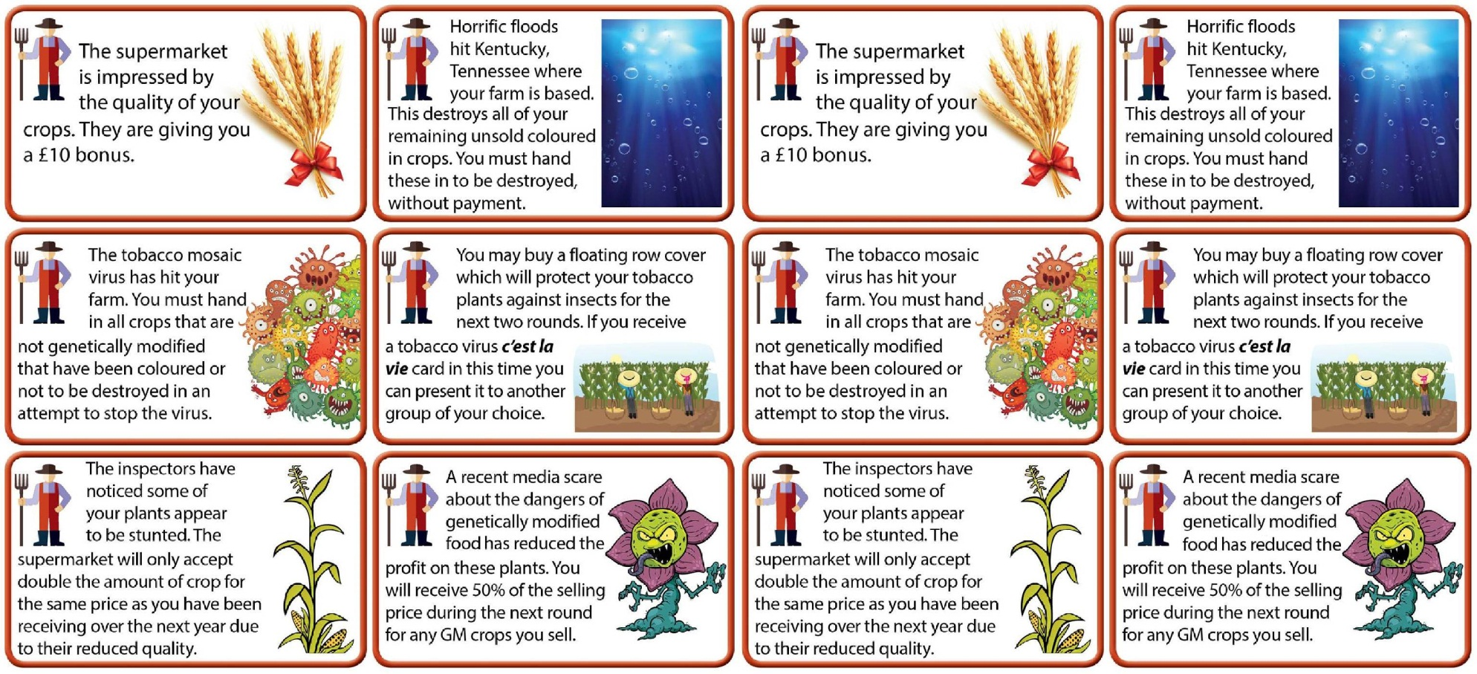
These should be printed multiple times and cut out ready for the end of each round.

Dice counters If dice are not available cut up the dice counters and select at random from a face-down pile.
Game money Print multiple times and cut out accordingly.

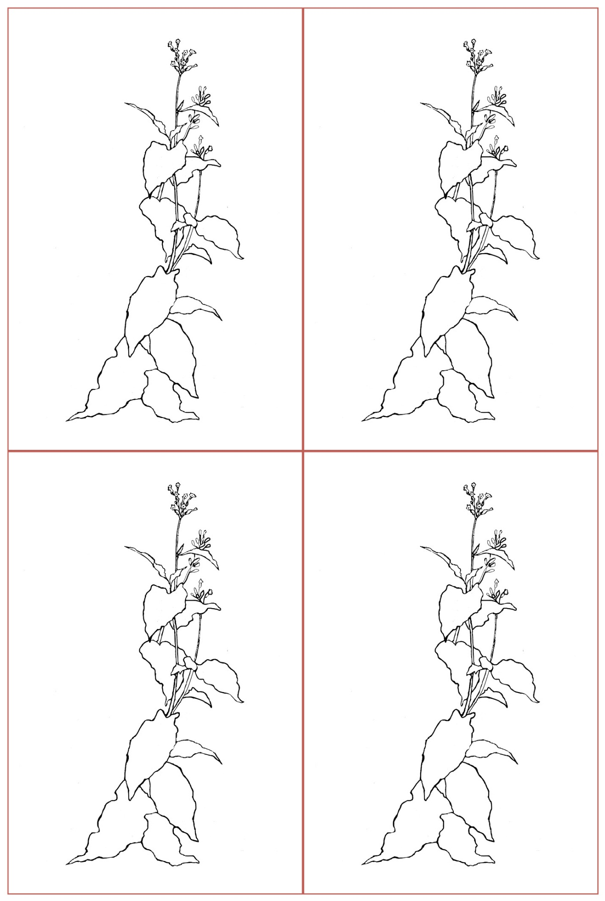
Non GM crop
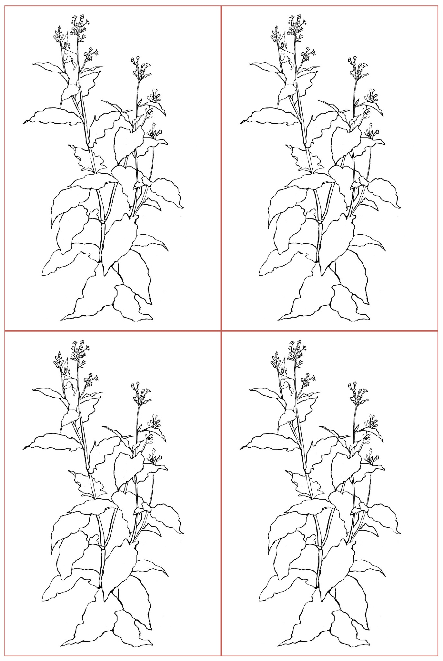
GM crop
Task 3 Research task:
Specification
B2.4 How can we identify the cause of an infection?
B2.4.1a Describe ways in which diseases, including plant diseases, can be detected and identified, in the lab and the field.
Research task on different pathogens in plants and their impacts. The aim of this resource is that learners can produce a case study about how diseases can be detected and controlled.
This resource gives websites that can be used as an introduction for learners to complete this task. They are also helpful for teachers to refresh the different plant diseases if this area is not of specific interest prior to delivering to learners.
Suggested activities: Learners should produce a case study about a disease that has had a negative impact on the crops. How the disease was identified and what was its cause should be researched.
Examples with some support websites include:
Dutch elm disease
http://www.forestry.gov.uk/fr/HCOU-4U4JCL
Video: http://news.bbc.co.uk/1/hi/programmes/newsnight/8912727.stm

Tobacco mosaic virus
Video: http://www.bbc.co.uk/education/guides/zr46fg8/revision/7
http://msue.anr.msu.edu/news/common_question_and_answers_about_tobacco_mosaic_virusnts_microorganisms/revision/1/
http://www.bbc.co.uk/schools/gcsebitesize/science/triple_edexcel/control_systems/plants_microorganisms/revision/1/

Extension: Learners could also be given the task of researching chemicals that are released by
plants in defence, but can also be used for human purposes. These include quinine and aspirin.

We’d like to know your view on the resources we produce. By clicking on ‘Like’ or ‘Dislike’ you can help us to ensure that our resources work for you. When the email template pops up please add additional comments if you wish and then just click ‘Send’. Thank you.
Whether you already offer OCR qualifications, are new to OCR, or are considering switching from your current provider/awarding organisation, you can request more information by completing the Expression of Interest form which can be found here: www.ocr.org.uk/expression-of-interest
Looking for a resource? There is now a quick and easy search tool to help find free resources for your qualification:
www.ocr.org.uk/i-want-to/find-resources/

OCR Resources: the small print
OCR’s resources are provided to support the delivery of OCR qualifications, but in no way constitute an endorsed teaching method that is required by the Board, and the decision to use them lies with the individual teacher. Whilst every effort is made to ensure the accuracy of the content, OCR cannot be held responsible for any errors or omissions within these resources.
© OCR 2017 - This resource may be freely copied and distributed, as long as the OCR logo and this message remain intact and OCR is acknowledged as the originator of this work.
OCR acknowledges the use of the following content: Page 5 – Maize: megastocker/www.shutterstock.com, Viruses: Lyudmyla Kharlamova/www.shutterstock.com, Wheat: ecco/www.shutterstock.com, Submerged: silvae/www.shutterstock.com, Monster: Sarawut Padungkwan/www.shutterstock.com, Crops: Smart Design/www.shutterstock.com, Farmer: Voodoodot/www.shutterstock.com, Page 6 – Money (modified) Tribalium/www.shutterstock.com, Page 9 – Famine: Photo12\Universal Images Group/Britannica.com, Page 10 Potato blight: Howard F. Schwartz/wikimediacommons.org
Please get in touch if you want to discuss the accessibility of resources we offer to support delivery of our qualifications: resources.feedback@ocr.org.uk

Lesson Element

Plant diseases

Learner Activity
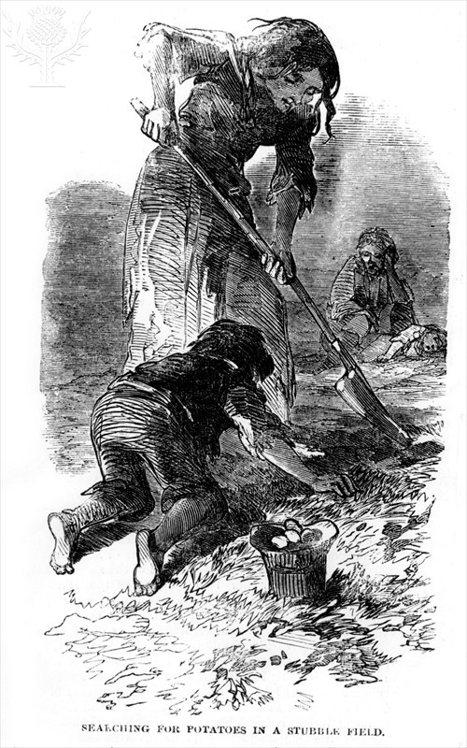

Task 1
A blight on our economy- could history be repeating itself?
“The leaves of the potatoes on many fields I passed were quite withered, and a strange stench, such as I had never smelt before, but which became a well-known feature in ‘the blight’ for years after, filled the atmosphere adjoining each field of potatoes. The crop of all crops, on which they depended for food, had suddenly melted away.”
Trench, an agent who worked for a landlord in County Cork.
The potato famine, 1845-1850, hit Ireland really hard, causing many families to be split up and sent to workhouses as their crops failed. It is estimated that almost one million people died of starvation or diseases in the workhouses.
Plants cannot move or fight back so it is important that every cell is capable of defending itself. Plants have two lines of defence - physical and chemical.
Plants can detect foreign invaders and have the ability to send messages to the cells to increase defences. Cell walls can become thicker and cells can secrete chemicals that may be harmful to the invading pathogens.

When plants are unsuccessful in defending themselves, initially small areas of the plant rapidly dies. This prevents the disease spreading to the rest of the plant. This is known as hypersensitivity response.
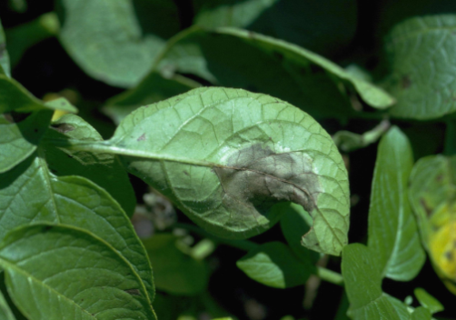 Fig 1: hypersensitivity response
Brown potato rot has been destroying crops across Europe, and although not yet a massive issue in the UK, could history repeat itself if we are not prepared?

Task 1: Read the article ‘A blight on our economy - could history be repeating itself?’
Check your understanding:
- Use the information in the article to creatively summarise how plants defend themselves. This can take the form of a flow chart, animation, or story board.

- The UK could shortly be exposed to another potato blight – what are the signs that a pathogen has started to act on a plant?

- What can farmers do to help prevent pathogens attacking their crops?

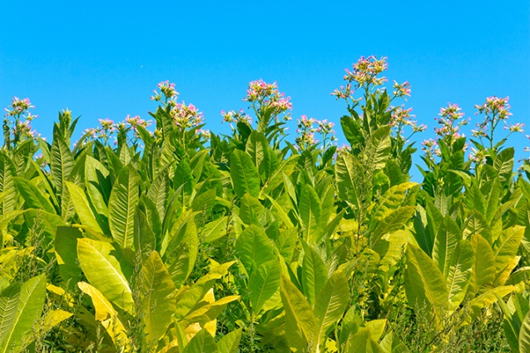
Tobacco plant Farmville

Aim of the game: To be the group with the most money at the end of their 3 years
(3 rounds), by selling perfect crops to the supermarket.
Rules:
1 The teacher or a learner should be nominated as the supermarket. They are in charge of the class bank. Depending on the size of the class this may require more than one person.
2 Learners should be split into groups of no more than five.
3 Each group has a ‘balancing the books’ learner sheet and £50 start-up cost.
4 Each group is to look at the price list for the tobacco plantation raw materials and decide what resources they would like to purchase. Crops vary in size and price, and also sell at different rates - they should take this into consideration using the selling costs section.
5 Each group throws one dice - if they throw an even number then they must sell their crops in groups of 10, if they throw an odd number then they must sell their crops in groups of 5.
6 Each round (year) lasts 10 minutes. During this time the group can bring up their crops as they reach the correct multiple (5 or 10) and sell them to the supermarket in return for the bank notes.
7 At the end of each round each group must take a ‘C’est la vie’ card. These have different scenarios that may be beneficial or detrimental to their business.
8 Groups can purchase further resources before the next round begins but must keep their accounts up to date on the ‘balancing the books’ learner sheet. Any unsold coloured cards can be kept in play for the next round unless the ‘C’est la vie’ card states they are to be destroyed.
8 The rounds are repeated until three rounds are played (or more if the teacher sees fit). Each group then calculates their bank balance and the winning team can be announced.

NB: It is at the supermarket’s discretion to reject any crops that have not been cut out carefully following the picture border, and that are not fully coloured in. The entire plant should be coloured in, not the square that they are in.

Balancing the books learner sheet

Tobacco plantation raw material costs
You have £50 in your starting budget - spend it wisely!
Genetically modified crop - larger and more resistant to disease: £5 each
Normal sized crop: £2 each
£5 per colouring pencil
£2 per scissors
Year | Expenditure | Income | Bank balance
1
2
3
Total bank balance:

Supermarket selling prices:
Genetically modified crop - £30 for multiples of 5, £50 for multiples of 10
Normal sized crop - £25 for multiples of 5, £40 for multiples of 10
Your crops may be rejected if they are not cut out accurately or if the plant is not coloured in well. Note: You should not be colouring in the entire square.

Keeping track of your bank balance
Follow up questions: Reflect on how well your farm did and answer the following questions.
- How could you have made more money?

- What risks did you take in an attempt to win the game?

- Would you have taken the same risks if you were a real life tobacco plantation farmer? If not, explain why not.

Task 3 – Case study
This task requires your investigation and research skills. You should produce a case study about a disease that has had a negative impact on a crop of your choice.
In order to reach the higher levels in this topic, you should begin at the lower demand areas and progress upwards to the higher demand areas.

Demand | Command term | Expected content
High demand (Highest level) | Explain | An explanation about how the area has worked around this problem such as developed farming strategies.
Medium demand | Describe | A description of the impacts the disease has had socially, economically and environmentally.
 |  | A description of what has happened to the crop.
 | Research | Used and referenced at least two additional references detailing where you have found your information from.
Low demand (Lower level) | State/Find | Diagrams/photographs of the crop in a healthy state, and then damaged by disease using the websites below.
 |  | Name of the crop being investigated.

Useful websites:
Dutch elm disease
http://www.forestry.gov.uk/fr/HCOU-4U4JCL
Video: http://news.bbc.co.uk/1/hi/programmes/newsnight/8912727.stm

Tobacco mosaic virus
Video: http://www.bbc.co.uk/education/guides/zr46fg8/revision/7
http://msue.anr.msu.edu/news/common_question_and_answers_about_tobacco_mosaic_virusnts_microorganisms/revision/1/
http://www.bbc.co.uk/schools/gcsebitesize/science/triple_edexcel/control_systems/plants_microorganisms/revision/1/
Extension: Certain chemicals can be released by plants when they are defending themselves. Two of these are Quinine and Aspirin. Find out which plants produce them and describe what they are used for by people.

