Lesson Element

Gottesman et al. (2010) Disorders in Offspring with Two Psychiatrically Ill Parents

Instructions and answers for teachers
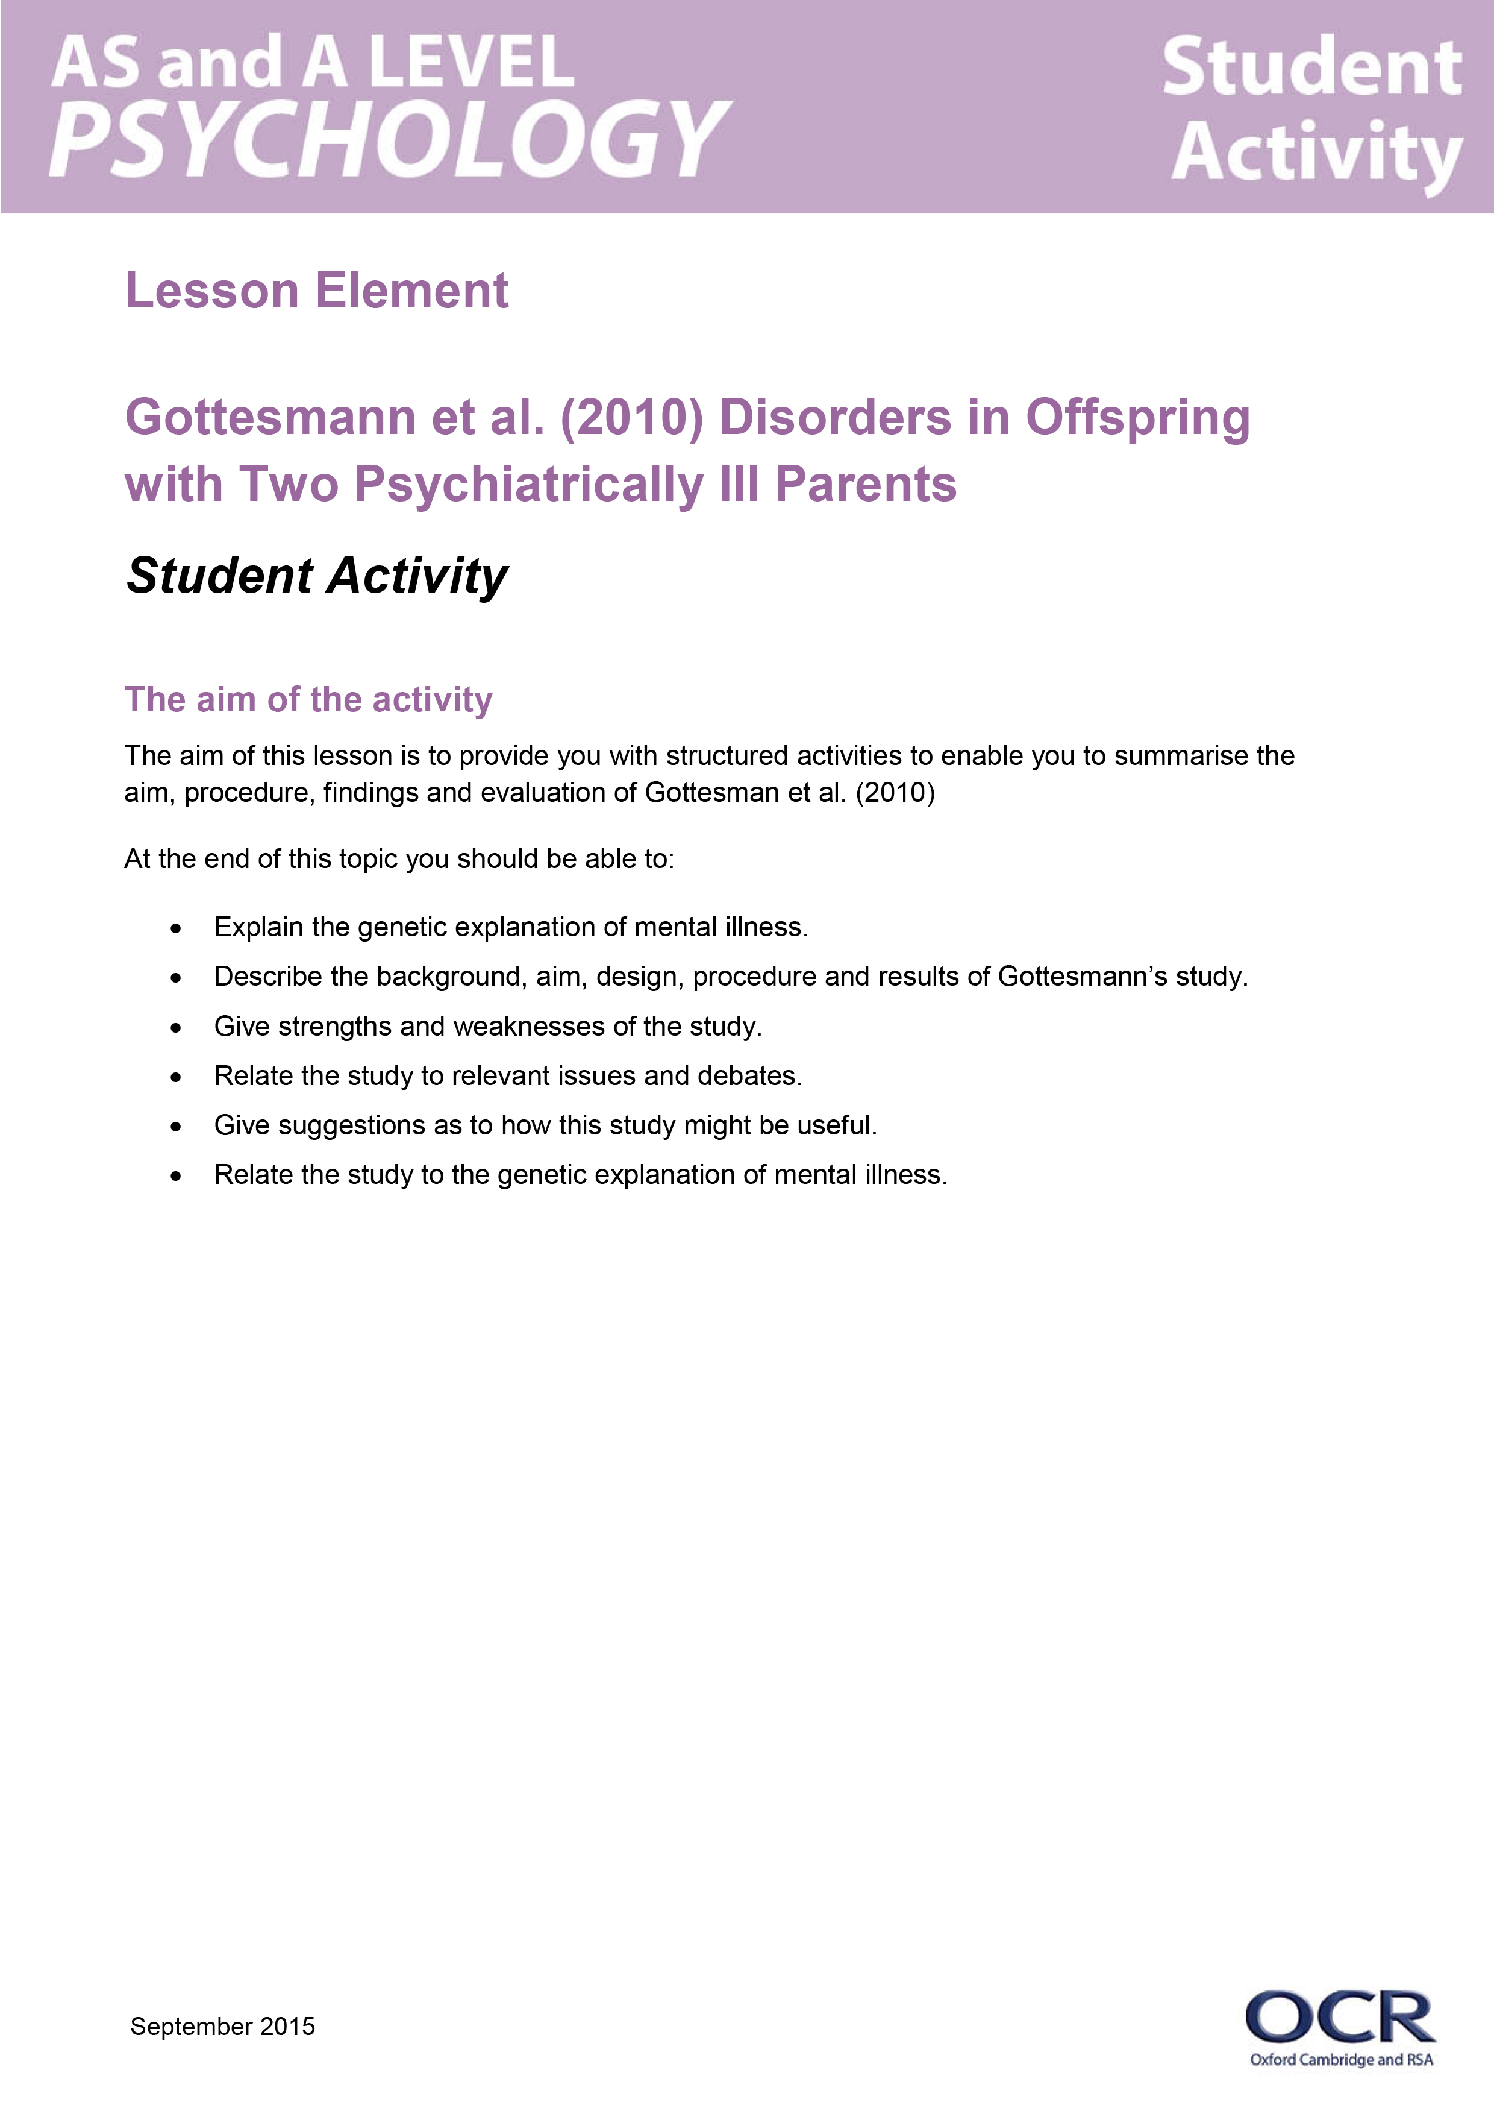
This lesson element supports OCR AS and A Level Psychology. It relates to Component 3 – Applied Psychology, and specifically the compulsory topic Section A: Issues in Mental Health, containing two student activities on The Medical Model.
When distributing the activity section on page 8 to students either as a printed copy or as a Word file you will need to remove the teacher section.

Aim
To provide structured activities, which enable students to summarise the aim, procedure, findings and evaluation of Gottesman et al. (2010).

Students should be able to:
- Explain the genetic explanation of mental illness.
- Describe the background, aim, design, procedure and results of Gottesmann’s study.
- Give strengths and weaknesses of the study.
- Relate the study to relevant issues and debates.
- Give suggestions as to how this study might be useful.
- Relate the study to the genetic explanation of mental illness.


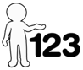
This activity offers an opportunity for English skills development.
This activity offers an opportunity for maths skills development.

Summary and Background
Gottesman et al (2010) investigated couples who have psychiatric illnesses and their offspring to calculate the risk of their offspring also being diagnosed with a psychiatric illness.

Aim of the study
To investigate the importance of genetic influence on offspring, where both parents have been admitted with a severe psychiatric disorder.

Procedure and results
Records of families from the national register in Denmark were used. Participants were born or alive after 1968 and offspring followed up to 52 years old. Patients were diagnosed using ICD-8 and ICD-10 which had been check for concurrent validity. The study measures the cumulative incidences of schizophrenia and bipolar disorder in the offspring up to the age of 52.
 | Both Parents with schizophrenia | One Parent with schizophrenia | Both parents with bipolar disorder | 1 parent with bipolar disorder | Neither parent ever admitted | General Population (unclean)
No of couples | 196 | 8006 | 83 | 11995 | 1.08million | 1.28million
No of offspring | 270 | 13878 | 146 | 23152 | 2.23million | 2.7million

Results
 | Both Parents with schizophrenia | One Parent with schizophrenia | Both parents with bipolar disorder | 1 parent with bipolar disorder | 1 parent with schizophrenia  1 parent with bipolar disorder | Neither parent ever admitted | General Population (unclean)
Schizophrenia admission in offspring | 27.3% | 7% | - | - | - | 0.86% | 1.12%
Bi-polar admission in offspring | 10.8% | - | 24.95% | 4.4% | 11.7% | 0.48% | 0.63%
Any psychiatric diagnosis | 67.5% | - | 44.2% | - | - | 11.9% | 14.1%

Conclusion
It can be concluded that there is a greater risk of being admitted with a psychological disorder if both parents have been admitted with a disorder, compared to the general population.

Evaluation
Strengths | Weaknesses
High in ecological validity  Representative sample  Ethical – records were available. Anonymity assured  Valid – diagnosis over time from ICD-8 to ICD-10 was valid  Useful to advise people on risks associated with having children, adopting and genetic counselling | Difficult to rule out influence of shared environment  May be unethical to use results to discriminate people from having children, adopting or for increasing health insurance premiums  May only apply to Denmark

Suggested activities

Activity 1: Structured writing frame
This is a structured writing frame for students to make notes on the study individually. See the student worksheets that follow from page 8.

Activity 2: Quiz trade class activity
This co-operative learning activity involves students standing up and walking around the room. They each have a card with a question on. As they walk around, they pair up with someone and answer each other’s questions. They then swap their cards and move on to someone else and repeat. They should aim to have answered all the questions as they move around the room. If they don’t have a partner they put their hand up and find someone who also has their hand up. They must not go back to someone they have already traded with. You will need to cut out the cards on the next page out. Answers are given on the page immediately following the cards to cut out.

Could you tell me what the genetic influence on mental illness means?

I agree with Gottesman
because…

I respectfully disagree with what Gottesman said
because…

Could you please explain the aim of Gottesman’s (2010) study?

Tell me who the participants in the Gottesman study were?

What mental disorders was Gottesman looking at?

The control group consisted of….

Gottesman found that if both parents had schizophrenia, the risk of their children being diagnosed was…

Of the families where one parent had been admitted for schizophrenia the risk was ___________%
The risk for children where both parents had been admitted for bi-polar disorder was ____________ whereas when only 1 parent had been admitted for bipolar disorder was _________.

In the control group, the risk of offspring being diagnosed with a severe mental disorder was _________%

It can be concluded that if parents have been diagnosed with a severe mental illness, then...

[add your own]

[add your own]

[add your own]

[add your own]

Activity 2 answers
Could you tell me what the genetic influence on mental illness means?
That mental illnesses can be passed from parents to child via their genetic code. It is inherited from the parents
I agree with Gottesman
because…
the study involved a large number of participants, was valid, diagnoses used ICD 8 and 10 which was shown to have validity. Records used were accurate and representative of the population.

I respectfully disagree with what Gottesman said
because...?
the results could only apply to Danish people so lack generalisability. The families share the same environment so the illness could be due to learning or dysfunctional families, or the environment. Only applies to people who were in the system and had diagnoses as patients.

Could you please explain the aim of Gottesman’s (2010) study?
The aim of the study was to find out if the offspring of families where both parents had a severe mental illness (schizophrenia, bi-polar disorder and unipolar depressive disorder) were more likely to experience a severe mental disorder.

Can you tell me who the participants in the Gottesman study were?
Target population: 2.7 million people born in Denmark, alive in 1968 or born later than 1968.
Children aged 10 years or older in 2007 with register link to parents.

Can you tell me what mental disorders Gottesman was looking at?
Schizophrenia
Bipolar disorder
Unipolar disorder/Depression

Gottesman found that if both parents had schizophrenia the risk of their children
being diagnosed with a psychiatric disorder was 3 times higher.
27% incidence rate of also being diagnosed with schizophrenia.
The control group consisted of…
offspring of parents who had never been admitted with a mental disorder (clean group). Also a sample of the general population of 2.2 million (unclean).

Of the families where one parent had been admitted for schizophrenia the risk was 7%
The risk for children where both parents had been admitted for bi-polar disorder was 25% whereas when only 1 parent had been admitted for bi-polar disorder was 4.4%

In the control group (general pop), the risk of offspring being diagnosed with a severe mental disorder was 1.12%
Neither parent admitted = 0.48%
It can be concluded that if parents have been diagnosed with a severe mental illness then…
their offspring are at higher risk than the general population of also being diagnosed with a severe mental illness. There is some evidence of genetic crossover between schizophrenia and bi-polar disorder.

Can you tell me what the conditions were in the study?
Both parents with schizophrenia.
One parent with schizophrenia.
Both parents with bi-polar disorder
One parent with bi-polar disorder, one with schizophrenia.
Neither parent admitted with a mental disorder (control).
Unclean control group of 2.2 million parents.

OCR Resources: the small print
OCR’s resources are provided to support the teaching of OCR specifications, but in no way constitute an endorsed teaching method that is required by the Board, and the decision to use them lies with the individual teacher. Whilst every effort is made to ensure the accuracy of the content, OCR cannot be held responsible for any errors or omissions within these resources.
© OCR 2015 - This resource may be freely copied and distributed, as long as the OCR logo and this message remain intact and OCR is acknowledged as the originator of this work.
OCR acknowledges the use of the following content: Maths and English icons: Air0ne/Shutterstock.com
Please get in touch if you want to discuss the accessibility of resources we offer to support delivery of our qualifications: resources.feedback@ocr.org.uk
We’d like to know your view on the resources we produce. By clicking on ‘Like’ or ‘Dislike’ you can help us to ensure that our resources work for you. When the email template pops up please add additional comments if you wish and then just click ‘Send’. Thank you.
If you do not currently offer this OCR qualification but would like to do so, please complete the Expression of Interest Form which can be found here: www.ocr.org.uk/expression-of-interest

Lesson Element

Gottesman et al. (2010) Disorders in Offspring with Two Psychiatrically Ill Parents

Student Activity

The aim of the activity
The aim of this lesson is to provide you with structured activities to enable you to summarise the aim, procedure, findings and evaluation of Gottesman et al. (2010)
At the end of this topic you should be able to:
- Explain the genetic explanation of mental illness.
- Describe the background, aim, design, procedure and results of Gottesmann’s study.
- Give strengths and weaknesses of the study.
- Relate the study to relevant issues and debates.
- Give suggestions as to how this study might be useful.
- Relate the study to the genetic explanation of mental illness.

Genetic explanation of mental illness
The genetic explanation suggests:

Family studies are interesting when studying mental illness because…

The aim of the Gottesman et al. (2010) study was:

The sample was taken from:

They gathered this information:

They found:

It was concluded that:

Issues and debates

Deterministic
Reductionism
Families share the same environment
Individual/situational explanations
Validity
Ethics
Usefulness of research
Socially Sensitive Research
Ethnocentrism/Sampling Bias

