Lesson Element

The Psychodynamic Perspective

Instructions and answers for teachers

These instructions cover the student activity section which can be found on page 5. This Lesson Element supports OCR AS and A Level Psychology.
When distributing the activity section to the students either as a printed copy or as a Word file you will need to remove the teacher instructions section.

Background
A perspective is a view that involves assumptions (beliefs) about human behaviour.
Each perspective brings something different to our understanding of human behaviour.

Objectives
Students are required to have knowledge and understanding of the psychodynamic and behaviourist perspectives in psychology.
For each perspective, they should know:
- The defining principles and concepts of each perspective.
- Strengths and weaknesses of each perspective.
- Research to illustrate each perspective.
- Applications of each perspective.
- How each perspective is different from, and similar to the other perspectives.
ABC – This activity offers an opportunity for English skills development.
123 – This activity offers an opportunity for maths skills development.

Introduction
Sigmund Freud is the founder of the psychodynamic perspective. The underlying principles and concepts are very much influential today, particularly in the field of therapy and counselling.
The psychodynamic perspective believes that our childhood can impact significantly on our behaviour as adults. As such, individuals have very little free will to make choices in life; instead behaviour is determined by unconscious motives and childhood experiences.
As a homework activity preceding this lesson, students could be set the task of finding three facts about Freud. Beginning the lesson sharing these facts should stimulate discussion about the concepts of the psychodynamic perspective.
The worksheets are designed to be used after the teacher has given some background to Freud’s theory and briefly outlined the perspective. Each worksheet contains an activity to reinforce and check learning.

Worksheet 1: The defining principles and concepts of the Psychodynamic Perspective
The specification states that learners must know the defining principles and concepts within the perspective. This worksheet provides a summary of the id, ego and superego once students have completed the exercise.
Learners could complete the exercise on labelling behaviour in pairs or individually and could be asked to think of their own.
Additional suggestions for activity (completed in class or as a homework / extension activity)
- Produce a cartoon strip illustrating the interaction of the three parts.
- Role play, one representing each part.
- Using fairy tales such as Snow White or Cinderella to illustrate each part, for example the Evil witch in Snow White could represent the Id.

Worksheet 2: The defining principles and concepts of the Psychodynamic Perspective: Psychosexual stages
Instructions are provided on the worksheet. This could be set as a class exercise, i.e. given to learners for completion after the teacher has provided information on the psychosexual stages or as an independent research task.
There is an amusing clip about the Oedipus Complex here: https://www.youtube.com/watch?v=ym5KMLxOPcQ
While this YouTube clip shows the comedian Mark Steele explaining Freud’s idea (before playing, you should check whether this is suitable for your students.) https://www.youtube.com/watch?v=ym5KMLxOPcQ

Worksheet 3: Research to illustrate the Psychodynamic Perspective story board material
Freud (1909) offered his case study of Little Hans as evidence of the Oedipus complex.
Students should be provided with details of the case study. This can be found in the OCR Guide to Core Studies 1. A template is provided where learners could draw a story board to represent how the case study of Little Hans provides evidence for Freud’s ideas.
For example: Hans’ use of defence mechanisms to cope with the continual castration anxiety or how Freud saw Hans’ phobia as an expression of the Oedipus complex with the horse symbolising the father. Learners could focus on Freud’s interpretation of Hans’ dreams and fantasies or more general concepts such as evidence of the phallic stage of development or the importance of childhood experiences and the unconscious.

Activity: Applications of the Psychodynamic Perspective
The Psychodynamic perspective is extremely influential. The following are all areas where the concepts and principles can be applied.
- Gender Role Development.
- Personality.
- Aggression (displacement).
- Attachment.
- Therapy – psychoanalysis.
- Moral Development.
- Abnormality (for example phobias).

Research Activity
In groups, learners could be given one of the areas as a research activity. They could be asked to research how the psychodynamic perspective has influenced the area and how the principles and concepts have been applied.
Learners could present to the class in a small scale presentation or asked to produce a summary of their findings which could be collated and shared with the class.

Worksheet 4: Strengths and weaknesses of the Psychodynamic Perspective
The instructions are included on the worksheet. Once completed, the table will provide a detailed summary of the evaluative points. This could be used as a differentiation activity – stronger learners could be given a blank copy of the table, or asked to provide more detailed evaluations as well as to consider further strengths and weaknesses themselves.

Worksheet 5: Applying debates to the Psychodynamic Perspective
Learners should circle the correct side of the debate the psychodynamic reflects. Then in the boxes below write a statement supporting why it reflects that debate. For example, determinism would be circled and the statement may say Freud believes that childhood experiences and unconscious conflicts forms and dictates adult behaviour and so the individual has little or no free will.

Worksheet 6: How the Behaviourist Perspective is different from and similar to the Psychodynamic Perspective
The final worksheet is designed to allow learners to compare the Psychodynamic perspective with Behaviourist Perspective. Learners are required to understand and explain the differences and similarities between them. The activity will enable them to achieve this.

We’d like to know your view on the resources we produce. By clicking on ‘Like’ or ‘Dislike’ you can help us to ensure that our resources work for you. When the email template pops up please add additional comments if you wish and then just click ‘Send’. Thank you.
If you do not currently offer this OCR qualification but would like to do so, please complete the Expression of Interest Form which can be found here: www.ocr.org.uk/expression-of-interest

OCR Resources: the small print
OCR’s resources are provided to support the teaching of OCR specifications, but in no way constitute an endorsed teaching method that is required by the Board, and the decision to use them lies with the individual teacher. Whilst every effort is made to ensure the accuracy of the content, OCR cannot be held responsible for any errors or omissions within these resources.
© OCR 2015 - This resource may be freely copied and distributed, as long as the OCR logo and this message remain intact and OCR is acknowledged as the originator of this work.
OCR acknowledges the use of the following content: Freud: Lee /leemage /Universal Images Group/EDIT/quest.eb.com; Freud’s theory: T and Z/Shutterstock.com
Please get in touch if you want to discuss the accessibility of resources we offer to support delivery of our qualifications: resources.feedback@ocr.org.uk

OCR Resources: the small print
OCR’s resources are provided to support the teaching of OCR specifications, but in no way constitute an endorsed teaching method that is required by the Board, and the decision to use them lies with the individual teacher. Whilst every effort is made to ensure the accuracy of the content, OCR cannot be held responsible for any errors or omissions within these resources.
© OCR 2015 - This resource may be freely copied and distributed, as long as the OCR logo and this message remain intact and OCR is acknowledged as the originator of this work.
OCR acknowledges the use of the following content: n/a
Please get in touch if you want to discuss the accessibility of resources we offer to support delivery of our qualifications: resources.feedback@ocr.org.uk
We’d like to know your view on the resources we produce. By clicking on ‘Like’ or ‘Dislike’ you can help us to ensure that our resources work for you. When the email template pops up please add additional comments if you wish and then just click ‘Send’. Thank you.
If you do not currently offer this OCR qualification but would like to do so, please complete the Expression of Interest Form which can be found here: www.ocr.org.uk/expression-of-interest

Lesson Element

The Psychodynamic Perspective

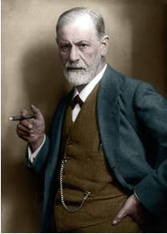
Student Activity

Worksheet 1: The defining principles and concepts of the Psychodynamic Perspective
The psychodynamic perspective believes that our childhood can impact significantly on our behaviour as adults. As such, individuals have very little free will to make choices in life; instead behaviour is determined by unconscious motives and childhood experiences.

The iceberg analogy
Freud explained that the human mind is like an iceberg with only a small amount being visible – this is our observable behaviour. It is the unconscious that has the most influence on our behaviour.
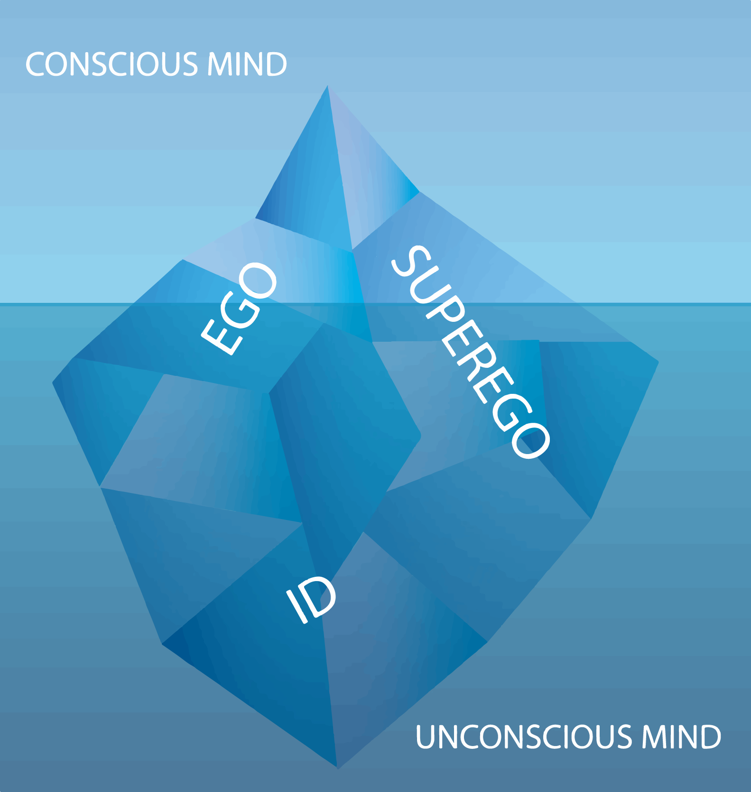
Conscious (observable behaviour)

Unconscious

The tripartite personality
Freud saw the human psyche (personality) as possessing three parts: the Id, Ego and Superego.
Together they govern the way we think and act. Freud states that the majority of our personality comes from our unconscious mind and that abnormal behaviour occurs as the result of an imbalance between the 3 parts. For example, an overdeveloped superego may lead to excessive anxiety later on whilst a dominant Id may lead to psychotic behaviour.
Using the words from the list below, complete the following:

ID
The Id is the ……………………………. and instinctive part of the personality. Present at ……………………., it consists of the life instinct (Eros) and ………………………instinct (Thanatos). The …………………………..principle, demanding immediate gratification, it operates on the basis that all impulses should be ………………………….. regardless of the consequence.

EGO
The ego or reality principle mediates between the irrationals …………………………. of the Id and the real world. Its purpose is problem solving; to devise realistic and reasonable …………………………………to the Id’s illogical demands.

SUPEREGO
The ego has no sense of right or ………………………… and so the Superego develops. The morality ……………………………. is focused on the morals of society instilled in a child through …………………………….and how one was brought up. The Superego controls the Id’s demands through the ……………………………and ideal self. Both of which may produce feelings of …………………………..for wrong doing or praise, making us feel good about ourselves.
Parts of the unconscious mind (Id and Superego) are in constant conflict with the conscious part (ego). Conflict creates ……………………………………… which is dealt with by using ………………

Demands | Wrong | Parenting | Impulsive
Conscience | Defence Mechanisms | Solutions | Birth
Death | Satisfied | Principle | Guilt
Anxiety | Pleasure

Activity
The following are all examples of behaviours that represent characteristics of the Id, Ego or Superego. Label each one accordingly.
- A toddler throwing a tantrum and not stopping until it gets what it wants.

- Finding £5.00 on the canteen floor and handing it in to the cashier.

- A baby crying until it is fed.

- Really wanting to eat a bar of chocolate but knowing you can’t as it will spoil dinner.

- Not cheating on a test because you know it’s wrong.

- Asking your parents first if you can take food from the cupboards rather than just helping yourself.

Your exams start next week. You really want to go out the weekend with your friends but you know that you should be spending your time revising.
How would the ego mediate (problem solve) in this dilemma?

Worksheet 2: The defining principles and concepts of the Psychodynamic Perspective - Psychosexual stages
Psychological development takes place in a series of fixed stages. In order for healthy adult development, individuals need to be able to leave one stage and move on to the next.
Fixation occurs when a stage is not completed or passed through successfully. The individual who is fixated will behave in a way that is characteristic of early childhood.
Complete the following with the characteristics of each stage and adult traits that are associated with fixation at each stage.
Stage | Part of Body | Characteristics | Adult Traits with fixation
Oral
Anal
Phallic
Latency
Genital

Think of a mnemonic that will help you to remember the stages:
O:
A:
P:
L:
G:

Worksheet 3: Research to illustrate the Psychodynamic Perspective
Freud (1909) offered his case study of Little Hans as evidence of the Oedipus complex.
Story board material.
Evidence

Explanation / link to theory

Worksheet 4: Strengths and weaknesses of the Psychodynamic Perspective
The following table shows some strengths and weaknesses of the psychodynamic perspective. Your task is to complete the table by writing a statement explaining how or why each point is a strength or weakness.
Strengths | Weaknesses
Highlights the importance of childhood… | Deterministic…
Psychoanalysis is effective as a form of therapy… | Unfalsifiable…
Highly influential … | Unscientific…
Has many practical applications… | Based on subjective interpretation …

Worksheet 5: Applying debates to the Psychodynamic Perspective
Circle which of the following debates are relevant to the psychodynamic perspectives and then write a supporting statement stating why it is relevant.
Reductionism | vs | Holism

Freewill | vs | Determinism

Nature | vs | Nurture

Individual | vs | Situational

Worksheet 6: How the Behaviourist Perspective is different from and similar to the Psychodynamic Perspective
The following is a comparison of the similarities and differences between the two perspectives. Complete the boxes with the opposing view and decide whether the perspectives share the view or whether they differ.
Psychodynamic | Behaviourist | Similarity or Difference
Current behaviour is determined by past experiences
 | Objective measurements
 | Deterministic assuming behaviour is beyond an individual’s free will
Concerned with internal events (mental processes) |  | Difference
 | Theory is based on animal research
Unscientific

