Checkpoint Task

Interdependence

Instructions and answers for teachers
These instructions cover the learner activity section which can be found on page 5. This Checkpoint Task should be used in conjunction with the KS3–4 Twenty First Century Science Biology B Transition Guide Interdependence, which supports OCR GCSE (9–1) Twenty First Century Science Biology B.
When distributing the activity section to the learners either as a printed copy or as a Word file you will need to remove the teacher instructions section.

Introduction
For checkpoint task 1 learners should look at the food web in the picture and answer the short answer questions. Lower ability learners may need some help with what the key words mean in the questions, before giving answers and attempting the questions. It might be worth going through the meanings with the whole class before starting, or using it as an opportunity to completely test how much learners remember.
For checkpoint task 2 learners should carefully consider the 3 words in each row. This has been differentiated in three ways. For higher ability – learners are provided with the key words only and it is up to them to decide which is the odd one out and they should write the reasoning underneath. For middle ability – learners are given hints that they should consider and again select the odd one out with the reasoning. For lower ability – the odd one out is identified and learners should write the reason for this underneath. Learners could pick any of the words, it is the justification that is important and this should bring a good discussion into the lesson.

Further information:
Strengthening Teaching and Learning of Interdependence, Secondary Teaching Strategy
https://www.stem.org.uk/elibrary/resource/29861/strengthening-teaching-and-learning-of-interdependence-secondary-national
This link provides a study guide for how to teach interdependence. There are also lots of great teaching resources that can be used.

Task 1
The idea of checkpoint task 1 is to identify what learners remember about interpreting food webs. The work at GCSE will build on some of these concepts, so it is important that the foundations are there. Some questions in examinations may rely on interpreting such diagrams and then linking these to calculations or discussing how energy is transferred in the food web, in terms of biomass. Some of the questions require learners to give more extended answers and critically consider aspects of the food web. Others are more straightforward and will allow you to assess whether the basic aspects of interdependence from Key Stage 3 need to be covered before moving onto the GCSE content.
Answer the questions, using the picture of the food web.
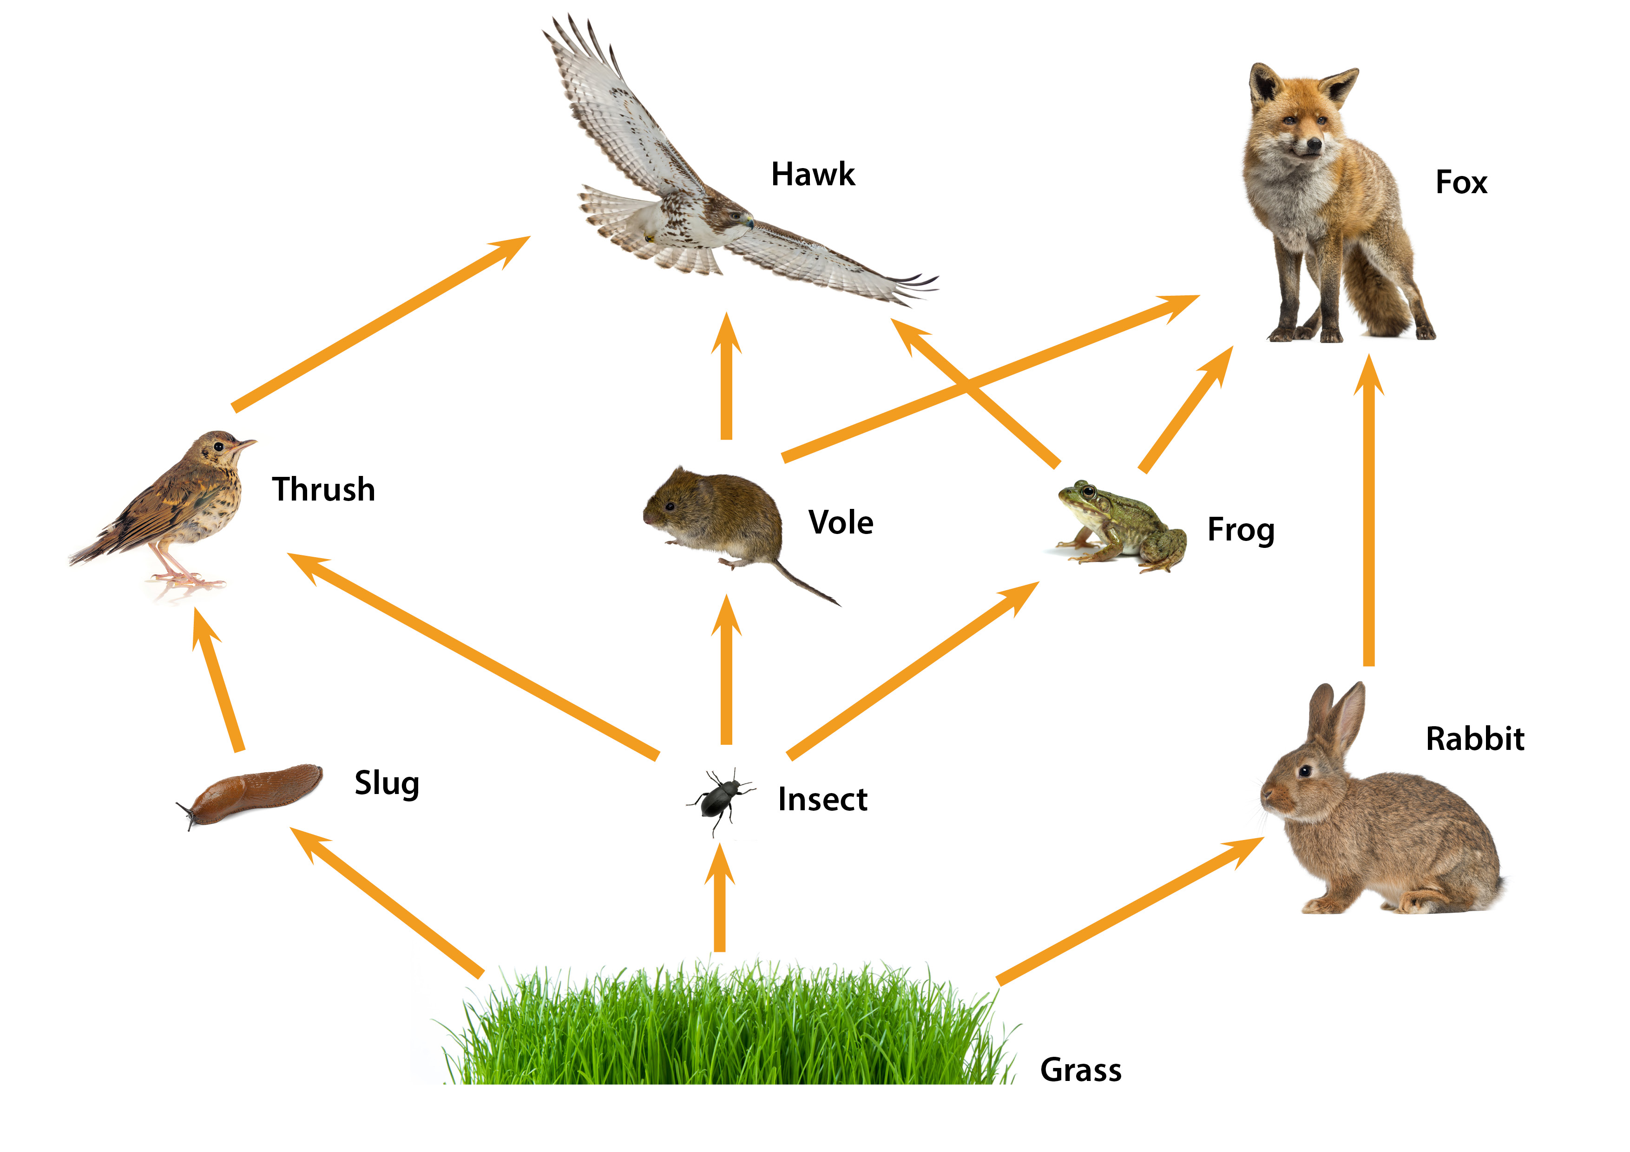

- Name the producer in this food web. Grass
- What is the source of energy for all the organisms in this food web? The Sun
- Name 2 herbivores. Two from: Rabbit / Insect / Slug
- Name 2 carnivores. Two from: Thrush / Vole / Frog / Fox / Hawk
- How many primary consumers are there? 3
- How many tertiary consumers are there? 2
- Draw three food chains from this food web.
Any valid suggestions:
e.g. grass → rabbit → fox, grass → insect → vole → hawk
- Explain what would happen if the hawk’s eggs were damaged by a pesticide so their numbers decreased dramatically.
The usual food of the hawk would survive so there would be an increase in thrushes, voles and frogs. This may impact the organisms they eat e.g. slugs and insects may decrease.
- Explain what would happen if the grass is burned in a wild fire.
All organisms depend on the producers for their energy so there would be a decrease in the organisms, unless there are alternative producers.
- Explain the effect of a disease that causes a decrease in the number of rabbits.
There will be an increase in the amount of grass, less competition for grass with the slug and insect, so they may increase with more food. The fox may have less food so may decrease or may eat more frogs and voles which would cause them to decrease. This would then have other effects on the food web.
- Draw a pyramid of biomass for one of the food chains you have drawn in question 7.
Drawn with blocks getting smaller, labelled correctly with producer at the bottom, primary consumer next and so on.

Task 2 - Odd One Out
The second checkpoint task allows learners to carefully think about a selection of key words and decide which is the odd one out. They should consider each key word in the row and discuss what this means before deciding which does not fit with the other two. All of the words link to the GCSE content in some way. Learners may know the words from the other Sciences and not know them as specifically linked to interdependence, but it will assess their understanding and allow you to decide how to introduce them into the GCSE lessons.

Suggested answers
Consider the three words and decide which one you think is the Odd One Out. This will really test your understanding of the words. Underneath, explain your reasoning in the box.
1 | Producer | Herbivore | Consumer
The producers use sunlight to make their own food whereas the other two rely on other organisms and eat for their energy source.
2 | Bacteria | Plant | Fungi
Plants are not microorganisms, fungi and bacteria are.
3 | Photosynthesis | Combustion | Respiration
Photosynthesis removes carbon dioxide from the atmosphere, whereas the other two add carbon dioxide
4 | Pesticide | Fertiliser | Herbicide
Fertilisers are used to encourage the growth of plants. Herbicides and pesticides are used to kill organisms that would reduce the growth of plants.
5 | Prey | Predator | Carnivore
Prey are eaten by predators and carnivores.
6 | Space | Light | Mates
Space and light are factors that plants compete for, whereas mates are something that animals compete for.
7 | Respiration | Decay | Photosynthesis
Photosynthesis removes carbon dioxide to the atmosphere, whereas decay and respiration both add carbon dioxide.
8 | Carbon dioxide | Oxygen | Water
Oxygen is not needed for photosynthesis – it is produced. Or, oxygen is needed for respiration and the other two are products.
9 | Worm | Woodlouse | Fungi
Fungi are examples of decomposers and the other two are detritivores. All involved in decay.
10 | Composting | Canning | Sewage
Canning is used to prevent decay and the other two use decay to assist the processes.

Challenge:
Can you justify one of the other words in the row being the Odd One Out?
Make up a selection of your own Odd One Out with the answers.
OCR Resources: the small print
OCR’s resources are provided to support the teaching of OCR specifications, but in no way constitute an endorsed teaching method that is required by the Board, and the decision to use them lies with the individual teacher. Whilst every effort is made to ensure the accuracy of the content, OCR cannot be held responsible for any errors or omissions within these resources.
© OCR 2016 - This resource may be freely copied and distributed, as long as the OCR logo and this message remain intact and OCR is acknowledged as the originator of this work.
OCR acknowledges the use of the following content: n/a
Please get in touch if you want to discuss the accessibility of resources we offer to support delivery of our qualifications: resources.feedback@ocr.org.uk
We’d like to know your view on the resources we produce. By clicking on ‘Like’ or ‘Dislike’ you can help us to ensure that our resources work for you. When the email template pops up please add additional comments if you wish and then just click ‘Send’. Thank you.
If you do not currently offer this OCR qualification but would like to do so, please complete the Expression of Interest Form which can be found here: www.ocr.org.uk/expression-of-interest

Checkpoint Task

Interdependence

Learner Activity

Task 1
Look at the food web in the picture and see how the organisms depend on each other.
You need to answer the questions, using the picture of the food web.

- Name the producer in this food web.

- What is the source of energy for all the organisms in this food web?

- Name 2 herbivores.

- Name 2 carnivores.

- How many primary consumers are there?

- How many tertiary consumers are there?

- Draw three food chains from this food web.

- Explain what would happen if the hawk’s eggs were damaged by a pesticide so their numbers decreased dramatically.

- Explain what would happen if the grass is burned in a wild fire.

- Explain the effect of a disease that causes a decrease in the number of rabbits.

- Draw a pyramid of biomass for one of the food chains you have drawn in question 7.

Task 2 - Odd One Out: Lower Ability
Consider the three words, the one that is Odd One Out has been put in bold. Can you explain, using the hint – why it is the Odd One Out – write your answer in the box under the three words..
1 | Producer | Herbivore | Consumer | Hint: How do they get their food?
2 | Bacteria | Plant | Fungi | Hint: What kind of organisms are they?
3 | Photosynthesis | Combustion | Respiration | Hint: What happens in these processes?
4 | Pesticide | Fertiliser | Herbicide | Hint: What do these chemicals do?
5 | Prey | Predator | Carnivore | Hint: How do the animals get their food?
6 | Space | Light | Mates | Hint: What needs these?
7 | Respiration | Decay | Photosynthesis | Hint: What happens in these processes?
8 | Carbon dioxide | Oxygen | Water | Hint: How are these substances made / used?
9 | Worm | Woodlouse | Fungi | Hint: How are these involved in decay?
10 | Composting | Canning | Sewage | Hint: What are the purposes of these things?

Challenge:
Can you justify one of the other words in the row being the Odd One Out?
Make up a selection of your own Odd One Out with the answers.

Task 2 - Odd One Out: Middle Ability
Consider the three words and decide which one you think is the Odd One Out. This will really test your understanding of the words. Underneath, explain your reasoning in the box. There are some hints to help.
1 | Producer | Herbivore | Consumer | Hint: How do they get their food?
2 | Bacteria | Plant | Fungi | Hint: What kind of organisms are they?
3 | Photosynthesis | Combustion | Respiration | Hint: What happens in these processes?
4 | Pesticide | Fertiliser | Herbicide | Hint: What do these chemicals do?
5 | Prey | Predator | Carnivore | Hint: How do the animals get their food?
6 | Space | Light | Mates | Hint: What needs these?
7 | Respiration | Decay | Photosynthesis | Hint: What happens in these processes?
8 | Carbon dioxide | Oxygen | Water | Hint: How are these substances made / used?
9 | Worm | Woodlouse | Fungi | Hint: How are these involved in decay?
10 | Composting | Canning | Sewage | Hint: What are the purposes of these things?

Challenge:
Can you justify one of the other words in the row being the Odd One Out?
Make up a selection of your own Odd One Out with the answers.

Task 2 - Odd One Out: Higher Ability
Consider the three words and decide which one you think is the Odd One Out. This will really test your understanding of the words. Underneath, explain your reasoning in the box.
1 | Producer | Herbivore | Consumer
2 | Bacteria | Plant | Fungi
3 | Photosynthesis | Combustion | Respiration
4 | Pesticide | Fertiliser | Herbicide
5 | Prey | Predator | Carnivore
6 | Space | Light | Mates
7 | Respiration | Decay | Photosynthesis
8 | Carbon dioxide | Oxygen | Water
9 | Worm | Woodlouse | Fungi
10 | Composting | Canning | Sewage

Challenge:
Can you justify one of the other words in the row being the Odd One Out?
Make up a selection of your own Odd One Out with the answers.

