Multiple Choice Questions (MCQ) topic quiz

Set 1 Measurements, materials, forces and motion

Instructions and answers for teachers

These instructions cover the learner activity section which can be found separately.
This Lesson Element supports OCR AS and A Level Physics A and OCR AS and A Level Physics B (Advancing Physics).
When distributing the activity section to the students either as a printed copy or as a Word file you will need to remove the teacher instructions section.

The Activity
This Lesson Element is a teaching and learning resource containing 24 multiple choice questions (MCQs) on the theme of measurements, materials, forces and motion. Some questions might require synoptic thinking, using knowledge and ideas from various topics across the full A Level content.
This resource can be used to test and consolidate understanding at the end of a topic or to revisit and refresh knowledge at a later point in the course.

Introduction
Multiple choice questions allow rapid coverage of a wide range of sub-topics.
Contrary to a widespread belief among students, multiple choice questions are not necessarily easy – they can be easy, moderate or difficult.
The questions are written so that the incorrect answers are plausible distractors based on common errors or misconceptions.
When the developers are writing such questions they have to provide the logic to support their answers and the reasoning for each distractor.

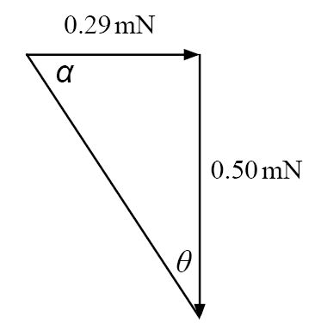
For example for question 8:
Sketching a vector diagram for the forces on sphere B:
tan θ = 0.29 mN/0.50 mN. So θ = 30°
A | Calculator set on radians. (0.66°).
B | Wrong angle i.e. tanα = 0.50 mN/0.29 mN with calculator on  radians.
C | Correct answer as above.
D  C | Wrong angle i.e. tanα = 0.50 N/0.29 mN.
Your answer

Possible techniques for completion
For calculation questions completing the calculation before looking at the alternative answers can avoid being deflected by the distractors and ensure an impartial response.
For questions involving thinking skills and logical deduction it may be possible to eliminate at least one answer as being a distractor, thus reducing the final choice.
It is not good practice to leave any answer blank, unless the marking for the multiple choice questions includes a penalty for incorrect answers, so it is worthwhile using knowledge or intuition to select what you believe is the most likely answer.

Topics covered
Teacher section
Multiple Choice Questions topic quiz - answers – Measurements and uncertainty 4
Multiple Choice Questions topic quiz - answers (Physics B only) 7
Multiple Choice Questions topic quiz - answers – Forces 8
Multiple Choice Questions topic quiz - answers – Motion 10
Multiple Choice Questions topic quiz - answers – Work, Energy and Power 16
Multiple Choice Questions topic quiz - answers – Moments (Physics A only) 17
Multiple Choice Questions topic quiz - answers – Materials 19
Multiple Choice Questions topic quiz - answers – Pressure (Physics A) 21
Learner resources
Multiple Choice Questions Measurements and uncertainty 23
Multiple Choice Questions – (Physics B only) 26
Multiple Choice Questions (MCQ) topic quiz – Forces 27
Multiple Choice Questions (MCQ) topic quiz – Motion 29
Multiple Choice Questions (MCQ) topic quiz – Work, Energy and Power 35
Multiple Choice Questions (MCQ) topic quiz – Moments (Physics A only) 36
Multiple Choice Questions (MCQ) topic quiz – Materials 38
Multiple Choice Questions (MCQ) topic quiz – Pressure (Physics A) 40

Multiple Choice Questions topic quiz - answers – Measurements and uncertainty
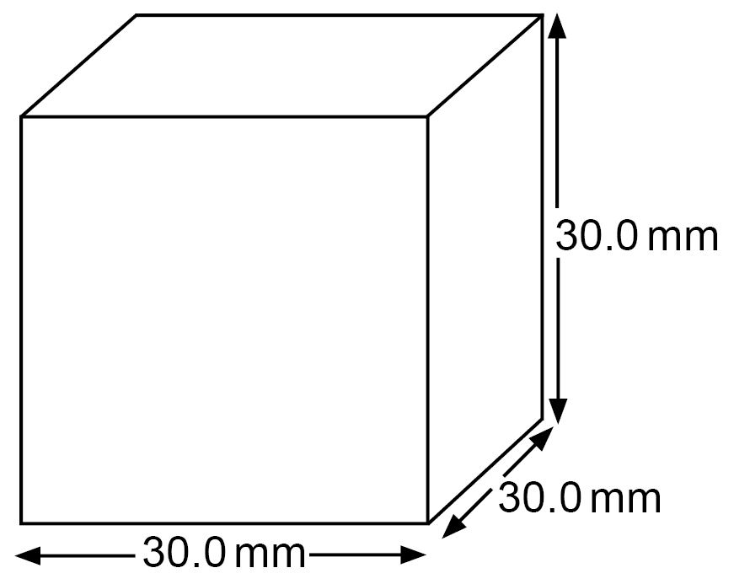
1. The dimensions of a cube are measured with vernier calipers.
The measured length of each side is 30.0 mm. If the vernier callipers can be read with an uncertainty of +/- 0.1 mm. What is the approximate percentage uncertainty in the value of the volume?

A | 4%
B | 3%
C | 0.3%
D  D | 1%
Your answer
2. To find the resistivity of a semiconductor, a student makes the following measurements of a cylindrical rod of the material :
length = 25 ± 1 mm
diameter = 5.0 ± 0.1 mm
resistance = 68 ± 1 Ω
The resistivity is calculated to be 53 mΩ m. What is the uncertainty in this result?
A | ± 1 mΩ m
B | ± 2 mΩ m
C | ± 4 mΩ m
D  D | ± 5 mΩ m
Your answer

3. Two students carry out an experiment to determine the ratio of potential difference across two resistors R₁ and R₂ which are connected in series across a low voltage d.c. supply. The resistors have different values such that R₂ = 10 R₁.
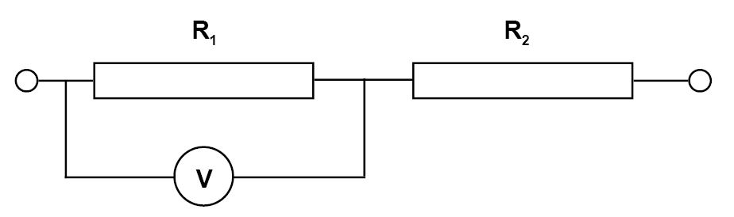

The voltmeter used to take the readings gives a reading of 0.2V before any potential difference is applied.
Amy takes one measurement across each resistor and calculates the ratio as V₁/V₂.
Matthew changes the supply voltage and takes a series of readings for V₁ and V₂. He then plots a graph of V₁ against V₂ and uses the gradient of his graph to determine V₁/V₂.
Which of the following statements is true?
A | Amy’s value for V₁/V₂ will not be affected by the error.
B | Amy’s value for V₁/V₂ will be increased because of the error.
C | Matthew’s value for V₁/V₂ will not be affected by the error.
D  C | Matthew’s value for V₁/V₂ will be decreased because of the error.
Your answer

4. The diameter of a wire being tested is measured as d = 0.40 ± 0.005 mm.
What is the percentage uncertainty in the result of the calculation when d is used to determine cross sectional area of the wire?
A | 2.50%
B | 1.56%
C | 1.25%
D  A | 0.016%
Your answer

5. A student determines a value for a force using the formula F = k I l .
k is a constant with units of N A⁻¹ m⁻¹
I is current measured in mA
l is length measured in mm
The student uses the numbers directly from each measurement in their calculation.
What will be the units of the force from that calculation?
A | μN
B | mN
C | N
D  A | MN
Your answer

Multiple Choice Questions topic quiz - answers (Physics B only)

6. A digital camera records each image as 8 megapixels, with each pixel transferring 14 bits of information.
What is the minimum capacity for a memory card which could hold 120 images?
A | 1.7 Mbyte
B | 13 Mbyte
C | 1.7 Gbyte
D  C | 13 Gbyte
Your answer

Multiple Choice Questions topic quiz - answers – Forces
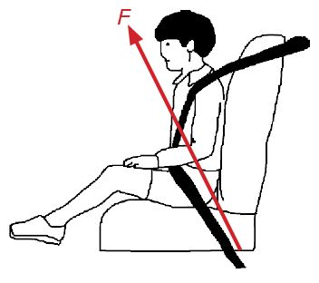
7. A child (mass m) sits on a car seat which is accelerating
horizontally at 0.50g (where g is the acceleration of free fall).
What is the magnitude of the total force F exerted by the car
seat on the child?
A | 0.50 mg
B | 1.0 mg
C | 1.1 mg
D  C | 1.5 mg
Your answer

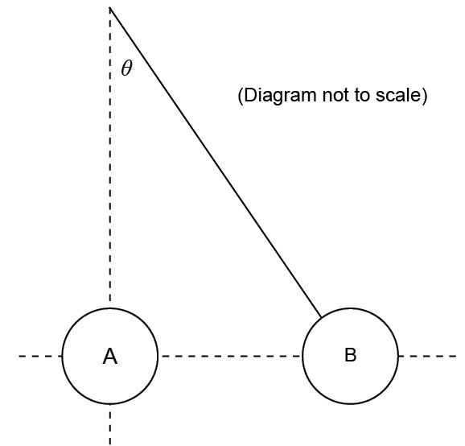
8. Two metal spheres, A and B, are positively charged. Sphere A is fixed in position. Sphere B is suspended by an insulating thread from a point directly above the centre of sphere A as shown in the diagram:
Sphere B has a weight of 0.50 m N. The size of the
electrostatic repulsive force is 0.29 m N.
What angle, θ, does the thread suspending sphere B
make to the vertical ?
A | 0.66°
B | 1.0°
C | 30°
D  C | 60°
Your answer

9. Each diagram below shows three newton meters, in a two dimensional arrangement, joined to demonstrate a system of three forces acting at a point. The readings represent the magnitudes of the forces.
Which system of forces could be in equilibrium?

A | 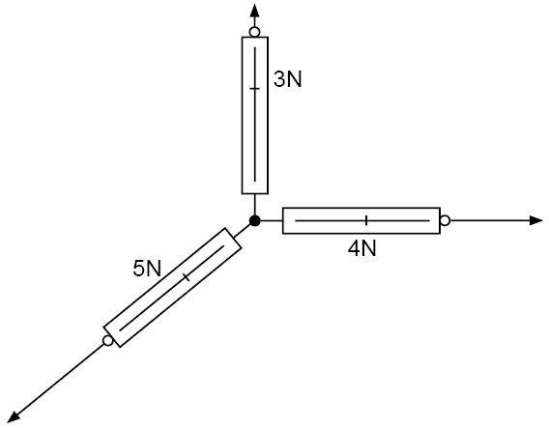
B | 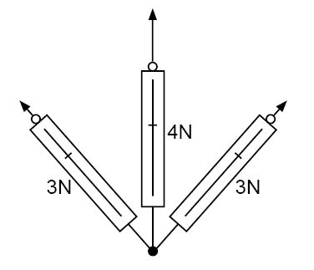
C | 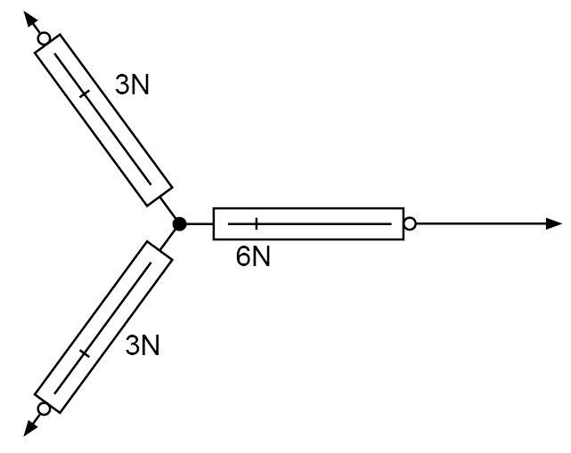
D  A | 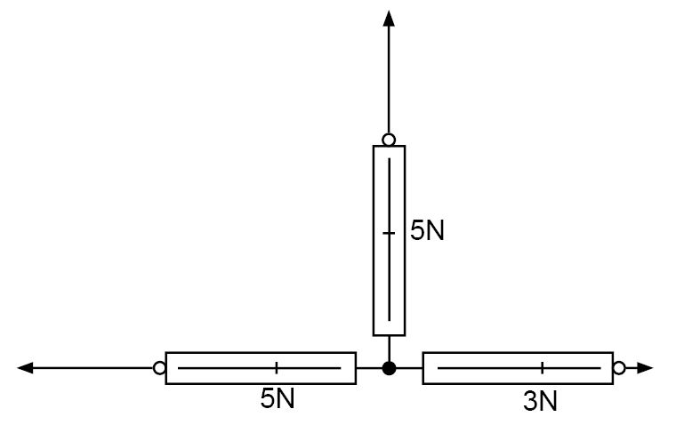
Your answer

Multiple Choice Questions topic quiz - answers – Motion
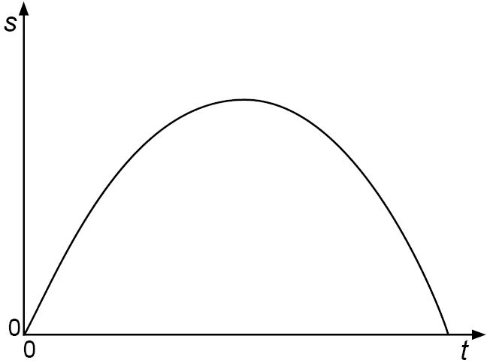
10. The diagram shows the graph of displacement s against time t for an object moving in a straight line.
Which of the following graphs of velocity v against time t represents the motion of the body over this period?

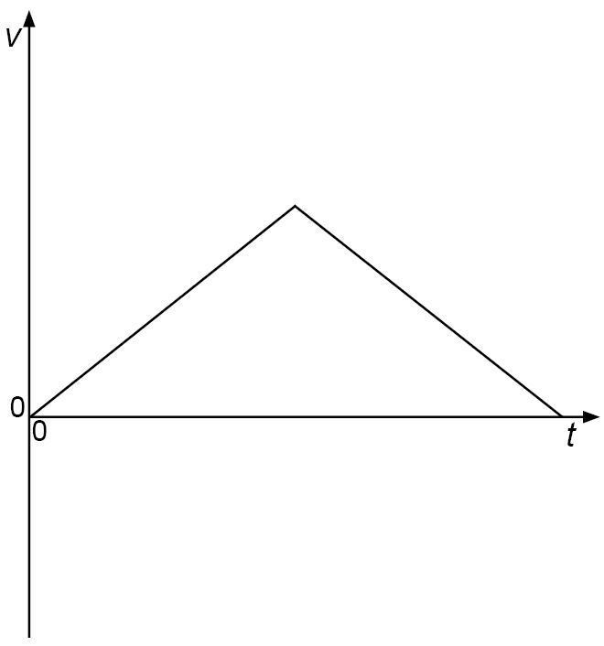  A | 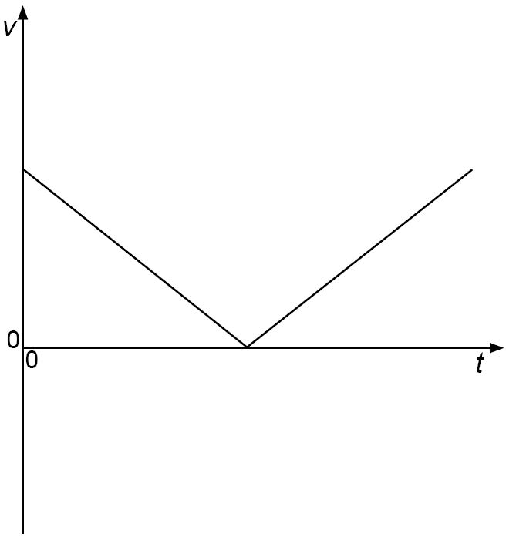  B
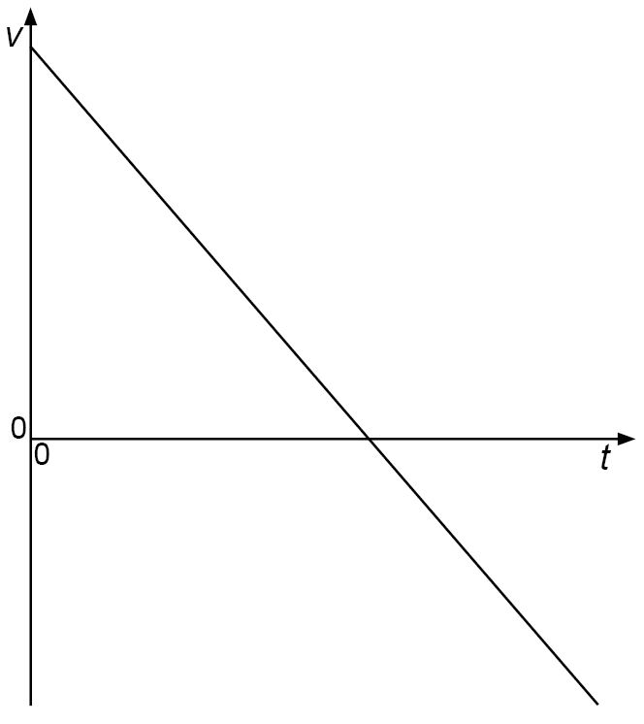  C | 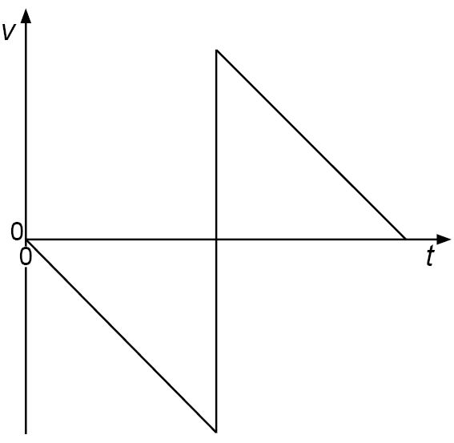  D
C
Your answer

11. In the absence of air resistance a stone is thrown from P and follows a parabolic path, as shown, in which the highest point reached is T.
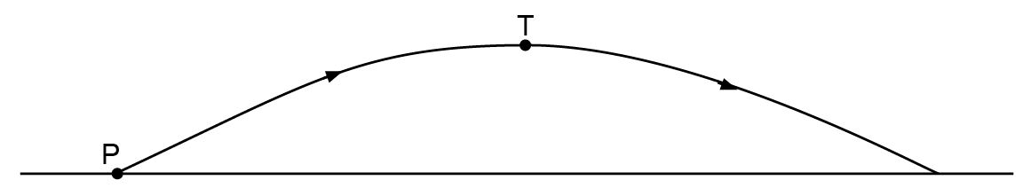

The vertical component of acceleration of the stone, as it follows this path, is:
A | zero at T
B | greatest at T
C | greatest at P
D  D | The same at P as at T
Your answer

12. A satellite moves at a constant speed in a circular orbit about the Earth.
Which pair of statements about momentum and kinetic energy are correct?
 | Momentum | Kinetic energy
A | constant | changing
B | constant | constant
C | changing | changing
D | changing | constant
D
Your answer
13. The graph below shows the velocity – time graphs of two cars.
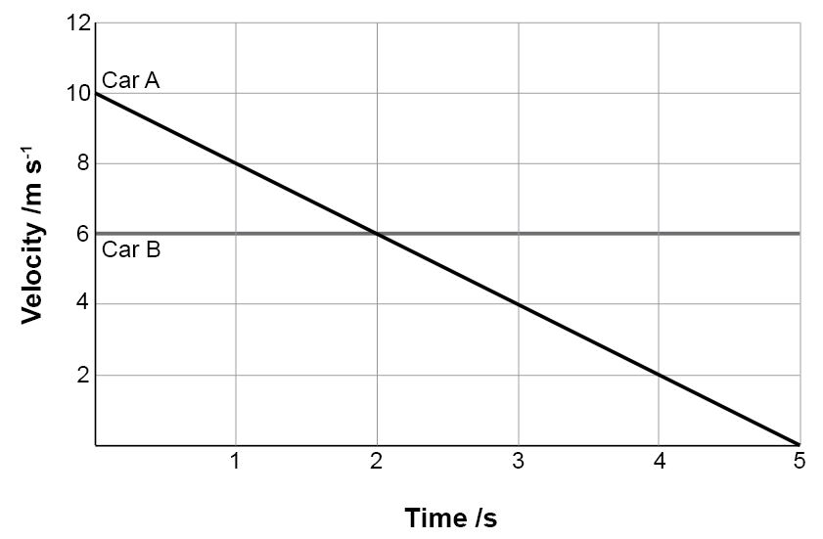

At what time have both cars travelled the same distance since t = 0 ?
A | 1.0 s
B | 2.0 s
C | 3.0 s
D  D | 4.0 s
Your answer

14. A door is fitted with a spring operated latch as shown.
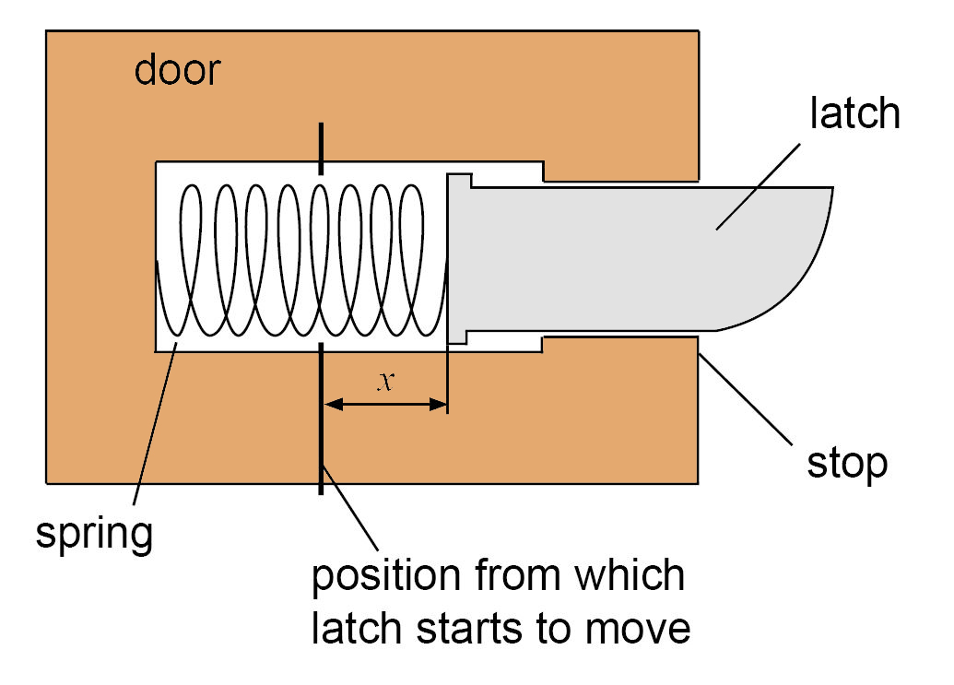

The latch is pushed in, the spring becomes compressed but remains within its elastic limit.
The latch is then suddenly released.
Which graph best shows how the acceleration of the latch varies with the distance x it moves before it is stopped?
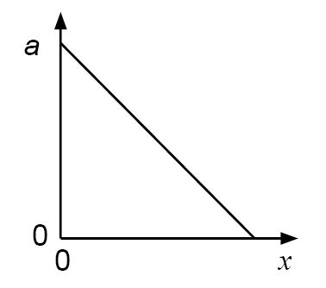  A | 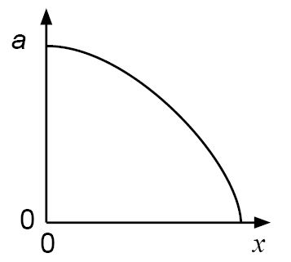  B
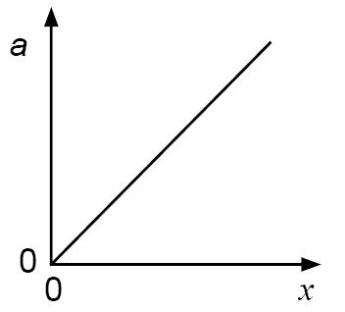  C | 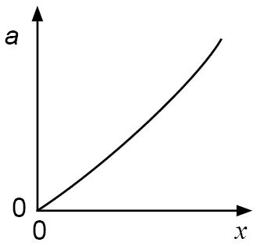  D
A
Your answer

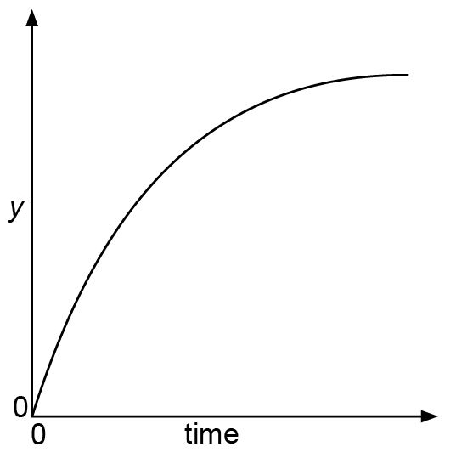
15. The graph relates to the motion of a falling body.
What could y represent on the vertical axis?

A | distance when air resistance is negligible
B | distance when air resistance is not negligible
C | speed when air resistance is negligible
D  D | speed when air resistance is not negligible
Your answer

16. A skydiver falls from the open door of an aircraft in steady level flight.
It is observed that it takes three seconds for the skydiver to reach terminal velocity.
Which statement about the motion of the object is correct?

A | The horizontal component of the skydiver’s velocity is constant.
B | The horizontal component of the skydiver’s acceleration is zero.
C | The vertical component of the skydiver’s velocity decreases for three seconds.
D | The vertical component of the skydiver’s acceleration is zero after three seconds.
D
Your answer

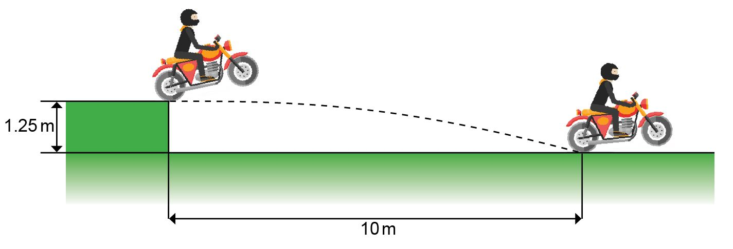
17. A motorcycle stunt-rider moving horizontally, takes off from a point 1.25 m above the ground.

She lands 10m away from the take-off point, as shown.
What was the speed at take-off?

A | 5 m s⁻¹
B | 10 m s⁻¹
C | 15 m s⁻¹
D  D | 20 m s⁻¹
Your answer

Multiple Choice Questions topic quiz - answers
– Work, Energy and Power

18. The engine of a high speed train, travelling at 50 ms⁻¹, delivers a power of 2 MW.
What is the force exerted by the engine?

A | 4 x 10⁴ N
B | 1 x 10⁵ N
C | 4 x 10⁷ N
D  A | 1 x 10⁸ N
Your answer

19. A force of 1000 N is needed to lift the hook of a crane at a constant velocity. The crane is then used to lift a load of 10000 N at a velocity of 0.50 ms⁻¹.
How much power does the motor of the crane need to develop to lift the hook and load?

A | 5.0 kW
B | 5.5 kW
C | 20 kW
D  B | 22 kW
Your answer

Multiple Choice Questions topic quiz - answers
– Moments (Physics A only)

20. Diagram 1 shows two parallel forces F acting on a bar of length l pivoted at P. The forces create a couple of torque M.
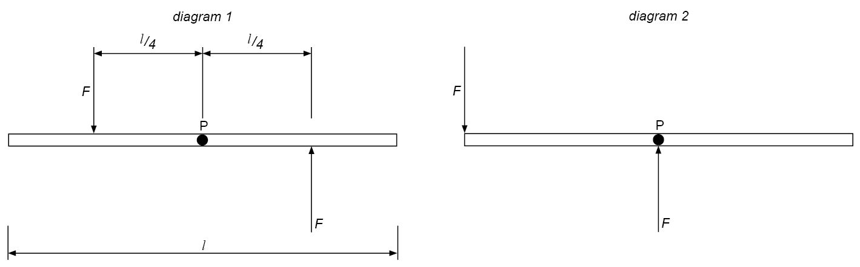
In diagram 2, the two parallel forces have each moved l/4 to the left.

What is the torque of the couple in diagram 2?

A | 0
B | M / 2
C | M
D  C | 2M
Your answer

21. A rod of length 1 metre has a non-uniform composition, so that its centre of gravity is not at the geometrical centre of the rod, which would be half way along its length.
The rod is laid on supports across two electronic balances, as shown in the diagram.
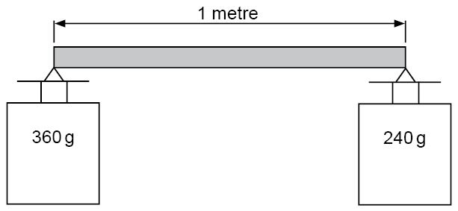
The balances, which have been previously set to zero, give readings of 360 g and 240 g.

Where is the centre of gravity of the rod relative to its geometric centre?

A | $\frac{1}{\text{10}}$m to the left
B | $\frac{1}{\text{10}}$m to the right
C | $\frac{1}{6}$m to the left
D  A | $\frac{1}{6}$m to the right
Your answer

Multiple Choice Questions topic quiz - answers – Materials

22. An iron wire and a brass wire, of equal lengths and cross sectional area, are joined at one end. A tensile force F is applied to the free ends as shown.

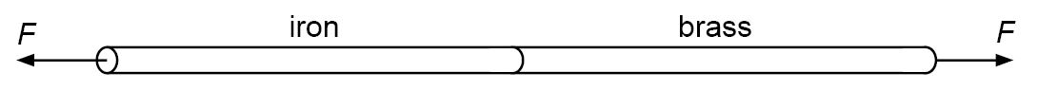

If the Young modulus of iron is twice that of brass, which statement is true?

A | The extension of the brass wire is twice that of the iron wire.
B | The extension of the iron wire is twice that of the brass wire.
C | The stress of the brass wire is twice that of the iron wire.
D  A | The stress of the iron wire is twice that of the brass wire.
Your answer

23. A uniform strip of rubber, marked with equal divisions, is fixed at end P and pulled by force F applied at end Q, as shown in the diagram.
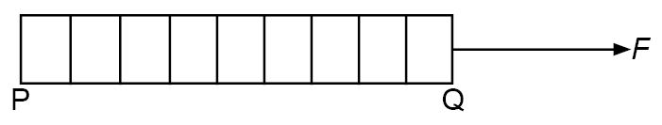

Which diagram shows the separation of the divisions when the elastic is extended to twice its original length?

A
B

C
D
C
Your answer

Multiple Choice Questions topic quiz - answers
– Pressure (Physics A)
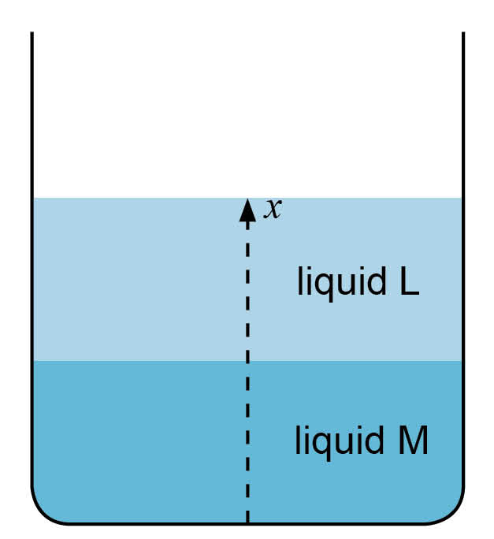
24. A tall container which is open to the atmosphere contains a layer of liquid L, floating on liquid M, which has a density which is twice that of liquid L.
Which graph shows how the pressure in the liquid, p, at a point varies with its height, x, above the base of the container?

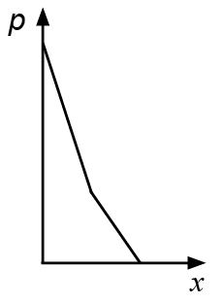  A | 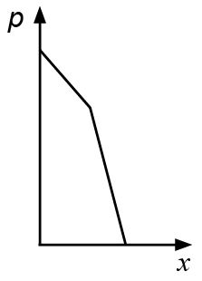  B
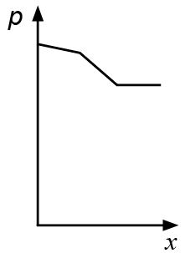  C | 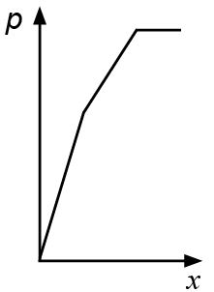  D
A
Your answer

OCR Resources: the small print
OCR’s resources are provided to support the teaching of OCR specifications, but in no way constitute an endorsed teaching method that is required by the Board, and the decision to use them lies with the individual teacher. Whilst every effort is made to ensure the accuracy of the content, OCR cannot be held responsible for any errors or omissions within these resources.
© OCR 2016 - This resource may be freely copied and distributed, as long as the OCR logo and this message remain intact and OCR is acknowledged as the originator of this work.
OCR acknowledges the use of the following content: n/a
Please get in touch if you want to discuss the accessibility of resources we offer to support delivery of our qualifications: resources.feedback@ocr.org.uk
We’d like to know your view on the resources we produce. By clicking on ‘Like’ or ‘Dislike’ you can help us to ensure that our resources work for you. When the email template pops up please add additional comments if you wish and then just click ‘Send’. Thank you.
If you do not currently offer this OCR qualification but would like to do so, please complete the Expression of Interest Form which can be found here: www.ocr.org.uk/expression-of-interest
This formative assessment resource has been produced as part of our free Physics teaching and learning support package. All the Physics teaching and learning resources, including delivery guides, topic exploration packs, lesson elements and more are available on the qualification webpages.
If you are looking for examination practice materials, you can find Sample Assessment Materials (SAMs) and a link to the Practice Papers on the qualification webpages: Physics A, Physics B.

Learner resources

Multiple Choice Questions (MCQ) topic quiz

Measurements and uncertainty

1. The dimensions of a cube are measured with vernier calipers.
The measured length of each side is 30.0 mm. If the vernier
callipers can be read with an uncertainty of +/- 0.1 mm. What
is the approximate percentage uncertainty in the value of the volume?

A | 4%
B | 3%
C | 0.3%
D | 1%
Your answer

2. To find the resistivity of a semiconductor, a student makes the following measurements of a cylindrical rod of the material :
length = 25 ± 1 mm
diameter = 5.0 ± 0.1 mm
resistance = 68 ± 1 Ω
The resistivity is calculated to be 53 mΩ m. What is the uncertainty in this result?
A | ± 1 mΩ m
B | ± 2 mΩ m
C | ± 4 mΩ m
D | ± 5 mΩ m | Your answer

3. Two students carry out an experiment to determine the ratio of potential difference across two resistors R₁ and R₂ which are connected in series across a low voltage d.c. supply. The resistors have different values such that R₂ = 10 R₁.

The voltmeter used to take the readings gives a reading of 0.2V before any potential difference is applied.
Amy takes one measurement across each resistor and calculates the ratio as V₁/V₂.
Matthew changes the supply voltage and takes a series of readings for V₁ and V₂. He then plots a graph of V₁ against V₂ and uses the gradient of his graph to determine V₁/V₂.
Which of the following statements is true?
A | Amy’s value for V₁/V₂ will not be affected by the error.
B | Amy’s value for V₁/V₂ will be increased because of the error.
C | Matthew’s value for V₁/V₂ will not be affected by the error.
D | Matthew’s value for V₁/V₂ will be decreased because of the error.
Your answer

4. The diameter of a wire being tested is measured as d = 0.40 ± 0.005 mm.
What is the percentage uncertainty in the result of the calculation when d is used to determine cross sectional area of the wire?
A | 2.50%
B | 1.56%
C | 1.25%
D | 0.016%
Your answer

5. A student determines a value for a force using the formula F = k I l .
k is a constant with units of N A⁻¹ m⁻¹
I is current measured in mA
l is length measured in mm
The student uses the numbers directly from each measurement in their calculation.
What will be the units of the force from that calculation?
A | μN
B | mN
C | N
D | MN
Your answer

Multiple Choice Questions (MCQ) topic quiz

– (Physics B only)

6. A digital camera records each image as 8 megapixels, with each pixel transferring 14 bits of information.
What is the minimum capacity for a memory card which could hold 120 images?
A | 1.7 Mbyte
B | 13 Mbyte
C | 1.7 Gbyte
D | 13 Gbyte
Your answer

Multiple Choice Questions (MCQ) topic quiz – Forces
7. A child (mass m) sits on a car seat which is accelerating
horizontally at 0.50g (where g is the acceleration of free fall).
What is the magnitude of the total force F exerted by the car
seat on the child?
A | 0.50 mg
B | 1.0 mg
C | 1.1 mg
D | 1.5 mg
Your answer

8. Two metal spheres, A and B, are positively charged. Sphere A is fixed in position. Sphere B is suspended by an insulating thread from a point directly above the centre of sphere A as shown in the diagram:
Sphere B has a weight of 0.50 m N. The size of the
electrostatic repulsive force is 0.29 m N.
What angle, θ, does the thread suspending sphere B
make to the vertical ?
A | 0.66°
B | 1.0°
C | 30°
D | 60°
Your answer

9. Each diagram below shows three newton meters, in a two dimensional arrangement, joined to demonstrate a system of three forces acting at a point. The readings represent the magnitudes of the forces.
Which system of forces could be in equilibrium?

A
B
C
D

Your answer

Multiple Choice Questions (MCQ) topic quiz – Motion
10. The diagram shows the graph of displacement s against time t for an object moving in a straight line.
Which of the following graphs of velocity v against time t represents the motion of the body over this period?

A | C
B | D

Your answer

11. In the absence of air resistance a stone is thrown from P and follows a parabolic path, as shown, in which the highest point reached is T.

The vertical component of acceleration of the stone, as it follows this path, is:
A | zero at T
B | greatest at T
C | greatest at P
D | The same at P as at T
Your answer

12. A satellite moves at a constant speed in a circular orbit about the Earth.
Which pair of statements about momentum and kinetic energy are correct?
 | Momentum | Kinetic energy
A | constant | changing
B | constant | constant
C | changing | changing
D | changing | constant
Your answer
13. The graph below shows the velocity – time graphs of two cars.

At what time have both cars travelled the same distance since t = 0 ?
A | 1.0 s
B | 2.0 s
C | 3.0 s
D | 4.0 s
Your answer

14. A door is fitted with a spring operated latch as shown.

The latch is pushed in, the spring becomes compressed but remains within its elastic limit.
The latch is then suddenly released.
Which graph best shows how the acceleration of the latch varies with the distance x it moves before it is stopped?
A | C
B | D

Your answer

15. The graph relates to the motion of a falling body.
What could y represent on the vertical axis?

A | distance when air resistance is negligible
B | distance when air resistance is not negligible
C | speed when air resistance is negligible
D | speed when air resistance is not negligible
Your answer

16. A skydiver falls from the open door of an aircraft in steady level flight.
It is observed that it takes three seconds for the skydiver to reach terminal velocity.
Which statement about the motion of the object is correct?

A | The horizontal component of the skydiver’s velocity is constant.
B | The horizontal component of the skydiver’s acceleration is zero.
C | The vertical component of the skydiver’s velocity decreases for three seconds.
D | The vertical component of the skydiver’s acceleration is zero after three seconds.
Your answer

17. A motorcycle stunt-rider moving horizontally, takes off from a point 1.25 m above the ground.

She lands 10m away from the take-off point, as shown.
What was the speed at take-off?

A | 5 m s⁻¹
B | 10 m s⁻¹
C | 15 m s⁻¹
D | 20 m s⁻¹
Your answer

Multiple Choice Questions (MCQ) topic quiz

– Work, Energy and Power

18. The engine of a high speed train, travelling at 50 ms⁻¹, delivers a power of 2 MW.
What is the force exerted by the engine?

A | 4 x 10⁴ N
B | 1 x 10⁵ N
C | 4 x 10⁷ N
D | 1 x 10⁸ N
Your answer

19. A force of 1000 N is needed to lift the hook of a crane at a constant velocity. The crane is then used to lift a load of 10000 N at a velocity of 0.50 ms⁻¹.
How much power does the motor of the crane need to develop to lift the hook and load?

A | 5.0 kW
B | 5.5 kW
C | 20 kW
D | 22 kW
Your answer

Multiple Choice Questions (MCQ) topic quiz – Moments (Physics A only)

20. Diagram 1 shows two parallel forces F acting on a bar of length l pivoted at P. The forces create a couple of torque M.
In diagram 2, the two parallel forces have each moved l/4 to the left.

What is the torque of the couple in diagram 2?

A | 0
B | M / 2
C | M
D | 2M
Your answer

21. A rod of length 1 metre has a non-uniform composition, so that its centre of gravity is not at the geometrical centre of the rod, which would be half way along its length.
The rod is laid on supports across two electronic balances, as shown in the diagram.
The balances, which have been previously set to zero, give readings of 360 g and 240 g.

Where is the centre of gravity of the rod relative to its geometric centre?

A | $\frac{1}{\text{10}}$m to the left
B | $\frac{1}{\text{10}}$m to the right
C | $\frac{1}{6}$m to the left
D | $\frac{1}{6}$m to the right
Your answer

Multiple Choice Questions (MCQ) topic quiz – Materials

22. An iron wire and a brass wire, of equal lengths and cross sectional area, are joined at one end. A tensile force F is applied to the free ends as shown.

If the Young modulus of iron is twice that of brass, which statement is true?

A | The extension of the brass wire is twice that of the iron wire.
B | The extension of the iron wire is twice that of the brass wire.
C | The stress of the brass wire is twice that of the iron wire.
D | The stress of the iron wire is twice that of the brass wire.

23. A uniform strip of rubber, marked with equal divisions, is fixed at end P and pulled by force F applied at end Q, as shown in the diagram.

Which diagram shows the separation of the divisions when the elastic is extended to twice its original length?

A
B

C
D

Your answer

Multiple Choice Questions (MCQ) topic quiz – Pressure (Physics A)
24. A tall container which is open to the atmosphere contains a layer of liquid L, floating on liquid M, which has a density which is twice that of liquid L.
Which graph shows how the pressure in the liquid, p, at a point varies with its height, x, above the base of the container?

A | B
C | D
Your answer

