
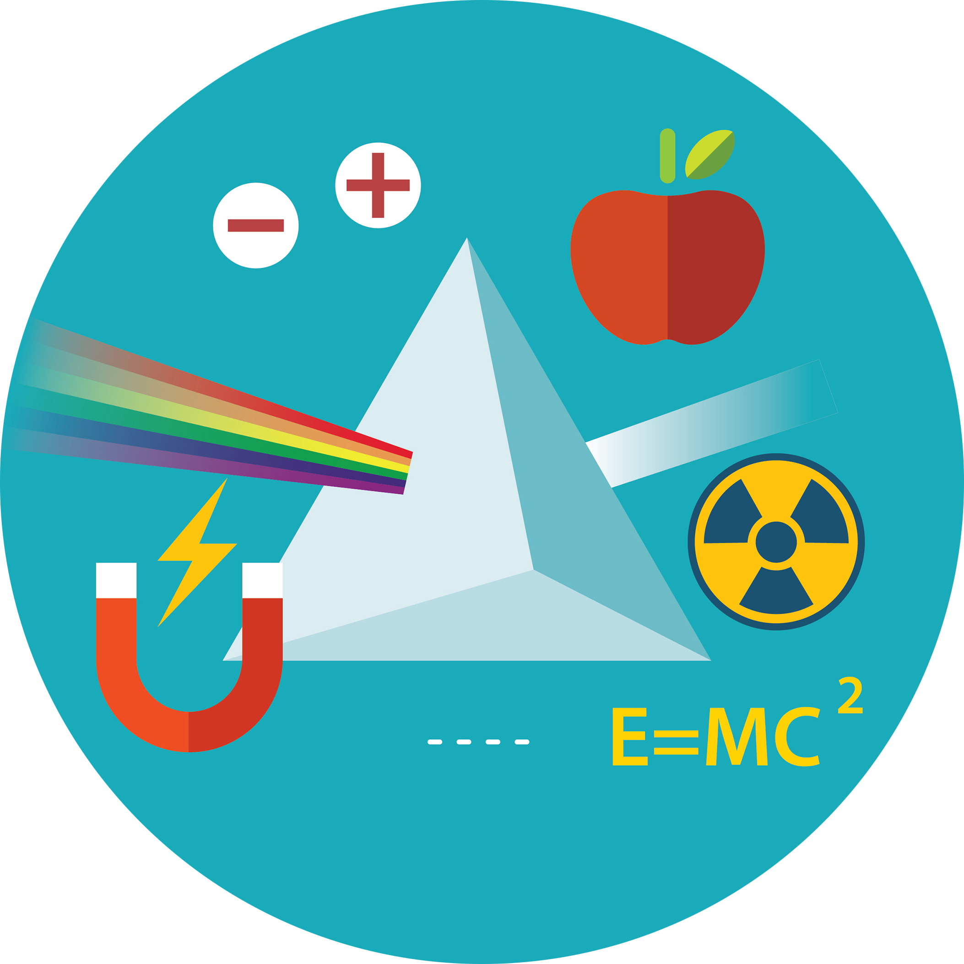
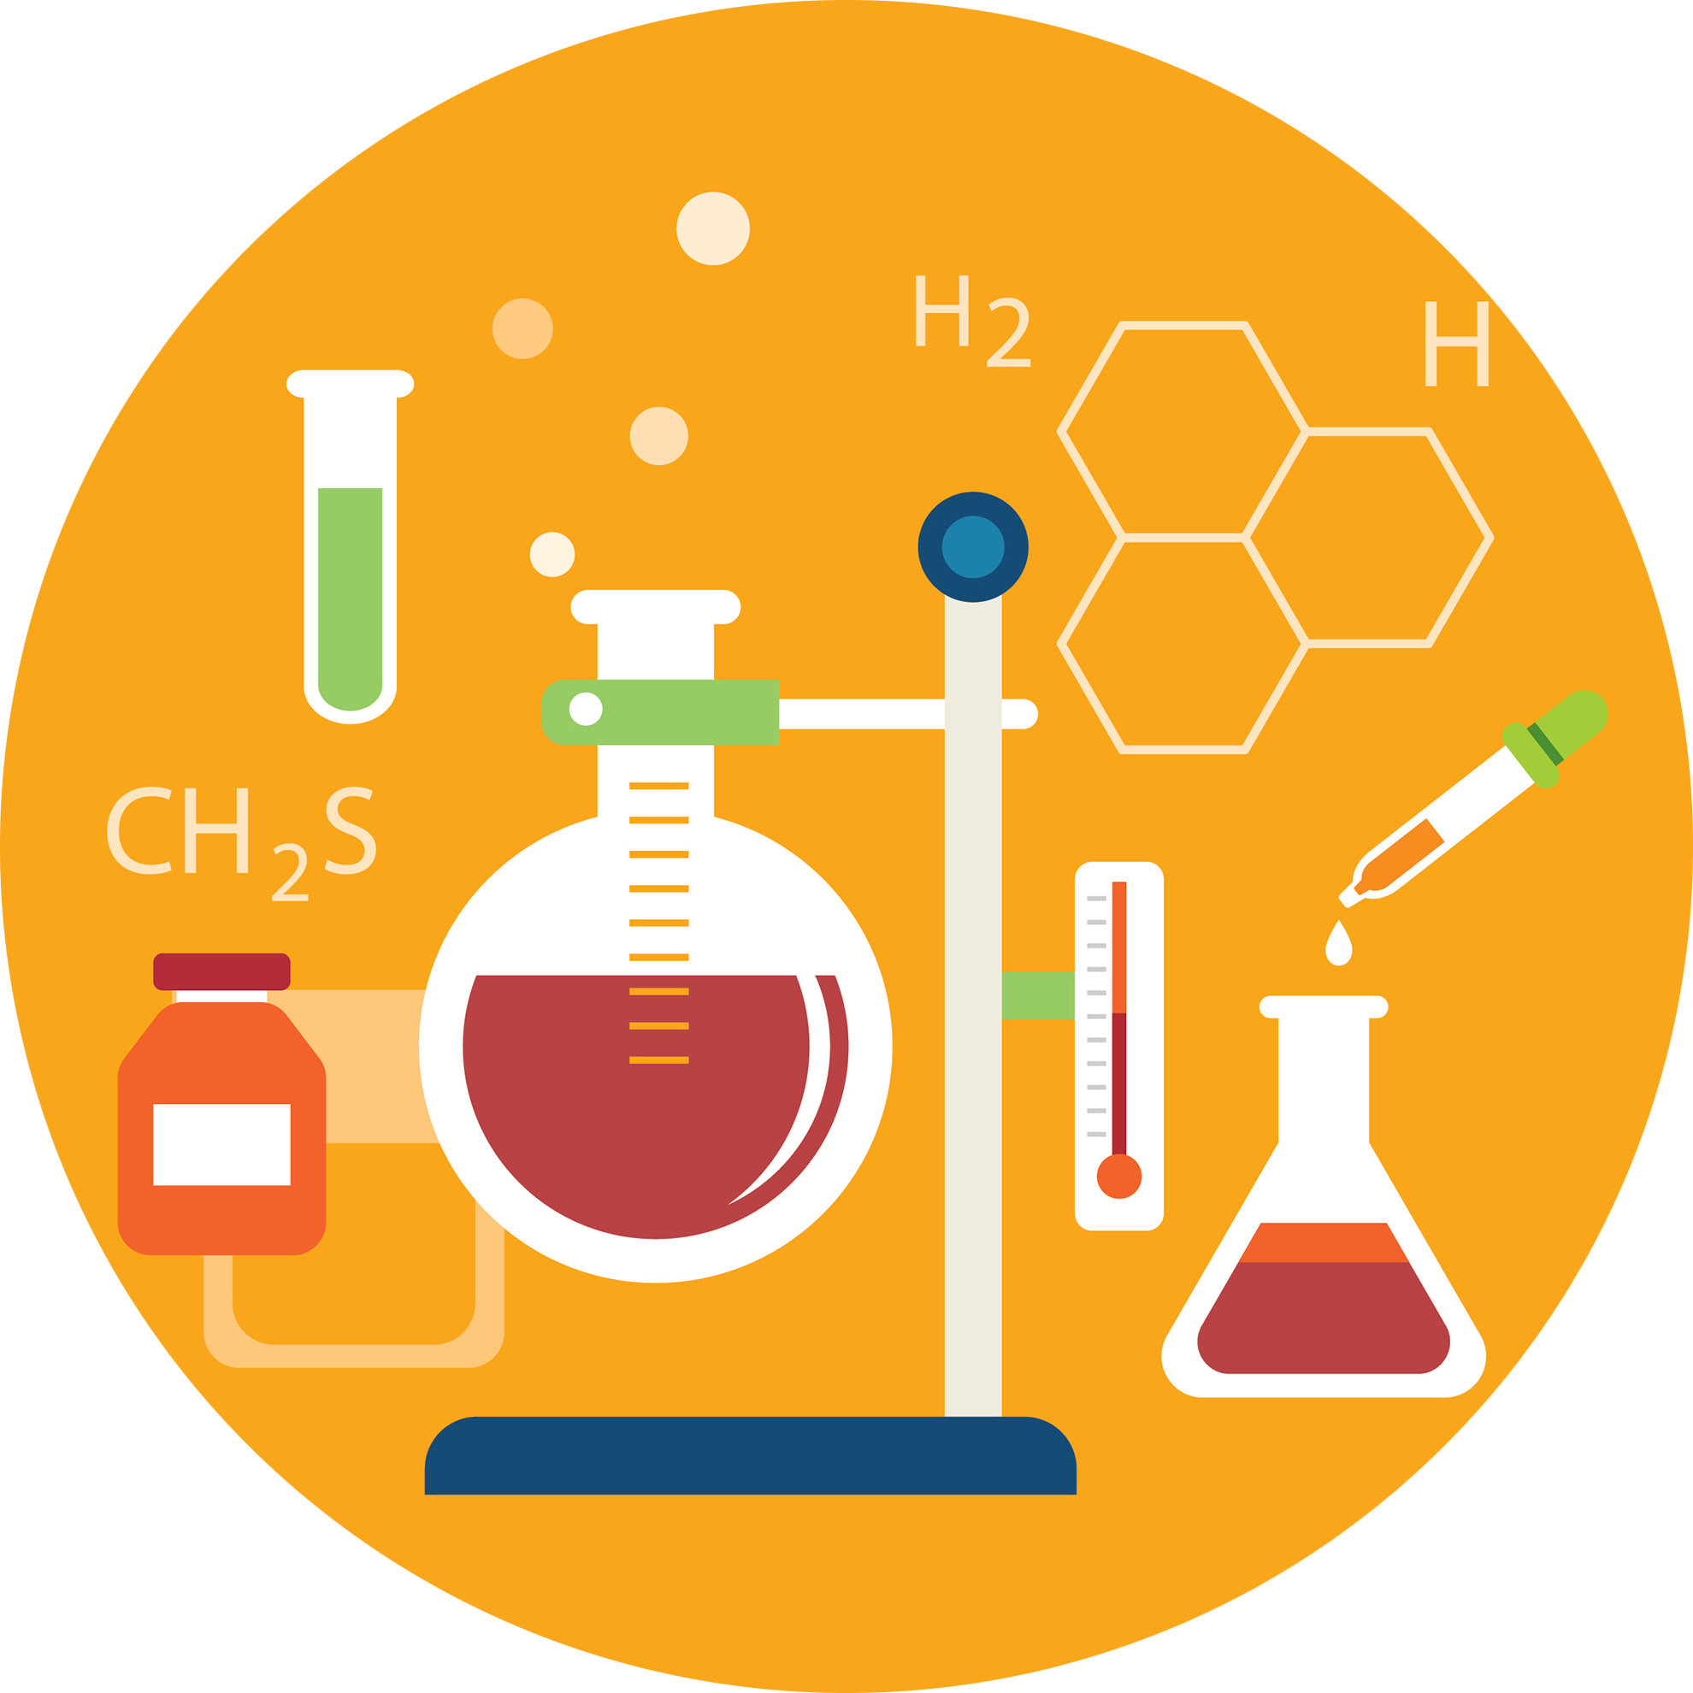
XXX

Combined Science

GCSE (9–1) Gateway and Twenty First Century

Practical Activity

Learner Record Sheet

You will be given the opportunity to carry out a minimum of 16 practical activities for combined sciences.
Name
Class
Teacher
School

List of apparatus and techniques
The following list includes opportunities for choice and use of appropriate laboratory apparatus for a variety of experimental problem-solving and/or enquiry based activities.
Safety is an overriding requirement for all practical work. Centres are responsible for ensuring appropriate safety procedures are followed whenever their students complete practical work.
Use and production of appropriate scientific diagrams to set up and record apparatus and procedures used in practical work is common to all science subjects and should be included wherever appropriate.
1 Use of appropriate apparatus to make and record a range of measurements accurately, including: |  |  |  |  |  |  | 
i |  |  | length
ii |  |  | area
iii |  |  | mass
iv |  |  | time
v |  |  | temperature
vi |  |  | volume of liquids
vii |  |  | volume of gases
viii |  |  | volume
ix |  |  | pH
 |  |  | The learner/I have completed this section
2 Safe use of appropriate heating devices and techniques including use of: |  |  |  |  |  |  | 
i |  |  | a Bunsen burner
ii |  |  | a water bath OR an electric heater
 |  |  | The learner/I have completed this section
3 Use of appropriate apparatus and techniques for the: |  |  |  |  |  |  | 
i |  |  | observation of biological changes and/or processes
ii |  |  | measurement of biological changes and/or processes
 |  |  | The learner/I have completed this section

4 Safe and ethical use of living organisms (plants or animals) to measure: |  |  |  |  |  |  |  |  |  | 
i |  |  |  | physiological functions
ii |  |  |  | responses to the environment
 |  |  |  | The learner/I have completed this section
5 Measurement of rates of reaction by a variety of methods including: |  |  |  |  |  |  |  |  |  | 
i |  |  |  | production of gas
ii |  |  |  | uptake of water
iii |  |  |  | colour change of indicator
 |  |  |  | The learner/I have completed this section
6 Application of appropriate sampling techniques to investigate the distribution and abundance of organisms in an ecosystem via direct use in the field |  |  |  |  |  |  |  |  |  | 
 |  |  |  | The learner/I have completed this section
7 Use of appropriate apparatus, techniques and magnification, including microscopes, to: |  |  |  |  |  |  |  |  |  | 
i |  |  |  | make observations of biological specimens
ii |  |  |  | produce labelled scientific drawings
 |  |  |  | The learner/I have completed this section

8 Use of appropriate apparatus and techniques for: |  |  |  |  |  |  |  |  |  | 
i |  |  |  |  | conducting and monitoring chemical reactions
ii |  |  |  |  | conducting and monitoring chemical reactions, including appropriate reagents and/or techniques for the measurement of pH in different situations
 |  | The learner/I have completed this section
9 Safe use of a range of equipment to purify and/or separate chemical mixtures including: |  |  |  |  |  |  |  |  |  | 
i |  |  |  |  |  | evaporation
ii |  |  |  |  |  | filtration
iii |  |  |  |  |  | crystallisation
iv |  |  |  |  |  | chromatography
v |  |  |  |  |  | distillation
 |  |  |  |  |  | The learner/I have completed this section
10 Making and recording of appropriate observations during chemical reactions including: |  |  |  |  |  |  |  |  |  | 
i |  |  |  | changes in temperature
ii |  |  |  | the measurement of rates of reaction by a variety of methods such as production of gas
iii |  |  |  | the measurement of rates of reaction by a variety of methods such as colour change
 |  |  |  | The learner/I have completed this section
11 Safe use and careful handling of gases, liquids and solids, including: |  |  |  |  |  |  |  |  |  | 
i |  |  |  | careful mixing of reagents under controlled conditions
ii |  |  |  | using appropriate apparatus to explore chemical changes and/or products
 |  |  |  | The learner/I have completed this section

12 Use of appropriate apparatus and techniques to: |  |  |  |  |  |  |  |  | 
i |  |  |  | draw electrochemical cells for separation and production of elements and compounds
ii |  |  |  | set up and use electrochemical cells for separation and production of elements and compounds
 |  |  |  | The learner/I have completed this section
13 Use of such measurements to determine: |  |  |  |  |  |  |  |  | 
i |  |  |  |  | densities of solid objects
ii |  |  |  |  | densities of liquid objects
 |  |  |  |  | The learner/I have completed this section
14 Use of appropriate apparatus to measure and observe the effects of forces including the extension of springs. |  |  |  |  |  |  |  |  | 
 |  |  |  |  | The learner/I have completed this section
15 Use of appropriate apparatus and techniques for measuring motion, including determination of: |  |  |  |  |  |  |  |  | 
i |  |  |  |  | speed
ii |  |  |  |  | rate of change of speed (acceleration/deceleration)
 |  |  |  |  | The learner/I have completed this section
16a Making observations of waves in fluids and solids to identify the suitability of apparatus to measure: |  |  |  |  |  |  |  |  | 
i |  |  |  |  | speed
ii |  |  |  |  | frequency
ii |  |  |  |  | wavelength
 |  |  |  |  | The learner/I have completed this section

16b Making observations of the effects of the interaction of electromagnetic waves with matter. |  |  |  |  |  |  | 
 |  |  | The learner/I have completed this section
17 Safe use of appropriate apparatus in a range of contexts to measure: |  |  |  |  |  |  | 
i |  |  | energy changes/transfers
ii |  |  | associated values such as work done
 |  |  | The learner/I have completed this section
18a Use of appropriate apparatus to measure: |  |  |  |  |  |  | 
i |  |  | current
ii |  |  | potential difference
iii |  |  | resistance
 |  |  | The learner/I have completed this section
18b Use of appropriate apparatus to explore a variety of circuit elements. |  |  |  |  |  |  | 
 |  |  | The learner/I have completed this section
19 Use of circuit diagrams to construct and check: |  |  |  |  |  |  | 
i |  |  | series circuits including a variety of common circuit elements
ii |  |  | parallel circuits including a variety of common circuit elements
 |  |  | The learner/I have completed this section

Please turn over
Practical activity record sheet
Record the practical activities you have carried out below. If additional pages are required a copy of this page can be attached.
No. |  | Date | Practical done
1
2
3
4
5
6
7
8
9
10
11
12
13
14
15
16
17
18
19
20
21
22
23
24
25
26
27
28

Table continues over the page
Practical activity record sheet (continued).
No. |  | Date | Practical done
29
30
31
32
33
34
35
36
37
38
39
40
41
42
43
44
45
46
47
48
49
50
51
52
We’d like to know your view on the resources we produce. By clicking on ‘Like’ or ‘Dislike’ you can help us to ensure that our resources work for you. When the email template pops up please add additional comments if you wish and then just click ‘Send’. Thank you.
If you do not currently offer this OCR qualification but would like to do so, please complete the Expression of Interest Form which can be found here: www.ocr.org.uk/expression-of-interest

OCR Resources: the small print
OCR’s resources are provided to support the teaching of OCR specifications, but in no way constitute an endorsed teaching method that is required by the Board, and the decision to use them lies with the individual teacher. Whilst every effort is made to ensure the accuracy of the content, OCR cannot be held responsible for any errors or omissions within these resources.
© OCR 2016 - This resource may be freely copied and distributed, as long as the OCR logo and this message remain intact and OCR is acknowledged as the originator of this work.
OCR acknowledges the use of the following content: science vectors: kaisorn/shutterstock.com
Please get in touch if you want to discuss the accessibility of resources we offer to support delivery of our qualifications: resources.feedback@ocr.org.uk

