Multiple Choice Questions (MCQ) topic quiz

Cells

Instructions and answers for teachers
These instructions cover the learner activity section which can be found on page 11.
This Lesson Element supports OCR AS and A Level Biology A (H020/H420) and Biology B (Advancing Biology) (H022/H422).
When distributing the activity section to the learners either as a printed copy or as a Word file you will need to remove the teacher instructions section.

The Activity
This Lesson Element is a teaching and learning resource containing 20 multiple choice questions (MCQs) on the theme of cells. Some questions might require synoptic thinking, using knowledge and ideas from various topics across the full A Level content.
This resource can be used to test and consolidate understanding at the end of a topic or to revisit and refresh knowledge at a later point in the course.

Introduction
Multiple choice questions allow rapid coverage of a wide range of sub-topics.
Contrary to a widespread belief among students, multiple choice questions are not necessarily easy – they can be easy, moderate or difficult.
The questions are written so that the incorrect answers are plausible distractors based on common errors or misconceptions.
The questions in this quiz cover topics mainly from specification sections:
Biology A
2.1.1 Cell structure
Biology B (Advancing Biology)
2.1.1 Cells and microscopy.

Multiple Choice Questions (MCQ) topic quiz - answers
1 Which of these structures contains RNA but not DNA?
A | nucleus
B | mitochondrion
C | chloroplast
D  D | ribosome
Your answer
2 Which of the following is a function of the Golgi apparatus?
A | to aid endocytosis
B | to make proteins from amino acids
C | to synthsise ATP
D  D | to make secretory products
Your answer
3 What is the name given to the structures which penetrate the walls of adjacent plant cells?
A | middle lamellae
B | plasmodesmata
C | pits
D  B | channels
Your answer
4 Cells in culture will absorb amino acids from the surrounding culture medium. If radioactively labelled glycine is provided in the culture medium, in which organelle will radioactivity be found first?
A | ribosomes
B | nucleus
C  A | lysosomes
D | Golgi apparatus
Your answer
5 What resolution can be achieved with a light microscope?
A | 20 μm
B | 2 μm
C | 0.2 μm
D  C | 0.02 μm
Your answer
6 Which of the following cell structures does not have an envelope?
A | lysosome
B | nucleus
C | mitochondrion
D  A | chloroplast
Your answer
7 Intestinal epithelial cells have observable “brush borders” seen on the cells.
What are they?
A | cilia
B | flagella
C | microvilli
D  C | villi
Your answer
8 What are centrioles involved in?
A | lysosome formation
B | intracellular digestion
C | ribosome formation
D  D | cell division
Your answer

9 Which one of the following is responsible for the destruction of damaged organelles?
A | Golgi apparatus
B | cytoskeleton
C | smooth ER
D  D | lysosome
Your answer
10 Which of the following is concerned with the synthesis and transport of lipids and steroids in the cell?
A | rough ER
B | smooth ER
C | Golgi apparatus
D  B | lysosome

Your answer

Question 11 and question 12 use the following photomicrograph:
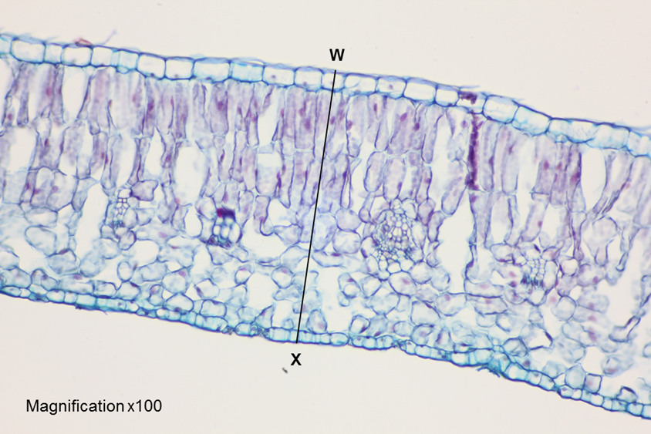

11 The photomicrograph shows a transverse section of the lamina of a beech tree leaf taken at low power.
What is the actual width of the leaf measured from point W – X?
A | 1.7 mm
B | 0.6 µm
C | 16.7 µm
D  D | 600 µm
Your answer
12 The beech leaf slide was prepared using two stains.
Which two macromolecules have been stained?
A | cellulose and starch
B | lignin and nucleic acid
C | cellulose and nucleic acid
D  C | starch and lignin
Your answer
13 When mitochondria are extracted from cells, they are usually kept in a
0.25 mol dm⁻³ sucrose solution.
What is the purpose of the sucrose solution?
A | it is used as a solvent
B | it maintains a constant pH by acting as a buffer
C | it acts as a source of food for respiration
D  D | it prevents the mitochondria from changing structure
Your answer
14 A prokaryotic cell can be distinguished from a eukaryotic cell.
Which of the options, A – D, would only be found in a eukaryotic cell?
A | a nucleus
B | a cell surface membrane
C | ribosomes
D  A | DNA
Your answer
15 Which one of the following has the lowest surface area to volume ratio?
A | a virus
B | a phagocyte
C | a red blood cell
D  B | a bacterium
Your answer
16 Which one of these organelles always contains DNA?
A | ribosome
B | Golgi body
C | mitochondrion
D  C | lysosome
Your answer
17 Some fresh rat liver was homogenised and the suspension subjected to differential centrifugation. The procedure used is shown in the diagram below.
treatment
800 g for 10 minutes
Supernatant
2000 g for 15 minutes
Supernatant
25 000 g for 15 minutes
Supernatant
105 000 g for 60 minutes
sediment
fraction 1

fraction 2

fraction 3

fraction 4
(g = gravitational force)

Which row, A – D, represents the order in which the organelles were removed from the suspension?
 | Fraction 1 | Fraction 2 | Fraction 3 | Fraction 4
A | mitochondria | lysosomes | nuclei | ribosomes
B | mitochondria | nuclei | lysosomes | ribosomes
C | nuclei | mitochondria | lysosomes | ribosomes
D | nuclei | ribosomes | mitochondria | lysosomes
C
Your answer

18 Some organelles are bounded by a single membrane whilst others have two membranes. Which of the options, A – D, is correct?
 | Single membrane |  | Two membranes
A | tonoplast | lysosome | nucleus | chloroplast
B | chloroplast | lysosome | nucleus | tonoplast
C | nucleus | chloroplast | lysosome | tonoplast
D | tonoplast | chloroplast | nucleus | lysosome
A
Your answer
19 Which of the following would be found in an animal cell undergoing mitosis but not in a plant cell undergoing mitosis?
A | chromosome
B | centriole
C | spindle
D  B | chromatid
Your answer
20 Which of the following is absent from prokaryotic cells?
A | plasmids
B | cell wall
C | rough endoplasmic reticulum
D  C | ribosomes
Your answer
OCR Resources: the small print
OCR’s resources are provided to support the teaching of OCR specifications, but in no way constitute an endorsed teaching method that is required by the Board, and the decision to use them lies with the individual teacher. Whilst every effort is made to ensure the accuracy of the content, OCR cannot be held responsible for any errors or omissions within these resources.
© OCR 2016 - This resource may be freely copied and distributed, as long as the OCR logo and this message remain intact and OCR is acknowledged as the originator of this work.
OCR acknowledges the use of the following content: n/a
Please get in touch if you want to discuss the accessibility of resources we offer to support delivery of our qualifications: resources.feedback@ocr.org.uk
We’d like to know your view on the resources we produce. By clicking on ‘Like’ or ‘Dislike’ you can help us to ensure that our resources work for you. When the email template pops up please add additional comments if you wish and then just click ‘Send’. Thank you.
If you do not currently offer this OCR qualification but would like to do so, please complete the Expression of Interest Form which can be found here: www.ocr.org.uk/expression-of-interest
This resource has been produced as part of our free Biology teaching and learning support package. All the Biology teaching and learning resources, including delivery guides, topic exploration packs, lesson elements and more are available on the qualification webpages.
If you are looking for examination practice materials, you can find Sample Assessment Materials (SAMs) and a link to the Practice Papers on the qualification webpages: Biology A, Biology B.

Multiple Choice Questions (MCQ) topic quiz

Cells

Learner Activity

1 Which of these structures contains RNA but not DNA?
A | nucleus
B | mitochondrion
C | chloroplast
D | ribosome
Your answer
2 Which of the following is a function of the Golgi apparatus?
A | to aid endocytosis
B | to make proteins from amino acids
C | to synthsise ATP
D | to make secretory products
Your answer
3 What is the name given to the structures which penetrate the walls of adjacent plant cells?
A | middle lamellae
B | plasmodesmata
C | pits
D | channels
Your answer

4 Cells in culture will absorb amino acids from the surrounding culture medium. If radioactively labelled glycine is provided in the culture medium, in which organelle will radioactivity be found first?
A | ribosomes
B | nucleus
C | lysosomes
D | Golgi apparatus
Your answer
5 What resolution can be achieved with a light microscope?
A | 20 μm
B | 2 μm
C | 0.2 μm
D | 0.02 μm
Your answer
6 Which of the following cell structures does not have an envelope?
A | lysosome
B | nucleus
C | mitochondrion
D | chloroplast
Your answer
7 Intestinal epithelial cells have observable “brush borders” seen on the cells.
What are they?
A | cilia
B | flagella
C | microvilli
D | villi
Your answer

8 What are centrioles involved in?
A | lysosome formation
B | intracellular digestion
C | ribosome formation
D | cell division
Your answer
9 Which one of the following is responsible for the destruction of damaged organelles?
A | Golgi apparatus
B | cytoskeleton
C | smooth ER
D | lysosome
Your answer
10 Which of the following is concerned with the synthesis and transport of lipids and steroids in the cell?
A | rough ER
B | smooth ER
C | Golgi apparatus
D | lysosome

Your answer

Question 11 and question 12 use the following photomicrograph:

11 The photomicrograph shows a transverse section of the lamina of a beech tree leaf taken at low power.
What is the actual width of the leaf measured from point W – X?
A | 1.7 mm
B | 0.6 µm
C | 16.7 µm
D | 600 µm
Your answer
12 The beech leaf slide was prepared using two stains.
Which two macromolecules have been stained?
A | cellulose and starch
B | lignin and nucleic acid
C | cellulose and nucleic acid
D | starch and lignin
Your answer
13 When mitochondria are extracted from cells, they are usually kept in a 0.25 mol dm⁻³ sucrose solution.
What is the purpose of the sucrose solution?
A | it is used as a solvent
B | it maintains a constant pH by acting as a buffer
C | it acts as a source of food for respiration
D | it prevents the mitochondria from changing structure
Your answer
14 A prokaryotic cell can be distinguished from a eukaryotic cell.
Which of the options, A – D, would only be found in a eukaryotic cell?
A | a nucleus
B | a cell surface membrane
C | ribosomes
D | DNA
Your answer
15 Which one of the following has the lowest surface area to volume ratio?
A | a virus
B | a phagocyte
C | a red blood cell
D | a bacterium
Your answer
16 Which one of these organelles always contains DNA?
A | ribosome
B | Golgi body
C | mitochondrion
D | lysosome
Your answer
17 Some fresh rat liver was homogenised and the suspension subjected to differential centrifugation. The procedure used is shown in the diagram below.
treatment
800 g for 10 minutes
Supernatant
2000 g for 15 minutes
Supernatant
25 000 g for 15 minutes
Supernatant
105 000 g for 60 minutes
sediment
fraction 1

fraction 2

fraction 3

fraction 4
(g = gravitational force)

Which row, A – D, represents the order in which the organelles were removed from the suspension?
 | Fraction 1 | Fraction 2 | Fraction 3 | Fraction 4
A | mitochondria | lysosomes | nuclei | ribosomes
B | mitochondria | nuclei | lysosomes | ribosomes
C | nuclei | mitochondria | lysosomes | ribosomes
D | nuclei | ribosomes | mitochondria | lysosomes

Your answer

18 Some organelles are bounded by a single membrane whilst others have two membranes. Which of the options, A – D, is correct?
 | Single membrane |  | Two membranes
A | tonoplast | lysosome | nucleus | chloroplast
B | chloroplast | lysosome | nucleus | tonoplast
C | nucleus | chloroplast | lysosome | tonoplast
D | tonoplast | chloroplast | nucleus | lysosome

Your answer
19 Which of the following would be found in an animal cell undergoing mitosis but not in a plant cell undergoing mitosis?
A | chromosome
B | centriole
C | spindle
D | chromatid
Your answer
20 Which of the following is absent from prokaryotic cells?
A | plasmids
B | cell wall
C | rough endoplasmic reticulum
D | ribosomes
Your answer

