Topic Exploration Pack

Devising from a stimulus – News article

Introduction/Article 2
Additional teacher preparation 4
Activity 1 4
Activity 2 6
Activity 3 7

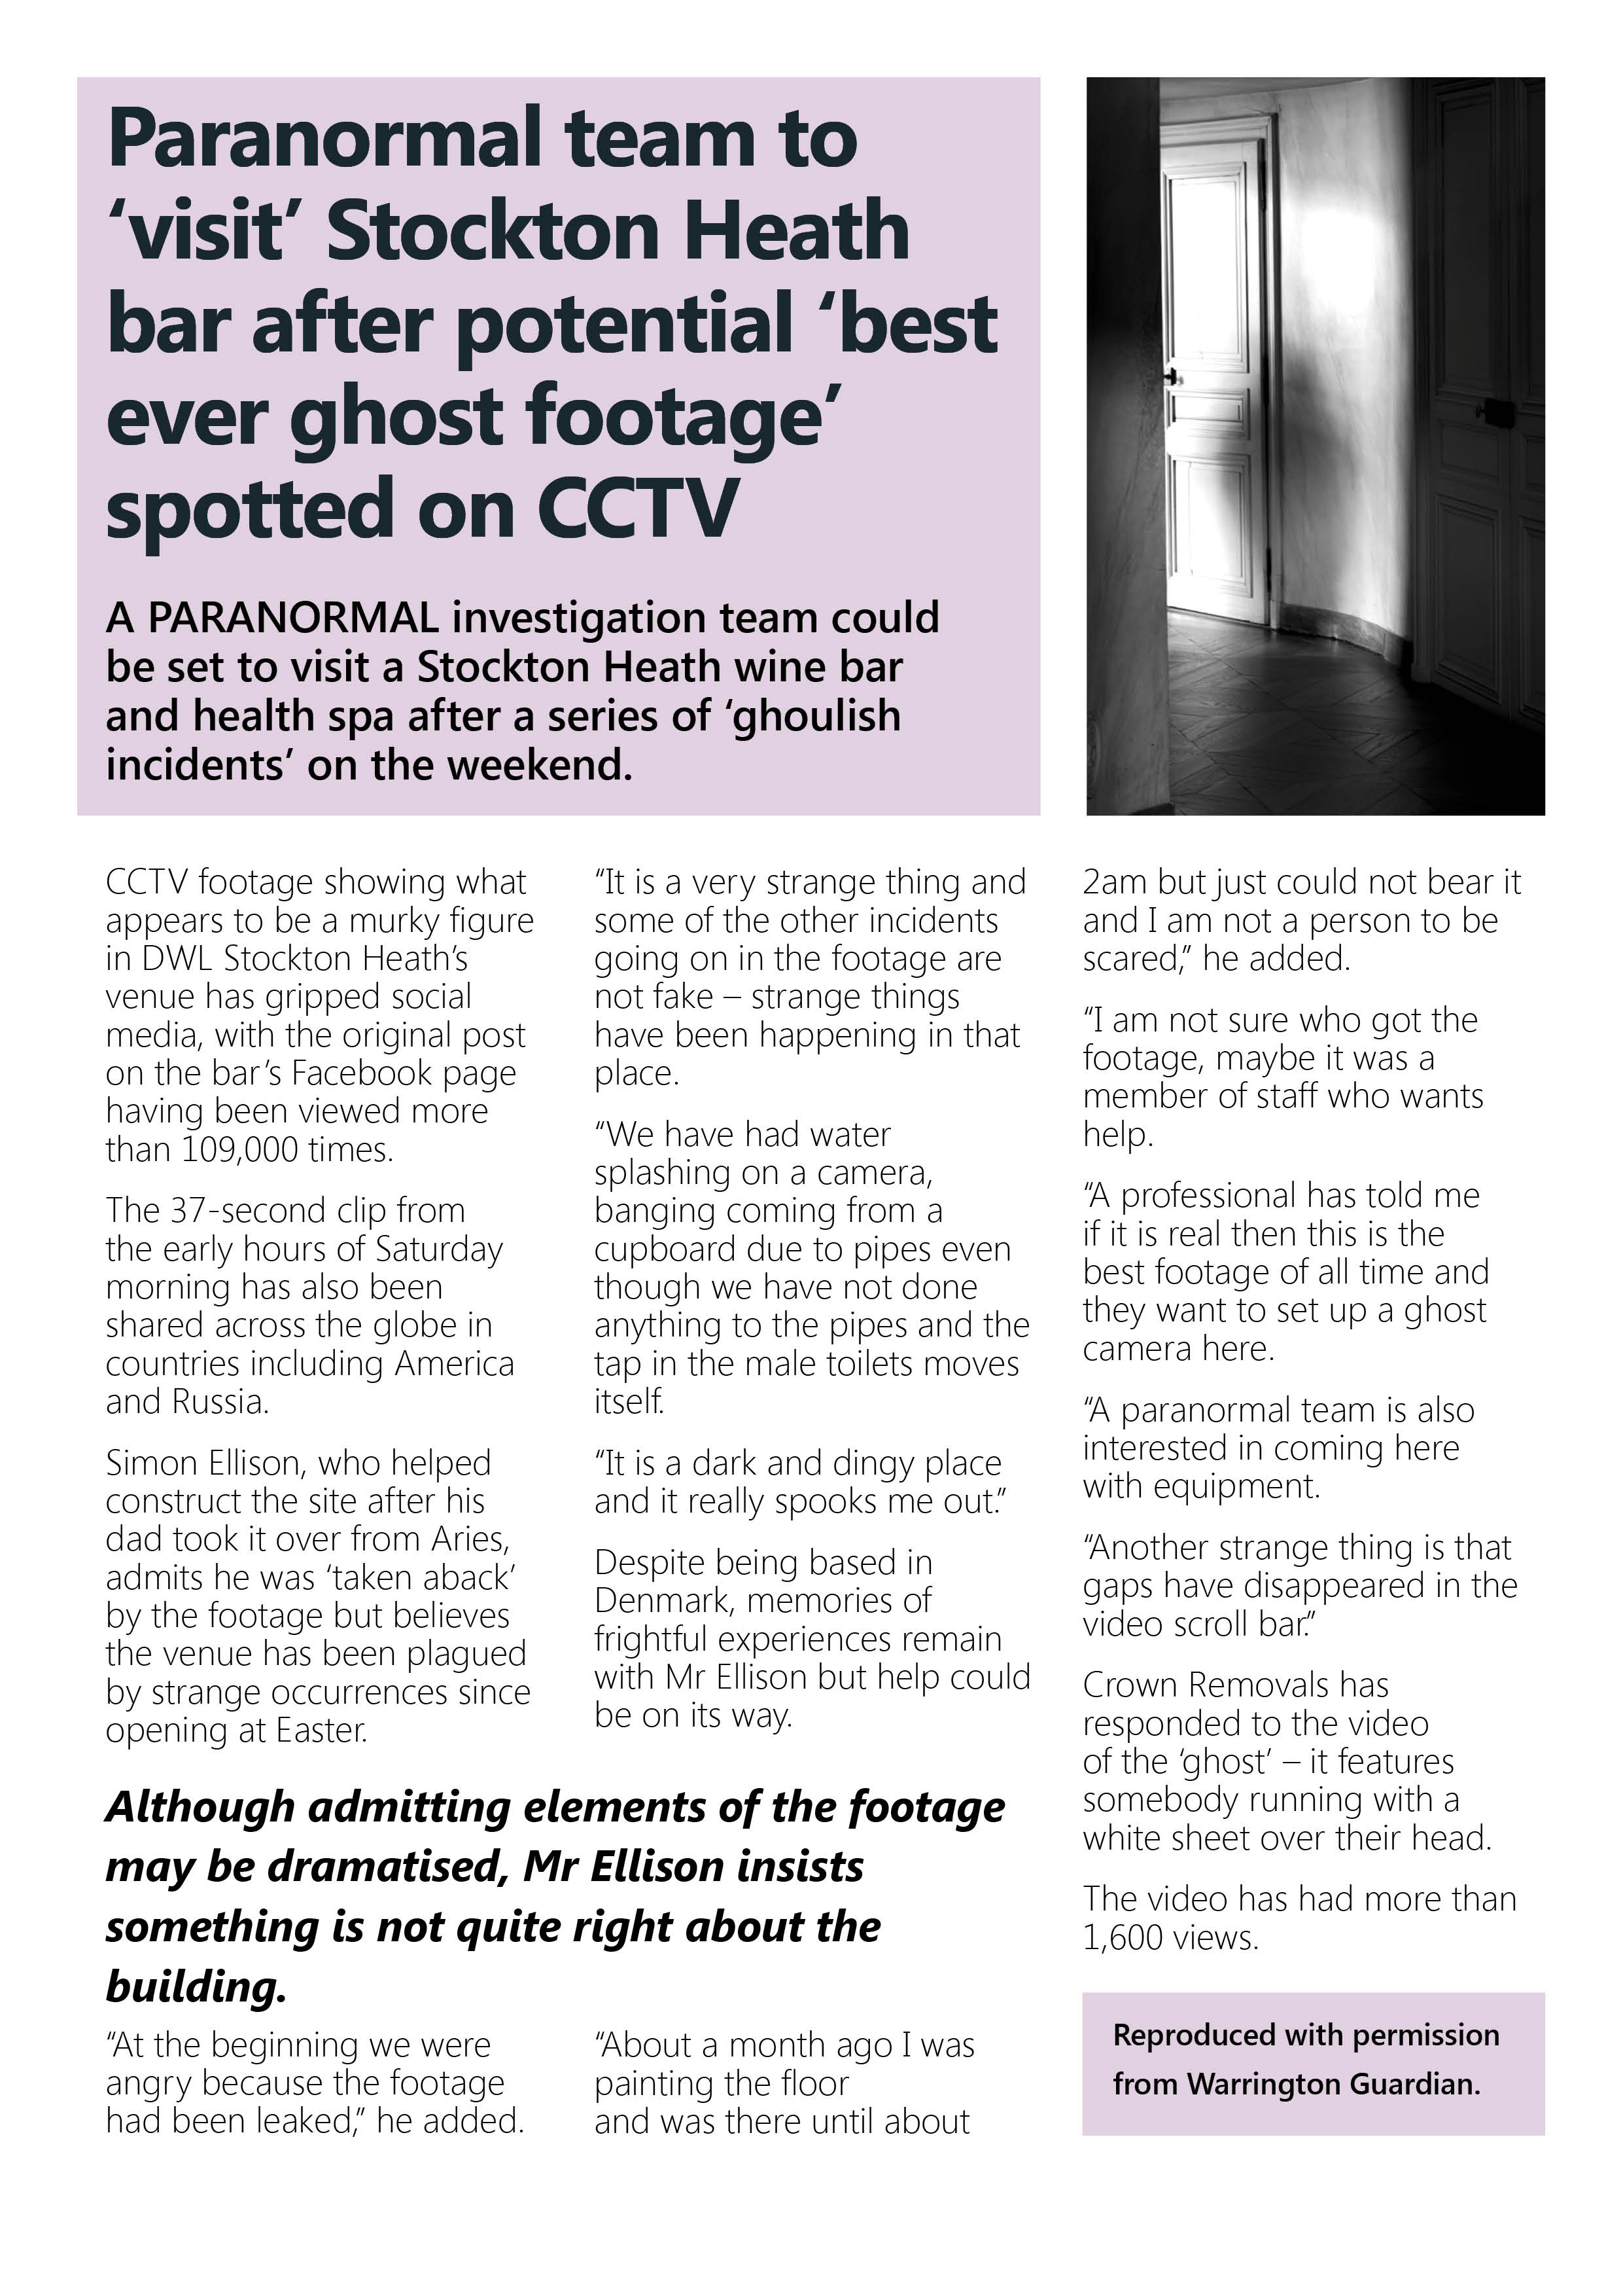
Introduction/Article

http://www.warringtonguardian.co.uk/news/13424326.Paranormal_team_to_visit_Stockton_Heath_bar_on_Monday_to_investigate__ghost_/

‘Beyond the range of normal experience or scientific explanation’
For thousands of years there has been a fascination with the ‘unexplainable’, ranging from prophets, ghosts, to UFO’s and extra sensory perception. Such phenomena have been reported frequently and portrayed in well-known ghost stories and films. In modern times the public reaction to paranormal phenomena is strongly influenced by what appears in the media.
There are a number of questions that are frequently asked and discussed, which may have led to some of the sensationalism that has grown through the media, including live ‘ghost sightings’ and celebrities on ‘ghost hunts’. These questions include:
- Are there such things as ghosts?
- Do we believe that places can be haunted?
- Do poltergeists really exist?
Professional paranormal investigators do exist and the subject will continue to be discussed and explored. People want to learn more about the supernatural in order to try and understand it.
Investigations often take place when no other logical or scientific reason can be found and accepted for unexplained noises, smells or ‘sightings’, from witnesses who do not know what they are experiencing.
Investigators working with computers and video cameras or other such technology are encouraged to base their investigations on logical thought and critical thinking. For example, if the noise of a door swinging open is recorded and nobody is seen, then first they must look at the wind factor and gravity. Similarly if faint ‘visions’ are reported, then they would consider the effect of infrared lighting, thus avoiding the misconceptions which can frequently occur.
It has to be said however, that at the time of writing, no scientific body including academics and educators, have been able to confirm the existence of ghosts.
This activity pack focuses on a news article based on a paranormal investigation. News articles can provide a strong starting point for discussion, often grabbing the attention by sensational headlines and allowing topical events to be explored. As news articles can be biased in their presentation, any practical work can look at varying sides of an argument or differing opinions, thus giving a more balanced and sometimes alternative viewpoint.
Naturally, many news articles relate to events unfolding in the world at any particular time, some more serious than others. All, however, form a basis for questioning and can develop as a stimulus for thought and creative development.
This news article specifically raises issues surrounding the paranormal and paranormal investigations, providing ideas for devising work and performance.

Additional teacher preparation
Teachers may wish to use the following questions as a starting point for the topic.
- Does the paranormal really exist?
- How would you explain a ‘haunted’ building?
- Can people communicate with spirits?
- What are UFO’s?
- What is a poltergeist?
- Is paranormal investigation a science? Can we take it seriously?
- How much does the Media influence what we believe?
There is no right or wrong for a lot of these questions, thus creating a forum for individual opinion.
The following websites may be used to support students’ research and exploration.
http://www.assap.ac.uk/newsite/htmlfiles/News.html
http://www.mysteriousbritain.co.uk/groups.html
www.ghostfinder.co.uk
http://skepdic.com/paranormalinvestigator.html
The use of newspaper articles can be looked at also, emphasising the need to present a balanced oversight of topical stories and events. The site below provides information on bias in the media.
www.umich.edu/~newsbias/links.html

Activity 1
Warm up game – ‘Ghosts’
Two students sit facing each other, leg distance apart with their eyes closed and arms reaching out in front of them (the hunters). One by one, the rest of group walk between the students without making any noise or being touched by the outreached arms. A count is taken at the end to see how many ghosts are successful. This can be repeated with different students hunting ghosts, or a maze of student hunters can be created around the room.
Discussion
Read the newspaper article (stimulus material). Briefly discuss the story and consider the following:
- Do you believe in ghosts?
- What is a ghost?
- Have you ever seen or heard of any Paranormal activity?
Hot seating
In pairs, create a short scene based on one person claiming to hear or see voices from people who have died, using hotseating.
Consider: How did the character explain their experience?
The great debate
In groups of four or five, devise your own tv or radio programme, between three to five minutes in length, called:
Is there such a thing as the paranormal? – The great debate.
Each student’s character should have different view including:
- somebody who has witnessed an actual event
- a scientist who tries to explain it
- somebody from the ‘Dead Live staff’ (as mentioned in the news article).
Share the scenes with the class and invite questions from the audience, with characters answering in role.
Devising activity
In small groups create a mime where somebody witnesses a ‘strange incident’ in Stockton Heath bar. Students may use the characters from the previous activities in the scene.
Start by creating three tableaux:
- when they arrive at the bar
- when they witness the ‘incident’
- after the event as they are leaving.
Add in a mime to join the action together. Students should consider how their movement shows their characterisation without using words.
To extend the performances, try and develop the movement so it can be shown forwards or backwards, as if on a CCTV camera, still freezing at the point the figure is noticed.
Plenary
Discuss the effectiveness of the mime and consider what impact this has on the audience.
Would it be different if it is performed backwards and/or forwards?
What affect would it have on the audience if the characters were speaking?

Activity 2
Warm up
In groups of two to four devise short 30 second scene based on one of the headlines below. Make it short and snappy like a newspaper report showing what has happened.
- Mysterious figure appears in hospital window.
- Children’s’ voices heard in empty school.
- Strange happenings in new housing estate.
- UFO spotted by famer working his field.
- Poltergeist causing trouble in Community Centre.
Discuss as a group which were the most factual and which were the most engaging. If the students could watch one for longer, which one and why?
The murky figure
Read the newspaper article and discuss who the ‘murky figure’ could be?
Brainstorm a list of emotions that the figure may by feeling.
Ask the students to imagine they are the murky figure. Walk into a space in the room, first slowly, then at a moderate pace, then quickly (always moving into a new space).
Add in an emotion to convey through their walk. They can choose the speed they move around.
As the students move around, they should observe others.
Discuss who appears believable and why.
In pairs, devise three ‘strange incidents’ as described in the article, where the investigator actually sees the ‘figure’. Consider:
- How do they communicate?
- Can they communicate?
- What does the figure want?
- Who exactly are you and what is your objective in the scene?
Join pairs together to create groups of four. Discuss what you have learned about the characters you created in the previous activities.
Devise a scene which gives a brief history of this ‘murky figure’
Students may want to choose one character or may want to merge elements of their characters to create a new one.
Share these scenes and ask the audience to describe the action they have seen. Was the history the group created the same as the audience understood?
Plenary
Discuss in groups or as a class the ways that their intentions can be shown to the audience successfully.

Activity 3
Warm up game – Guess and disguise
One student closes their eyes in the middle of the circle (the investigator).
Another student is then chosen and has to disguise their voice while saying ‘It’s only me, don’t be scared’.
The investigator then has to guess who in the class spoke. The game continues with more people being chosen to guess and disguise. Guesses can be limited in larger classes/groups to 3/5 guesses.

Setting activity
Many older buildings had different uses in the past. Discuss as a class a possible (and imaginary) history of Stockton Heath bar and decide what the original building could have been used for.
Create a short scene, in groups of 4 – 6, exploring the idea of a character being ‘trapped’ in the building in the past. Present this in the form of a documentary or performed story, using a narrator (or 2) to tell the story. They should describe the origins of the building, introduce of the figure as a character and then describe the haunted building as it is seen today. This should show the ‘facts’ of what happened.
Spotlight performances.
Adding bias to the story
Newspapers usually have an ‘angle’ or bias where they tell the story from a single point of view.
Recreate the performance where the narrators become reporters. Each group may be given a different bias such as:
- A report for a national tabloid newspaper.
- A report for a ‘paranormal’ special in a magazine.
- A report for a scientific journal.
- A report for the local news business section.
Show performances and ask the audience which bias they had with reasons why they believe this from the performance they have seen.

We’d like to know your view on the resources we produce. By clicking on ‘Like’ or ‘Dislike’ you can help us to ensure that our resources work for you. When the email template pops up please add additional comments if you wish and then just click ‘Send’. Thank you.
Whether you already offer OCR qualifications, are new to OCR, or are considering switching from your current provider/awarding organisation, you can request more information by completing the Expression of Interest form which can be found here: www.ocr.org.uk/expression-of-interest
Looking for a resource? There is now a quick and easy search tool to help find free resources for your qualification:
www.ocr.org.uk/i-want-to/find-resources/

OCR Resources: the small print
OCR’s resources are provided to support the delivery of OCR qualifications, but in no way constitute an endorsed teaching method that is required by the Board, and the decision to use them lies with the individual teacher. Whilst every effort is made to ensure the accuracy of the content, OCR cannot be held responsible for any errors or omissions within these resources.
© OCR 2016 - This resource may be freely copied and distributed, as long as the OCR logo and this message remain intact and OCR is acknowledged as the originator of this work.
OCR acknowledges the use of the following content: n/a
Please get in touch if you want to discuss the accessibility of resources we offer to support delivery of our qualifications: resources.feedback@ocr.org.uk

