Biology PAG 7: Microbiological techniques

Combined Science PAG B5: Microbiological techniques

Suggested Activity 1: Microbiological techniques

Instructions and answers for teachers & technicians
These instructions cover the learner activity section which can be found on page 14. This Practical activity supports OCR GCSE Biology.
When distributing the activity section to the learners either as a printed copy or as a Word file you will need to remove the teacher instructions section.
This is a suggested practical activity that can be used as part of teaching the GCSE (9-1) Gateway Science (A) and Twenty First Century Science (B) specifications.
These are not controlled assessment tasks, and there is no requirement to use these particular activities.
You may modify these activities to suit your learners and centre. Alternative activities are available from, for example, Royal Society of Biology, Royal Society of Chemistry, Institute of Physics, CLEAPSS and publishing companies, or of your own devising.
Further details are available in the specifications (Practical Skills Topics), and in these videos.

OCR recommendations:
Before carrying out any experiment or demonstration based on this guidance, it is the responsibility of teachers to ensure that they have undertaken a risk assessment in accordance with their employer’s requirements, making use of up-to-date information and taking account of their own particular circumstances. Any local rules or restrictions issued by the employer must always be followed.
CLEAPSS resources are useful for carrying out risk-assessments: (http://science.cleapss.org.uk).
Centres should trial experiments in advance of giving them to learners. Centres may choose to make adaptations to this practical activity, but should be aware that this may affect the Apparatus and Techniques covered by the learner.

Introduction
With the selection of multi-drug resistant bacteria depleting our useable antibiotics the fight against infection and disease is becoming more difficult. Scientists are having to look for new antimicrobial substances as alternatives to antibiotics. There are many naturally occurring substances that could be used from a large range of organisms. A good starting point for this activity is to use gross plant extract.
Learners could be made aware of the concerns scientists have that as species become extinct we may lose some ‘wonder drugs’.

DfE Apparatus and Techniques covered
1 [1]: Use of appropriate apparatus to make and record a range of measurements accurately, including: i [i]) length; ii [ii]) area; vi [vi]) volume of liquids
2 [2]: Safe use of appropriate heating devices and techniques including use of: i) a Bunsen burner
3 [3]: Use of appropriate apparatus and techniques for the: i) observation of biological changes and/or processes; ii) measurement of biological changes and/or processes

Aims
To introduce learners to aseptic technique.
To investigate the effectiveness of naturally occurring antimicrobial substances.
To introduce learners to the manipulation of microbes.

Supplementary practicals
Streaking of a bacterial culture to obtain a single colony (the method is described in the technician notes).

Intended class time
This activity will take 60 minutes.

Links to Specifications:

Twenty First Century
Describe and explain the aseptic techniques used in culturing organisms.
Calculate cross-sectional areas of bacterial cultures and of clear zones around antibiotic discs on agar jelly using πr².
Describe the process of discovery and development of potential new medicines including preclinical and clinical testing.

Gateway
Explain the aseptic techniques used in culturing organisms to include use of alcohol, flaming, autoclaving of glassware and growth media, and measures used to stop contaminants falling onto/into the growth media (e.g. working around a Bunsen burner).
Describe the processes of discovery and development of potential new medicines to include: preclinical and clinical testing.

Mathematical Skills covered
BM6.3v calculate cross-sectional areas of bacterial cultures and clear agar jelly using πr²

Twenty First Century IaS references covered
Suggest appropriate apparatus, materials and techniques, justifying the choice with reference to the precision, accuracy and validity of the data that will be collected.

Identify factors that need to be controlled, and the ways in which they could be controlled.

Suggest an appropriate sample size and/or range of values to be measured and justify the suggestion.

Plan experiments or devise procedures by constructing clear and logically sequenced strategies to:
- make observations
- produce or characterise a substance
- test hypotheses
- collect and check data
- explore phenomena.
In a given context evaluate data in terms of accuracy, precision, repeatability and reproducibility, identify potential sources of random and systematic error, and discuss the decision to discard or retain an outlier.

Evaluate an experimental strategy, suggest improvements and explain why they would increase the quality (accuracy, precision, repeatability and reproducibility) of the data collected, and suggest further investigations.

In a given context interpret observations and other data (presented in diagrammatic, graphical, symbolic or numerical form) to make inferences and to draw reasoned conclusions, using appropriate scientific vocabulary and terminology to communicate the scientific rationale for findings and conclusions.

Gateway Working scientifically references covered
WS1.2b - plan experiments or devise procedures to make observations, produce or characterise a substance, test hypotheses, check data or explore phenomena
WS1.2b - plan experiments or devise procedures to make observations, produce or characterise a substance, test hypotheses, check data or explore phenomena
WS1.2c - apply a knowledge of a range of techniques, instruments, apparatus, and materials to select those appropriate to the experiment
WS1.2e - evaluate methods and suggest possible improvements and further investigations
WS2a - carry out experiments to include due regard to the correct manipulation of apparatus, the accuracy of measurements and health and safety considerations, and following written instructions
WS2b - make and record observations and measurements using a range of apparatus and methods to include keeping appropriate records
WS2c - presenting observations using appropriate methods to include methods to include descriptive, tabular diagrammatic and graphically
WS2d - communicating the scientific rationale for investigations, methods used, findings and reasoned conclusions to include presentations through paper-based and electronic reports and presentations using verbal, diagrammatic, graphical, numerical and symbolic forms

Equipment (all equipment in this section is per group)
- A bacterial stock 10 cm³
- 9 cm petri dishes containing growth medium
- Plastic spreader
- 1 cm³ syringe
- 10 cm³ syringe
- Bunsen burner
- Method to light Bunsen burner (e.g. matches/gas lighter)
- heat proof mat
- access to disinfectant in spray bottler
- Marker pen
- Pestle
- Mortar
- Forceps
- Sterile filter paper disks
- Sterile water
- Contaminated waste disposal method (e.g. autoclave bags/beakers).

Health and Safety
Ensure that the any stock bacteria used is safe for use in a school. Escherichia coli strain K12 is a suitable microbe.
Growing bacteria in anaerobic conditions will favour the growth of anaerobic bacteria. To avoid this use vented Petri dishes and only secure with tape following incubation.
Following incubation learners must not remove the lids to the Petri dishes.
Learners will need to work close to a Bunsen flame during this activity. Ensure that long hair is tied up.
Ensure that ties (if applicable) are tucked in or removed prior to the activity.
All work surfaces need to be thoroughly disinfected at the end of the activity. This has to be done for long enough to effectively disinfect the surface.
Roll up sleeves when working with microbes and ensure that hands are washed with soap prior to leaving the laboratory.
Following the activity all materials need to be sterilized then disposed or washed up as appropriate.

Technician Notes
For this practical the teacher will require for a class of 30:
- 30 agar plates
- 30 1 cm³ syringes or sterile Pasteur pipettes
- 30 spreaders
- 10 sterile forceps
- 10 pestles
- 10 mortars
- Spray bottles of disinfectant
- 10 autoclave bags or 10 waste pots
- 10 Bunsen burners
- 10 heat proof mats
- Some way to light the Bunsen burner (matches or gas lighter)
- 10 permanent pens
- 10 universal jars (or equivalent) of sterile
- 1 pack of sterile filter paper disks (20 per pack)
- Some starting plants may be useful (e.g. garlic, onion, daisy and grass) but learners could collect their own.

Preparation of the liquid media
- A number of different liquid mediums are available for the growth of bacteria. Nutrient media is always a good start but LB broth is very a suitable alternative.
- Follow the instructions from the manufacturer for the preparation of the media.
- Aliquot 10 cm³ of the media into glass universal jars and then sterilize by autoclaving with the lids loosened.
- Once cool the lids can be tightened and stored. The media can be stored for about a month. Dispose of as contaminated waste if the liquid becomes turbid.

Preparation of agar plates
- A number of different agars are available for the growth of bacteria. Nutrient agar is always a good start but LB agar is very a suitable alternative.
- Follow the instructions from the manufacturer for the preparation of the media.
- Sterilize the media in an autoclave or pressure cooker [121ºC, 103.421kPa (15 p.s.i.) for 15 minutes].
- Allow to cool to hand hot.
- Using aseptic technique (working beside a blue flame Bunsen burner, flaming the lip of the bottle when removing the bung and then flaming the lip of the bottle) pour approximately 20-25 cm³ of the media into 9cm diameter Petri dishes.
- If the surface of the media is bubbly flame the bubbles with the blue flame of a Bunsen burner very briefly.
- Allow the agar to set.
- Plates can be stored upside down (media uppermost) in a fridge for a number of days.

Preparation of the bacterial stock
Note there are a number of bacterial strains that are suitable for use in a school e.g. E. coli strain K12. Obtain these from educational suppliers.
- The bacteria may arrive in a number of different ways (e.g. stab culture, reduced temperature etc.)
- Follow the manufacturer’s instructions as to how to culture the bacteria from the stock.
- It is advisable to streak the stock onto a suitable agar medium to obtain a single bacterial colony to use. There are two suitable methods for this – the first is a quick and dirty method, the second a more traditional approach.
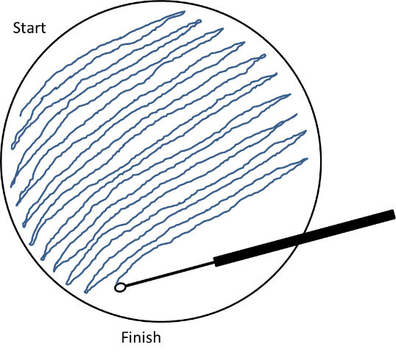
Method 1 – start in one place and draw the loop side to side across the plate whilst moving down the plate from start to finish. This will result in some single colonies but is very quick so you could do a number of plates this way.

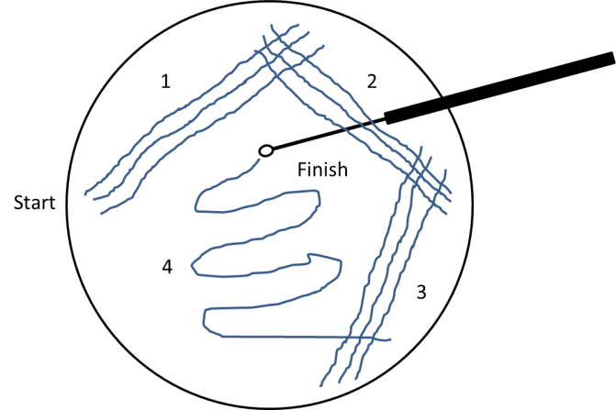
Method 2 – make three lines from the start point in position 1 then flame the loop. Next do three lines in position two then flame the loop. Repeat at position three then flame the loop. Finally do the path indicated by 4 ensuring that lines in position 1, 2 or 3 are not crossed. This method usually results in more single colonies but can be time consuming.

Once you have a single colony then inoculate this using a sterile tooth pick into 10 cm³ of sterile liquid media (e.g. nutrient broth or LB). These can be grown at 30ºC for 24-48 hours until turbid or at room temperature until turbid. During the growth regularly swirl the mixture to stop the bacteria pelleting.

Preparation of sterilized equipment
It is safer to present learners with pre-sterilized equipment rather than to get them to flame-sterilize equipment.
- Metal/glassware can be sterilized by wrapping it/covering the openings with aluminium foil then autoclaving it in an autoclave or pressure cooker [121ºC, 103.421kPa (15 p.s.i.) for 15 minutes].
- Metal/glassware can be sterilized by wrapping in/covering the openings with aluminium foil then baking at 170ºC for 60 minutes or 160ºC for 120 minutes.
- Some plastics can be autoclaved, but it is preferable to use single use plastics and dispose of as contaminated waste after use (e.g. petri dishes and spreaders).
- Filter paper disks can be made by using a hole punch on filter paper. These can be wrapped in aluminium foil and then autoclaved. Following autoclaving these can be dried prior to use in a warm oven.

Disposal of contaminated equipment
- Contaminated equipment/used Petri dishes etc. should be sterilized by autoclaving.

Quiz questions - answers
- Which word defines a method of working that minimises contamination? [1 mark]
A | Antiseptic
B | Aseptic
C | Abiotic
D | Antibiotic
Your answer
B

- Probash’s doctors want to check that the bacteria causing his illness are not resistant to the antibiotic erythromycin.
They set up an experiment to test this.
This is the method they use:
- a petri dish is made that has the bacteria growing evenly over the surface
- a disc of filter paper is soaked in erythromycin
- the disc is placed on the agar in the centre of the petri dish
- the lid of the dish is fixed on with a piece of tape
- the dish is then incubated.
 | (a) | (i) | Why did the doctors tape the lid on the petri dish? [1 mark]
To prevent other people taking in the microbe

or

to prevent other microbes starting to grow/contamination
or
to prevent release of the bacteria if the dish is dropped/knocked
 |  | (ii) | 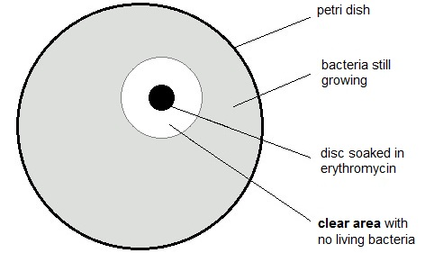  The diagram shows the doctor’s results.  Use a ruler to measure the diameter of the clear area in mm.  Use this diameter to calculate the area of the circle where there are no living bacteria.  (the area of a circle = $π$r² and $π$ = 3.14) [3 marks]
area = 452 mm²

or
correct measurement of diameter to calculate radius
correct calculation using calculated radius

 |  | (iii) | This table is used to analyse the results of the experiment.  Area clear of bacteria including the area of the disc (mm²) Level of resistance  less than 133 resistant  133 to 416 intermediate resistance  more than 416 not resistant  Use your result from part (ii) to judge the level of resistance in the microbe. [1 mark]
 |  |  | Not resistant

- Jay investigates different antibiotics.
- He puts antibiotic discs onto agar containing bacteria.
- The bacteria are left to grow.
- The diagram shows his results.
- The larger the clear zone around the antibiotic disc the more effective the antibiotic.
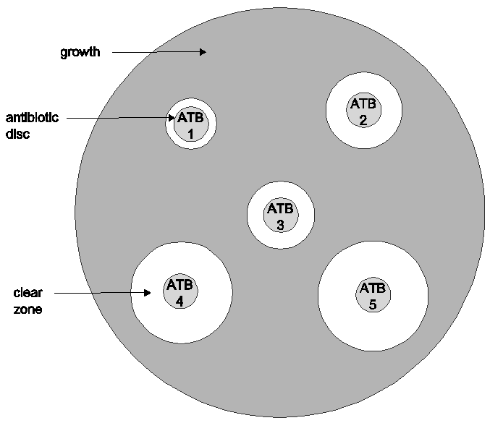

The table shows the cross sectional areas for the antibiotic discs tested.
antibiotic | cross sectional area  (mm²)
ATB1 | 113.0
ATB2 | 254.3
ATB3 | 201.0
ATB4 | 452.2
ATB5 | 530.7

 | (a) | (i) | Calculate the cross sectional area of the clear zone for ATB 4.  Show your working: [3 marks]
415
Answer: mm²
 |  | (ii) | Jay concludes that ATB5 is the best antibiotic for treating bacterial infections.  Evaluate his conclusion. [3 marks]
Correct in that it does have the largest area / clear zone
But only correct for the antibiotics tested
Idea that results are not valid as very close together or idea that results are not valid because he has only tested them once /not done any repeats

Document updates
v1 Published on the qualification pages
v1.1 January 2017 Consolidated labelling and formatting of activities
v1.2 June 2017 Correction to image and calculations on q3
v1.3 June 2021 Update to meet digital accessibility standards

We’d like to know your view on the resources we produce. Click ‘Like’ or ‘Dislike’ to send us an auto generated email about this resource. Add comments if you want to. Let us know how we can improve this resource or what else you need. Your email will not be used or shared for any marketing purposes.
Looking for another resource? There is now a quick and easy search tool to help find free resources for your qualification.
OCR is part of Cambridge Assessment, a department of the University of Cambridge.
For staff training purposes and as part of our quality assurance programme your call may be recorded or monitored.
Oxford Cambridge and RSA Examinations is a Company Limited by Guarantee. Registered in England. Registered office
The Triangle Building, Shaftesbury Road, Cambridge, CB2 8EA. Registered company number 3484466. OCR is an exempt charity.
OCR operates academic and vocational qualifications regulated by Ofqual, Qualifications Wales and CCEA as listed
in their qualifications registers including A Levels, GCSEs, Cambridge Technicals and Cambridge Nationals.
OCR provides resources to help you deliver our qualifications. These resources do not represent any particular teaching method we expect you to use. We update our resources regularly and aim to make sure content is accurate but please check the OCR website so that you have the most up to date version. OCR cannot be held responsible for any errors or omissions in these resources.
Though we make every effort to check our resources, there may be contradictions between published support and the specification, so it is important that you always use information in the latest specification. We indicate any specification changes within the document itself, change the version number and provide a summary of the changes. If you do notice a discrepancy between the specification and a resource, please contact us.
© OCR 2021 - You can copy and distribute this resource freely if you keep the OCR logo and this small print intact and you acknowledge OCR as the originator of the resource.
OCR acknowledges the use of the following content: N/A
Whether you already offer OCR qualifications, are new to OCR or are thinking about switching, you can request more information using our Expression of Interest form.
Please get in touch if you want to discuss the accessibility of resources we offer to support you in delivering our qualifications.

Biology PAG 7: Microbiological techniques

Combined Science PAG B5: Microbiological techniques

Suggested Activity 1: Microbiological techniques

Learner Activity

Introduction

With the selection of multi-drug resistant bacteria depleting our useable antibiotics the fight against infection and disease is becoming more difficult. Scientists are having to look for new antimicrobial substances as alternatives to antibiotics. There are many naturally occurring substances that could be used from a large range of organisms. A good starting point for this activity is to use gross plant extract.

Learners could be made aware of the concerns scientists have that as species become extinct we may lose some ‘wonder drugs’.

Aims
To introduce learners to aseptic technique.
To investigate the effectiveness of naturally occurring antimicrobial substances.
To introduce learners to the manipulation of microbes.

Intended class time
60 minutes.

Method
Preparation of the work area
- Clear the work space of all non-essential items.
- Clean the desk with disinfectant.

Preparing the plate
- The following should be done beside a blue Bunsen flame to create an updraft to stop the agar media getting contaminated.
- Swirl (do not shake) the bacterial suspension to make sure that the bacterial culture is well mixed.
- Remove the lid from the bacterial bottle and flame the moth of the bottle.
- Take out 0.1 cm³ from the bottle. This can be done with a syringe or plastic Pasteur pipette.
- Lift of the lid of the Petri dish and hold 10 cm above the agar.
- Add the 0.1 cm³ sample onto the surface of the agar.
- Dispose of the pipette as contaminated waste either in a beaker or directly into an autoclave bag.
- Spread the liquid over the top of the agar using the spreader.
- Replace the petri dish lid.
- Dispose of the spreader as contaminated waste either in a beaker or directly into an autoclave bag.
- Allow the plate to dry then label the half of the petri dish containing the media (Do not label the top).
- Incubate at a temperature that does not favour the multiplication of pathogens.
- It is essential that hands are washed with soap and water following this practical.
Obtaining the plant extract
- Obtain a suitable plant to test.
- Grind the plant material using the pestle and mortar (a little sand may be used here to assist grinding).
- Using the 10 cm³ syringe measure out 10 cm³ of the sterile water into the pestle.
- Using the sterile forceps transfer the filter paper disks to the liquid and allow to soak.
- Remove the disk with the liquid using the same forceps.
- Remove the lid from the Petri dish and place the disk onto the surface of the agar.
- Replace the lid.
- Label the disk on the bottom of the plate (the side containing the agar).
- It is possible to get six different disks onto the surface of the agar. This process can be repeated with different samples. We are suggesting that learners do not extract each samples separately but use other groups extractions. It is easier to swap pestles and forceps between groups.
- Incubate the samples upside down (media uppermost) until grown.
- Measure the clearing zone surrounding the disk (diameter).

Clearing up following the activity
- All contaminated materials need to be disposed of either in autoclave bags (for disposable materials that need to be sterilized e.g. spreaders/Petri dishes) or pots (for items that are to be sterilized washed then reused).
- It is essential that all work surfaces need to be thoroughly disinfected at the end of the activity. This has to be done for long enough to effectively disinfect the surface.
- Ensure that hands are washed with soap and water at the end of the activity.

Quiz – test your knowledge and understanding
- Which word defines an method of working that minimises contamination? [1 mark]
A | Antiseptic
B | Aseptic
C | Abiotic
D | Antibiotic
Your answer

- Probash’s doctors want to check that the bacteria causing his illness are not resistant to the antibiotic erythromycin.
They set up an experiment to test this.
This is the method they use:
- a petri dish is made that has the bacteria growing evenly over the surface
- a disc of filter paper is soaked in erythromycin
- the disc is placed on the agar in the centre of the petri dish
- the lid of the dish is fixed on with a piece of tape
- the dish is then incubated.
 | (a) | (i) | Why did the doctors tape the lid on the petri dish? [1 mark]
 |  | (ii) | The diagram shows the doctor’s results.  Use a ruler to measure the diameter of the clear area in mm.  Use this diameter to calculate the area of the circle where there are no living bacteria.  (the area of a circle = πr² and π = 3.14) [3 marks]
 |  |  | area = mm²
 |  | (iii) | This table is used to analyse the results of the experiment.  Area clear of bacteria including the area of the disc (mm²) Level of resistance  less than 133 resistant  133 to 416 intermediate resistance  more than 416 not resistant  Use your result from part (ii) to judge the level of resistance in the microbe. [1 mark]
- Jay investigates different antibiotics.
- He puts antibiotic discs onto agar containing bacteria.
- The bacteria are left to grow.
- The diagram shows his results.
- The larger the clear zone around the antibiotic disc the more effective the antibiotic.

The table shows the cross sectional areas for the antibiotic discs tested.
antibiotic | cross sectional area  (mm²)
ATB1 | 113.0
ATB2 | 254.3
ATB3 | 201.0
ATB4
ATB5 | 530.7

 | (a) | (i) | Calculate the cross sectional area of the clear zone for ATB 4.  Show your working: [3 marks]
 |  |  | Answer: mm²
 |  | (ii) | Jay concludes that ATB5 is the best antibiotic for treating bacterial infections.  Evaluate his conclusion. [3 marks]

DfE Apparatus and Techniques covered
If you are using the OCR Practical Activity Learner Record Sheet (Biology / Combined Science) you may be able to tick off the following skills:

Biology |  |  |  |  | Combined Science
1-i | 1-ii | 1-vi | 2-i |  | 1-i | 1-ii | 1-vi | 2-i
3-i | 3-ii |  |  |  | 3-i | 3-ii

