Topic Exploration Pack

Switzerland

Introduction 3
Section 1: The nature of democracy 4
Section 2: Swiss direct democracy 7
Section 3: The UK and Switzerland compared 11
Teacher answers to student worksheet activities 14
Section 1: The nature of democracy 14
Resource 1: Comparing Athenian and UK democracy 14
Resource 2: What makes an effective democracy 15
Resource 3: UK referendums 16
Section 2: Swiss direct democracy………………………………………………………………………17
Resource 4: The Swiss political system 17
Section 3: The UK and Switzerland compared……………………………………………….………...17
Resource 5: Key features of citizen participation 17
Student activity section…………………………………………………………………………………19
Resource 1: Comparing Athenian and UK democracy 19
Resource 2: What makes an effective democracy? 22
Resource 3: UK referendums 24
Resource 4: The Swiss political system 26
Resource 5: Key features of citizen participation 28

Instructions and answers for teachers

These instructions cover the student activity section which can be found on page 19. This Topic Exploration Pack supports OCR GCSE (9-1) Citizenship Studies.
When distributing the activity section to the students either as a printed copy or as a Word file you will need to remove the teacher instructions section.

Introduction
This TEP enables learners to explore some of the key differences between the nature and extent of citizens’ political participation in the UK, a representative democracy, and Switzerland, a direct democracy.
Learners will find it useful to have already studied specification section 2.1 ‘democracy, voting and elections in the UK’ and 2.6 ‘citizenship participation in the UK’. Learners may find it helpful to work through the TEP on China following their comparison of Swiss and UK democracy.
The pack enables learners to clarify and develop their understanding of democracy by comparing classical Athenian democracy with representative democracy. Learners then study the characteristics of a modern example of direct democracy – Switzerland – before making a comparison between the Swiss political system and that of the UK.
The pack introduces learners to the criteria that may be used to compare political systems and to the rankings generated by these comparisons.
The Swiss Government is proud of its political system and its website provides a clear but detailed coverage of how that system works. There are few educational resources currently available for school students on the Swiss political system and so teachers should be prepared to adapt the recommended materials to make them fully accessible to learners.
Learners may wish to consider the potential of electronic technologies for enabling higher degrees of direct democracy. The pack has been designed to enable all learners to explore and refine their own opinion through research, analysis and reasoned argument.

Section 1: The nature of democracy

Teacher introduction
Democracy appears a straightforward concept - ‘rule by the people’ - but implementing this apparently simple idea has caused considerable controversy.
It is widely acknowledged that democracy began in Athens and other Greek states around 2500 years ago.
In classical Athenian democracy even seemingly routine decisions involving such matters as the regulation of ferry boats were made at frequent meetings of all citizens. Much of the work in Athens was done by slaves or foreign workers. These groups were denied citizenship and so could not vote. Although female Athenians could be citizens, women didn’t have voting rights. It was only property-owning adult male citizens who had the right to vote.
As decision-making in Athens became ever more complex and time consuming, male citizens began to find attendance at meetings somewhat inconvenient. As in other early democratic states, Athens found a solution in representative democracy, with all male citizens being able to participate directly in the event of a particularly important vote. Athens used a lottery system to select representatives to serve for one year in a parliament – the Council of 500.
For more on Athenian democracy see: http://www.bbc.co.uk/history/ancient/greeks/greekdemocracy_01.shtml
For a more detailed coverage placing Athenian democracy within its historical context try the BBC/ National Geographic video at https://www.youtube.com/watch?v=OM0w7hBCZfs .
Also worth considering is a three minute cartoon-based introduction to democracy which, although made in the USA, raises some important points about the characteristics of an effective democracy https://www.youtube.com/watch?v=u6jgWxkbR7A&ebc=ANyPxKpkIZ4If8jWSp4CtS1llq2_ZZBM_QyMxD_C2q1Bxj6uaY06NTg88YSJHhGY4WcW9pZpVr6crlr_KlFknkjZT3-iO7ZhKg .
Representative democracies use elections to choose those men and women to make decisions on behalf of all citizens. Sometimes decisions are thought to be too important to be left to such representatives. Recently the UK Government has used a referendum (a type of direct democracy) to decide each of the following:
- UK - continued membership of the ‘Common Market’ [forerunner of the European Union] (1975)
- Scotland and Wales - increased powers (1997)
- Northern Ireland - power sharing (1998)
- UK - changes to the voting system (2011)
- Wales - law-making powers (2011)
- Scotland - independence (2014)
- UK - membership of the European Union (2016).
Technology now makes it possible to use referendums far more frequently to decide local and national issues, and remove such responsibilities from our representatives. That’s why it’s particularly interesting to study Swiss direct democracy where the referendum is an accepted and well-established part of the political process. Other countries are trying forms of direct democracy – most notably the Netherlands, where, from 2015, citizens have been able to call for a referendum on new laws approved by parliament. For the latest on direct democracy see http://people2power.info/ - a website supported by the Swiss authorities.
Effective democracy is characterised by the following features:
- An inclusive franchise.
- High levels of citizen engagement.
- Freedom for citizens to generate fresh ideas, hold representatives to account and criticise authority.
- Equal opportunities for all citizens to exercise power and authority.
- Widespread tolerance and respect for diversity.
- Checks and balances– power is commonly separated between the executive, legislature and judiciary.
- Universal acceptance of the rule of law.
The features above rely on widespread support for democratic values, and a shared understanding of the inseparable links between democracy, human rights and civil liberties. Guaranteeing, promoting and balancing freedom and equality are the core challenges of a democratic system. This can only happen if citizens understand these values and the tensions between them, and are able to control their elected representatives in pursuit of these values.
A detailed but clear explanation of the concept of democracy and its fundamental characteristics is provided by the Swiss National Science Foundation at http://www.democracybarometer.org/concept_en.html
(These points are developed in more depth and detail in Activities 1 and 2 of the TEP Rights in Conflict on the OCR website http://www.ocr.org.uk/Images/307933-rights-in-conflict-topic-exploration-pack.docx)

Activities
- Ask learners to use Resource 1 to compare classical Athenian democracy with representative democracy in the UK. Once they have completed the chart and studied the recommended resources, they could explain why the Athenians replaced their direct democracy with a type of representative democracy. Ask them to include the following concepts and terms in their explanation: citizen, vote, electorate, direct democracy and representative democracy.
- Ask learners to consider the seven features of effective democracy above and to explain why each of the features is so important. (Resource 2 can be used to assist learners in this activity in case of difficulty.)
- Ask learners to discuss the advantages and disadvantages of giving all UK citizens the opportunity to vote on whether or not the country should remain in the European Union (EU). As part this activity learners may design and conduct a simple survey to test people’s feelings about using referendums to decide important decision. Resource 3 can be used to help learners develop, record and organise their ideas.

Section 2: Swiss direct democracy

Teacher introduction
Switzerland is not a member of the European Union and is a relatively small country geographically. However, it is an influential and very wealthy nation enjoying strong trading relationships with the rest of Europe. Although Switzerland is a member of the United Nations, it avoids joining any military Alliances such as NATO and strives for political neutrality. As a result, Switzerland has not engaged in warfare since Napoleonic times. Nevertheless Switzerland does have an army to defend its borders. Switzerland is a direct democracy - citizens elect representatives to their parliament and assemblies but they also have the right to vote in referendums on a range of issues affecting their country, region or community.
Four languages are spoken in Switzerland: German; French; Italian and Romansh. Most Swiss people also speak of English.
Switzerland is a republic but its president has a far lower profile than in most republics; their main role being to chair the seven-member Federal Council (Switzerland’s executive) for a one year term.
Switzerland is a federation of cantons (regions). Cantons have considerable independence from the federal (national) government. Authority in Switzerland is shared between the Confederation (central state), the 26 cantons (federal states) and the 2352 communes. Each of these three levels of government has legislative powers (to draw up laws and regulations) and executive powers (to implement them). Swiss cantons have far more power and influence than local authorities in England and Wales, holding responsibility for education, hospitals and policing. The Confederation and the cantons also have judicial powers - through their courts - to ensure that laws are enforced.
This considerable devolution of power contributes to Switzerland’s high position in democracy rankings as does the country’s status as a direct democracy. Swiss citizens have the right to vote in referendums on a range of issues affecting their country, region or community as well as electing representatives to their parliament and assemblies.
Perhaps rather surprisingly in this context, Switzerland was one of the last countries in the world to enfranchise women who first voted in federal elections in 1971. One canton, Appenzell Innerrhoden, required a judgement of the Federal Supreme court in 1990 before women were granted voting rights in cantonal elections.
As soon as Swiss citizens become entitled to vote (at age 18 apart from some regional elections where the voting age is 16), they are automatically registered on the electoral roll in the community where they live.
About 25 per cent of Switzerland's eight million permanent residents are foreign nationals. Those without Swiss citizenship may vote in some regional and local elections but not in the federal elections. Foreigners must live in the country for at least 12 years before they can apply for citizenship. Applicants must be well integrated, familiar with Swiss customs and traditions, law abiding, and pose no threat to internal or external security.

Swiss government, elections and referendums
Citizens elect the 200 members of the National Council and the 46 members of the Council of States (two from each canton) every four years using a system of proportional representation. These two chambers form a United Federal Assembly which jointly elects the president and federal judges.
After the 2015 federal election, eleven different political parties had representatives in the National Council. The largest party, the Swiss People’s Party (a conservative, populist party), won 53 seats – far too few to form a government on its own. Coalition government is the norm in Switzerland and this helped to shape a political culture based on consensus which enables Federal Council to be shared out between the biggest parties according to a proportional representation formula agreed in 1959.

Swiss political system
National Council
200 members elected every four years with representatives from every canton.

with representatives from every canton

Council of States
46 members representing the 26 cantons. Elected every four years.

EXECUTIVE
Federal Council, including a president
7 National Council members representing the largest political parties and elected by the Federal Assembly.

LEGISLATURE
United Federal Assembly (a bicameral parliament)

If Swiss citizens disagree with an act of parliament, they can oppose it by launching a referendum. As long as 50,000 signatures are collected in support, the contested law is put to the vote. Only hand-written signatures are accepted and all are checked using official electoral registers.
Any member of the Swiss electorate, including leaders of political parties, can also demand an amendment to the Federal Constitution. 100,000 signatures are needed for a referendum to be held on their proposal. Any change to the law requires a double majority (both a majority of the valid votes cast and more than 50 per cent support in the majority of cantons). In 2014 Swiss laws were changed to reduce immigration following a referendum on the issue.
A referendum must also be held if eight out of the twenty six cantons ask for one. Citizens also have the right to launch a referendum at cantonal and communal level.
Some acts passed by the Federal Assembly, including all changes to the Constitution, must automatically be voted on by the Swiss electorate. A double majority is needed for the constitutional change to be accepted.
Swiss citizens are generally called on four times a year to vote in referendums on federal proposals. There are additional referendums on proposals from citizens. Average turnout in Swiss federal elections and referendums is 48%.
Citizens have the right to petition any authority. There is no time limit for petitions and no minimum number of signatures. Authorities have to acknowledge petitions but they do not necessarily have to respond.
Try https://www.ch.ch/en/swiss-political-system/ or https://www.bk.admin.ch/dokumentation/02070/index.html?lang=en for guides to government and politics in Switzerland. See https://www.youtube.com/watch?v=y5W45Va0cPE for a short video describing the Swiss system and its advantages / disadvantages.
Corina Casonova, Swiss Federal Chancellor in 2015, offers a clear, concise and accessible justification of the Swiss system on page 1 of The Swiss Confederation, a Brief Guide, 2015 http://www.slideshare.net/xinxinjin79/swiss-federal-gov-intro

Criticisms of direct democracy
A concern about democracy, and about direct democracy in particular, is that it can result in a ‘tyranny of the majority’. For example, in 2009, Swiss citizens voted to ban minarets. The country’s constitution was changed and the ban came into force. This was in spite of many Swiss politicians believing that the ban was unfair to the county’s 400,000 Muslims, it infringed international human rights law and it contradicted one of the core values of the Swiss constitution - respect for minorities. For more details see: http://www.theguardian.com/world/2009/nov/30/switzerland-ban-minarets-reaction-islam
Direct democracy can constrain elected representatives in ways that are not necessarily in a country’s interests. Governments can be reluctant to make a necessary but unpopular decision because a referendum might reverse it. On the other hand, Swiss politicians know that they must consult the electorate fully before trying to pass new laws.
Turnout in Swiss elections is generally lower than in the less frequent UK elections - this is a consequence of ‘voter fatigue’ and a feeling amongst some electors that elected representatives should make more of the decisions.
For a useful evaluation of direct democracy try: http://www.tutor2u.net/politics/blog/as-politics-direct-democracy

Activities
- Ask learners to use Resource 4 to design a diagram of the Swiss political system using information from Swiss Political System – Facts and Figures at https://www.eda.admin.ch/aboutswitzerland/en/home/politik/uebersicht/politisches-system-der-schweiz---fakten-und-zahlen.html, from the YouTube video https://www.youtube.com/watch?v=y5W45Va0cPE and from their own research. (Teachers may add some of the labels to the outline in advance as appropriate.)
Learners could:
- Produce their first draft independently or in pairs.
- Compare their diagram with those of other learners and make adjustments as necessary.
- Add a further label (Citizens elect their representatives) and arrow to the diagram.
- Add their own short commentaries to the diagram showing differences and similarities between the political systems in the UK and Switzerland. (Learners may prefer to do this after they have completed Activity 3 below.)

Section 3: The UK and Switzerland compared

Teacher introduction
Switzerland achieves consistently high scores in international comparisons of how well governments ‘measure up’ to democratic principles. The table below compares the three main international rankings and what they reveal about the quality of democracy in Switzerland and the UK.
Ranking | What is measured | Comparison of UK and Switzerland
Democracy Index | Ranks countries according to five measures:  - electoral process and pluralism  - civil liberties  - the functioning of government  - political participation  - political culture.  (For details of this scoring system – see page 47 of the 2015 report.) | Switzerland is ranked 6th  UK is ranked 16th  Switzerland is ranked significantly ahead of the UK on the ‘functioning of government’ and ‘political participation’.
Democracy Ranking | Ranks countries according to the quality of politics and the quality of society.  According to Democracy Ranking the two are linked. If people are fully involved in decision-making, then their society should become a satisfying place to live. | Switzerland is ranked 2nd  UK is ranked 12th  Switzerland is slightly ahead of the UK on the ‘political system’ but much further ahead on all measures of ‘quality of society’ apart from gender equality where the UK has a higher rating.
Democracy Barometer | Uses three fundamental measures – the extent to which citizens experience:  FREEDOM (individual freedom and the rule of law).  EQUALITY (equal treatment in the political process, equal rights to influence decision-making and equal access to political power).  CONTROL (control of their representatives in government in order to secure freedom and equality). | The barometer checks each country according to the three measures.  FREEDOM. The UK does better on than Switzerland on individual liberties but less well on the rule of law and expressing opinions.  EQUALITY. UK citizens and media are better than their Swiss counterparts at holding politicians to account.  Switzerland is much more effective than the UK at making sure all citizens' have the chance to participate in the decision-making process and all that preferences are adequately represented.  CONTROL. The UK does as well as Switzerland on government responsiveness to citizens’ preferences but much less well on checks and balances within the political process and the extent of genuine choice for voters.  The barometer doesn’t provide an overall ranking.

Sources of information:
- Democracy Index. Economist Intelligence Unit http://www.eiu.com/public/topical_report.aspx?campaignid=DemocracyIndex2015 (Registration required to enable free download of materials)
- Democracy Ranking. Alpen-Adria University, Austria http://democracyranking.org/
- Democracy Barometer. Swiss National Science Foundation http://www.democracybarometer.org/about_en.html
The TEP ‘Rights in Conflict’ includes further information on how UK and Swiss democracies compare.
The extent to which each country’s political system enables citizen participation is perhaps the most worthwhile and accessible point of comparison. However, while Swiss citizens enjoy extensive rights to participate, most Swiss residents are unable or unwilling to vote (turnout is usually significantly lower in Switzerland) and people living in the UK are more likely to be included in the franchise than residents of Switzerland. The Swiss Government promotes direct democracy and other countries, including the UK and, most notably, the Netherlands, have begun to adopt some aspects of the Swiss system. Nevertheless direct democracy has its disadvantages and some Swiss citizens would prefer their representatives to make more decisions without recourse to referendums.

Activities
- Learners may have already completed a comparison of the UK, Switzerland and China as part of Student Activity 2 in the TEP ‘Rights in Conflict’. They should review this comparison before moving on to the activity below.
- Ask learners to complete a simple chart to compare and evaluate citizen participation in the UK and Switzerland. Learners may use Resource 5 to help them collect and organise their information. Learners should apply their own knowledge and understanding of Swiss and British political systems to complete the chart. A video summary of the Swiss system will also be useful https://www.youtube.com/watch?v=y5W45Va0cPE
- Organise a discussion or debate about how far the UK should adopt a Swiss system of direct democracy. Learners could be asked to consider and develop one of the points included the evaluation of direct democracy at http://www.tutor2u.net/politics/blog/as-politics-direct-democracy

Teacher answers

Section 1: The nature of democracy

Resource 1: Comparing Athenian and UK democracy - answers
Key questions | Classical Athenian direct democracy | UK representative democracy
Who can vote? | Male citizens who own property. | Any person aged 18 or above as long as they are citizens and not convicted prisoners.
Where are decisions made? | In the Athenian Assembly. | In parliament.
How are decisions made? | By the majority vote of those citizens attending the Assembly. | The Government (Executive) proposes new laws to representatives in Parliament (Legislature). Citizens elect their representatives every five years. Some important decisions are made through a referendum (a vote by all citizens on a single issue).
What can citizens do if they want to change something? | They join the debates in the Assembly and try to persuade other citizens to support their ideas. | They can wait for the next general election and vote for different representatives. They may also lobby existing representatives, join a pressure group, campaign in the media, protest directly or start an on-line petition.
What are the main advantages of this system? | The majority opinion determines what will happen.  All citizens can take part. | Representatives have time to study and debate the issues.  Representatives can take minority views into account.
What are the main disadvantages of this system? | Time consuming.  Citizens may not always have the chance to consider issues in detail.  Minority interests can be ignored. | Representatives may make unpopular decisions.  Representatives may lose touch with the opinions of those who elected them.

Resource 2: What makes an effective democracy - answers
Features of an effective democracy | Reasons for their importance
Everybody accepts of the rule of law | Citizens think it is unfair If some people are allowed to break the law. This undermines their faith in justice and makes it more likely that they will also disobey the law. Trust begins to break down and society is less stable.
Widespread tolerance and respect for diversity | It is possible for the majority in a democracy to vote for laws that discriminate against a minority group. This unfairness could lead to anger, resentment and an unstable society. It is therefore important that the majority does not use its power against minorities.
High levels of citizen engagement | If citizens put forward ideas and help to make decisions, then it is more likely that they will be happy with the place in which they live as it will reflect their opinions and aspirations.
An inclusive franchise | People who are not allowed to vote cannot easily influence decisions. They may feel forgotten and undervalued, becoming unwilling to contribute to their society and resentful of those in power.
Freedom for citizens to generate fresh ideas, hold representatives to account and criticise authority | People in power don’t always make good decisions so it’s important that citizens are able to find out what is going on. This gives citizens the chance to object and to shift their support to representatives who may do a better job.
Checks and balances– power is commonly separated between the executive, legislature and judiciary | If a government’s decisions have to be approved by an elected parliament, then it is more likely that those decisions will reflect people’s wishes. If judges are independent of government, they can more easily take action against a government that acts unlawfully.
Equal opportunities for all citizens to exercise power and authority | Effective leadership and organisation in a democracy depends the most skilled people becoming involved.

Resource 3: UK referendums - answers
Should referendums be used in the UK to decide important issues?
Points in favour | Points against
Everyone should have the right to help decide important issues. | People don’t always have access to the information they need to make an informed decision.
Votes on single issues can cut across party lines so can’t easily be decided by votes cast in a general election. | Representatives are able to take minority views into account in making their decisions.
People can become more active and engaged in the political process. | Important decisions are often too complex to be decided by a simple yes/no vote.

(Other points may also be valid.)

Section 2: Swiss direct democracy

Resource 4: The Swiss political system - answers
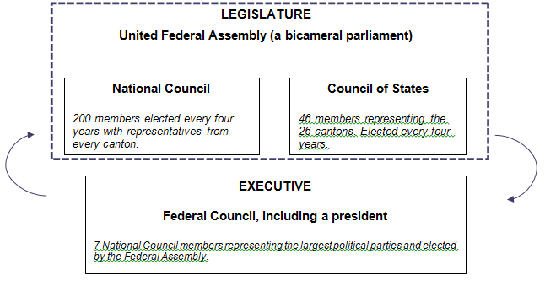
Learners’ diagrams should be similar to the diagram in the Teacher Introduction to Swiss direct democracy on page 7.

Section 3: The UK and Switzerland compared

Resource 5: Key features of citizen participation - answers
Key features of citizen participation | United Kingdom | Switzerland
Elections are free and fair | Yes | Yes
Elections are held regularly | Yes | Yes
Voter turnout for parliamentary elections is well above 50% | Yes | No
All citizens have a right to vote and stand as candidates | Yes | Yes
Most people resident in the country can vote | Yes | No
The number of votes for each political party determines each party’s strength in parliament | No | Yes
A variety of views are represented in government | No | Yes
Citizens can vote to overturn laws made by their parliament | No | Yes
Citizens can vote to alter the county’s constitution | No | Yes
Complete the chart below to show whether each statement is more likely to apply to Switzerland or the UK. Write a short explanation for your choice.
Statement | Switzerland or UK? | Explanation of my choice
Decision-making takes a long time. | Switzerland | With coalition governments and referendums, it can sometimes require considerable negotiation and consultation before decisions can be made.
Government is usually decisive. | UK | UK governments are usually single-party governments supported by the majority of MPs in parliament.
Politicians listen carefully to public opinion. | Switzerland | Politicians realise that citizens can use referendums to oppose new laws or demand changes to the constitution. This makes it more likely that politicians will make sure they have people’s support for new ideas.
A government is able to make unpopular but necessary decisions. | UK | The UK Government is able to make unpopular decisions in its first three years in office hoping that people will have learned to support the decision before the general election.
People are more likely to take an interest in politics. | Switzerland

Learners will find it useful to have already studied specification section 2.1 ‘democracy, voting and elections in the UK’ and 2.6 ‘citizenship participation in the UK’. Learners should also refer to sections one, two and three of the TEP ‘Rights in Conflict’ to broaden and deepen their understanding of democracy.
OCR Resources: the small print
OCR’s resources are provided to support the teaching of OCR specifications, but in no way constitute an endorsed teaching method that is required by the Board, and the decision to use them lies with the individual teacher. Whilst every effort is made to ensure the accuracy of the content, OCR cannot be held responsible for any errors or omissions within these resources.
© OCR 2016 - This resource may be freely copied and distributed, as long as the OCR logo and this message remain intact and OCR is acknowledged as the originator of this work.
OCR acknowledges the use of the following content: n/a
Please get in touch if you want to discuss the accessibility of resources we offer to support delivery of our qualifications: resources.feedback@ocr.org.uk
We’d like to know your view on the resources we produce. By clicking on ‘Like’ or ‘Dislike’ you can help us to ensure that our resources work for you. When the email template pops up please add additional comments if you wish and then just click ‘Send’. Thank you.
If you do not currently offer this OCR qualification but would like to do so, please complete the Expression of Interest Form which can be found here: www.ocr.org.uk/expression-of-interest

Switzerland

Student activity section

Resource 1: Comparing Athenian and UK democracy
Construct the chart below to show the main differences between classical Athenian direct democracy and representative democracy in the UK.
- First place the four captions on your chart and check your decisions with another learner.
- Complete the chart by writing captions of your own.
To help you with this task:
- Apply your knowledge of representative democracy in the UK.
- Use information from the following web pages:
https://www.youtube.com/watch?v=u6jgWxkbR7A&ebc=ANyPxKpkIZ4If8jWSp4CtS1llq2_ZZBM_QyMxD_C2q1Bxj6uaY06NTg88YSJHhGY4WcW9pZpVr6crlr_KlFknkjZT3-iO7ZhKg a short cartoon-based introduction to democracy
https://www.youtube.com/watch?v=OM0w7hBCZfs - a detailed video on Athenian democracy
http://www.bbc.co.uk/history/ancient/greeks/greekdemocracy_01.shtml - a detailed text-based commentary on the development of Greek democracy
Key questions | Classical Athenian direct democracy | UK representative democracy
Who can vote?
Where are decisions made?
How are decisions made?
What can citizens do if they want to change something?
What are the main advantages of this system?
What are the main disadvantages of this system?

Captions Put these on your chart first)
They join the debates in the Assembly and try to persuade other citizens to support their ideas.

In the Athenian Assembly
The Government (Executive) proposes new laws to representatives in Parliament (Legislature). Citizens elect their representatives every five years. Some important decisions are made through a referendum (a vote by all citizens on a single issue).

Once you have completed the chart, write a paragraph (maximum 150 words) to explain why the Athenians replaced their direct democracy with a type of representative democracy.
Use the following concepts and terms in your paragraph:
citizen
vote
electorate
direct democracy
representative democracy

Resource 2: What makes an effective democracy?
Study the seven essential features of democracy below. Place the features in their correct place on the chart by matching each feature with the best explanation of why it is important.
Essential features of an effective democracy
- An inclusive franchise.
- High levels of citizen engagement.
- Freedom for citizens to generate fresh ideas, hold representatives to account and criticise authority.
- Equal opportunities for all citizens to exercise power and authority.
- Widespread tolerance and respect for diversity.
- Checks and balances– power is commonly separated between the executive, legislature and judiciary.
- Universal acceptance of the rule of law.

Features of an effective democracy | Reasons for their importance
 | Citizens think it is unfair if some people are allowed to break the law. This undermines their faith in justice and makes it more likely that they will also disobey the law. Trust begins to break down and society is less stable.
 | It is possible for the majority in a democracy to vote for laws that discriminate against a minority group. This unfairness could lead to anger, resentment and an unstable society. It is therefore important that the majority does not use its power against minorities.
 | If citizens put forward ideas and help to make decisions, then it is more likely that they will be happy with the place in which they live as it will reflect their opinions and aspirations.

People who are not allowed to vote cannot easily influence decisions. They may feel forgotten and undervalued, becoming unwilling to contribute to their society and resentful of those in power.
People in power don’t always make good decisions so it’s important that citizens are able to find out what is going on. This gives citizens the chance to object and to shift their support to representatives who may do a better job.
If a government’s decisions have to be approved by an elected parliament, then it is more likely that those decisions will reflect people’s wishes. If judges are independent of government, they can more easily take action against a government that acts unlawfully.
Effective leadership and organisation in a democracy depends the most skilled people becoming involved.

Resource 3: UK referendums
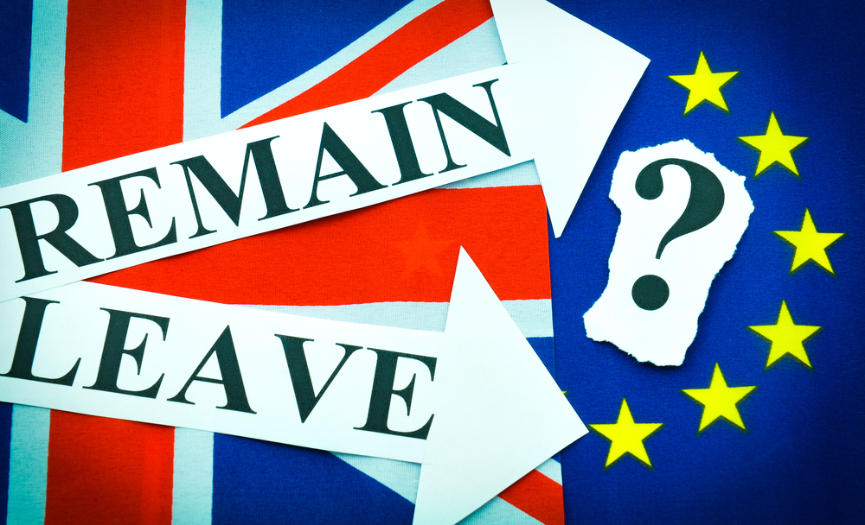
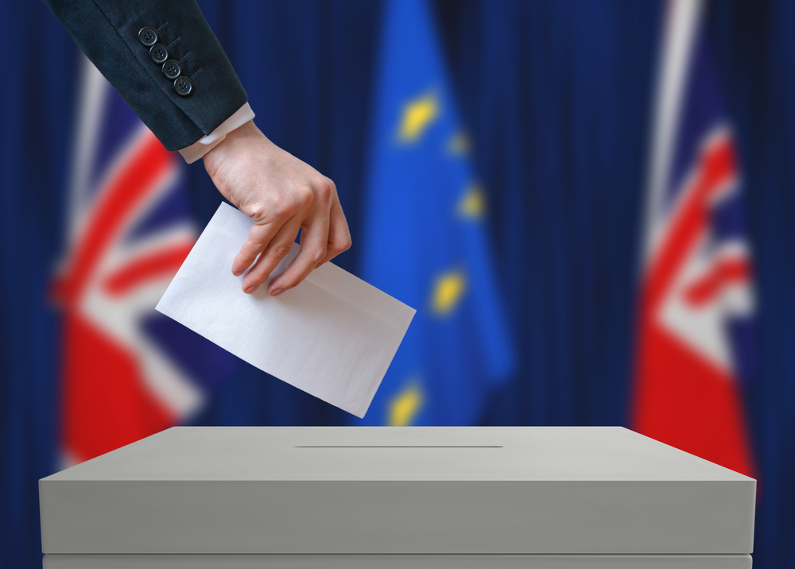

On 23 June 2016, the UK electorate was asked to vote on the question below:
Should the United Kingdom remain a member of the European Union or leave the European Union? They could vote for one of these two alternatives:
- Remain a member of the European Union.
- Leave the European Union.
Study the viewpoint below.
We elect politicians to make decisions. They have time to look into the facts and make a good decision. Ordinary people should not vote on the big issues that affect the country. What if they get it wrong? Voters don’t have all the information and are influenced too much by their friends and family. Some don’t even understand the referendum question. In any case, the issue is too complex just for a ‘remain’ or ‘leave’ answer.

- Make a short audio or written statement opposing the viewpoint above.
- Separate the viewpoint above into at least five separate statements. Deign a short survey with other learners so see how far at least twenty adults support or oppose the statements in the viewpoint. Analyse your results and summarise your findings before sharing them with the rest of the class.
- Using your findings and following a discussion with other learners and your teacher, complete the chart below to show the advantages and disadvantages of using a referendum to decide important issues. Place the most important points in the upper rows of the chart.
Should referendums be used in the UK to decide important issues?
Points in favour | Points against

Resource 4: The Swiss political system

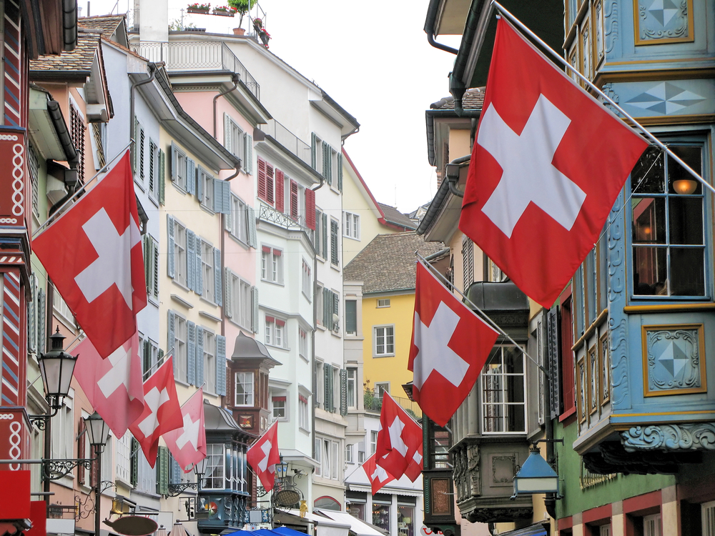
Design a diagram of the Swiss political system using:
- The outline on the next page (or an outline you design yourself).
- Labels and commentaries from the data file.
- Information from Swiss Political System – Facts and Figures at https://www.eda.admin.ch/aboutswitzerland/en/home/politik/uebersicht/politisches-system-der-schweiz---fakten-und-zahlen.html, from the YouTube video https://www.youtube.com/watch?v=y5W45Va0cPE
- Additional information from your own web search.
Swiss political system (outline)
Label 1
Label 2
Commentary 1
Label 3
Commentary 2
Label 4
Commentary 3

Label 5
Label 6
Label 7
Commentary 4
Commentary 5

Data file
Labels
Executive
Legislature
Federal Council
National Council
Council of States
Federal Assembly
President
Commentaries
200 members elected every four years with representatives from every canton.
Chosen to serve for one year. Chairs the National Council.
7 National Council members representing the largest political parties and elected by the Federal Assembly.
46 members representing the 26 cantons. Elected every four years.
These two chambers form a bicameral parliament.

Resource 5: Key features of citizen participation

Complete the simple charts below to compare and evaluate citizen participation in the UK and Switzerland. Apply your own knowledge and understanding of Swiss and British political systems to complete the chart. A video summary of the Swiss system will also be helpful https://www.youtube.com/watch?v=y5W45Va0cPE

Key features of citizen participation | United Kingdom | Switzerland
Elections are free and fair. | Yes / No | Yes / No
Elections are held regularly. | Yes / No | Yes / No
Voter turnout for parliamentary elections is well above 50%. | Yes / No | Yes / No
All citizens have a right to vote and stand as candidates. | Yes / No | Yes / No
Most people resident in the country can vote. | Yes / No | Yes / No
The number of votes for each political party determines each party’s strength in parliament. | Yes / No | Yes / No
A variety of views are represented in government. | Yes / No | Yes / No
Citizens can vote to overturn laws made by their parliament. | Yes / No | Yes / No
Citizens can vote to alter the county’s constitution. | Yes / No | Yes / No

Complete the chart below to show whether each statement is more likely to apply to Switzerland or the UK. Write a short explanation for your choice.
Statement | Switzerland or UK? | Explanation of my choice
Decision-making takes a long time

Government is usually decisive

Politicians listen carefully to public opinion
A government is able to make unpopular but necessary decisions
People are more likely to take an interest in politics

