Topic Exploration Pack

Pastry

SECTION D - Skills requirements: preparation and cooking techniques (dough). Topic 7.

Pastry explained 2
Function and working characteristics of the main ingredients 2
Activity 1 Using different pastries to make a range of recipes 4
Activity 2 Functions of ingredients in shortcrust, flaky and choux pastry 5
Points to remember for making successful pastry 7
Activity 3 Recognising faults when making pastry 8
Palmiers 9
Choux pastry 11
Presentation and styling 12
Activity 4: Pastry dishes can lack appeal: Ways to make pastry dishes more appealing 13
Food science activity to support Task 1 – Food Investigation 14
Recipes and practical activities to support Task 2 – Food Preparation 14

Student Activity section 16
Activity 1 Using different pastries to make a range of recipes….. 16
Activity 2 Functions of ingredients in shortcrust, flaky and choux pastry 17
Activity 3 Recognising faults when making pastry 19
Activity 4 Pastry dishes can lack appeal: Ways that dishes can be improved 21
Activity 5 Practical application 22

123 – This activity offers an opportunity for maths skills development.
ABC – This activity offers an opportunity for English skills development.
When distributing the Student Activity section to students either as a printed copy or as a Word file you will need to remove the teacher instructions section.

Pastry explained
Definition
Pastry has many different uses, from savoury starters to delicious desserts. The ingredients and proportion of fat to flour affects the pastry and what it can be used for.
A wide variety of different pastries can be used to produce dishes using a vast range of skills, to develop differing flavours and textures.

Function and working characteristics of the main ingredients
Scientific explanation
The main ingredients used in pastry making are, flour, fat, water and a little salt.
Flour
Generally a soft flour with a low gluten content is used. The exceptions are choux pastry and flaky pastry. For these pastries, a high gluten content flour is used.
There are many important types of protein in flour.
There are two insoluble proteins called gliadine and glutamine which are important in baking. When they are mixed with a liquid a substance called gluten is formed. The amount of gluten in flour depends on its use.
Gluten is vital in baking because it is elastic enough to hold pockets of air in the mixture and strong enough to support the structure and stop the air escaping.
Fat
Shortening: This term is used when rubbing in fat and flour. It gives a waterproof coating to the grains of flour, which prevent gluten in the flour from developing and forming long molecules and produces a short, crumbly texture.
Plasticity: This term is used to describe the fact fats do not melt at fixed temperatures, but over a range. This property is called plasticity. It gives all fats unique character.
The plasticity is due to the mixture of triglycerides, each with its own melting point. Some products are formulated with fats with lower melting points so they can spread from the fridge, e.g. margarine.
Other fats have a higher melting point and are used for cooking, for example pastry.

Flakiness: This term is used for flaky and puff pastry which use the fat to help separate layers of gluten and starch formed in the dough. This is called lamination. The fat melts during cooking, leaving minute layers. The liquid present produces steam which evaporates and causes the layers to rise. The fat prevents the layers sticking together.

Water: Helps to bind flour and fat together to make a dough. In choux pastry water is converted to steam or water vapour, which acts as the raising agent.
Salt: provides some flavouring.
The most common types of pastry are:
- Shortcrust
- Flaky/rough puff
- Choux
Different types of pastry use similar ingredients but are combined in different ratios using varied methods to produce a variety of textures and finishes.
Information about the main types of pastry
Type of Pastry | Basic Recipe | Ratio of fat to flour | How fat is mixed | Texture quality
Shortcrust  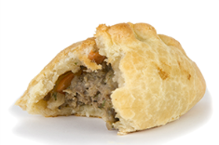 | 200g plain flour  100g hard fat mixture of margarine and white fat  water | 1:2 | Fat is rubbed into flour | Light texture which is crisp and short
Flaky/rough puff  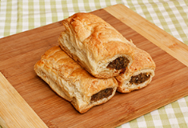 | 200g strong flour  150g fat mixture of margarine and white fat  2tsp lemon juice  water | 3:4 | A ¼ of the fat is rubbed into the flour, water is added.  Pastry rolled and folded adding ¼ of the fat each time | Layers of crisp pastry
Choux  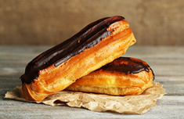 | 75g strong plain flour  50g butter  2 eggs  125ml water | 1:3 | Fat is melted in the water | Hollow inside, well risen with a crisp texture
Useful links

http://www.bbcgoodfood.com/howto/guide/pieminister-top-10-pastry-making-tips
http://www.britishfood.com/
https://www.jusrol.co.uk/pastry-tips
Dough
In this section you will need to cover:
- The use of technical skills of shortening.
- How to roll out pastry.
- Create layers for example, palmiers.
- Ways of glazing dishes.
- Piping for example choux pastry.
- A range of finishing techniques for example, lattice and decorations.

Activity 1 Using different pastries to make a range of recipes
Ask your students to complete Student Activity 1 on page 15 by selecting a range of recipes which use each of the three types of pastry above. List the recipe and skill level required to make each different pastry item.

Activity 2 Functions of ingredients in shortcrust, flaky and choux pastry
Ask your students to complete Student Activity 2 by completing the key functions of ingredients when making three different types of pastry. Answers are shown below.
Ingredient | Shortcrust | Flaky | Choux
Flour  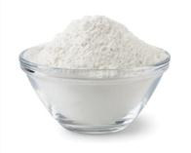 | Why is plain flour used?  Plain flour.  Low gluten content to produce short crumby texture. | How is a crispy texture with flaky layers achieved?  Strong plain flour.  High gluten content to produce crispy, flaky layers. | Explain why is a flour with a high gluten content used?  Strong plain flour.  High gluten content which stretches to hold the expanding steam and air.
Fat  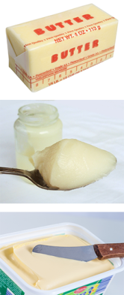 | What function does fat have in pastry making?  Use of hard margarine, white fat or butter  Fat coats the flour granules to reduce the water mixing with the gluten. | What function does the fat have in this pastry?  Mixture of white fat and margarine.  Small pieces of fat are placed on the dough the fat traps air between the layers of dough. | Name the two fats used?  Butter or margarine for flavour.
Water  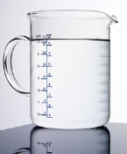 | What is the key function of water in pastry making?  Binds the rubbed - in fat to the flour. | How is elastic dough achieved?  Combines with gluten to form stretchy, elastic dough.  Why is lemon juice added to this pastry?  Lemon juice is added to strengthen the gluten. | Explain what happens when the flour is heated to 100 degrees?  Boiled at 100̊̊C so the heat causes the starch in flour to gelatinise.  Mixes with flour to develop the gluten.
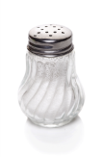  Salt | Why is salt added?  Helps develop the flavour. | What two reasons is salt added?  Helps to develop the flavour and strengthen the gluten.
Egg  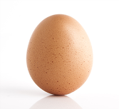 |  |  | What are two key functions of using egg in choux pastry?  Helps to hold air in the starch mixture. Gives a smooth, glossy finish and aids piping of the mixture.
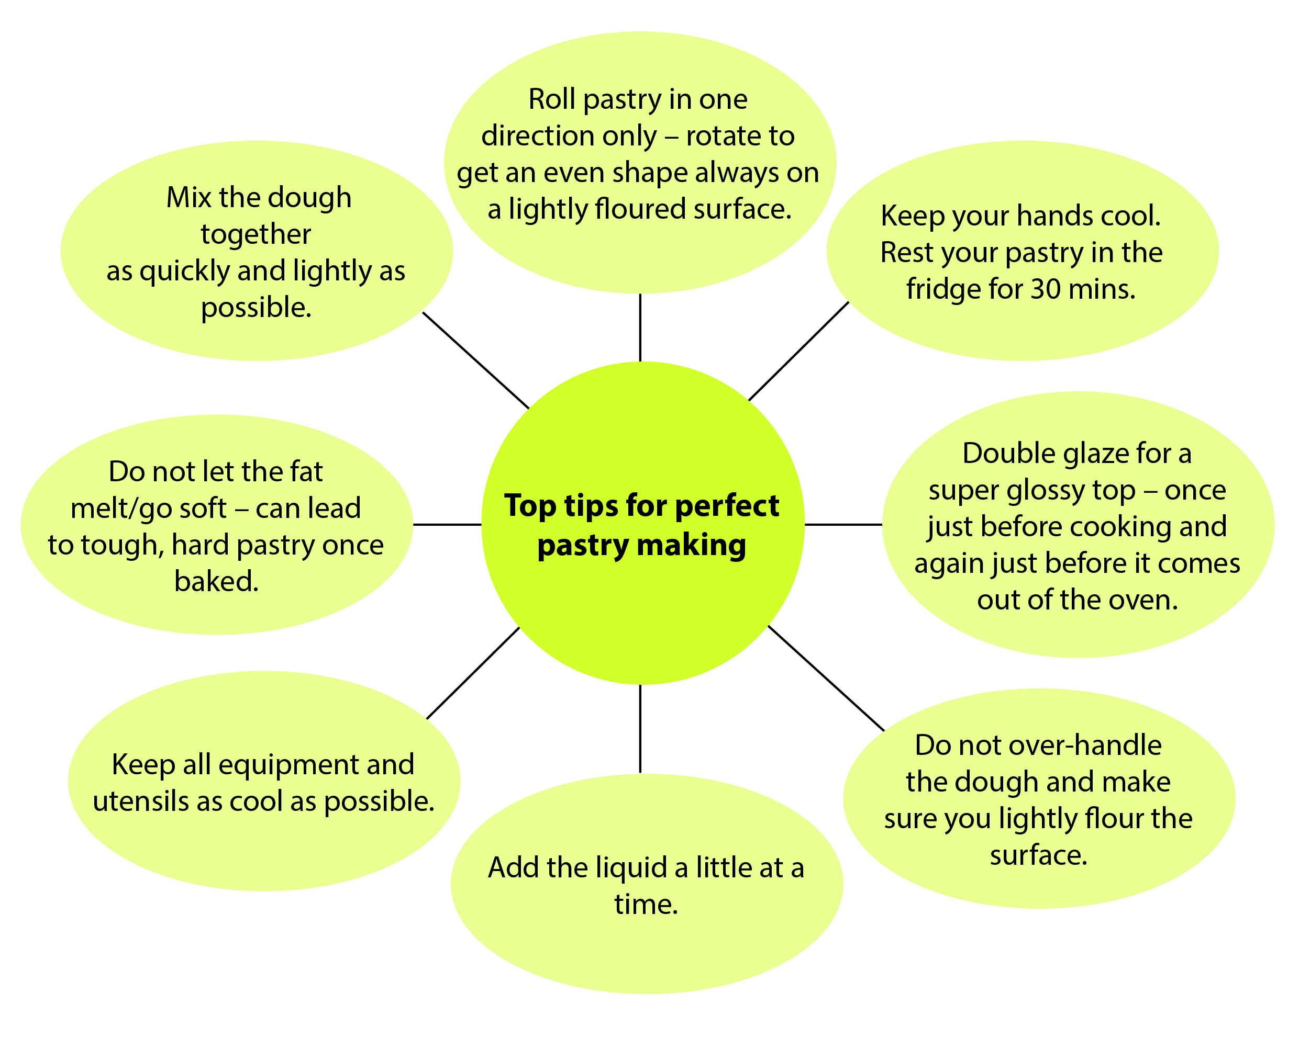

Points to remember for making successful pastry
Keeping cool
When preparing pastry except for choux pastry it is most important that you keep everything cool including ingredients, utensils, hands and pastry.
Rolling out
- Rolling out any pastry carefully is important to create an even surface. The pastry needs to be as cool as possible.
- Rolling out should be undertaken on a lightly floured surface. Flour the rolling pin before rolling out.
- The pastry should be rolled in even strokes and then turn it through a quarter turn and continue rolling. Pastry should never be turned over.
- Choux pastry is not rolled out, but piped or spooned into the designed shapes. This illustrates a high level of skill.
Accurate weighing and measuring
Accurate weighing and measuring is essential to ensure consistency.
Baking blind
This term is used when you want to pre-cook a pastry case before adding the filling, for example, quiches and lemon meringue pie.
Heat oven to 180̊C fan/gas 6. Fill the pastry case with a round of baking paper and add baking beans. Bake for 15 mins, then remove the paper and beans and cook the pastry for 5 mins more.
Useful links
How to make shortcrust pastry and bake it blind - www.youtube.com/watch?v=yzY4yh06bTY
How to blind bake pastry | BBC Good Food - www.bbcgoodfood.com/videos/techniques/how-blind-bake-pastry
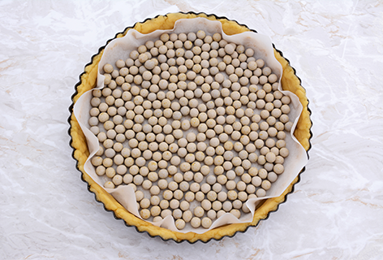

Activity 3 Recognising faults when making pastry
Ask your students to complete Student Activity 3 by completing the chart of common faults with reasons when making pastry. Some faults have more than one reason. Here is the fault/reason list which is also in the student section; you may want students to complete the table on page 19 and 20 with or without the aid of this fact sheet.
Fault | Reason
Pastry is sticky and very soft making it difficult to handle. | A soft fat was used, for example, a margarine spread.  Too much liquid was used.  The mixture had been over handled.
Cooked pastry is dry, brittle and crumbly. | Not sufficient liquid was added.
Cooked pastry is hard and tough. | Pastry was handled too in the making.  Too little fat was used.  Pastry was over rolled.  Too much water had been added and the gluten in the pastry was over developed.
Pastry is soft and oily when cooked. | The temperature of the oven was too low.
Pastry shrinks when it is cooking. | The stretched was stretched during the handling and rolling out
Pastry is soft and crumbly. | Too much was fat was used  Too much baking powder, if this ingredient had been added.  Not sufficient water was used.
Pastry blisters. | Fat not rubbed in sufficiently  Too much water was used.
Pastry is very pale. | Not baked for a long enough time.  Oven temperature was not hot enough.
Pastry is too dark. | Cooked too long.  Oven temperature was too high.

Skills and finishes for making pastry dishes
There are a number of skills that can be used to create a range of attractive and exciting dishes.
- Create layers for example, palmiers
- Piping for example, choux pastry
- A range of finishing techniques for example, lattice and decorations.

Palmiers

Useful links

http://www.bbcgoodfood.com/videos/techniques/how-make-and-shape-palmier-biscuits
www.marthastewart.com/339389/palmiers
www.foodnetwork.com (for recipes and how to…)
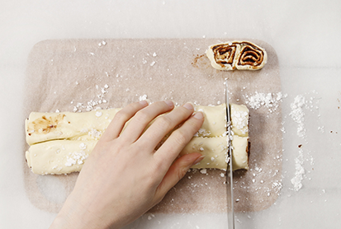
Top tips for making palmiers
- Palmiers are made with puff pastry and some sugar.
- Use demerara or another coarse-grained sugar.
- Brown sugar or granulated sugar work well and make a sweeter palmier.
Folding and shaping the palmiers
- Fold the left and right sides of the pastry to the middle
- Fold the dough in half again length-wise
- Sandwich the first folds inside
- Cut into individual palmiers
- This is what gives the palmiers their distinctive "palm" or elephant-ear shape.
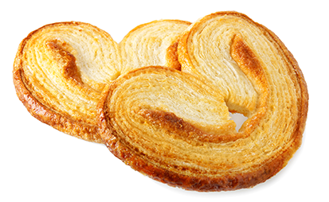

Different fillings can be explored to give a different taste
Sweet palmiers
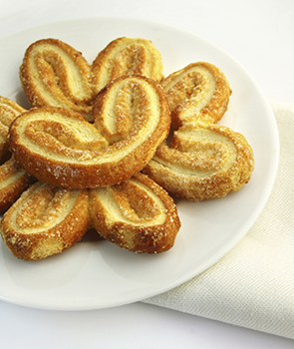
You could add the following:
- cinnamon
- crystallized ginger
- lemon peel
- dried chopped fruits, for example currants, apricots
- cranberries, sultanas, cherries

Savoury Palmiers
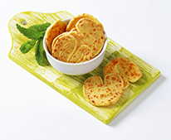
- pesto
- tapenade
- cheeses
- dried tomatoes

Choux pastry
Piping - useful links
Piping techniques – how to pipe choux cream puffs - https://www.youtube.com/watch?v=d4JC-EmOGZ4
Piping and baking choux buns – illustrated recipe – http://www.bbc.co.uk/food/techniques/using_piping_bags

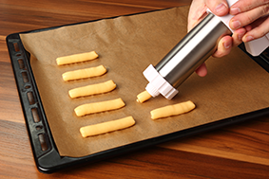
Choux pastry - https://timetocookonline.com/2012/01/22/choux-pastry/
Choux pastry is made in a different way to other pastries although the basic ingredients are flour, margarine, water and egg.
Choux pastry has the lightest, crispiest, airiest texture.
It can be used to make profiteroles, éclairs or savoury gougères.
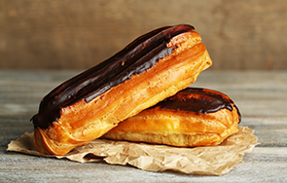
It puffs up in the oven until it is set by the heat.
The airiness, is caused because choux pastry has a high water content, which is turned into steam during baking. Steam ,which is a gas (also known as water vapour) starts to be produced at 100̊ C.
This pushes the pastry shell outwards and gives it volume. Water vapour expands to 1,600 times its original volume and therefore it is an effective raising agent.
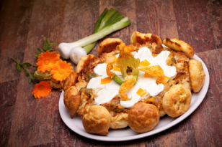
Top tips for making choux pastry.
Piping bags: Not compulsory. For choux buns, the batter can be spooned out using just a couple of teaspoons.
If you want a consistent appearance, you can use a piping bag with a plain or star shaped nozzled – 1cm diameter.
An alternative is a re-sealable freezer bag with the corner snipped off.
Strong plain flour is recommended as it has a higher gluten content, which gives crisper results than ordinary soft, plain flour.
Add the flour in one go while you beat the mixture using a wooden spoon, or an electric hand whisk will save you lots of energy and time.

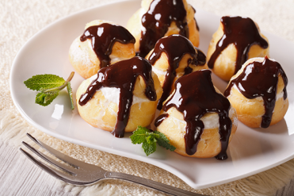
Make sure the paste forms a soft ball in the saucepan.
Cool to blood heat (37̊C) before adding the eggs and add a little at a time.
When the pastry is cooked, pierce the side of each one to let out the steam.
Cool on a wire rack.

Presentation and styling
As part of the Non Examined Assessment (NEA) Task 2, 25 marks are awarded for the presentation, finish and styling of the final dishes.
Useful links
https://www.jusrol.co.uk/pastry-tips/puff-pastry-pie-top
http://www.greatbritishchefs.com/search?search=pastry&type=How+to+cook+articles
http://www.onlinepastrytrainingschool.com
There are a number of ways to decorate and improve the appearance of your pastry dishes.
Short crust pastry is often used for a range of pie making.
These dishes can be made to look more appealing / attractive by having some type of decoration and / or finishing technique applied.
Glazing
Egg, milk or a mixture of both and sugar and water mixed are the key ingredients for glazing pastry dishes.
- Egg white
- Egg yolk
- Whole eggs
- Milk
- Water
- Sugar syrup
- Fruit glaze
- Fruit juice

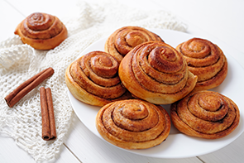
They should be lightly brushed on the surface of the finished pastry dish before cooking.
The purpose of glazing gives the finished dish a glossy attractive look!
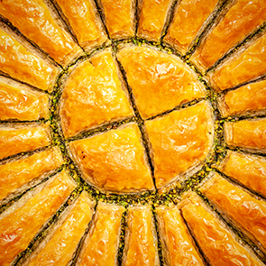
To provide a fabulous finish, glaze with an egg before putting it in the oven.
Milk or cream glaze provides a reddish brown colour with a flat finish.
Egg white glaze provides little colour but a shiny finish.
Beaten egg yolk glaze provides a golden brown finish.
Whole egg beaten provides a concentrated glossy golden finish.
Sugar syrup glazes provide a shiny semi caramelised finish
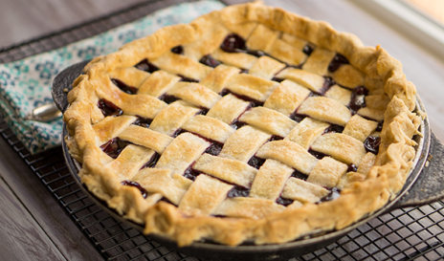
Left over pastry can be used to make simple and cost effective decorations, for example:
- leaves
- hearts braids
- lattice strips
To personalise your dish you could create a name, birthday message or greeting.
Finishing techniques – these can also add a skill to your dish. For example:
- honeycomb pie crust
- crimping the edges
- making a pattern.

Activity 4: Pastry dishes can lack appeal: Ways to make pastry dishes more appealing
Ask your students to complete Student Worksheet 4 on page 21 by suggesting ideas to improve the presentation and/or styling of pastry dishes.

Food science activity to support Task 1 – Food Investigation
Testing the strength of gluten.
Try this:
A squeeze test to test the strength of flour.
Is the flour soft or strong?
Squeeze some flour in the palm of your hand. If the flour holds together it is soft, if it falls apart it is strong.

Recipes and practical activities to support Task 2 – Food Preparation
Dishes using pastry
Useful links
www.jusrol.co.uk/pastry-recipes/
www.bbc.co.uk/food/recipes/shortcrustpastry_
https://www.bakingmad.com/pastry-recipes
- All day breakfast tartlets
- Spiced lamb and apricot filo pie
- Cheese Roquefort , celery and walnut tiny tartlets
- Pork, apple and mustard roll
- Savoury lattice pie with butternut squash , leek and ricotta
- Pizza puffs
- Mushroom and cheese parcels
- Cheese twist straws
- Sausage plait
- Weekend brunch – egg brunch with spicy tomato salsa
- Pesto and roasted vegetable puff rounds
- Fish pie
- Spiced Pineapple puff ring tart
- Pear and walnut tart Tatin
- Cherry almond tart
- Honey and lavender panna cotta tartlets
- Multi-Cultural twist
- Baklava
- Mexican chicken fajita tart
- Chocolate, hazelnut and banana croissant
We’d like to know your view on the resources we produce. By clicking on ‘Like’ or ‘Dislike’ you can help us to ensure that our resources work for you. When the email template pops up please add additional comments if you wish and then just click ‘Send’. Thank you.
If you do not currently offer this OCR qualification but would like to do so, please complete the Expression of Interest Form which can be found here: www.ocr.org.uk/expression-of-interest
OCR Resources: the small print
OCR’s resources are provided to support the teaching of OCR specifications, but in no way constitute an endorsed teaching method that is required by the Board, and the decision to use them lies with the individual teacher. Whilst every effort is made to ensure the accuracy of the content, OCR cannot be held responsible for any errors or omissions within these resources.
© OCR 2016 - This resource may be freely copied and distributed, as long as the OCR logo and this message remain intact and OCR is acknowledged as the originator of this work.
OCR acknowledges the use of the following content: page 3 and 24: pasty – Alan Egginton/Shutterstock.com, page 3: sausage roll – StockSolutions/Shutterstock.com, page 3 and 10: chocolate eclairs – Africa Studio/Shutterstock.com, page 4 and 16: flour – Coprid/Shutterstock.com, page 5 and 16: butter – Hurst Photo/Shutterstock.com, lard – Settva/Shutterstock.com, margarine – JPC-PROD/Shutterstock.com, water – CKP1001/Shutterstock.com, page 5 and 17: salt – artproem/Shutterstock.com, egg – Suradech Prapairat/Shutterstock.com, page 7: blind baking – Sarah Marchant/Shutterstock.com, page 9: making palmiers - Agnes Kantaruk/Shutterstock.com, palmiers – Lyudmila Suvorova/Shutterstock.com, page 10: sweet palmiers – Taiftin/iStock.com, savoury palmiers - Vikif/Shutterstock.com, piping choux pastry – Ninikas/iStock.com, page 11: savoury choux - eZeePics Studio/iStock.com, page 12 : cinnamon whirls – Green Art Photograph/Shutterstock.com, baklava – Bulentin Ince/iStock.com, page 13: lattice tart – Tammy Valenzia/Shutterstock.com
Please get in touch if you want to discuss the accessibility of resources we offer to support delivery of our qualifications: resources.feedback@ocr.org.uk

Topic Exploration Pack

Pastry

Student Activity section

Activity 1 Using different pastries to make a range of recipes
Pastry | Three recipes | Justify skills Level High/Medium/Low
Short crust pastry | 1  2  3
Flaky/rough puff | 1  2  3
Choux | 1  2  3

Activity 2 Functions of ingredients in shortcrust, flaky and choux pastry
Ingredient | Shortcrust | Flaky | Choux
Flour | Why is plain flour used? | How is a crispy texture with flaky layers achieved? | Explain why a flour with a high gluten content is used.
Fat  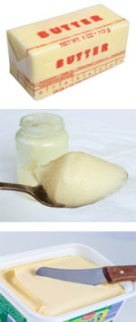 | What function does fat have in pastry making? | What function does the fat have in this pastry? | Name the two fats used?
Water | What is the key function of water in pastry making? | How is elastic dough achieved?  Why is lemon juice added to this pastry? | Explain what happens when the flour is heated to 100̊C.
Salt | Why is salt added? | Why is salt added? (Two reasons.)
Egg |  |  | What are two key functions of using egg in choux pastry?

Key facts
Shortening: this term is used when rubbed in fat and flour gives a waterproof coating to the grains of flour, which prevent gluten in the flour from developing and produces a short, crumbly texture.
Choux pastry: is not rolled out but usually piped or spooned into desired shapes for example, eclairs and profiteroles.
Other types of pastry include:
Filo pastry: originally came from Greece.
Puff pastry: similar to flaky pastry which many people buy as chilled or frozen product as it is quick to use and saves a length preparation time.

Activity 3 Recognising faults when making pastry
There are a number of common faults which can occur when pastry making. Complete the chart below matching the fault with possible reasons.
Fault | Reasons
Pastry blisters.
 | Not sufficient liquid was added.
Cooked pastry is hard and tough.
 | The temperature of the oven was too low.
Pastry shrinks when it is cooking.
Pastry is soft and crumbly.
Fat not rubbed in sufficiently.
Too much water was used.
Not baked for a long enough time.
Oven temperature was not hot enough.
Pastry is too dark.

Activity 4 Pastry dishes can lack appeal: Ways that dishes can be improved
Complete the tables below, suggesting ways dishes can be made more appealing.
- By decorating and finishing when preparing and cooking.

 | Recipe/pastry type | Appeal
1 | Cornish pasty/shortcrust. | Crimp and glaze.
2
3

- By providing suitable accompaniments to enhance the dish.

 | Recipe/pastry type | Appeal
1 | Spring rolls/filo pastry. | Serve with green salad and lemon and mustard dressing.
2
3
4

Activity 5 Practical application
Aims:
- To work in an organised and methodical manner following a recipe independently and accurately.
- To apply the correct method and skills within a practical lesson to make a pastry dish.
Cornish Pasty | Ingredients | Equipment
Method:  1. Prepare – work area, equipment and self.  2. Pre-heat oven 200C/gas 6.  3. Sieve flour, salt in mixing bowl.  4. Rub in fats until breadcrumb appearance. Make a well in middle  5. Add cold water – approx. 3 tbsp - stir with knife first then lightly with fingers.  6. Draw mixture together to a soft dough on a lightly floured surface - knead until smooth.  7. Wrap and leave in fridge to rest.  8. Cut meat into small cubes.  9. Finely slice/ grate swede, carrot,onion and potato.  10. Place all in mixing bowl and season well.  11. Cut pastry in half, make into a ball. Roll each to 20cms diameter.  12. Put equal amounts of filling in each. DO NOT OVER FILL.  13 Brush edges of pastry with water.  14 Fold pasty over mixture and seal together OR bring to the top and crimp.  15 Glaze with egg and milk – make a 1cm slice in top.  16 Bake in oven 200C/Gas 6.  17 – If too brown reduce oven to 180C/Gas 4.  18 Bake for 45 minutes approx. | 150 g plain flour  75 g hard margarine and lard mixed  Pinch of salt  Approx 3 tbsp cold water to mix  1 large potato – finely sliced or grated  100g swede/ carrot – finely sliced or grated  125g beef – skirt or chuck steak, minced or finely chopped  1 medium onion – finely chopped  Seasoning  Beaten egg / milk for glazing | Scales  Two medium size mixing bowls  Pastry brush  Chopping board  Knife  Vegetable peeler  Measuring jug  Rolling pin  Flour dredger  Fork  Baking tray

Top tips
- Leave pastry to rest in fridge to enable better handling.
- Add all the water but may need a little more to get to a soft dough.
- Use knife to stir the water into flour first, finish using fingers lightly.
- Crimp edges of pastry evenly by squeezing and folding edges.
- Use pointed knife to make a cm hole in top for steam to escape.
- Can be served hot or cold.
- Serve with a salad or range of colourful vegetables to add colour, texture and provide a balanced meal.
List skills to be used during the making | What skills are involved in the overall dish?  High  Medium  Low skill | 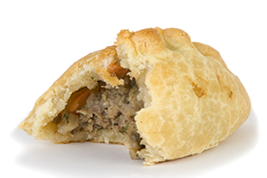
Costs of your pasties  Food provenance of key ingredients  Eg Beef – Scotland | Seasonality - pasty ingredients  Eg British Swede – winter months  Local farmers market – onions  August – November | How could you adapt the pasties  - Sweet fillings – apple and cinnamon  - Apple turnovers – triangle shape  - Jam tarts  - Vegetarians  - Flaky pastry - Cheese and onion filling  - Stilton and leek  - Smoked haddock and leek  Multicultural flair  - Add curry powder  - Filo pastry – spring rolls/samosas

