Topic Exploration Pack

Raising agents

Introduction to raising agents 2
Activity 1: Starter activity and recipe ideas 6
Activity 2: Function of yeast in bread making – answers and recipe ideas 7
Activity 3: Yeast experiment - outcomes 8
Activity 4: Colloid foam experiment and recipe ideas 10
Activity 5: End of unit quiz - answers 11

Student activity section – worksheets 13
Activity 1: Starter activity 13
Activity 2: Function of yeast in bread-making 14
Activity 3: Yeast experiment 16
Activity 4: Colloid foam experiment 17
Activity 5: End of unit quiz - Think about it! 18

These instructions cover the student activity section which can be found on page 13. This Topic Exploration Pack supports OCR GCSE (9‒1) Food Preparation and Nutrition.
When distributing the activity section to the students either as a printed copy or as a Word file you will need to remove the teacher instructions section.
This topic pack covers the content of the specification Section D 6, Skills requirements: preparation and cooking techniques (Raising agents):
- Use egg (colloid foam) as a raising agent – create a gas-in-air foam – whisking egg whites, whisked sponge.
- Use chemical raising agents – self-raising flour, baking powder.
- Use steam in a mixture (choux pastry, batter).
It also covers section C 1: Raising agents: yeast, chemical raising agents, air and steam.

Introduction
As part of the specification - Section C Cooking and food preparation – students will explore the working characteristics and the functional and chemical properties of ingredient groups. In particular they will focus on raising agents: yeast, chemical agents, foams, air and steam,
Students will need to be able to explain these processes. They will also be expected to look at a recipe or method and be able to name the raising agent or method that causes the food to rise.
Learning objectives
- Define the meaning of the term raising agent
- Identify the types of raising agents used in food
- Describe how raising agents enable a food product to rise.
Definition: Raising agents
A raising agent is added to a mixture to give lightness to a product. It is often used in cake and bread mixtures.
Scientific explanation – How do raising agents work?
This lightness is based on the principle that gases expand when heated. The gases used are air, carbon dioxide or water vapour (steam). These gases are introduced before baking. When the product is cooked the gases expand. The action of moisture, heat or acidity (or all three combined) creates a reaction with the raising agent to produce gas bubbles. Gas bubbles then become set in a mixture and provide a soft sponge like texture.
Types of raising agent
There are two types of raising agent: chemical and natural.
Chemical raising agents
- Baking Powder
- Baking Soda
- Self-raising flour
Baking Powder is a blend of acid and alkali (baking soda/sodium bicarbonate). These create carbon dioxide bubbles when liquid and heat are added.
Most baking powders are ‘double acting’, that is they produce an initial set of gas bubbles upon mixing and then a second set during the baking process.
When using baking powder, add this ingredient last as it will begin to create CO₂ as soon as it comes into contact with moisture.
Bicarbonate of Soda (baking soda) is used when there is already an acid ingredient in the recipe such as: Buttermilk, lemon juice, vinegar.
When baking soda comes in contact with an acid and liquid is added, carbon dioxide (CO₂), water and a neutral salt are produced. Care must be taken with how much baking soda is used. If too much, a ‘soapy’ aftertaste remains and the product bakes darker. If not enough is used, an acid flavour remains.
When carbon dioxide is released by either baking soda and/or baking powder, it first dissolves in the liquid. When this becomes saturated, the carbon dioxide produced turns into the air bubbles which expand. Towards the end of baking the bubbles set. You have a well risen product showing tiny air pockets when opened.
Self-raising flour
This is a low gluten content plain flour with added baking powder.

Natural raising agents
Air
This can be added to food mechanically in the following ways: whisking, sieving, creaming, beating, rubbing in, rolling and folding.
Flour can be aerated by sieving. Air can be enclosed in the fat and sugar when it is creamed. When a batter is beaten air is enclosed in it. Whisking eggs cause a foam where the air will be trapped.
As air is heated it expands, trapping pockets throughout a mixture. This makes the product light and risen at the end of the process.
Steam
Steam is produced when the water in a mixture reaches 100̊C. Steam is a gas also known as water vapour. Water vapour expands to 1,600 times its original volume.
For steam to be an effective raising agent, two conditions are essential. A high proportion of liquid in the mixture and a high baking temperature. A good example of this is a Yorkshire pudding batter mixture.
Although it may seem the easiest raising agent to use, it is the most complex in technique.
As an example, choux pastry uses steam as the main raising agent. As with bread making, strong flour is needed to ensure that the force of the steam does not break through the delicate gluten structure. Once all of the moisture has evaporated, the starch in the risen choux pastry will set leaving it hollow, crispy and golden brown. Due to its nature, this process is considered a high skill level.
CO₂
This is a by-product of using a chemical raising agent such as baking powder, or a biological raising agent such as yeast. As with all raising agents, it works in the following way: gasses expand when heated which pushes and raises the mixture upwards. As it rises the heat of the oven fixes the structure in place (protein sets).
Yeast
Yeast is a microscopic single-celled micro-organism. It requires the following conditions to begin fermentation (the process where carbon dioxide and alcohol are produced, while at the same time yeast produces itself.)
Conditions for fermentation:
- MOISTURE - yeast requires moisture. The liquid should be added at 38̊C.
- WARMTH - a good temperature for fermentation is around 25-30̊C.
- FOOD – yeast requires food, this is obtained from the starch in the flour or added sugar.
- TIME – time is need to allow the yeast to grow.
Yeast is used to make products such as bread, doughnuts and buns. This is because the gas bubbles (CO₂), created from the fermentation process, make the stretchy dough rise when it left in a warm place for an hour. This is called proving.
Faults when using raising agents
What happens when too much raising agent is used?
- Over- risen product that might collapse giving a sunken effect.
- A coarse texture; poor colour and flavour.
- Bitter taste.
- Fruit sinking to the bottom of a cake.
What happens if insufficient proportion of raising agent is used?
- Lack of volume.
- Insufficient lift.
- Close texture.
- Shrinkage.

Scientific explanation of a colloid foam
A foam is an aerated liquid. The thickness of a foam will depend on the ratio of liquid to air. Some can be seen as a froth, such as cappuccino, or most commonly it can be demonstrated through whisking egg whites to create a meringue or swiss roll.
Egg whites are made up of water, protein, and small amounts of minerals and sugars. When the egg whites are beaten, air is added and the egg white protein, albumen, is denatured. Denaturation is the change of a protein’s shape under stress (for example when whisked). The denatured protein coats the air bubbles and holds in the water, causing them to become stiff and stable. When an acid such as cream of tartar is added, the foam becomes even more stable and less likely to lose water (a process known as syneresis).
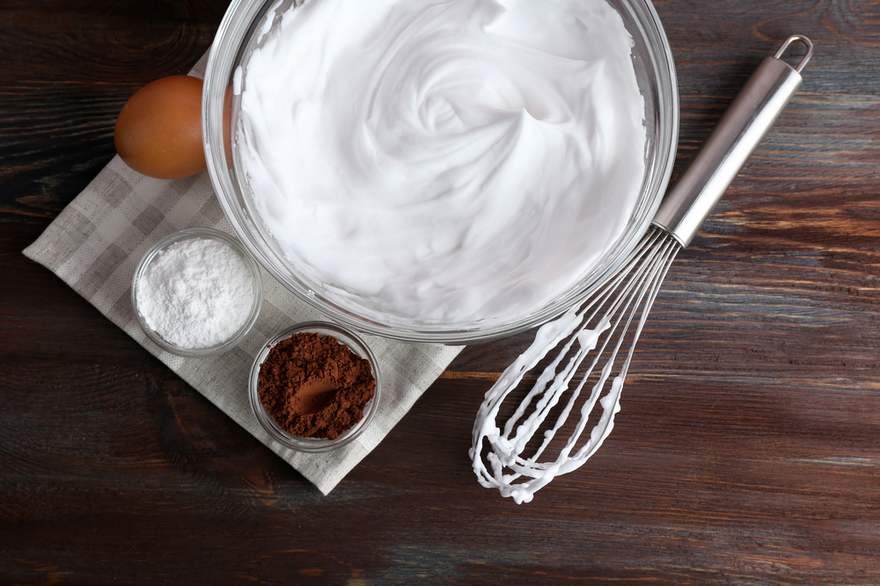
Often sugar is added to meringues, mousses and cakes. Sugar also stabilises foams as it binds with water in the egg, preventing it from leaking out of the foam.

There are different kinds of colloids:
- A gel is a colloid of a liquid in a solid; sauce is a gel of starch and water.
- A foam is a colloid of a gas in a liquid; whipped cream is a foam of air in cream.
- An emulsion is a colloid of liquid in a liquid; mayonnaise is an emulsion of egg yolk in oil.

Activity 1: Starter activity
Ask your students to complete the question below. This could be set as supporting homework or completed in class.
In your own words explain what a natural raising agent does to food.
Use the following keywords: Carbon dioxide, air, steam, heat, rise, protein, structure.
To support your answer, refer to a food product as an example e.g. sponge cake.
Students can write their answer into the worksheet on page 13

Practical learning
The teacher can demonstrate or students could make the following products to support the theory:
- Victoria Sponge – baking powder/self-raising flour/air/creaming method
- Choux pastry (profiteroles) – steam
- Buttermilk pancakes
- Yorkshire puddings or toad in the hole.
Recipe links
- Victoria Sponge – http://www.bbc.co.uk/food/recipes/victoriasponge_13555
- Choux pastry – http://www.deliaonline.com/how-to-cook/baking/how-to-make-choux-pastry.html
- Buttermilk pancakes – http://www.marthastewart.com/318689/best-buttermilk-pancakes
- Toad in the hole – http://allrecipes.co.uk/recipe/221/toad-in-the-hole.aspx

Activity 2: Function of yeast in bread making – answers
Fill in the missing keywords:
yeast
As the dough warms up, the produces CO2 gas bubbles and alcohol. The gas bubbles in the heat and push up the dough. The gluten in the dough . Water from the dough
turns to which helps to expand the gas bubbles and cook the dough. When the dough
reaches the gluten starts to set and the starch in the flour the water which also makes the dough set.
expand
stretches
steam
68̊C to 80̊C
absorbs
spongy
The inside of the dough becomes a and open network. The outside develops a The dough sounds when tapped.
golden crust.
hollow
firm
As the dough cools the starch becomes so that it can be sliced. Buns cook in the same
way and the egg they contain helps the dough to set, the sugar and the
gluten. The fats melts and is absorbed by the in the flour.
melts
softens
starch
KEYWORDS
Yeast. Expand. Stretches. Steam. 68̊C to 80̊̊C. Absorbs. Spongy. Golden crust. Hollow. Firm. Melts. Softens. Starch.

Practical learning
Teacher can demonstrate or students could make the following products to support the theory:

- Bread rolls
- Pizza
Recipe links
- Bread rolls – https://realfood.tesco.com/recipes/really-easy-bread-rolls.html
- Pizza – http://www.jamieoliver.com/recipes/category/dishtype/pizza/

Activity 3: Yeast experiment
This task allows students to explore the physical changes which occur when yeast is activated. Students may ask what will happen if the water added is too hot or too cold. If it is too hot the yeast will be killed and if it is too cold the yeast will not be activated. These factors could be included as another variable if students are designing their own experiments.
Equipment list
Fast action yeast sachets, sugar, water (warm, hot and cold), clear plastic bottles or test tubes, balloons.
Method
- Add one packet of yeast (7g) and 1 tsp (5g) of sugar into 100ml of warm water.
- Place this fluid mix into a clear plastic bottle/test tube.
- Stretch the balloon over the neck of the bottle.
- Leave the bottles/ test tubes for a controlled period of time.
Possible variables
- Cold/very hot water added instead of warm.
- Do not add yeast/sugar.
- Change the size of the balloon (normal/water).
- Log the various outcomes over time.
What’s going on?
Students can write a conclusion to their experiment stating the key stages during the bread making process. They should be encouraged to use the key terms learnt from task 3. Diagrams would be especially helpful for visual and lower level students to summarise their learning.

Outcomes (with reference to the bread making process)

The bottle which contains the warm water, yeast and sugar will have the most inflated balloon. This indicated that the yeast have been activated and have fermented. The cells have budded and created CO₂ as waste.

The bottles which had no sugar, very hot or very cold water have inflated slightly or not at all. This is due to the non-activation of the yeast cells.

The balloons stretchy structure is similar to that of the gluten bonds found in strong or bread flour. Without these bonds (as with the smaller water balloon), the walls would burst and the CO₂ would escape leaving bread dough flat.

It took X amount of time for the balloon to start inflating. If this process is not carried out, the yeast cells do not produce enough CO₂ for the balloon to inflate. Yeast needs time to ‘prove’ to make the bread dough rise and create a spongy and open network.

Activity 4: Colloid foam experiment
Equipment list
- Pen or pencil
- Electric whisk
- Bowl
- Stop watch
- Measuring jug or electronic scales
- Sticky label or masking tape.
Ingredient list
- Eggs
- Cream of tartar.
Investigation
ONE HOUR before the demonstration:
- Whisk one egg white with an electric whisk until stiff peaks form. Pour the beaten egg white into a clear glass. Label the bowl “without cream of tartar.”
- Beat a second egg white with an electric whisk until foamy. Add 1/8 teaspoon cream of tartar. Start whisking again at the same speed until stiff peaks form. Pour the beaten egg white into a clear glass labelled “with cream of tartar.”
- Let the egg whites stand for one hour.
Practical learning
Teacher can demonstrate or students could make the following products to support the theory:
- Baked Alaska
- Macaroons
- Swiss roll
- Cheese soufflé.

Activity 5: End of unit quiz - Think about it! Answers
Aim of task: Portable plenary. Can be used at any time during the lesson and used for a variety of topics.
Students can identify how many questions they answered correctly. This system encourages all students to engage in the activity and helps build confidence and reinforce learning. It is particularly useful if students have been seated for an hour and need an interactive activity.
List one of the following questions on a piece of paper/card. Write the correct answer below.
Stretch activity: High level students can write their own questions relating to raising agents.
Example:
Question: Name two natural raising agents.*
Answer(s)
- Air
- Steam
- Carbon dioxide
* There could be more than one possible answer.

- Name two mechanical raising agents.
Answers – Sieving, creaming, whisking, folding, rubbing.

- How can you set a foam?
Answer – by using an acid such as cream of tartar.

- What are the three conditions that yeast needs to ferment?
Answer – moisture, warmth, food.

- Give a reason why a cake may not rise.
Answer – Plain flour used instead of self raising. Raising agent not added. Flour was not sieved.

- What could be a disadvantage of using bicarbonate of soda as a raising agent?
Answer – it can leave a ‘soapy’ flavour in the mixture.

Students can use their notes to answer the selected question or for low level students they can be supported directly by teaching staff.
Teacher pairs up students. This activity is best undertaken standing up and with music to indicate movement and still time. Students need to take turns to ask their questions. They should be encouraged to try to help their partner answer the questions by giving clues or by giving the first letter. Once both partners have taken a turn they need to put their hands up to indicate that they have both finished. Students need to swap cards at this point. If using, music can be played until teacher is ready to pair and stop students. Repeat the process as required.

Existing OCR resources
- GCSE (9–1) Food Preparation and Nutrition Topic Exploration Pack. http://www.ocr.org.uk/Images/203047-eggs-topic-exploration-pack.pdf
- Student Worksheet 8 – Versatility of eggs: Research task
http://stgprd-ocr.ucles.internal/qualifications/gcse-food-preparation-and-nutrition-j309-from-2016/

OCR Resources: the small print
OCR’s resources are provided to support the teaching of OCR specifications, but in no way constitute an endorsed teaching method that is required by the Board, and the decision to use them lies with the individual teacher. Whilst every effort is made to ensure the accuracy of the content, OCR cannot be held responsible for any errors or omissions within these resources.
© OCR 2016 - This resource may be freely copied and distributed, as long as the OCR logo and this message remain intact and OCR is acknowledged as the originator of this work.
OCR acknowledges the use of the following content: Whipped egg whites in a bowl, Africa Studio/Shutterstock.com: Active yeast, ChameleonsEye/Shutterstock.com: Cooking concept, AntartStock/Shutterstock.com: Bread basket, Monticello/Shutterstock.com
Please get in touch if you want to discuss the accessibility of resources we offer to support delivery of our qualifications: resources.feedback@ocr.org.uk
We’d like to know your view on the resources we produce. By clicking on ‘Like’ or ‘Dislike’ you can help us to ensure that our resources work for you. When the email template pops up please add additional comments if you wish and then just click ‘Send’. Thank you.
If you do not currently offer this OCR qualification but would like to do so, please complete the Expression of Interest Form which can be found here: www.ocr.org.uk/expression-of-interest

Topic Exploration Pack

Raising Agents

Student Activity

Activity 1: Starter activity
In your own words explain how a natural raising agent works.
Use the following keywords: Carbon dioxide, air, steam, heat, rise, protein, structure.
To support your answer, refer to a food product as an example e.g. sponge cake.

Activity 2: Function of yeast in bread-making
Fill in the missing keywords.

As the dough warms up, the produces CO2 gas bubbles and alcohol. The gas bubbles in the heat and push up the dough. The gluten in the dough . Water from the dough
turns to which helps to expand the gas bubbles and cook the dough. When the dough
reaches the gluten starts to set and the starch in the flour the water which also makes the dough set.

The inside of the dough becomes a and open network. The outside develops a The dough sounds when tapped.

As the dough cools the starch becomes so that it can be sliced. Buns cook in the same
way and the egg they contain helps the dough to set, the sugar and the
gluten. The fats melts and is absorbed by the in the flour.

KEYWORDS
Yeast. Expand. Stretches. Steam. 68̊C to 80̊C. Absorbs. Spongy. Golden crust. Hollow. Firm. Melts. Softens. Starch

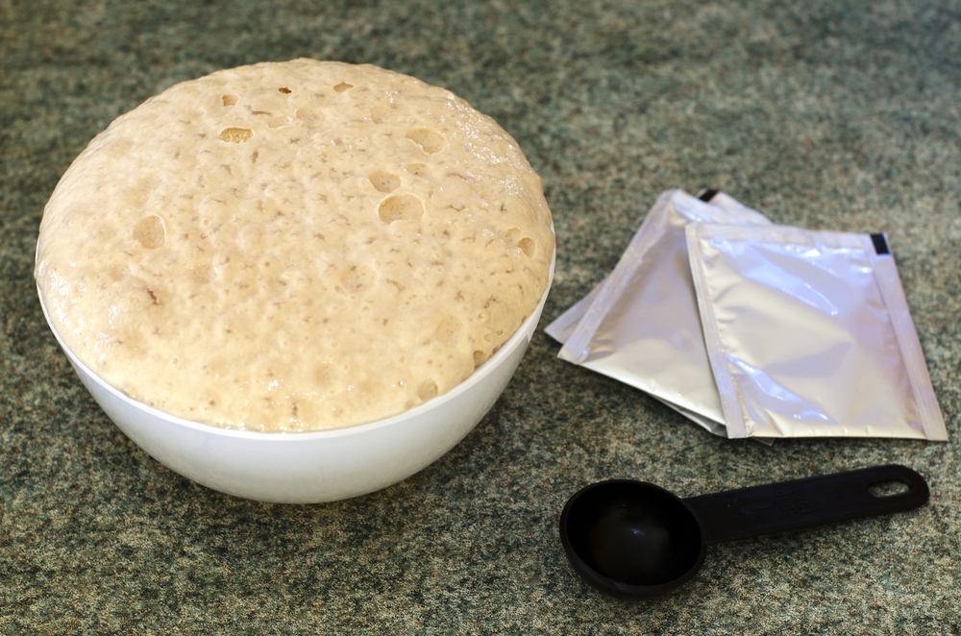

Activity 3: Yeast experiment
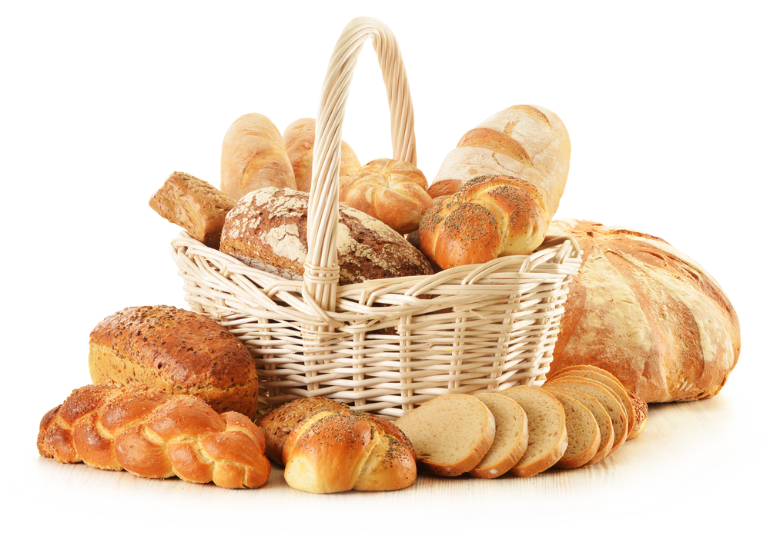
Learning objective
Explore the physical changes which occur when yeast is activated. Identify the key terms in the bread making process.
Remember to relate what is happening in these experiments to the bread making process and how yeast is used as a raising agent. Refer to the keywords in task 2.

Equipment list
Fast action yeast sachets, sugar, water (warm, hot and cold), clear plastic bottles/test tube, balloons.
Basic method
- Add one packet of yeast (7g) and 1 tsp (5g) of sugar into 100ml of warm water.
- Place this fluid mix into a clear plastic bottle/test tube.
- Stretch the balloon over the neck of the bottle/test tube.
- Leave the bottles/ test tubes for a controlled period of time.
List two possible variables which would show the conditions needed for yeast to be activated:

1.

2.
Complete these control experiments alongside your basic method.
What’s going on?
Write a conclusion to your experiment stating the key stages during the bread making process. Tip: diagrams can be a useful tool to help you explain the process.

Outcomes (with reference to the bread making process)

Activity 4: Colloid foam experiment
Learning objective
To study foams and investigate what affects their formation and stability.
Recording sheet
 | Liquid in glass (ml) | Time to form peaks (secs)
Cream of tartar
Without cream of tartar

Procedure
- You will need to record the exact time you begin to beat each egg white. Record the time the time in the table provided.
- In a mixing bowl, beat one egg white with the electric mixer until stiff peaks form when the beaters are lifted out of the egg white. Record the time this took. Keep this egg white for comparison.
- Beat the second egg white in the remaining bowl until it is foamy. Add the cream of tartar and immediately start beating again at the same speed until stiff peaks form. Record the total beating time.
- Pour off the accumulated liquid in the initial batches and measure the liquid in the measuring jug. Record the amount.
Student mini plenary
- Which took longer to beat: the egg white with cream of tartar or the egg white without cream of tartar?
- Which egg white lost LESS liquid after one hour?
- What can you conclude about how cream of tartar affects egg whites when beaten?
- Why would you want egg whites to be stable after beating?

Activity 5: End of unit quiz - Think about it!
List one of the following questions on a piece of paper/card. Write the correct answer below.
Stretch activity: High level students can write their own questions relating to raising agents.
Example:
Question: Name two natural raising agents.*
Answer(s)
- Air
- Steam
- Carbon dioxide
* There could be more than one possible answer.

- Name two mechanical raising agents.

- How can you set a foam?

- What are the three conditions that yeast needs to ferment?

- Give a reason why a cake may not rise.

- What could be a disadvantage of using bicarbonate of soda as a raising agent?

Tip: Use your notes to help you answer your selected question.
How many questions did you answer correctly?

