Topic Exploration Pack

Fetal Development Measurements and Techniques

Instructions and answers for teachers 2
Learning outcome 3
Introduction 3
Suggested activities 4
Activity 1 4
Activity 2 5
Activity 3 9
Activity 4 11
Activity 5 13
Additional teacher preparation 15
Learner Activity 16
Learner activity 1 - Fetal Monitoring Chart 16
Learner activity 2 19
Part a. Using Ultrasound to Determine Gestational age 19
Part b. The Fruit-Baby Practical 20
Questions 22
Learner activity 3 25
Part a - Biparietal Diameter and Measuring Growth in Balloon-Babies 25
Questions 26
Part b - The Balloon-Baby Practical 27

Bi-pariental Diameter (mm) 29
Learner activity 4 - Exploring the Intergrowth-21st project 30
Questions 30
Learner activity 5 – Evaluating the Advantages and Disadvantages of Antenatal Monitoring Techniques 33

Instructions and answers for teachers

These instructions cover the student activity section which can be found on page 16. This Topic Exploration Pack supports OCR A Level Biology B (Advancing Biology).
When distributing the activity section to the students either as a printed copy or as a Word file you will need to remove the teacher instructions section.

Learning outcome
This topic exploration pack covers the AS and A Level Biology B (Advancing Biology) Learning Outcomes 3.1.2(g) and (h):
3.1.2(g)(i) the use of ultrasound for measuring fetal growth  (ii) the analysis of secondary data from fetal growth  charts | To include the measurement of biparietal diameter of the cranium, crown-rump length of the back.  M0.1, M0.3, M1.3, M1.4, M1.6
3.1.2(h) the advantages and disadvantages of techniques  for assessing fetal development and detecting  disorders. | To include fetal ultrasonography, amniocentesis and chorionic villus sampling.

Introduction
This pack explores three antenatal care interventions used to monitor fetal growth, health and development. These are ultrasound scanning, amniocentesis and chorionic villus sampling.
Fetal development is presented in the specification in the context of section 3.1.2, the developing individual, which begins with the production of unique gametes by meiosis. Section 3.1.1 the developing cell, is essential background knowledge and its three main concepts can be reinforced when teaching 3.1.2 with examples relevant to fetal development. These include:
- mitotic cell division to increase the number of cells from one in the zygote to approximately 1 x 10¹² in the newborn baby
- differentiation of the inner cells of the blastocyst into the discrete tissues and organs of the embryo
- apoptosis to remove webs of skin between fingers and toes.
Additional background required is a working knowledge of the structure of different eukaryotic cells from section 2.1.1, and the roles of nucleic acids (DNA and RNA in protein synthesis, DNA replication to maintain genetic integrity in daughter cells) from 2.1.4. It is assumed learners will study 3.1.2 (a) to (f) before proceeding to (g) and (h), so will have knowledge of the antenatal care programme in the UK and of the impact of environmental effects such as maternal diet and smoking on the expression of the fetal genotype, and therefore the phenotype and long-term health of the about-to-be-born child. Later sections of the specification are likely to be briefly introduced while teaching 3.1.2 (g) and (h), notably fertilisation (4.2.1) and gene and chromosome mutations and the role of a genetic counsellor (5.1.1).
This topic is of general interest to most learners. The physics of ultrasound scanning and the mathematical skills needed for analysing fetal measurement data are areas where some learners may need extra support.

Suggested activities
This topic provides opportunities for learners to:
- improve their mathematical skills (interpreting graphs and tables of data organised into percentiles)
- consider some morally sensitive issues (prenatal diagnosis with the option of abortion of disabled fetuses, poverty and inequality affecting perinatal mortality in the developing world).
It should be noted that this topic has emotional loading for all learners as they are likely to reflect on their own development before birth and their own family situation (possibly there may be a learner who was an IVF baby, who developed in a surrogate mother or who is adopted or does not know their mother). They may also reflect on having children of their own in the future. Professional judgement is required to steer a course that focuses on medical terminology and data while also acknowledging and respecting diverse personal emotional responses to the topic of pregnancy, motherhood and babies.
Resources for five learner activities are provided to cover the learning outcomes. Each has an accompanying learner worksheet containing instructions for carrying out the activity and associated written tasks or follow-up work, plus a separate teacher answer sheet. Useful weblinks are given within the learner and teacher guides.

Activity 1
In activity 1 learners add labels and annotations to a colour print-out of a pregnancy timeline diagram. This introduces them to the three antenatal monitoring and testing methods and builds an understanding of the counting of pregnancy (gestational age) not from the time of fertilisation but from the last menstrual period. The activity can be done as a self-contained activity or alternatively in a more extended fashion with learners using the weblinks provided to pursue their own research. Activity 1 provides a background for going on to activities 2 and 3. The sheet could be used for whole-class teaching on a screen rather than as an individual learner task to save time.
Running the activity
Each learner needs a print out of the pregnancy timeline diagram.
For more rapid or class use learners can annotate the diagram with information from the worksheet. For a homework activity they can be encouraged to also research the weblinks provided to gain more information, particularly about combination screening for genetic abnormality by use of the first ultrasound scan together with maternal blood testing.

Activity 2
Activity 2 can either be used just as a worksheet for written analysis of the standard graph showing the relationship between crown-rump length and gestational age, or as part of a more hands-on practical where different fruits are used as models of in utero babies. If done as the ‘fruit-babies’ class practical, the questions could be tackled together in class discussion or set as homework. Photographs of the finished ‘fruit-babies’ line-up would provide a novel visual insight into Biology A Level work for departmental or school publications.
Running the activity
Part a and the questions can potentially be used alone to shorten this to a written comprehension and data analysis exercise for class work or homework.
To include the practical fruit-baby activity, learners will need a selection of pieces of fruit ranging in size from 5 mm (representing a fetus with gestational age of 6 weeks) to around 120 mm (fetus at 16 weeks). Suggestions are given on the table below.
fruit-baby name | crown-rump length ( mm) | gestational age (weeks) | fetal age (weeks)
blackcurrant
blueberry
grape
strawberry
apricot
plum
tangerine
kiwi fruit
lemon
peach
apple
orange
mango

Other equipment per pair of learners:
- measuring callipers
- ruler with a millimetre scale
- cocktail sticks
- scissors (to cut cocktail sticks)
- selection of small food items to skewer onto the fruits with the cocktail sticks, e.g. raisins, dried cranberries, dolly mixtures, jelly tots, small sweets that are shaped like lips, eyes or limbs or that can be easily cut (marshmallows, foam shrimps, strawberry liquorice bootlaces)
- large pieces of paper, e.g. flipchart size
- marker pens
- optional: stick-on googly eyes (available from craft suppliers, Amazon and some large supermarkets)
If time is short this can be run as a class activity with each pair of learners measuring and customising one fruit-baby of a range of 8 to 10. The whole class can then put the display together. Alternatively pairs could complete a range of 6 to 8 fruits of different sizes themselves, or could link up with other pairs in a team to cover the full size range (e.g. three sets of pairs responsible for three fruits each.) The ideal is probably to have two or more groups competing to produce the best (and most amusing) fruit-baby display. Funny fruit-babies can be made using stick-on ‘googly’ eyes from craft suppliers.
The questions about the graph on page 1 can form a written exercise or the questions and answers could be gone through in class as a discussion session with learners writing notes on the worksheet after doing the fruit-baby activity.
Health and safety – learners should be warned to take care carrying and using scissors and cocktail sticks. Discretion should be exercised as to whether sufficiently hygienic conditions can be provided to allow learners to eat their fruit-babies after the practical.
The fruit-baby line-up could provide a striking image for departmental or school notice-boards, websites or publications.
Answers to Questions
- State the median crown-rump length and the range of crown-rump lengths for a fetus at 10 weeks gestational age.
median = 32 mm range = 22 – 42 mm

- State the gestational age range of a fetus with a crown-rump length of 70 mm.
gestational age range = 12 weeks – 14 weeks 2 days

- An ultrasound scan on 1st January shows a fetus with a crown-rump length of 15 mm. Predict the due date if the pregnancy is normal and lasts for exactly 40 weeks.
15 mm = 8 weeks gestational age on January 1st. Due date of 40 weeks = 12th August.

- A pregnant woman recalls the date of onset of her last period as 3rd March. Her fetus’ crown-rump length is measured on May 5th as 40 mm. Calculate the gestational age using the last menstrual period data and again using the graph and suggest an explanation for the difference in the two figures obtained.
3rd March date suggests fetus gestational age on 5th May = 9 weeks. Fetus’ crown-rump length of 40mm on 5th May suggests gestational age = 10-12 weeks (mean around 11 weeks). The explanation for the discrepancy could be that the woman made an error remembering the date of her last menstrual period, or that there was some vaginal bleeding early in the pregnancy (this occurs in a significant minority of pregnancies).

- Explain why the x axis of the graph does not start at 0 weeks.
The fetus does not exist at 0 weeks. Fertilisation to create the zygote occurs two weeks after the start of the last menstrual period.

- Use the graph to suggest why the crown-rump length measurement determines gestational age more accurately if an ultrasound scan occurs 4 weeks after the last missed period compared to 8 weeks afterwards.
The grey shaded area is narrower for the early data, i.e. there is less variability in crown-rump length when fetuses are younger. As time goes on different factors, including environmental effects like maternal nutrition and smoking, cause more variation to arise in the size of fetuses of different mothers.

- The figures for gestational ages less than 9 weeks have been extrapolated from real collected data using the assumption that the crown-rump length at 2 weeks is 0 mm. Explain why this is justified.
At 2 weeks gestational age the fetus is in fact a one-celled zygote measuring
0.1 mm, which on the scale of the graph can be taken as 0 mm.

- Explain why it is important to determine gestational age accurately.
Gestational age is used to plan scans for the appropriate time, and to prepare for the birth of the baby. Gestational age determined accurately by the first scan is used to inform the second ultrasound scan to check that the baby is growing at a normal rate.

- Suggest an explanation for the shape of the curve showing the effect of gestational age on crown-rump length.
The shape of the graph is exponential. Crown-rump length increases slowly at first as growth is based on mitotic cell division. The initial zygote cell dividing into two cells which each divide into two and so on means that a pattern of geometric growth is seen (2 → 4 → 8 → 16 etc). Therefore, similar to population growth in a microorganism, there is a lag phase as the cell number builds up initially, followed by a log phase as each doubling in cell number becomes more and more significant.

Activity 3
Activity 3 centres around a graph of the relationship between biparietal diameter of the fetal head and gestational age and also makes use of the same set of data in table format. Learners work in pairs to model fetal growth by blowing up balloons and mimicking the idea of regular ultrasound scans to track fetal growth by measuring the heads of their ‘balloon-babies’ using callipers and a ruler. Learners can evaluate whether their balloon-baby grew normally by identifying the percentile its biparietal diameter falls into at each scan. A weblink to a resource to allow the final birthweight of the balloon-baby to be predicted is given for display on a screen in class, for printing or for access by learners on laptops or tablets. The graph and questions could be used without the practical activity to provide a written comprehension exercise only if time is short.
Part a and the questions can be used alone without proceeding to the balloon practical if desired.
Running the balloon practical activity
Learners work in pairs and ideally swap roles, so that both boys and girls get to act as the mother-to-be and the medical professional who measures the balloon-baby’s head.
Provide each learner with an uninflated balloon. These should be the long tube-shaped or wavy tube-shaped balloons where the final inflated diameter at the top will be around 10 cm. Note that round balloons are likely to grow too big to accurately model the baby’s head. Each pair also needs callipers, a ruler and a marker pen.
Depending on the size and shape of the balloon, you might need to adjust the instructions as to how many breaths the mother-to-be adds to the balloon in each time interval representing four weeks of gestation. The learner guidelines state four breaths for the four week interval. Learners can be told whether these should be small, normal or forced breaths after trialling blowing up a balloon of the size and shape you have available. The final distance of the top from side to side should be around 100 mm, which is the size of a baby’s head at birth.
Pairs can be left to work independently or the whole class can be kept together and work at the same pace if the teacher or a learner calls instructions as to when to blow the balloon-babies up and when to measure them for their 24, 28, 32 and 36 week scans.
Health and safety: A latex allergy can be a serious health problem and a learner with a known hypersensitivity to rubber proteins should not handle balloons. Using sharp callipers to measure the diameter of balloons is likely to result in a few popped balloons. Nervous learners should be warned of the likelihood of sudden loud noises and arrangements made for those who would rather observe at a distance. The noise of a balloon popping could be particularly distressing for learners with experience of bomb blasts or war zones. Learners should be strongly discouraged from deliberately popping balloons close to another learner’s ear.
Answers to Questions
- Use the graph to determine the range of biparietal diameter measurements likely to be encountered by ultrasonographers at the mid-pregnancy scan at 18-21 weeks.
35 – 57 mm.

- A first scan has shown that the gestational age of a fetus is now 21 weeks. A second scan is carried out and the biparietal diameter of the fetus is measured as 47.5 mm. Use the graph or the table of data here to find out if this a concern. Discuss the possible causes of this situation and suggest what action should be taken in the care of this woman and her fetus.
The graph shows that this figure is near the lowest boundary of the normal range. The table of data shows more precisely that the figure is within the 5th percentile, in other words, it falls in the lowest 5% of the normal range of fetuses of this age. The baby’s head is small so the baby’s growth is slow. Possible causes of slow growth include poor maternal nutrition and maternal smoking. The clinician could find out if these risk factors exist. Results of risk assessment for genetic conditions should also be considered, and the results of any amniocentesis or chorionic villus tests. Action initially might be to invite the woman for an extra scan at 25 weeks and every four weeks thereafter to monitor this fetus’s growth. If the growth curve is maintained on the same or a higher centile this is a positive sign, but if there is a progressive drop from one centile to a lower one there is a problem. More information on fetal growth restriction for class discussion can be found here, from the Ottawa Hospital website.

Balloon-baby evaluation
Encourage class discussion, perhaps followed by a written summary of what learners learnt from the activity. If learners blow equally hard into the balloon each time growth may appear arithmetic (straight line plot) rather than geometric but this may depend on the shape of the balloon. Learners could be encouraged to blow softly for the first ‘scan’ and then progressively harder each time to get a more realistic exponential growth curve. The most important thing however is that the modelling activity stimulates discussion and gets the learners to look at the growth chart data more carefully and to make active use of the graph on this worksheet and the table of data from the Intergrowth-21st website. Male learners on average will have larger lung volumes and forced expiratory flow rates so will produce bigger balloon-babies.

Activity 4
Activity 4 is a stretch and challenge activity for more able and ambitious classes that explores the website of the Intergrowth-21st project. A collaboration of 300 health care professionals collated standardised data from 60 000 healthy pregnancies in 8 countries across the globe to produce the new international growth standard data used in activities 2 and 3. This activity gives learners an insight into the scale of major health initiatives in the 21st century and the precision of high standard study protocols. It also raises issues of global health inequality and efforts to tackle this.
This worksheet encourages able and ambitious learners to find out how the data they have used in activities 2 and 3 has been collected. It gives them insights into the scale of international research collaborations and also the socio-economic factors globally that affect perinatal mortality, birthweight and long-term health.
Answers to questions
- How many researchers and health care professionals are working together to produce the new globally validated growth data standards?
300

Use the publications link to find out about the study protocol for questions 2, 3 and 4.
- In how many countries has data for the project been collected?
8

- List some of the criteria that pregnant women must meet to be admitted to the study and explain why these criteria are important.
Women in the study must be between 18 and 35 years of age, non-smokers, with a normal body mass index and expecting single babies. The full list of criteria is on page 20 of the 76 page study protocol document which can be accessed directly via this link: http://www.medscinet.net/Intergrowth/patientinfodocs/Intergrowth%20Protocol%20Sept%202009.pdf It would be valuable for classes containing many aspiring medics for the teacher to browse through some of this document on the whiteboard to point out the huge scale of the study and the level of professional planning and standardised methodology involved in collecting international standard data.

- Explain why it is desirable to replace growth standards from separate countries with an international standard.
Data in some countries is old, or unreliable. One hundred different sets of data are used in different countries. It was previously thought that low birth weights in some countries were partly caused by ethnicity but the new standardised data shows the ideal growth curve of healthy babies of every race is the same. Page 11 of the protocol document gives more information on how this study provides a benchmark to identify intrauterine growth restriction due to poor diet or other factors, and of the importance of tackling this issue to improve the lifelong health of people.

Go to the ‘download Intergrowth-21st tools and standards’ for questions 5 and 6.
- What measure does the Intergrowth-21st study use for pregnancy dating?
Crown-rump length.

- What measures does the Intergrowth-21st study use for assessing fetal growth?
Abdominal circumference, biparietal diameter, femur length, head circumference, occipito-frontal diameter.

- Summarise the goals of the Intergrowth-21st project using the ‘About Us’ webpage.
Improving perinatal health globally, reducing preventable newborn deaths, providing international fetal and neonatal growth standards to improve maternal and newborn care. There is a 4 minute video available on this page.

- Browse the list of published articles about the project under the ‘Media’ tab and outline the most publicised result of the project so far.
The health of the mother is the key factor in determining baby size. Well-educated and adequately nourished mothers produce full-term babies of healthy weight. Disparity in baby size is primarily caused by inequalities in maternal education, wealth, nutrition and general health. The research team want to use this study as an impetus to improve these things so that all babies worldwide start life with a chance of good health.

Activity 5
Activity 5 concludes with learners reviewing the risks and benefits of the three different antenatal monitoring techniques, ultrasound scanning, amniocentesis and chorionic villus sampling. Weblinks and resources including video animations are provided on the teacher guide.
Videos and PowerPoints can be shown and learners can make written notes to supplement their own research. Suitable resources are:
http://www.webmd.com/baby/video/amniocentesis (animation, 2 minutes 50 seconds)
http://www.nhs.uk/conditions/pregnancy-and-baby/pages/ultrasound-anomaly-baby-scans-pregnant.aspx
(1 minute 28 seconds)
http://www.powershow.com/view/3c30ab-NmMwO/Amniocentesis_and_CVS_powerpoint_ppt_presentation (Slides 1 – 22 useful for quantified risks for procedures. However there is a consistent typo of ‘70th’ ‘80th’, etc, instead of ‘70s’ and ‘80s’ to refer to times when techniques were introduced. Other PowerPoints are available online but often contain too much medical detail or pictures of disabled babies that may cause distress to sensitive learners so review with care before using.)
Sample answers for the learner table are provided here but the summary is not exhaustive. Only 5% of pregnant women are offered further invasive tests if problems are flagged up at the first ultrasound and blood testing stage. The main advantage of CVS is that it can be done earlier, so if abortion of the fetus is chosen, the fetus will be smaller and an earlier abortion is safer and less stressful. However the risk of damage to the fetus, which may be perfectly healthy, is higher.
In teaching this topic sensitivity to the differing religious and moral beliefs of learners should be shown. They should realise that the advantages of early knowledge of fetal abnormality is either opting to terminate the pregnancy or to prepare through education and contact with relevant support groups for the birth of a disabled child.

Technique | Advantages | Disadvantages
ultrasound scanning | - allows gestational age to be determined  - allows fetal growth monitoring  - can indicate risks of Down’s syndrome and neural tube defects e.g. spina bifida  - can be used with maternal blood test for integrated risk assessment  - safe  - non-invasive  - quick (15 minute appointment)  - real-time imaging  - cost-effective  - popular with mothers-to-be  - can get printed image of fetus  - timing from pregnancy week 12 | - not diagnostic for genetic disorders  - 5% of fetuses need further tests
amniocentesis | - allows prenatal diagnosis of:  - chromosome mutations,  - specific gene mutations  - infectious diseases  from pregnancy week 15 | - invasive therefore risk of infection, pain to mother and damage to fetus  - 1% risk of miscarriage  - results take 2-3 weeks  - possible needle injury to fetus  - possible loss of amniotic fluid  - increases mother-to-baby transmission of HIV  - option of termination if abnormality detected is a stressful decision
chorionic villus sampling | - allows prenatal diagnosis of:  - chromosome mutations,  - specific gene mutations  - infectious diseases  from pregnancy week 11 | - invasive therefore risk of infection, pain to mother and damage to fetus  - >1% risk of miscarriage  - results may be quicker than amniocentesis  - possible needle injury to fetus  - possible loss of amniotic fluid  - option of termination if abnormality detected is a stressful decision

Additional teacher preparation
Learners may want details of how ultrasound imaging works. This webpage provides details, http://www.physics.utoronto.ca/~jharlow/teaching/phy138_0708/lec04/ultrasoundx.htm
as does this 1.42 minute video introduction: http://physicsworld.com/cws/article/multimedia/2014/oct/28/how-does-medical-ultrasound-imaging-work
For a clear explanation of the statistical terms median and percentiles (used in activities 2 and 3) see: http://www.statisticshowto.com/percentiles/
A gallery of pictures of foetuses for use in class teaching about ultrasound scanning is available here: http://www.ob-ultrasound.net/frames.htm
New international standards for ultrasound measurements have been established in an Oxford University study of 60 000 pregnancies in 8 countries across the globe. This study provided the data for learner activities 2 and 3, and is looked at in more detail in activity 4. The home website of the Intergrowth 21 study gives additional resources here: https://intergrowth21.tghn.org/

We’d like to know your view on the resources we produce. By clicking on ‘Like’ or ‘Dislike’ you can help us to ensure that our resources work for you. When the email template pops up please add additional comments if you wish and then just click ‘Send’. Thank you.
If you do not currently offer this OCR qualification but would like to do so, please complete the Expression of Interest Form which can be found here: www.ocr.org.uk/expression-of-interest
OCR Resources: the small print
OCR’s resources are provided to support the teaching of OCR specifications, but in no way constitute an endorsed teaching method that is required by the Board, and the decision to use them lies with the individual teacher. Whilst every effort is made to ensure the accuracy of the content, OCR cannot be held responsible for any errors or omissions within these resources.
© OCR 2016 - This resource may be freely copied and distributed, as long as the OCR logo and this message remain intact and OCR is acknowledged as the originator of this work.
OCR acknowledges the use of the following content: Page 17 Häggström, Mikael. "Medical gallery of Mikael Häggström 2014". Wikiversity Journal of Medicine 1 (2). DOI:10.15347/wjm/2014.008. ISSN 20018762. (Own work) [Public domain], via Wikimedia Commons: Page 19 Adapted from Häggström, Mikael. "Medical gallery of Mikael Häggström 2014". Wikiversity Journal of Medicine 1 (2). DOI:10.15347/wjm/2014.008. ISSN 20018762. (Own work) [Public domain], via Wikimedia Commons: Page 21 Fetal Development, Dragana Gerasimoski/Shutterstock.com: Page 25 Adapted from Häggström, Mikael. "Medical gallery of Mikael Häggström 2014". Wikiversity Journal of Medicine 1 (2). DOI:10.15347/wjm/2014.008. ISSN 20018762. (Own work) [Public domain], via Wikimedia Commons: Page 29 The Lancet, 384:9946, Papageorghiou, A. T., et al., International standards for fetal growth based on serial ultrasound measurements: the Fetal Growth Longitudinal Study of the INTERGROWTH-21st Project, p869–879. Copyright 2014, reproduced with permission from Elsevier. http://www.thelancet.com/: Page 30 Two mothers with children, Karva/Shutterstock.com
Please get in touch if you want to discuss the accessibility of resources we offer to support delivery of our qualifications: resources.feedback@ocr.org.uk

Topic Exploration Pack

Fetal Development Measurements and Techniques

Learner Activity

Learner activity 1 - Fetal Monitoring Chart
Your teacher will provide you with a large colour diagram showing a timeline of pregnancy.
Three medical interventions are commonly used to monitor the growth, development and health of a baby inside its mother. Your task is to annotate the pregnancy timeline diagram with the times, names and purposes of these screening procedures. Note that the chart starts at week zero two weeks before conception of the baby. The timeline begins with the onset of the mother’s last menstrual period.
Use arrows to label the name of each test at its correct time point on your diagram. You can use the summary information given below to annotate each label with the test’s purpose, or you can use the weblinks provided to find out more detailed information.

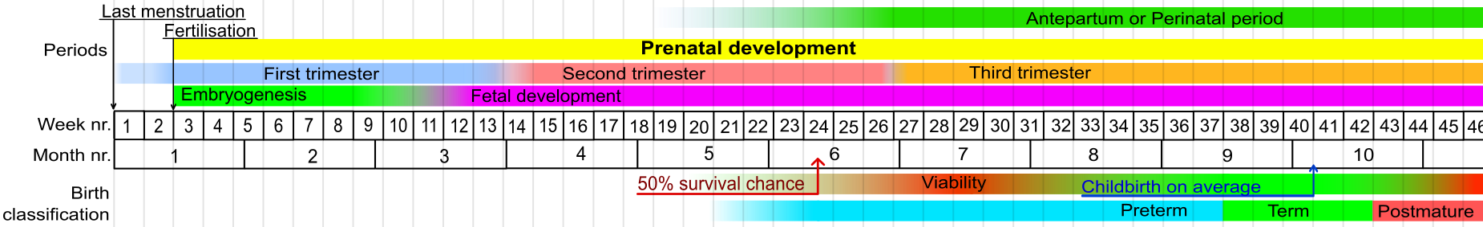

Häggström, Mikael. "Medical gallery of Mikael Häggström 2014". Wikiversity Journal of Medicine 1 (2). DOI:10.15347/wjm/2014.008. ISSN 20018762. (Own work) [Public domain], via Wikimedia Commons

- Transabdominal ultrasound scanning. This method of monitoring the fetus is safe, non-invasive and cost-effective. The programme for scanning in the UK is:
- 8-14 weeks. This is called the dating scan. Crown rump length (CRL) measurements (from the top of the fetus’ head to the base of its buttocks) allow the baby’s gestational age to be calculated. From this the anticipated birth date (due date) can be calculated (see Activity 2 for more details). The earlier this scan is done the more accurate the dating information. This scan will also show whether one or more than one fetus is present.
- 18-21 weeks. This is called the mid-pregnancy scan. At this age the most useful measurement for the sonographer to make is the biparietal diameter (BPD), that is, the diameter between the two sides of the fetus’ head. Comparing the BPD measurement with the fetus’ gestational age shows if the baby is growing normally or not (see activity 3 for more details). Femur length is an alternative measurement that can be used. At this stage the fetus is also assessed for structural abnormalities and for its position in the uterus. Mothers can opt to find out if their baby is a boy or girl.
- Amniocentesis. This test is offered from 15 to 20 weeks only if several lines of evidence show that there is a high risk of the fetus having a genetic disorder. A fine needle is passed through the mother's abdomen into the uterus to collect a sample of amniotic fluid. This contains cells from the baby, which are karyotyped to see if the chromosome number is normal. An extra copy of a chromosome can result in Down's (extra chromosome 21), Edwards' (18) or Patau's (13) syndrome. DNA from the cells can also be analysed to look for specific gene mutations if there is a family history of a certain genetic disorder. The risk of the amniocentesis procedure is that it causes miscarriage (death of the fetus) in 1% of cases.
- Chorionic villus sampling (CVS). This is where some cells from the fetus’ placenta are removed for testing for gene and chromosome mutations. The test can be performed earlier than amniocentesis, from weeks 11-14, but the risk of miscarriage is slightly higher than for amniocentesis (1-2%). This test is also only offered if there is a high risk of a genetic disorder bring present.
Links to websites for more information:
NHS: http://www.nhs.uk/conditions/pregnancy-and-baby/pages/pregnancy-and-baby-care.aspx

Stanford Children’s Health: http://www.stanfordchildrens.org/en/topic/default?id=common-tests-during-pregnancy-85-P01241

Learner activity 2

Part a. Using Ultrasound to Determine Gestational age
The first ultrasound scan in pregnancy takes place somewhere between 8 and 14 weeks. This scan is very important for accurately determining the gestational age of the fetus, that is, the time since the beginning of the woman's last normal menstrual period. This is taken as the onset of pregnancy although it is two weeks longer than the fetal age (how long the fetus has been developing for).
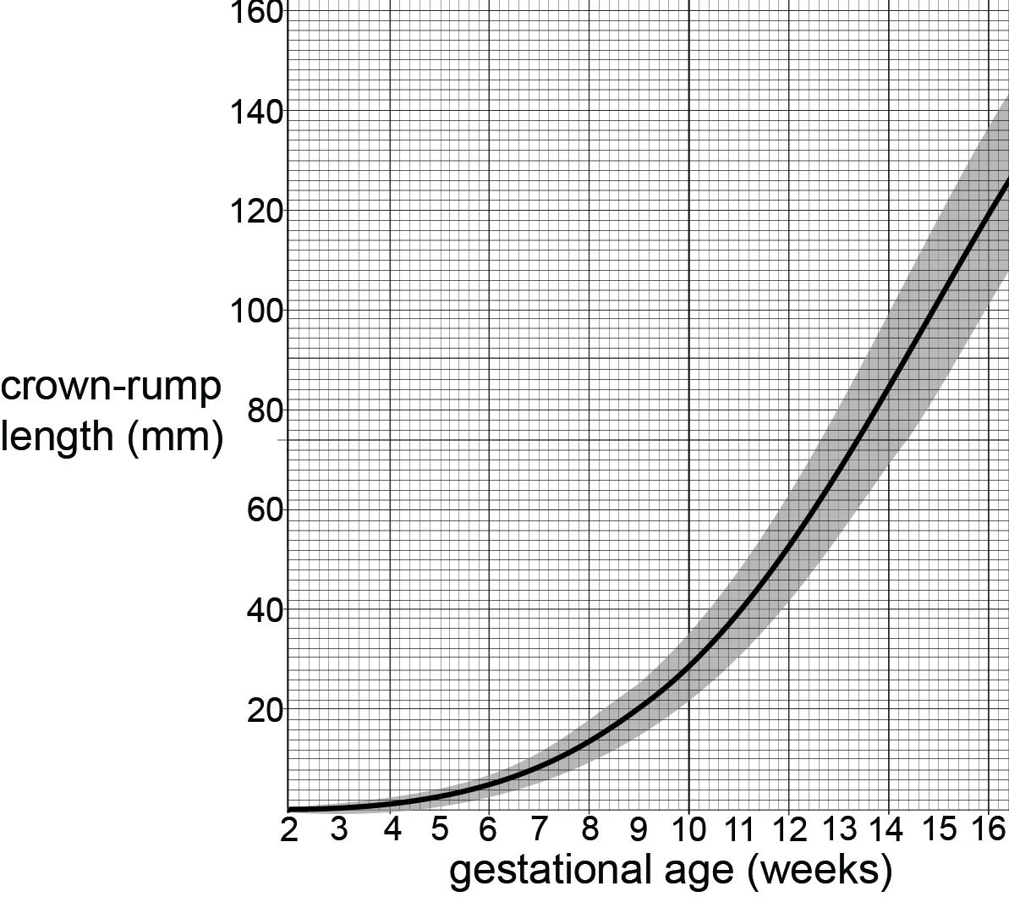
To determine the gestational age a real-time ultrasound image of the fetus is obtained and the crown-rump length (CRL) on the 2D screen is measured in millimetres, from the top of the fetus’ head to the base of its buttocks. The graph shows how crown-rump length changes as a fetus grows.
Black line = median, grey area = range from 3rd to 97th percentiles.

Adapted from Häggström, Mikael. "Medical gallery of Mikael Häggström 2014". Wikiversity Journal of Medicine 1 (2). DOI:10.15347/wjm/2014.008. ISSN 20018762. (Own work) [Public domain], via Wikimedia Commons

Part b. The Fruit-Baby Practical
Your teacher will provide you with a selection of fruit and tell you whether you are working as part of a whole class team or in a smaller group. Each piece of fruit represents an in utero baby. You will work out its fetal age from its size.
Measure each piece of fruit from top to bottom using callipers and a ruler with a millimetre scale. The top-to bottom measurement represents the crown-rump length of a fetus. Look this figure up on the y axis of the graph to find the fruit-baby’s gestational age. Subtract two weeks from this to determine the fruit-baby’s fetal age. You can summarise your findings in this table.
fruit-baby name | crown-rump length (mm) | gestational age (weeks) | fetal age (weeks)

When you know the fetal age of your fruit-babies you can customise them with faces. Limbs can be added to the older, larger fruit-babies. Use small pieces of cocktail stick to stick on dried fruits, small sweets or pieces of cut-up fruit or liquorice for limb buds. The image below shows the relative proportions of limbs and body on fetuses of different fetal ages.
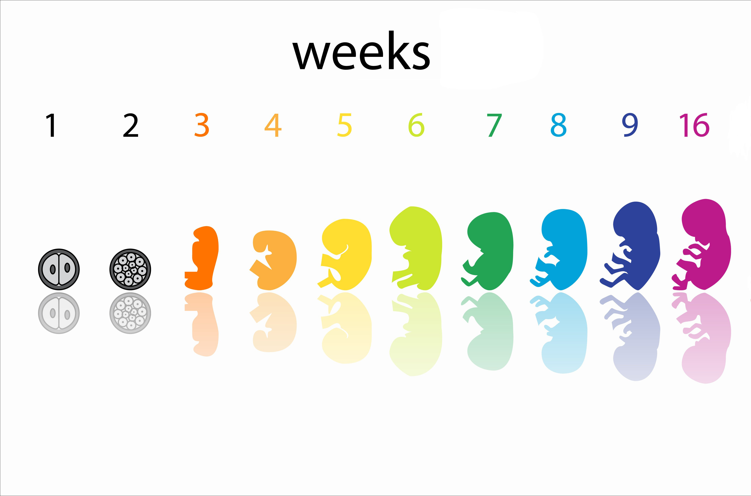
To conclude the activity, line up the finished fruit-babies in size and age order and label them with their ages. The fruit-babies could sit in a row on a large piece of paper with each fruit-baby’s gestational age written in front of it. Alternatively you could copy the graph onto a large piece of paper and line the fruit-babies up along the curve of the median line, so that each sits at the correct intercept of its crown-rump length and age. Photograph your team or class fruit-baby line-up and keep the photo to remember how fetal size changes over the first 16 weeks of pregnancy.

Questions
- State the median crown-rump length and the range of crown-rump lengths for a fetus at 10 weeks gestational age.

- State the gestational age range of a fetus with a crown-rump length of 70 mm.

- An ultrasound scan on 1st January shows a fetus with a crown-rump length of 15 mm. Predict the due date if the pregnancy is normal and lasts for exactly 40 weeks.

- A pregnant woman recalls the date of onset of her last period as 3rd March. Her fetus’ crown-rump length is measured on May 5th as 40 mm. Calculate the gestational age using the last menstrual period data and again using the graph and suggest an explanation for the difference in the two figures obtained.

- Explain why the x axis of the graph does not start at 0 weeks.

- Use the graph to suggest why the crown-rump length measurement determines gestational age more accurately if an ultrasound scan occurs 4 weeks after the last missed period compared to 8 weeks afterwards.

- The figures for gestational ages less than 9 weeks have been extrapolated from real collected data using the assumption that the crown-rump length at 2 weeks is 0 mm. Explain why this is justified.

- Explain why it is important to determine gestational age accurately.

- Suggest an explanation for the shape of the curve showing the effect of gestational age on crown-rump length.

Learner activity 3

Part a - Biparietal Diameter and Measuring Growth in Balloon-Babies

The second ultrasound scan in pregnancy takes place somewhere between 18 and 21 weeks. The gestational age of the fetus has already been determined at the first scan. If the crown-rump length at the second scan suggests a different age (usually a younger age) the predicted due date is not changed but this indicates that the baby is growing more slowly than normal.

To measure the fetus to compare with reference growth data, a real-time ultrasound image of the fetus is obtained and the biparietal diameter on the 2D screen is measured in millimetres, that is, the distance between the two sides of the fetus’ head. The graph shows how biparietal diameter changes as a fetus grows.
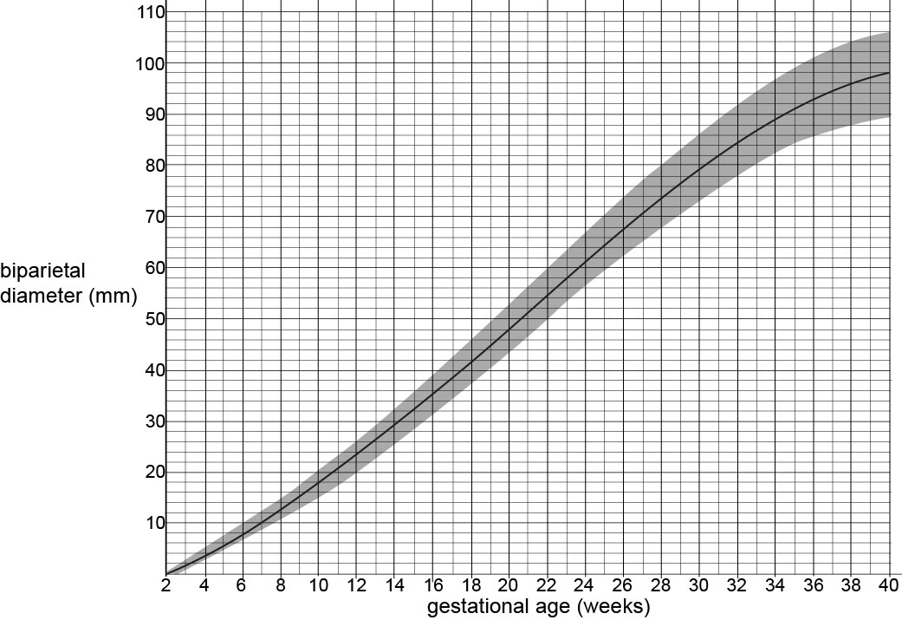

Black line = median, grey area = range from 3rd to 97th percentiles.
Adapted from Häggström, Mikael. "Medical gallery of Mikael Häggström 2014". Wikiversity Journal of Medicine 1 (2). DOI:10.15347/wjm/2014.008. ISSN 20018762. (Own work) [Public domain], via Wikimedia Commons

Questions
- Use the graph to determine the range of biparietal diameter measurements likely to be encountered by ultrasonographers at the mid-pregnancy scan at 18-21 weeks.

- A first scan has shown that the gestational age of a fetus is now 21 weeks. A second scan is carried out and the biparietal diameter of the fetus is measured as 47.5 mm. Use the graph or the table of data here to find out if this a concern. Discuss the possible causes of this situation and suggest what action should be taken in the care of this woman and her fetus.

Part b - The Balloon-Baby Practical
You and your partner play these roles:
- a mother-to-be, responsible for blowing up a balloon in stages to represent the head of the growing baby
- an ultrasound sonographer, responsible for measuring the biparietal diameter of the balloon-baby’s head using callipers and a ruler with a millimetre scale.

Start by drawing a baby face on the top ‘head area’ end of your balloon with a marker pen. Then blow the balloon up till the biparietal diameter of the top of the balloon measures about 50 mm. Hold the neck of the balloon but don’t tie it. Check the graph or data table to see that this starting point can be taken as the head of a fetus at 20 weeks gestational age. Check the beginning of the worksheet to know where you should be measuring in relation to the balloon-baby’s face for the biparietal diameter.
The mother-to-be will blow four breaths of air into the ballon to model four week’s fetal growth. The final balloon diameter should not exceed 100 mm if the activity is to model a human baby.
The sonographer will measure the biparietal diameter of the balloon-baby’s head every four breaths or ‘four weeks’. Record the results in the table provided. Use the Intergrowth-21st table of data to identify which percentile the balloon-baby falls into at each stage of its growth. Then swap roles with your partner and collect a second set of data.
Balloon-baby 1
gestational age (weeks) | biparietal diameter (mm) | percentile
20
24
28
32
36

Balloon-baby 2
gestational age (weeks) | biparietal diameter (mm) | percentile
20
24
28
32
36

Evaluating the health of your balloon-babies
Discuss whether each balloon-baby grew normally by seeing if the percentile changes at each stage or by plotting the data onto the graph on the first page of this activity.
Decide whether your own balloon-baby is a boy or a girl and then predict its final birth weight using these graphs and tables from the health service of Canada http://www.phac-aspc.gc.ca/rhs-ssg/bwga-pnag/pdf/bwga-pnag-poster_e.pdf.

The International Fetal Standards

Bi-pariental Diameter (mm)
Gestational age  (exact weeks) | Centiles
 | 3rd | 5th | 10th | 50th | 90th | 95th | 97th
14 | 26.34 | 26.75 | 27.38 | 29.61 | 31.84 | 32.48 | 32.89
15 | 29.14 | 29.57 | 30.24 | 32.59 | 34.93 | 35.60 | 36.03
16 | 32.03 | 32.49 | 33.19 | 35.65 | 38.11 | 38.81 | 39.26
17 | 34.99 | 35.46 | 36.20 | 38.78 | 41.36 | 42.10 | 42.57
18 | 38.00 | 38.50 | 39.27 | 41.97 | 44.67 | 45.44 | 45.93
19 | 41.05 | 41.57 | 42.37 | 45.19 | 48.01 | 48.82 | 49.34
20 | 44.12 | 44.66 | 45.50 | 48.44 | 51.38 | 52.22 | 52.76
21 | 47.21 | 47.77 | 48.64 | 51.70 | 54.76 | 55.64 | 56.20
22 | 50.29 | 50.87 | 51.78 | 54.96 | 58.13 | 59.04 | 59.62
23 | 53.36 | 53.96 | 54.90 | 58.19 | 61.48 | 62.41 | 63.02
24 | 56.40 | 57.02 | 57.99 | 61.38 | 64.78 | 65.74 | 66.37
25 | 59.39 | 60.03 | 61.03 | 64.52 | 68.02 | 69.02 | 69.66
26 | 62.32 | 62.98 | 64.00 | 67.60 | 71.19 | 72.22 | 72.88
27 | 65.18 | 65.85 | 66.90 | 70.59 | 74.27 | 75.32 | 76.00
28 | 67.94 | 68.63 | 69.71 | 73.48 | 77.25 | 78.33 | 79.02
29 | 70.60 | 71.31 | 72.41 | 76.26 | 80.11 | 81.21 | 81.92
30 | 73.13 | 73.85 | 74.97 | 78.91 | 82.84 | 83.96 | 84.68
31 | 75.52 | 76.26 | 77.40 | 81.41 | 85.42 | 86.56 | 87.30
32 | 77.75 | 78.50 | 79.67 | 83.76 | 87.84 | 89.01 | 89.76
33 | 79.81 | 80.57 | 81.76 | 85.92 | 90.09 | 91.27 | 92.04
34 | 81.66 | 82.44 | 83.65 | 87.90 | 92.15 | 93.36 | 94.14
35 | 83.30 | 84.10 | 85.34 | 89.67 | 94.01 | 95.24 | 96.04
36 | 84.71 | 85.52 | 86.79 | 91.22 | 95.65 | 96.92 | 97.73
37 | 85.85 | 86.69 | 87.99 | 92.53 | 97.08 | 98.37 | 99.21
38 | 86.72 | 87.58 | 88.91 | 93.59 | 98.27 | 99.60 | 100.46
39 | 87.28 | 88.17 | 89.55 | 94.38 | 99.22 | 100.59 | 101.48
40 | 87.52 | 88.44 | 89.87 | 94.89 | 99.91 | 101.34 | 102.26

The Lancet, 384:9946, Papageorghiou, A. T., et al., International standards for fetal growth based on serial ultrasound measurements: the Fetal Growth Longitudinal Study of the INTERGROWTH-21st Project, p869–879. Copyright 2014, reproduced with permission from Elsevier. http://www.thelancet.com/

Learner activity 4 - Exploring the Intergrowth-21st project

Intergrowth-21st is an ambitious project to collect data on fetal growth from around the globe and to create international pregnancy dating and fetal growth standards for use in antenatal care. The aim is to improve maternal and newborn care worldwide.
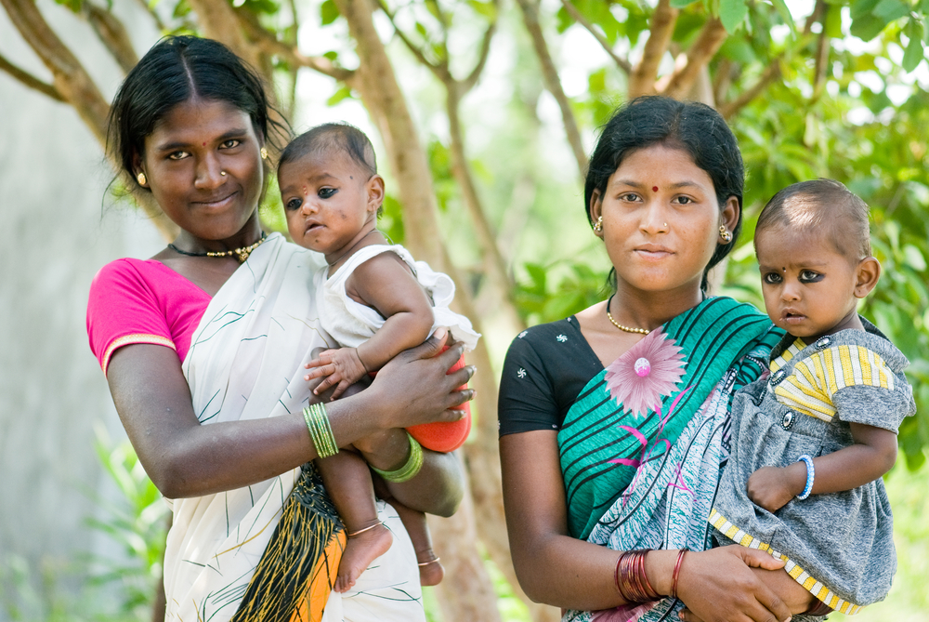

Questions
Access the Intergrowth-21st website at https://intergrowth21.tghn.org/ and browse it to find answers to these questions.

- How many researchers and health care professionals are working together to produce the new globally validated growth data standards?

Use the publications link to find out about the study protocol for questions 2, 3 and 4.
- In how many countries has data for the project been collected?

- List some of the criteria that pregnant women must meet to be admitted to the study and explain why these criteria are important.

- Explain why it is desirable to replace growth standards from separate countries with an international standard.

Go to the ‘download Intergrowth-21st tools and standards’ for questions 5 and 6.
- What measure does the Intergrowth-21st study use for pregnancy dating?

- What measures does the Intergrowth-21st study use for assessing fetal growth?

- Summarise the goals of the Intergrowth-21st project using the ‘About Us’ webpage.

- Browse the list of published articles about the project under the ‘Media’ tab and outline the most publicised result of the project so far.

Learner activity 5 – Evaluating the Advantages and Disadvantages of Antenatal Monitoring Techniques
Collate information on the techniques of ultrasound scanning, amniocentesis and chorionic villus sampling by cutting and pasting to make notes on a Word document. Activity 1 provides some introductory information. Further information is available via these websites:
NHS, UK: http://www.nhs.uk/conditions/pregnancy-and-baby/pages/pregnancy-and-baby-care.aspx
Stanford Children’s Health, USA: http://www.stanfordchildrens.org/en/topic/default?id=common-tests-during-pregnancy-85-P01241
University of Utah, USA: http://library.med.utah.edu/WebPath/TUTORIAL/PRENATAL/PRENATAL.html
Organise your notes into the following table and print it for future reference.
Technique | Advantages | Disadvantages
Ultrasound scanning

Amniocentesis

Chorionic villus sampling

