Lesson Element

Unit 1: Media products and audiences

LO1: Understand the ownership models of media institutions

Ownership structures

Instructions and answers for tutors
These instructions cover the learner activity section which can be found on page 9. This Lesson Element supports Cambridge Technicals Level 3 in Digital Media.
When distributing the activity section to the learners either as a printed copy or as a Word file you will need to remove the tutor instructions section.

The activity
For this unit, learners will need to be able to identify and evaluate how media industries operate based on their ownership. Therefore learners will need to know the difference between the ownership of a conglomerate company compared to an independent company.
NOTE: Learners should not just focus on the conglomerates and independent companies in the media sector that the tutors have assigned, but have an awareness of a range of media sectors and how they work together. Examples from a range of industries should also be used to aid the learning and understanding of learners.
This lesson element supports learners in identifying and evaluating the ownership structures of conglomerates and independent companies in a range of sectors. This is further developed by the learners demonstrating their knowledge by researching an example of a cross media conglomerate and independent company based on the media sector chosen by the tutor and presenting their findings to the class.

Suggested timings
Activity 1: 1 hour
Activity 2: 1 hour
WORK – This activity offers an opportunity for work experience.
ABC – This activity offers an opportunity for English skills development.

Activity 1: Ownership terminology
The tutor could begin by asking the learners what they think a conglomerate is and to provide examples. This could be a group task and or starter task to the lesson. It would be beneficial at this stage for the tutor to mention to the learners that as part of their learning for Unit 1 they will be focussing on one media sector, but will look at others to see how and why they work together.
In order for learners to research an example of a cross media conglomerate compared to an independent company for Activity 2, they need to identify and evaluate key terminology (conglomerate, independent, cross media ownership, commercial, public service broadcaster, joint venture, vertical integration, horizontal integration, synergy, production process) and how ownership structures impact a conglomerate compared to an independent company. Note: This should be a whole class task, working through the questions while the tutor supports and aids learning.
Learners will require:
- Key terminology section with questions as a handout.
- Copies of the images to support understanding of key terms.
- Access to the ‘Inside the BBC’ article either online for learners to read or printed as part of the ‘Key terminology questions’ handout.
Activity 1 requires learners to:
Define key terminology in regards to ownership: cross media ownership, vertical integration, horizontal integration, synergy, production process.
Key terminology questions
- What is a conglomerate? Can you think of any examples?
- What is an independent company? Can you think of any examples?
- How could independent companies be disadvantaged compared to conglomerates in regards to ownership?
- Examples of contemporary cross media conglomerates are shown in the infographic below:
Figure 1: Examples of cross media conglomerates
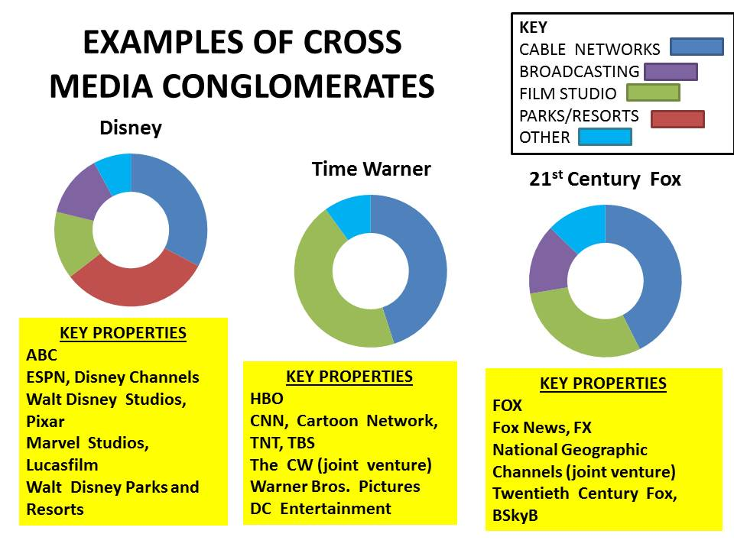
Using the infographic above answer the following:
  - What is a cross media company?
  - What subsidiaries does 21st Century Fox own?
  - How can this type of ownership impact a conglomerate compared to an independent company?
- What is the purpose of a company that is described as commercial?
- The BBC is classed as a public service broadcaster. Using the article ‘Inside the BBC’ (http://www.bbc.co.uk/corporate2/insidethebbc/whoweare/ataglance), answer the following questions:
- What is the purpose of a public service broadcaster?
- What is the mission statement of the BBC?
- How is the BBC funded?
- How does the BBC have cross media ownership?
- What is a joint venture?
- Vertical integration is where a company can control the production, distribution and consumption of its products. Therefore, how can a conglomerate use this integration, compared to an independent company?
- Horizontal integration is where a company uses its subsidiaries to cross promote a brand and/or product across different platforms/subsidiaries. Using Figure 2, what are the opportunities for a company based on horizontal integration?
Figure 2: Horizontal integration of Sony and Skyfall
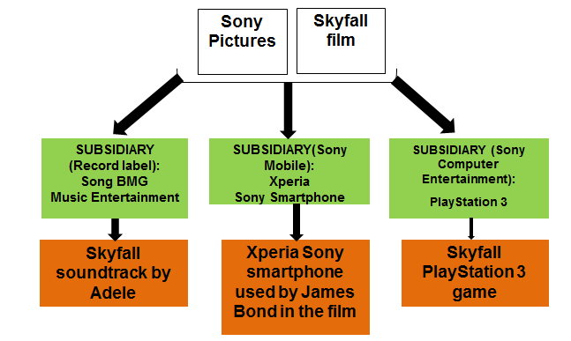
- The effect of horizontal integration is called synergy which means cross promotion. Provide three more examples of synergy you have seen recently of a brand and/or product.
- The production process is when a media product is being made and includes pre-production, production and post-production.
- Define what pre-production, production and post-production mean.
- Using the mind map diagram below, state what would happen in each of the pre-production, production and post-production processes for a video game.
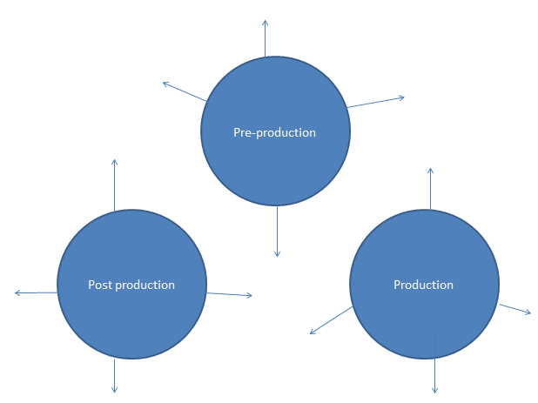
Answers for key terminology task
- What is a conglomerate? Can you think of any examples?
A company that is made up of subsidiaries. Subsidiaries are smaller companies in their own right but still operate under a conglomerate. Examples of conglomerates would include Disney, Comcast, Universal etc.
- What is an independent company? Can you think of any examples?
An independent company is not owned by another company; it operates and makes products by itself. e.g. Warp Films, Sumo Digital etc.
- How could independent companies be disadvantaged compared to conglomerates in regards to ownership?
Because independent companies are not owned by another company and are not integrated like a conglomerate so that they have the use of subsidiaries, they sometimes have to rely on joint ventures with conglomerates to distribute and exchange products. This means that independent companies can only produce products and tend to specialise in what they make. This could be an advantage as they have control over what they produce.

- Examples of contemporary cross media conglomerates are shown in the infographic below:
Using the infographic above answer the following:
  - What is a cross media company?
A company that can produce more than one type of media product.
  - What subsidiaries does 21st Century Fox own?
Fox, Fox News, FX, National Geographic channels, 20th Century Fox, BSkyB.
  - How can this type of ownership impact a conglomerate compared to an independent company?
For a conglomerate it means that it can generate a large revenue from the products the subsidiaries make as part of the conglomerate. The subsidiaries can each create synergy by promoting/marketing each others’ products which will be easy and cheap to do. It also means it is easier to target a mass audience. However an independent company, although it may be able to make two different types of products (e.g. Warp Films and Warp Records), may still need joint ventures to distribute and exchange products to an audience. However web 2.0 is making it easier for independent companies to reach an audience.
- What is the purpose of a company that is described as commercial?
To create a profit using the products that it produces.
- The BBC is classed as a public service broadcaster. Using the article ‘Inside the BBC’ (http://www.bbc.co.uk/corporate2/insidethebbc/whoweare/ataglance), answer the following questions:
    - What is the purpose of a public service broadcaster?
To create content for the public rather than for commercial purposes.
    - What is the mission statement of the BBC?
To enrich people’s lives with programmes that inform, educate and entertain.
    - How is the BBC funded?
The licence fee.
    - How does the BBC have cross media ownership?
TV, radio, magazine.
- What is a joint venture?
This is where separate companies work together to benefit each other. For example, Warp Film and Film4 worked together to produce the film ‘Four Lions.’ This was subsequently advantageous for Film4 as the film was later distributed and exchanged on Film4 and Channel 4.
- Vertical integration is where a company can control the production, distribution and exchange of their products. Therefore, how can a conglomerate use this integration, compared to an independent company?
Conglomerates can use vertical integration to control the production, distribution and sometimes exchange of a product using their subsidiaries. This therefore makes it possible for a conglomerate to utilise this integration. However, because independent companies do not have subsidiaries, they have to rely on joint ventures to distribute and exchange their products and therefore cannot use vertical integration.
- Horizontal integration is where a company uses its subsidiaries to cross promote a brand and or product across different platforms/ subsidiaries. Using Figure 2, what are the opportunities for a company based on horizontal integration?
It can easily cross promote brands and products across different subsidiaries/platforms to generate a larger profit. It also means that it is easier to reach a mass audience.
- The effect of horizontal integration is called synergy which means cross promotion. Provide three more examples of synergy you have seen recently of a brand and/or product.
ITV and The X factor (TV show, app, Twitter, Facebook), The Martian film (TV, radio, magazines, online), Halo 5: Guardians (Xbox, Microsoft Lumia, Microsoft tablet computer).
- The production process is when a media product is being made and includes pre-production, production and post-production.
- Define what pre-production, production and post-production mean.
- Pre-production means planning i.e. storyboard etc.
- Production is the making of a product i.e. filming, recording etc
- Post-production is the editing stage i.e. arranging footage, adding transitions etc.
- Using the mind map diagrams below, state what would happen in each of the above stages for a video game:
- Pre-production: storyboard game play, budget, sourcing voice actors etc.
- Production: recording voices, creating the virtual world etc.
- Post-production: editing audio and visuals etc.

Activity 2: Conglomerates v independent companies
Using the media sector of their choice, learners are to investigate and evaluate the similarities and differences between a conglomerate and independent company from that sector. Tutors may prefer for learners to be in groups and to provide learners with a list of three independent and three conglomerate companies and each group is to pick or be assigned which independent and which conglomerate to investigate. This is so that checking of learning by the tutor can be more effective.
- Televisual (http://www.televisual.com/blog-detail/The-UKs-top-100-TV-production-companies_bid-380.html) has a breakdown of the top 100 independent TV production companies in the UK that may be useful as a starting point for this task.
Learners will require:
- access to the internet
- a handout for this task.
Activity 2 requires learners to:
- Identify a conglomerate and an independent company from the chosen sector.
- Evaluate the similarities and differences in the ownership of the chosen companies.
Learners must find out about the following for each company:
- Evidence that it is an independent company OR evidence that it is a conglomerate company (i.e. what are its subsidiaries? cross media ownership examples?).
- Example of synergy.
- Examples of joint ventures.
Based on their findings learners are to state the similarities and differences between their chosen/assigned companies, using the table shown overleaf.

Similarities | Differences


We’d like to know your view on the resources we produce. By clicking on ‘Like’ or ‘Dislike’ you can help us to ensure that our resources work for you. When the email template pops up please add additional comments if you wish and then just click ‘Send’. Thank you.
If you do not currently offer this OCR qualification but would like to do so, please complete the Expression of Interest Form which can be found here: www.ocr.org.uk/expression-of-interest
OCR Resources: the small print
OCR’s resources are provided to support the teaching of OCR specifications, but in no way constitute an endorsed teaching method that is required by the Board, and the decision to use them lies with the individual teacher. Whilst every effort is made to ensure the accuracy of the content, OCR cannot be held responsible for any errors or omissions within these resources.
© OCR 2016 – This resource may be freely copied and distributed, as long as the OCR logo and this message remain intact and OCR is acknowledged as the originator of this work.
Please get in touch if you want to discuss the accessibility of resources we offer to support delivery of our qualifications: resources.feedback@ocr.org.uk

Lesson Element

Unit 1: Media products and audiences

LO1: Understand the ownership models of media institutions

Learner Activity

Ownership structures
Ownership structures are important in understanding how media industries operate in creating products to target an audience.
Your task is to:
- Identity and evaluate key terminology associated with ownership structures.
- Identify the similarities and differences in the ownership of conglomerates compared to independent companies.

Activity 1: Ownership terminology
In order for you to identify and analyse the difference in the operating structures of a conglomerate compared to an independent company in Activity 2, you need to have an understanding of key terminology in regards to ownership structures. These include: conglomerate, independent, cross media ownership, commercial, public service broadcaster, joint venture, vertical integration, horizontal integration, synergy, production process.
For Activity 1, complete the following key terminology questions:
Key terminology questions
- What is a conglomerate? Can you think of any examples?
- What is an independent company? Can you think of any examples?
- How could independent companies be disadvantaged compared to a conglomerate in regards to ownership?
- Examples of contemporary cross media conglomerates are shown in the infographic below:
Figure 1: Examples of cross media conglomerates
Using the infographic above answer the following:
  - What is a cross media company?
  - What subsidiaries does 21st Century Fox own?
  - How can this type of ownership impact a conglomerate compared to an independent company?
- What is the purpose of a company that is described as commercial?
- The BBC is classed as a public service broadcaster. Using the article ‘Inside the BBC’ (http://www.bbc.co.uk/corporate2/insidethebbc/whoweare/ataglance), answer the following questions:
- What is the purpose of a public service broadcaster?
- What is the mission statement of the BBC?
- How is the BBC funded?
- How does the BBC have cross media ownership?
- What is a joint venture?
- Vertical integration is where a company can control the production, distribution and consumption of its products. Therefore, how can a conglomerate use this integration, compared to an independent company?
- Horizontal integration is where a company uses its subsidiaries to cross promote a brand and/or product across different platforms/subsidiaries.
Using Figure 2, what are the opportunities for a company based on horizontal integration?
Figure 2: Horizontal integration of Sony and Skyfall
- The effect of horizontal integration is called synergy which means cross promotion. Provide three more examples of synergy you have seen recently of a brand and/or product.
- The production process is when a media product is being made and includes pre-production, production and post-production.
- Define what pre-production, production and post-production mean.
- Using the mind map diagram below, state what would happen in each of the pre-production, production and post-production processes for a video game.

Activity 2: Conglomerates v independent companies
Using your learning from Activity 1, you will now research one conglomerate and one independent company based on the media sector provided by your tutor. You will use the space provided below to evidence your research:
Name of chosen independent company:
Name of chosen conglomerate company:
You must find out about the following for each company:
- Evidence that it is an independent company OR evidence that it is a conglomerate company (i.e. what are its subsidiaries? cross media ownership examples?).
- Example of synergy.
- Examples of joint ventures.
Based on your findings state what the similarities and differences are between your chosen/assigned companies.

Similarities | Differences

