Checkpoint Task

Waves in matter

Instructions and answers for teachers

These instructions cover the student activity section which can be found on page 5. This Checkpoint Task should be used in conjunction with the KS3–4 Physics A Transition Guide: Waves in matter, which supports OCR GCSE Twenty First Century Science Physics A.
When distributing the activity section to the students either as a printed copy or as a Word file you will need to remove the teacher instructions section.

Introduction
The checkpoint task requires learners to be familiar and comfortable with manipulating basic equations concerning frequency, wavelength and speed, and asks them to consider the relationships between these quantities and observable phenomena. Activity 1 deals with audible sound waves, and asks learners to calculate the wavelengths of various audible pitches, with results that might surprise them, while Activity 2 compares these with visible light (with connected calculations relating to visual perception) and the extension task assesses the differences between light- and sound-based phenomena and how the scales of the waves affect them. Learners are encouraged throughout to bring in examples of the principles underlying the phenomena being described, and to consider how our ability to measure and experiment on the wave nature of light and sound differ.
In all tasks, there is an emphasis on translating the quantities being manipulated in learned equations into scales that can be understood intuitively, which can help to reinforce the essential connection between physics, even when describing quite abstractly mathematical relationships, and real observable phenomena. For learners who are going on to study the subject at higher levels, there is some encouragement to consider the deeper differences between light and sound in the attached resources, where ideas of diffraction, interference and diffusion are introduced along with the more familiar emission, absorption, reflection and refraction.
Teacher preparation
Learners should have no trouble doing the calculations, as long as they get the orders of magnitude right. The more conceptual parts may bother less advanced or creative individuals, while the difficulty of filling in one or two of the boxes in the extension task may be an issue for those who are used to having a known correct answer to most questions. In most cases, those who are struggling can be given examples, or at least hints for their own research, but care should be taken not to spoon-feed the information, and to try and provoke learners to attempt their own explanations wherever possible.

Activity 1:

Answers
Q1: (a) The wavelength of a note at A0 (27.5 Hz) will, given a speed of 343 m/s, be 12.472 m (to three DP),
(b) The wavelength of a note of C8 (4186 Hz) will be 0.0819 m, or 81.9 mm (to 3DP).
(c) The wavelength of a notes at 20 Hz and 20 KHz would be 17.15 m and 0.01715 m (or 17.15 mm) respectively.
Q2: This is a more open-ended question. The obvious answer is that there’s a big difference between the longest and shortest wavelengths, and learners may also observe that the wavelengths of lower notes are unexpectedly long. Of the many familiar observable phenomena learners might mention, among the more obvious are: bigger musical instruments tend to make lower-pitched noises, small speakers tend to lack bass, smaller animals make higher-pitched noises than larger ones, and so on. Whichever phenomenon the learner chooses to describe, make sure they relate the wavelength of the note directly to the physical properties of the phenomena; in all cases, there is detail to be gone into by learners who wish to do so. Learners should be reminded to use actual numbers wherever possible, for instance in order to relate the wavelength of a frequency concretely to the size of object that is likely to produce it with reference to the way in which the sound is produced.

Activity 2:

Answers
Q1: (a) The frequencies would be 7.5 x 10¹⁴ Hz and 4 x 10¹⁴ Hz for the 400 nm and 750 nm light waves respectively; these could be named 700 and 400 Terahertz if learners are feeling creative, but it is best to encourage the use of powers of ten. The longer wavelengths are towards the red end of the spectrum and the shorter ones toward the blue/violet end, so ‘red’ and ‘purple/violet’ and variations/expansions on that theme are fine.
(b) The frequencies, to three significant figures, are: Red: 5.17 x 10¹⁴ Hz; Green: 5.56 x 10¹⁴ Hz (in fact, the five is recurring); Blue: 6.82 x 10¹⁴ Hz (in this case, the ‘18’ is recurring).
Q2: This question relates the answers to both sets of questions, and is again more qualitative. The answers are fairly obvious; (a) should have something specific about the orders or magnitude of the differences, and/or the different behaviour of matter at the relevant scales. Answers to (b) should also include some mention of the fact that, while the highest perceptible frequencies (and wavelengths) of light are not even twice the magnitude of the lowest, the lowest and highest perceptible sound waves vary by a factor of up to 1000, or three orders of magnitude.

Extension task:
This task asks learners to give examples of the familiar properties of waves for both light and sound. It also introduces diffraction, diffusion and interference. Learners who are not yet familiar with these concepts can be encouraged to research them, and of course questions should be encouraged. The point of the exercise is really Q2, which is designed to provoke ideas about how properties of waves on different scales can affect their observable behaviour, and to encourage learners to think about experiments from the point of view of the people who devise them. If time and resources allow, learners can perform an experiment of their choice from their selection of suggestions and write it up.
Some possible answers to Q1 include:
Phenomenon | Example in light | Example in sound | What difference do the wavelengths/frequencies make to the phenomena?
Emission | Lightbulb; the sun | Person making noise; loudspeaker | Noises are just changes in air pressure; only atoms emit light.
Reflection | Mirror | Echo from a wall or tunnel | Sound reverberates for much longer.
Absorption | Dark object | Insulating foam | Light absorption depends on factors at scales smaller than we can see; sound absorption does not.
Refraction | Lens; pencil in water. | *See below | Very difficult to observe refraction of sound.

Phenomenon | Example in light | Example in sound | What difference do the wavelengths/frequencies make to the phenomena?
Diffusion | The color of the sky and the sun | The echo, or reverb, in large cuildings. | Again, what affects diffusion of light happens on a small scale; what affects sound can be seen macroscopically.
Diffraction | Diffraction gratings; CD | Being able to “hear round corners”. | To see diffraction of light, you need tiny sources; most light sources are many times bigger than the wavelength of the light, whereas many sound sources are of similar wavelength to the sound.
Interference | Young’s two-slit experiment | Acoustic “dead spots” | Again, the scales involved with light waves are so tiny that only very narrow slits allow any effect to be observed on a macroscopic scale.

*Refraction of sound: learners may be unable to think of examples. This is perfectly reasonable. It is the case that atmospheric conditions can make it possible to show sound travelling at different speeds through regions of different air temperature, but this is difficult to demonstrate measurably.
OCR Resources: the small print
OCR’s resources are provided to support the teaching of OCR specifications, but in no way constitute an endorsed teaching method that is required by the Board, and the decision to use them lies with the individual teacher. Whilst every effort is made to ensure the accuracy of the content, OCR cannot be held responsible for any errors or omissions within these resources.
© OCR 2016 - This resource may be freely copied and distributed, as long as the OCR logo and this message remain intact and OCR is acknowledged as the originator of this work.
OCR acknowledges the use of the following content: n/a
Please get in touch if you want to discuss the accessibility of resources we offer to support delivery of our qualifications: resources.feedback@ocr.org.uk
We’d like to know your view on the resources we produce. By clicking on ‘Like’ or ‘Dislike’ you can help us to ensure that our resources work for you. When the email template pops up please add additional comments if you wish and then just click ‘Send’. Thank you.
If you do not currently offer this OCR qualification but would like to do so, please complete the Expression of Interest Form which can be found here: www.ocr.org.uk/expression-of-interest

Checkpoint Task

Waves in matter

Learner Activity

Introduction
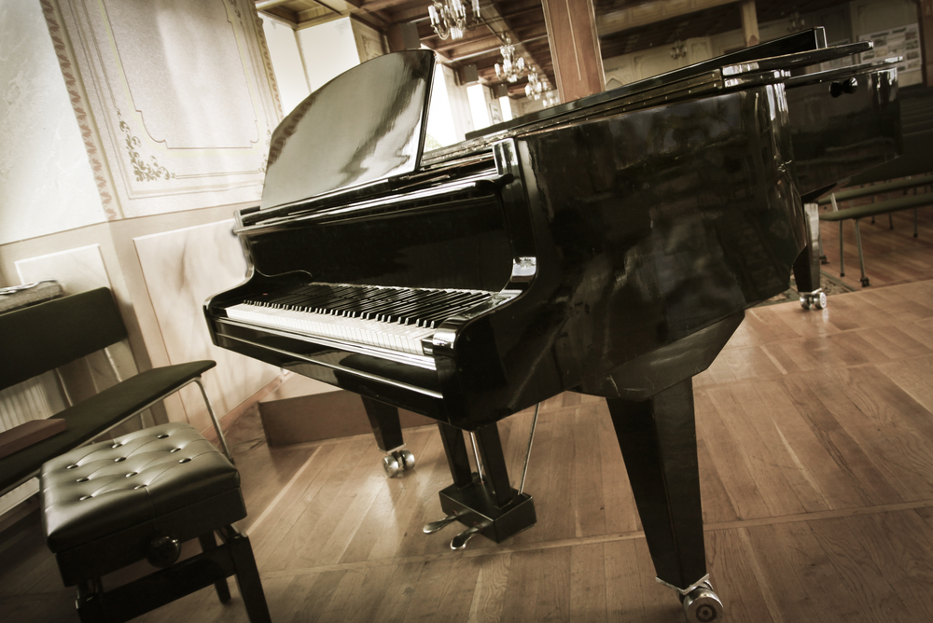
These tasks will give you some information about light and sound waves, and you will be asked to think about how that affects their behaviour.

Activity 1
The speed of sound in air, for the purpose of this task, can be taken as 343 ms⁻¹. The speed of light can be taken as 3.00 x 10⁸ms⁻¹.

Question 1:
(a) The lowest note on a full-sized piano keyboard is known as A0; it has a fundamental frequency of 27.5 Hz. What is the wavelength of a note travelling through air?

(b) The piano’s highest note, C8, has a frequency of 4186 Hz. What is the wavelength?

(c): The highest and lowest pitches humans can hear are around 20 Hz and 20 KHz. Work out the wavelengths of those pitches.

Question 2:
What do you notice about those wavelengths? Name as many familiar phenomena as you can that relate to the differences between the wavelengths of high- and low-pitched sounds.

Activity 2

Question 1:
Human eyes can see wavelengths of light from the about 400 nm (400 x 10⁻⁹ m) to about 750 nm. What are the frequencies of those wavelengths of light, and what colour would each of them be?

Question 2:
- What do you notice about the differences between the wavelengths of light and sound?

- What do you notice about the differences between the shortest and longest perceptible waves of light and sound respectively?

Extension task
Being waves, light and sound can both be emitted, reflected, absorbed and refracted. They can also be diffused and diffracted, and experience interference. What difference do their respective frequencies and wavelengths make to the ways we can observe them and the experiments we can do to test and measure them?

Question 1:
Fill in as many of the boxes in the table below as you can.
Phenomenon | Example in light | Example in sound | What difference do the wavelengths/frequencies make to the phenomena?
Emission
Reflection
Absorption
Refraction
Diffusion
Diffraction
Interference

Question 2:
Take three of the boxes above. For each of them, devise an experiment to demonstrate what you have written in a measurable way, i.e. in a way that allows you to work out any of the properties (frequency, wavelength or speed) of the wave, or the differences between waves with different properties.

