Set Text Guide for students

Group 3 Verse Set Text: Homer, Odyssey 10, lines 144–399

General Introduction

Homer
Homer is one of the most famous and influential authors in the western tradition, but also one of the most problematic. The earliest biographies of Homer were written in the sixth century BC, when he was already famous, but even these do not contain any reliable information about his life. Few facts about the author are undisputed; whilst both the Iliad and the Odyssey are published under his name, there is serious disagreement over whether he was the author of both epics, and even whether each epic individually is the work of a single hand.
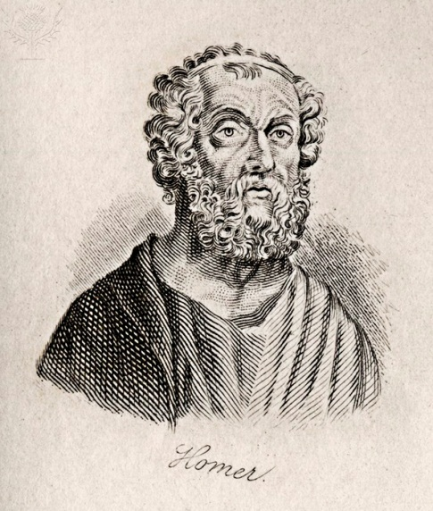
There is a general agreement that the Odyssey was composed somewhat later than the Iliad in eighth or seventh century BC, and that the poet was Ionian. It was composed in an era of orally recited poetry, in a society where the travelling bard was a well-known character. The bard’s tales were drawn from a stock of common themes and characters, based in a mythical past, and possibly preserving some historical echoes of the bronze age of four to five hundred years earlier. Out of this tradition, possibly centuries later, the two poems of the Iliad and the Odyssey became fixed written texts and the foundation of the Greek literary tradition and educational system. Homer's was only poetry thought worthy by Alexander the Great to be taken on campaign, and by the Hellenistic period there were even temples dedicated to Homer – for example, by the Egyptian Hellenistic king Ptolemy Philopator.

Epic
The most obvious defining feature of epic as an ancient genre is it poetic form: all ancient Greek and Roman epic is written in dactylic hexameter, and is notable for its length. The Iliad and the Odyssey consist of twenty-four books each, and, unlike other long works of antiquity (notably historical writing) keep a clear focus on a connected chain of events throughout the whole work – in the case of the Iliad, the wrath of Achilles, and in the Odyssey, Odysseus’ desire to return home. In theme, epic poetry deals with great heroic deeds, taken from larger narratives of Greek heroic mythology. Both the Iliad and the Odyssey assume a familiarity with the characters and plot-lines.
The Iliad and the Odyssey are the only early epics we have; all other epics we possess from the ancient world are to a large degree written in imitation of these Homeric originals. We do know from Aristotle, however, that the two works were seen as remarkable because of the variety of ways with which they presented the stories – including the four books in the Odyssey which are a tale-within-a-tale, told by Odysseus himself, from which our set text is drawn.
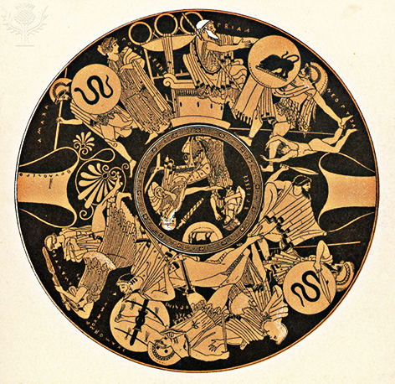
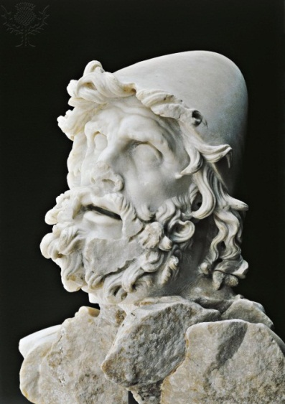
The Odyssey is in some sense a sequel to the Iliad. The earlier work tells of the dissension and strife amongst the Greeks in the tenth year of the Trojan War, as well as their battles with the Trojans, although it does not actually describe Troy’s final defeat. The Iliad sets the stage for the Odyssey, not only because its events form the back-story, but the themes and settings of the Odyssey form a contrast and counterpoint to those of the Iliad. Whereas the Iliad is set in a society at war, the Odyssey deals with peace-time; the Iliad is all heroic saga, whereas the Odyssey has a great deal which comes from sailors’ fables and folk-tale elements.
The Odyssey begins ten years after the fall of Troy and focuses on Odysseus, one of the Greek heroes from the Trojan War, famed for his cunning even more than his prowess in battle, and his journey homewards to Ithaca after the Trojan War. The prologue tells us that although Odysseus longs for home, he has suffered numerous disasters, lost all his companions, and is languishing on the island Ogygia with the nymph Calypso. The first four books are mostly about Odysseus’ son, Telemachus, who was born just as Odysseus was setting off. Now about twenty, he goes off to find news of his father. The situation on Ithaca is unhappy: Penelope, Odysseus’ faithful wife, is surrounded by arrogant suitors who want her to forsake Odysseus and marry one of them – meanwhile they have taken over Odysseus’ house and are living off his wealth.
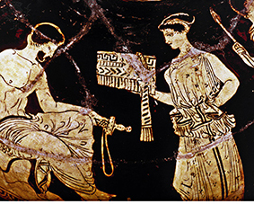
At the same time, Athena, Odysseus’ divine champion, successfully persuades Zeus to allow Odysseus’ return. He is released by Calypso, but Poseidon shipwrecks Odysseus on the island of Scheria, where he is entertained at King Alcinous’ court. While there, he recounts the story of his journey from Troy to Ogygia, which makes up the bulk of the fantastic, weird and wonderful tales of the Odyssey. This section of Odyssey 10, is where Circe’s story fits amongst stories of giants, Cyclopes, Sirens and a descent to the underworld.
The last part of the epic sees the hero’s return home. Initially disguising himself as a beggar on his arrival in Ithaca, he discovers the situation of the arrogant suitors and the plight of the faithful Penelope. Telemachus has returned from his travels and in league with him, Odysseus reveals himself, kills the suitors and is reunited with his wife - at last.

Talking Points
Talking Point | Notes
If the Odyssey were being composed as a film in the modern world, to what genre would it belong?
Sometimes the Homeric epics are referred to as ‘the Bible of the Greeks’. What do you think this might mean? How might they be similar or different to the way the bible is viewed in modern western culture?

Context

The Homeric Question
It was in the Hellenistic period that the first recorded debates about authorship of the Homeric poems occurred – the 'separatists', Xeno and Hellanicus, claimed that the Iliad and the Odyssey were by different poets. Certainly there are differences in both style and content between the two poems, but the question is still undecided. In the nineteenth century, even the notion that the each poem on its own was the work of a single author was disputed due to internal inconsistencies. The so-called ‘analysts’ argued that the poems were the product of stitching together various earlier sources (written and/or oral) by a more or less talented redactor or editor.
In the early twentieth century, the studies of the American scholar Milman Parry into living traditions of oral poetry gave another possible way of explaining the inconsistencies and discrepancies: as results of the process of oral composition. Parry compared the epics to the performances of poetry he had witnessed from illiterate Serbo-Croation singers; they did not have a whole performance memorised, but rather had to hand a store of stories and scenarios around which they could frame their compositions. They also had a treasury of stock phrases and elements which formed lines or half-lines and could be fitted together as circumstance demanded. In Homer, repeated half-lines, epithets, and stock descriptions of dawns, arrivals, departures, and introductions to speeches all show these characteristics.

Folklore and Fairytale
Much of the Odyssey is in a markedly different world to that of the Iliad: instead of fierce battles and brave warriors, we are in the realm of giants, witches, magic and sorcery. These stories seem to have different cultural sources than other epic: the ancient traditions of fairytale, fantastical tales of sailors, and even possibly the rituals of northern shamanistic magic.
The character of Circe has two archetypes as forerunners: the wicked witch, who transforms humans into beasts, and is overcome by the folklore hero; but also the beautiful temptress who seduces men, and then undoes them with magic. The magical and folklore elements, however, are often underplayed: when the sailors go to Circe’s house for the first time, they are met by tame bears and lions; these are possibly from a branch of the story where they are metamorphosed humans, but the Odyssey refrains from labelling them as such. Real magic is only present in the sparse lines in which Circe turns the men into pigs, and then back again. The action is instead transferred from the realm of magic to the heroic register of epic: Odysseus is not the fairytale hero who beats the sorceress with stronger magic, but the resourceful epic hero, and the climax of their conflict is a very heroic leap with a drawn sword.

The Circe Narrative
The story of Circe and Odysseus was clearly part of the epic tradition before the composition of the Odyssey; in Hesiod's Theogony (1011-1014) also written in the 8th-7th century BC, several children are listed as the offspring of Circe and Odysseus. She is the daughter of Helios and the Oceanid Perse, and the sister of Aietes, the father of Medea (see Odyssey 10:135-9, Hesiod Theogony 956-7). Outside of the Odyssey, another story-cycle, the Telegony, recounts the adventures of Telegonus, one of the children of Odysseus and Circe: in this version, Telegonus unknowingly kills his father and marries Penelope, and Circe ends up marrying Telemachus.
Her role within the Odyssey extends beyond her appearance in Book 4; she gives Odysseus advice on how to consult Tiresias in the land of the dead, and on the hero’s return, directs him how to avoid further dangers. Like Tiresias, she functions as a seer (to whom Odysseus compares her at 12.267-8), and as a literary device, her advice foreshadows for the audience the events to come. She also forms a pair with Calypso; both are from outside the human world; both represent a threat or a delay to his nostos; both are exceedingly beautiful and take him as their lover, wishing him to be their husband; and both eventually assist him on his homeward journey. It is only Circe, however, of all the characters in the Odyssey, who is described as possessing Odysseus' own distinctive trait of πολυμηχανία (resourcefulness), suggesting she is his match.

Talking points
Talking Point | Notes
How does an evolving understanding of the sources of the Odyssey and its method of composition change our understanding of it?
Penelope has been lauded as one of the great heroines of ancient literature because she successfully fends off troublesome suitors; Odysseus spends one year with Circe and seven years living with Calypso; how much of a hero is he?

The Text

Books 9-12 of the Odyssey
The prescribed section from Odyssey 10 is part of a cohesive narrative that stretches through books 9-12 of the epic: all form a first-person narration by Odysseus himself of his several years of wandering after the fall of Troy. The epic itself in fact only covers forty days, but the device of Odysseus' own epic-within-an-epic allows for the events of several years to intervene in this relatively restricted timeframe.
The framing for the travel narrative is the court of Alcinous, leader of godlike Phaeacians, who, at the conclusion of his tale, agree to send him back at last to Ithaca. The land of the Phaeacians, Scheria, lies half-way between the discernibly real, human world of Ithaca (the beginning and second half of the Odyssey), and the realm of his travels. His adventures take place in a mythical geography, peopled by fabulous monsters, where the values of Greek civilisation do not exist. The technique of framing these adventures in a first-person narrative, told on neutral territory, allows for these two quite different worlds to form a unity in the overall structure of the Odyssey.
In Book 10 itself, the sailors encounter Aeolus, keeper of the winds; he gives to Odysseus a bag containing the wind necessary for their return home. Odysseus’ men, however, thinking it contains gold, tear it open, causing an overwhelming storm to be unleashed, which blows them back to Aeolus, who refuses to help them further. Disheartened, they manage to row to Laestrygonia, land of giants, who kill and eat yet more of Odysseus’ men. The remainder find their way to Circe’s island, Aeaea, and at this point the set text begins.

Odyssey 10, lines 144–399
The text opens with Odysseus at dawn scaling the heights of a hill, and seeing smoke rising from the midst of dense woods; this will prove to be the dwelling of Circe (as the first-person narrator, Odysseus himself, tells us). However, before exploring further, Odysseus kills a deer on his way back to his companions, and they feast and discuss their plan; the scene is filled with tears and foreboding, as the crew fear the same hostile reception they received at the hands of the Laestrygonians and earlier, the Cyclopes.
Odysseus splits the crew into two parties, and by lot, the other, led by Eurylochus, goes in search of the source of the smoke. They find Circe’s house in a clearing, surrounded by tame lions and wolves. Circe herself is singing and weaving, and invites the men in for refreshment – all except Eurylochus, who senses a trap. Drinking the wine she offers them, the men are drugged, and tapped by her wand, are turned into pigs and herded into Circe’s pigsty. Eurylochus escapes with the news to Odysseus, and advises flight, but Odysseus returns to the scene on his own.
On his way, he is met by Hermes, who gives him advice on how to deal with Circe and arms him with her drugs’ antidote, the plant moly. Odysseus thus to her surprise is not affected by her drugs and instead threatens her with his sword, and resists her seduction; at least until she swears she will not harm him. After mounting her bed, Odysseus manages to obtain the release of his men, and Circe returns them to human form.

Themes and Motifs
Iliadic Parallels
Our section sees some interesting intertextual allusions to the Iliad; some might simply betray the common stock of metrical building-blocks handed down in oral tradition, but others are cleverly worked to give an extra dimension to their context. For instance, at 162-5, Odysseus’ killing of the stag is described in terms used in the Iliad for the death of heroes in battle: 162= Il. 16.346; 163 = Il. 16.469, 164 ≈Il. 6.65. A little later, the decision of how to split the party in two (203-9) is given in terms of decisions on a much grander scale are taken by lot: e.g. 205 ≈ Il. 3.316; 207a ≈ Il. 7.182a. Odysseus preparing himself to go to Circe’s house at 261-2 is given in the style of Iliadic arming scenes.
On a larger scale, Odysseus venturing to the Circe’s house is both in structure and in many details based around Priam’s journey to Achilles in Iliad 24. Both are met by Hermes in the form of a young man (266-9); at 373 onwards, we are reminded of Priam’s refusal to sit down, concerned with the fate of his son’s body (Il. 24.552-3); and Odysseus’ request for his men to be released is given with the same term (λύω), properly used of the release of corpse, as that used by Priam (Il. 24.553-8).
Odysseus and his men
We see in this episode part of a continuing decline in the relationship between Odysseus and his men; already Odysseus has been reduced from leading a fleet to a single ship, and here we see Eurylochus beginning to develop as a character of resistance to Odysseus leadership (see 264 and following, and, after our selection, 428-30). Eventually, of course, Odysseus returns home alone.
Much of the decisive action is undertaken by Odysseus leaving the group and acting on his own, such as the hunting of the deer, and the decisive scene with Circe. The distance between Odysseus and his men is clear here: we see 230 (Circe inviting the men in) repeated at 312 where Odysseus goes in, to highlight the following differences in approach and outcome between Odysseus and his men: remember it is Odysseus speaking and deliberately repeating the same line.

Stylistic Features
Dactylic Hexameter:
Integral to all ancient epic is its poetic form: the dactylic hexameter. The aural effect of the Odyssey is entirely dependent on this metrical form, with its combination of regularity and scope for a great deal of variation. Familiarity with how the hexameter works is not only valuable to get a sense of how the poetry sounded to its ancient audience, but also to pick up on choices and variations made by the poet. For instance, the commentator Stanford picks up on the odd rhythm of 224, with the six feet alternating dactyls and spondees.
Narrative perspective:
The composition of the whole of Book 10, as a story-within-a-story, is a pervasive feature, and the framing of the narrative is subtly introduced at various points; for instance, lines 210-243 are clearly informed by what Odysseus only later learns, and it is filled in here to foreshadow the forthcoming narrative. Interestingly (and showing the complexity of how the different levels of narration function) in line 250, we are presented with Eurylochus’ version of events, in which he assumes his comrades have been killed (ἀιστώθησαν), or at least have vanished forever – although we as an audience already know that his interpretation is incorrect.
Poetic features:
Of course, the most consistently notable features of the text are the commonly recurring devices regularly seen in ancient poetry which make individual lines memorable and striking; A few sparse examples: we see deliberate play with the sound of the line at 221 and following, with both assonance and a general euphony, echoing the beauty of Circe and her song; in line 251-2, the obvious asyndeton gives character to the speech, suggesting Eurylochus’ agitation; and the anaphora in scene where Circe’s attendants prepare for the meal (at 352, 354, 356, 358), gives a leisurely, drawn-out pace to proceedings which builds tension before the climactic moment of the release of Odysseus’ men.

Glossary of Key Terms
Key terms regarding content and literary techniques. | Now over to you.  Now find your own examples of these techniques and list them in the boxes below.
alliteration: repetition of consonants.
allusion: reference in one work of literature to another work, by paraphrase, echoing of theme or style, or other indirect means.
analysts: scholars who interpret the Homeric text as the accumulation of successive strata of text, joined together by a redactor, but not ultimately the work of ‘an’ author.
anaphora: repetition of a word or phrase at the beginning of successive clauses.
asyndeton: connection of two co-ordinate clauses without a connective particle (and or but or similar).
dactylic hexameter: the poetic metre of epic poetry.
epithet: a descriptive word attached as a defining formula to a noun.
euphony: any combination of sounds having a pleasing aural effect.
intertextuality: A broader term than allusion; the shaping of a text’s meaning by its engagement with another text.
oralists: Scholars who interpret the Homeric text as the accretion of an oral tradition of poetry.

Talking points
Talking Point | Notes
How important is it to read the Odyssey in the original language, rather than in translation?
What difference does the knowledge that all of Book 10 is a tale told by Odysseus make to our understanding of the text?

Activities and tasks
Vocabulary List for Odyssey 6
The Perseus Project
http://www.perseus.tufts.edu/hopper/text?doc=Perseus:text:1999.01.0135:book=10
Click on ‘vocab tool’ in the right-hand column for a vocabulary list which gives the most frequent words used in Od. 6.
The Perseus text can be used on its own by students – especially helpful is the morphological analysis of individual words.
In Our Time: The Odyssey
BBC
http://www.bbc.co.uk/programmes/p004y297
Discussion of the Odyssey as a whole: Melvyn Bragg with Edith Hall, Oliver Taplin and Simon Goldhill.
Ancient Images of Circe
Theoi.com
http://www.theoi.com/Titan/Kirke.html
Background on, literary references to, and (most interestingly) ancient vase images of Circe: what do ancient visual representations of Circe add to our understanding of the Odyssey?
Poetry in Translation
Stephen Spender Trust
http://www.stephen-spender.org/spender_prize.html
Choose a short section of the set text to translate into English as English poetry.
The challenge is not merely to translate the Greek words or sentences, but to try to convey the tone, style, feel, and form of Greek poetry as English poetry.

Task 1 - Odyssey 10 reconfigured.
Re-tell Odyssey 10 (either the whole book, or the set portion of it) in a different medium. This task can either be set as group-work or an individual assignment. Any format or medium is possible:
- A film.
- A comic strip (there are some good sites which can help here: e.g.https://www.bitstrips.com/create/comic/).
- A twitter conversation (#stopcryingEurylochus); some sites will allow you to generate it in a form that imitates twitter itself - e.g. http://simitator.com/generator/twitter/tweet, or http://www.lemmetweetthatforyou.com/.
It may be useful to start the activity by coming up as a class with a timeline of key events in the text which must be included in the retelling.
It’s worthwhile stressing that the value of this exercise doesn’t lie in the quality of the retelling produced: stick figure drawings will be no less useful than carefully produced and edited film versions. What is important is reading over the story, picking out the key components, and using the exercise as a creative tool to really get to know the text intimately.

Task 2 - Poetry in Translation
Your task is to select a passage from the set text and create a poetic translation of it, with an explanation of the choices you have made in your translation. The translation may not be at all close to the original Greek – but as long as you have good reasons for your changes, it may well make it a better poetic translation. A good discussion of the principles underlying literary translation can be found on the website of the Stephen Spender prize (http://www.stephen-spender.org/poetry_translation_notes.html), along with some excellent examples of classical poems (including many from tragedy) turned into English poetry. In order to translate, you will need to consider the following:
- Form: how does one effectively translate hexameter into English? Using an English verse form (Blank verse? Free verse? Or spoken-word style?)
- What balance can you strike between poetic form and dramatic realism?
- Poetic effects: alliteration, assonance, and other aural effects – how are they rendered? Do you try to keep them, avoid them, or replace them with English equivalents, like rhyme or word-play?
- Context: How do you cope with the political and social context of the drama, as well as the knowledge of the plot familiar to a Greek audience but not to a modern one? Do you replace them with modern referents, keep them as mysterious references, or gloss them with an explanation?

Task 3 - Research Task
Select one of the options below, and either individually or in groups, research the following questions:
- How does it fit into the Odyssey as a whole?
- How does it relate to the set text? This might be because of a repeated character, shared motifs, or because of thematic similarities (or contrasts).
- How does it change, enrich, or challenge our interpretation of the set text?
The research might be given as a presentation, in the form of a written essay, or in a poster format.
OPTION 1: Calypso
OPTION 2: Penelope
OPTION 3: Eurylochus
OPTION 4: Nausicaa

Reading List For Students
Extensive further reading is available at
Camps, W. A. (1980). An Introduction to Homer. Oxford: Clarendon Press.
A good, easily readable overview.
Graves, Robert, Homer’s Daughter [originally published 1955] (Penguin Modern Classics, 2012)
A fictional reconstruction – very speculative! – about the origins of the Odyssey.
http://www.aoidoi.org/articles/meter/intro.pdf
An introduction to Greek metre, including dactylic hexameter.
http://www.perseus.tufts.edu/hopper/text?doc=Perseus%3Atext%3A1999.01.0135%3Abook%3D10%3Acard%3D1
Odyssey 10 on Perseus, including hyperlinks for morphology and definitions, an English translation, and the 1886 notes of W. Walter Merry, James Riddell, and D. B. Monro.
Stanford, W.B. (2013), The Odyssey of Homer. Vol. 1: Book 1-12. London: Bloomsbury. ISBN: 9781853995026
The most useful commentary on the Greek text, giving both linguistic and interpretational help, as well an excellent introductory overview to both Homeric dialect and dactylic hexameter.

We’d like to know your view on the resources we produce. By clicking on ‘Like’ or ‘Dislike’ you can help us to ensure that our resources work for you. When the email template pops up please add additional comments if you wish and then just click ‘Send’. Thank you.
If you do not currently offer this OCR qualification but would like to do so, please complete the Expression of Interest Form which can be found here: www.ocr.org.uk/expression-of-interest
OCR Resources: the small print
OCR’s resources are provided to support the teaching of OCR specifications, but in no way constitute an endorsed teaching method that is required by the Board, and the decision to use them lies with the individual teacher. Whilst every effort is made to ensure the accuracy of the content, OCR cannot be held responsible for any errors or omissions within these resources.
© OCR 2016 - This resource may be freely copied and distributed, as long as the OCR logo and this message remain intact and OCR is acknowledged as the originator of this work.
OCR acknowledges the use of the following content: n/a
Please get in touch if you want to discuss the accessibility of resources we offer to support delivery of our qualifications: resources.feedback@ocr.org.uk

