Topic Exploration Pack

Theme: Family dynamics

The Caucasian Chalk Circle – Bertolt Brecht

Introduction 2
The play 2
Key characters 3
Activity 1: Exploring the Prologue 4
Activity 2: The noble child 4
Activity 3: In the northern mountains 5

This Topic Exploration Pack supports OCR AS and A Level Drama and Theatre.

Introduction
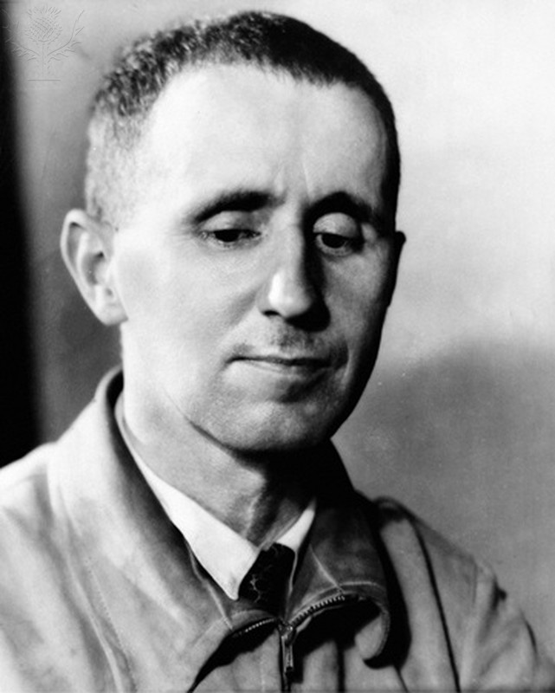
The Caucasian Chalk Circle is a play that features family dynamics in its themes, along with war, justice and class. The play poses many questions about the complexities and moral decisions in relation to raising a child and also how families can be broken by conflict, jealousy and greed. Written by Brecht in 1944 and translated into English by Eric Bentley, the play is uses many elements of Brecht’s epic theatre in its structure, style and content.
The Caucasian Chalk Circle was inspired by an ancient Chinese play, with clear Biblical influences and communist themes. It was originally intended for Broadway. The play is a Brechtian parable set at the end of World War II.

The play
The play tells two stories which come together at the end in a dispute over the custody of a child. Starting with a prologue, the situation of those at the start, mirrors the story told of the chalk circle.
Two communities are fighting over land. One claims they have always used the land so should be awarded it, and the other who want to use it for fruit trees, creating more food for the area.
The action takes place in a Caucasian city ruled by a Governor under the Grand Duke. The Fat Prince stages a coup; he murders his brother (the Governor), forcing the Grand Duke, many solders and the Governor’s wife (Natella) to flee. As she flees to save her own life, Natella leaves behind her son Michael. He is given to Grusha, a maid, who hides him from the Fat Duke, and then they flee to safety in the north, at her brother’s house. The solders find Grusha and take Michael away, and Grusha follows them back to the city.
The second story is of Azdak. He is a fugitive who saves a man’s life. This was the Grand Duke and Adzak is worried he could be called a traitor. He returns to the city claiming he saved the Grand Duke. The soldiers do not believe him and let him go. The Fat Prince arrives and wants to make his nephew the new city judge. He is convinced to let the soldiers decide; they appoint Azdak to the job. As judge, he becomes well known for favouring the poor. He is then presented with the case of Grusha and Michael.
After hearing the testimony, Azdak orders a chalk circle to be drawn. Grusha and Natella are told that whoever pulls the child out of the circle will gain custody. Grusha keeps letting go, to avoid hurting Michael. Grusha proves that although she may not be the baby’s birth mother, the care she has given him for over two years, her inability to hurt him and her willingness to let go, deems her to be the best mother for the child.

Key characters
Natella
Natella is the Governor's wife. She is a selfish woman who is jealous of the attention her son is given by her husband. When conflict erupts and she is widowed, Natella flees and leaves her baby behind. The baby is called Michael and is found and cared for by a kitchen maid called Grusha. Later, Natella tries to reclaim Michael in order to access the estates he has inherited. When he is placed in the chalk circle, she shows no hesitation in roughly pulling him out of the circle to try and show that she is the real mother, however the judge rules against her and decides that Grusha is the true mother of the child.
Grusha Vashadze
A kitchen maid in the palace, engaged to a soldier named Simon whom she is separated from by the war. She rescues the Governor's baby son Michael, taking him with her when she escapes the conflict. For two years, she cares for the child until his mother tries to reclaim him. During this time she stays with her brother and is forced to marry a dying man. Simon returns to see Grusha married with a child whom he assumes is the product of her marriage. When soldiers take the baby back to the city to return him to Natella, Grusha (and Simon) follow in order to try and keep him. Both Natella and Grusha appear before the judge Azdak who uses a chalk circle to decide who should keep the child. The judge also divorces Grusha from the dying man, allowing her to finally marry Simon.
Azdak
Azdak often comes to unexpected judgments in his cases. These are often in favour of the poor, meaning Grusha has a chance of winning her case. His character is symbolic of some of the religious elements that Brecht alludes to in the play. When he listens to Grusha’s case, he draws the chalk circle on the ground and decides by seeing which one of them would rather lose the case than hurt the child. When Natella pulls the child roughly from the circle not once, but twice, he makes up his mind. After awarding Grusha the child, he signs her divorce papers then disappears.

Suggested activities
In this topic exploration pack for The Caucasian Chalk Circle, the activities explore family dynamics in three different examples.
These are:
- The farming families of the war-ravaged Caucasian village
- The Governor, his wife and child
- Grusha and her brother Lavrenti
The activities often use ‘off text’ exercises to explore characterisation, improve performance skills and develop a deeper understanding of the family dynamics at work in the scene. There are also clear opportunities to use Brechtian rehearsal and performance techniques in order to extend the students understanding of how Brecht’s theories can work alongside his texts.

Activity 1: Exploring the Prologue
In this activity, students will use the characters, themes and events from the Prologue to explore family dynamics.
The characters are members of two collective farms who are ‘sitting in a circle, smoking and drinking wine’ and reminiscing about the conflict they have experienced.
Students choose a character that is at the event in the Prologue. There are characters of various ages to choose from. Create a character profile for their chosen character.
Students should consider:
- What influences their opinions?
- How do they react to others?
- What are their attitudes to change?
In small groups, students improvise a scene (or scenes) which contains three key family moments from the war. They should explore how different family members behaved in relation to the threat of conflict. For example:
- Are they protective of others?
- Do they blame each other?
- Are they seeking approval?
- Are there family disagreements?
Students should be encouraged to challenge themselves with their use of voice and physical skills to show how they have interpreted their character and consider their communication with the audience.
These improvisations can be developed further by adding one or two Brechtian techniques such as:
- Narration
- Placards
- Song
- Gestus
- Direct address.
Rehearse and perform the prologue using the script. Students should try to retain the subtext and their characters’ history from the previous improvisations when performing this scene.

Activity 2: The noble child
Discuss the line: ‘apple of the Governor's eye.’
- What could this mean?
- How is this linked to the theme family dynamics?
- What does the baby symbolise to the crowds?
Explore the idea that the Governor and his wife might have very different views on how to bring up the baby. As he is a part of an important family, the crowd of beggars and petitioners are very interested in the baby.
Students articulate their own vision for how the Governor and his wife, Natella, would act to care for Michael. Do they agree or disagree about their hopes for his future?
Create a scene or a series of images with a third person narration showing their family values.
When exploring the family dynamic between the Governor and his wife, students can explore their use of non-verbal communication to show the characters’ motivations in this scene and the contrast in wealth between the families of beggars and the Governor's family.

Activity 3: In the northern mountains
Ask students to discuss the family dynamics between siblings they know:
- Are there different types of relationships?
- Do some siblings get on better than others?
- Is age a factor? Are adult siblings closer than teenage siblings?
- Do family relationships change with age or distance?
Students rehearse the scene where Lavrenti is trying to give Grusha advice and help by arranging the wedding to the sick peasant.
Select key moments in the scene to add a flashback(s) to the characters’ childhood. The added scenes should further develop their characters’ bond by examining moments from their childhood that have formed the dynamic between them and their relationship now. It could be a family celebration, a moment where they had to protect each other or and a moment of sibling rivalry.
- Discuss why Grusha should accept Lavrenti’s advice and help at this stage.
- What other options does she have?
- Does Lavrenti have Grusha’s best interests at heart?
OCR Resources: the small print
OCR’s resources are provided to support the teaching of OCR specifications, but in no way constitute an endorsed teaching method that is required by the Board, and the decision to use them lies with the individual teacher. Whilst every effort is made to ensure the accuracy of the content, OCR cannot be held responsible for any errors or omissions within these resources.
© OCR 2016 - This resource may be freely copied and distributed, as long as the OCR logo and this message remain intact and OCR is acknowledged as the originator of this work.
OCR acknowledges the use of the following content: Image of Lorca on page 2: Image of Bertolt Brecht on page 2
BERTOLT BRECHT (1898–1956). – German playwright and poet. Photographed in New York in 1940, The Granger Collection / Universal Images Group
Please get in touch if you want to discuss the accessibility of resources we offer to support delivery of our qualifications: resources.feedback@ocr.org.uk
We’d like to know your view on the resources we produce. By clicking on ‘Like’ or ‘Dislike’ you can help us to ensure that our resources work for you. When the email template pops up please add additional comments if you wish and then just click ‘Send’. Thank you.
If you do not currently offer this OCR qualification but would like to do so, please complete the Expression of Interest Form which can be found here: www.ocr.org.uk/expression-of-interest
Looking for a resource? There is now a quick and easy search tool to help find free resources for your qualification:
www.ocr.org.uk/i-want-to/find-resources/

